**CS2030S RECITATION 06**

Q1

1. Data type is void and the execution is immediate since println is a method under System.out ok
2. Functional interface only has one method, the command is to use a lambda expression where the body is System.out.println(“CS2030S”)

Gets error instead because it is not a functional interface. Its Data type is lambda which must assign to some variable

Different from doing void foo() { System.out.println(“CS2030S”); }. This System.print.out is deferred until foo() is called as opposed to just calling System.out.println directly

Q2

1. See code
2. average(list, (x,y) -> x+y, (x,y) -> x*y) wrong.

average(list, (Point x, Point y) -> x.add(y), (Point x, Double k) -> x.scale(k))

OR

average(list, Point::add, Point::scale)

1. see code ok

.

.

.

average(list, Circle::add, Circle::scale)

Q3

1. see code (issue below) wrong.

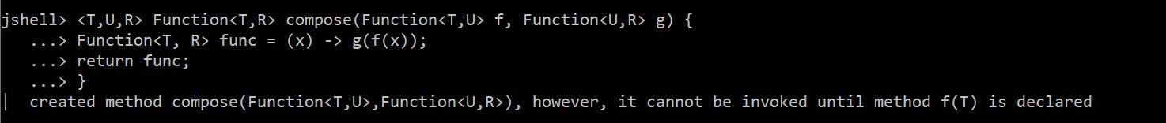

return t or (T t) or (t) -> {return g.apply(f.apply(t));};

1. 25 ans is correct, but need the working

compose(g, compose(f, g)).apply(5);

5 gets passed to g, then to compose(f,g)’s f, then g

OR

Compose(compose(g,f),g).apply(5);

1. Issue above

Q4

1. Y= 5, x= 7. Still results in 12 but the difference is that it is 2 HOFs.

So instead of add5 = addN(5).apply(7),

it is add5 = addN.apply(5).apply(7)

ok

1. 17 ok
2. Function<Double, Function<Double, Double>> ok
3. See below

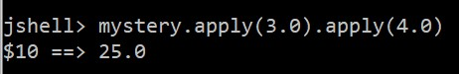

ok