ER Diagram
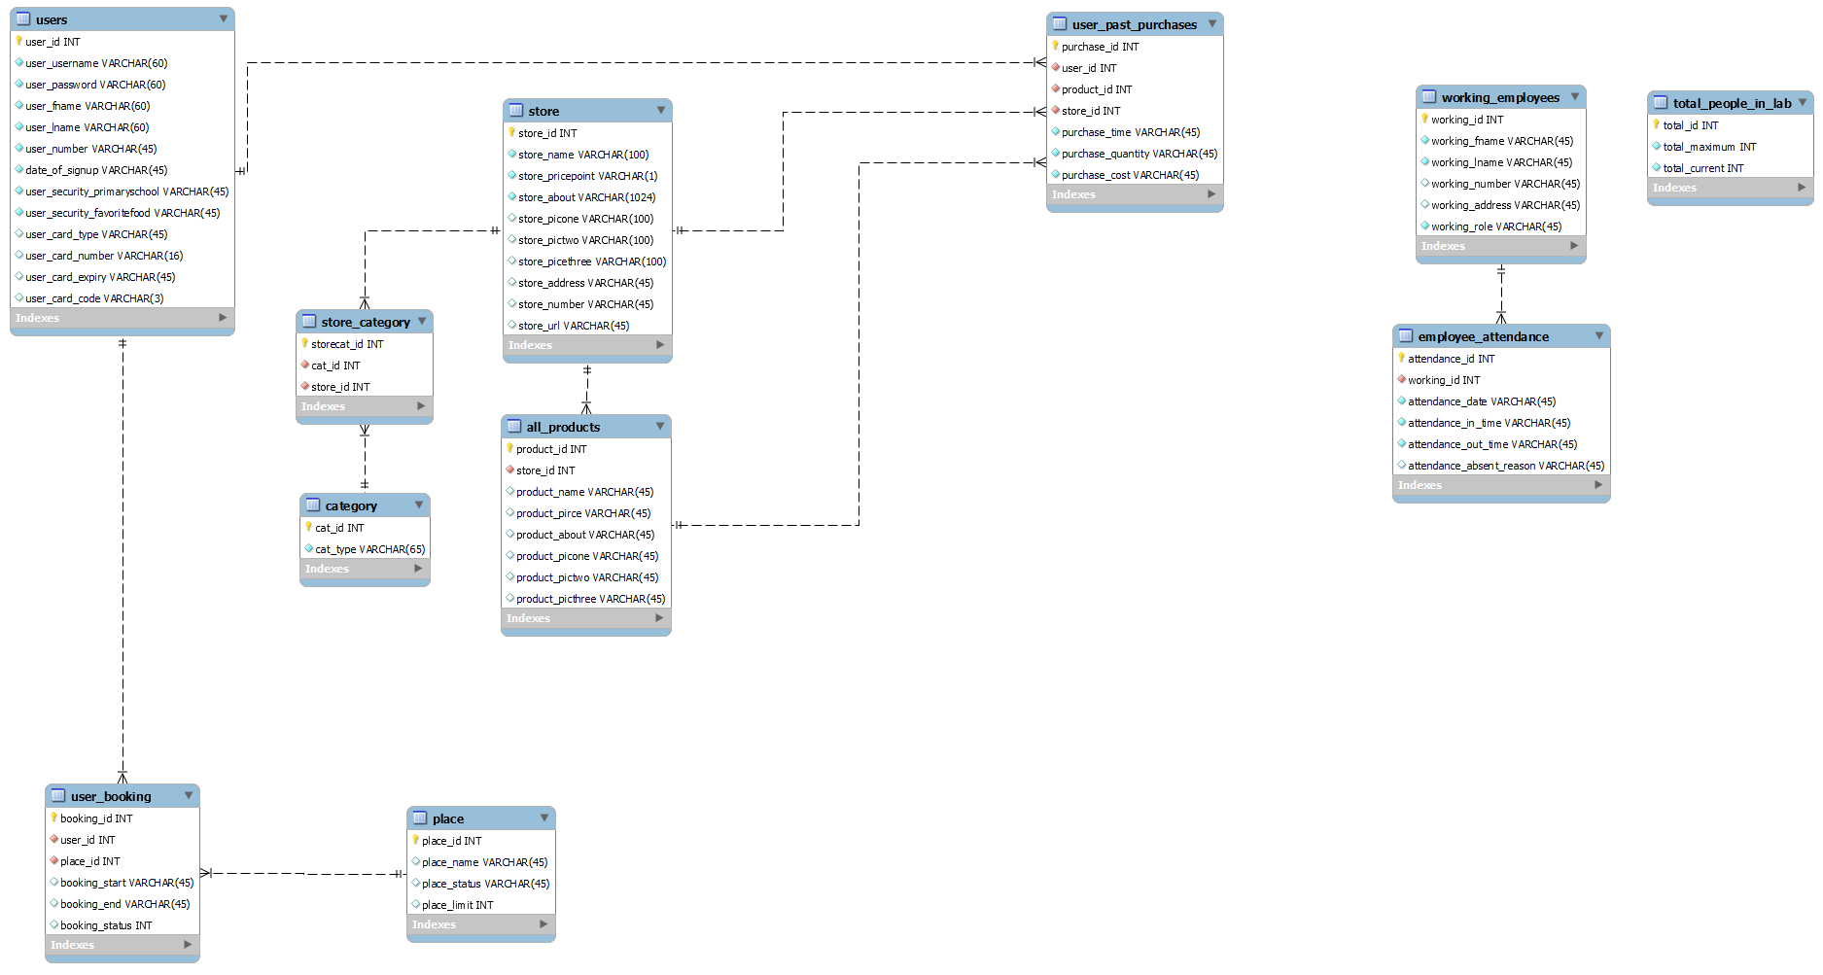

Files:

Table Explanations
Users:
Information of users who come up
Includes basics information, date of sign up, credit card information.
Security codes for “forgetting password”

User_past_purcases
Consists of information on past purchases of users

Store
Information of store. We are doing buying(admin can purchase items for AMC) and selling(normal users can purchase products from AMC). To differentiate, if we are selling, store_name will be AMC. Else, it will be external vendors(e.g. cisco, singtel? Idk)

All_products
Consists of product information

Store_category
Table to fit which store fits which category

Category
Category genes

Working_emploryees
Employees working in AMC. NOTE: this is not users who signup/register

Employee_attendance
See which employee came on which day, worked for how long, and if they are absent

Total_people
find out how many people there are. Admins can change this number on the frontend.

