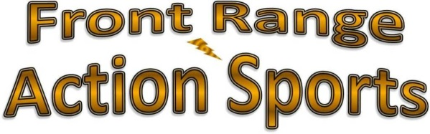

February 5, 2016

Fitness City

4786 Open Greens Dr

Santa Fe, NM 87506

Attention Fitness City

At Front Range Action Sports, we are exploring some new advertising opportunities. We have contracted with a large firm to implement some innovative campaigns to increase sales in our store and online.

Because higher sales would benefit each of our suppliers, we are extending an invitation for cooperative efforts on some of the projects. If you are interested, please contact me as soon as possible so we can include you in the planning process as well.

Thank you

Darren Rector