The Dignity Center is an organization that helps economically disenfranchised people that call upon it for assistance. These people are called CLIENTS and they are helped by the ADVOCATES. Given the following ERD, I would like you to answer the following questions (and provide the SQL)

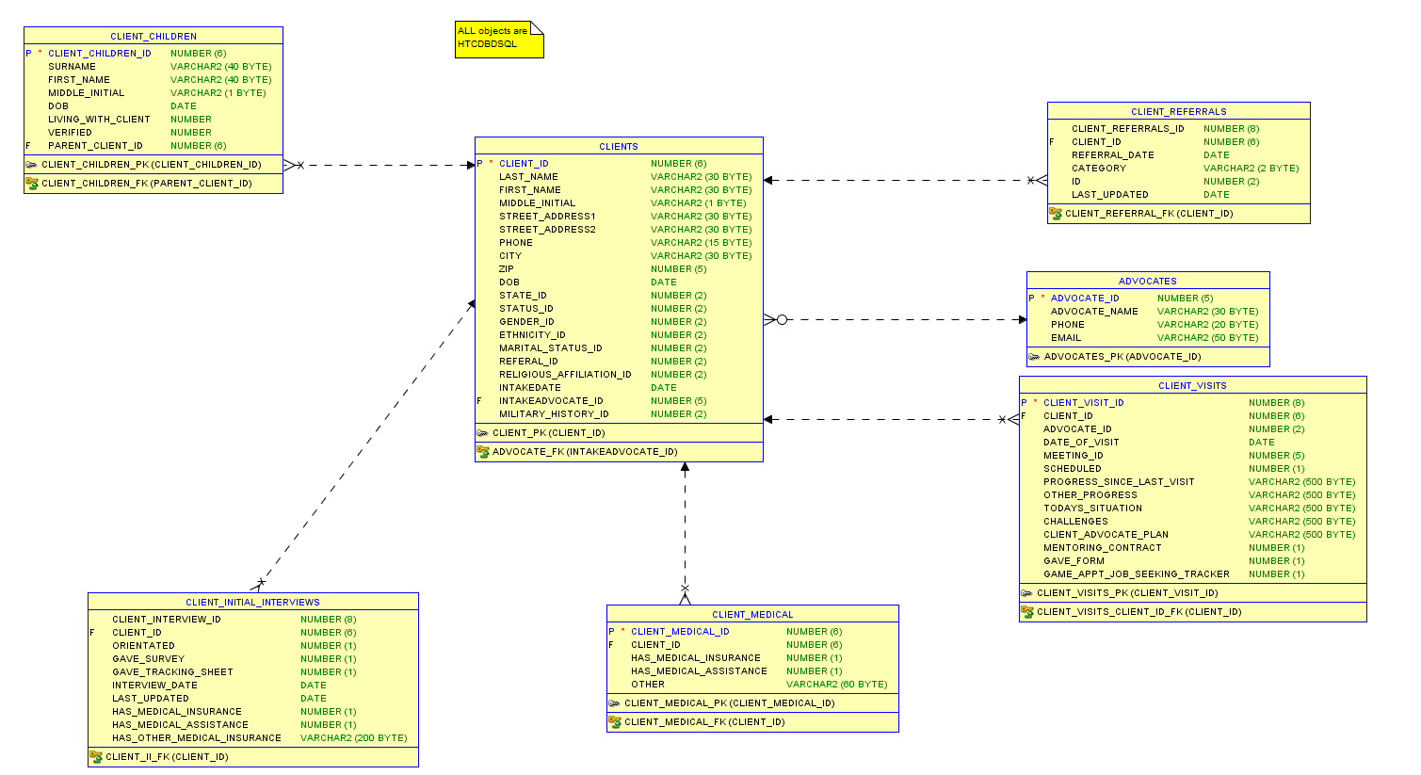

**How many Clients are there?**

SELECT COUNT(DISTINCT client_id)

FROM HTCDBDSQL.clients;

**82**

**How many Children are there that live with these clients?**

SELECT COUNT (living_with_client)

FROM htcdbdsql.client_children

WHERE living_with_client = 1;

**16**

**Which Client (name, please) has the most kids?**

SELECT cl.client_id, cl.first_name, cl.last_name, COUNT (ccl.parent_client_id)

FROM htcdbdsql.clients cl

INNER JOIN htcdbdsql.client_children ccl

ON cl.client_id = ccl.parent_client_id

GROUP BY cl.client_id, cl.first_name, cl.last_name

HAVING COUNT (ccl.parent_client_id) =

(SELECT MAX (a.cc)

FROM

(SELECT COUNT(client_children_id) cc

FROM htcdbdsql.client_children

GROUP BY parent_client_id) a

);

**G Bo 5 kids**

**Which Advocate has had the most clients in the INTAKE process?**

SELECT a.advocate_name, COUNT (client_id)

FROM htcdbdsql.advocates a

INNER JOIN htcdbdsql.clients cl

ON a.advocate_id = cl.intakeadvocate_id

GROUP BY a.advocate_name

HAVING COUNT (client_id) =

(SELECT MAX (bc)

FROM

(SELECT COUNT (client_id) c

FROM htcdbdsql.clients

GROUP BY intakeadvocate_id) b

);

**B CARLSON 12 CLIENTS**

**The following query gives you a list of the genders of the DC clients. Using this as a SUBQUERY, aggregate the data to determine how many of each gender there are.**

SELECT CASE WHEN GENDER_ID = 1 THEN 'MALE'

WHEN GENDER_ID = 2 THEN 'FEMALE'

ELSE 'UNDISCLOSED'

END AS GENDER

FROM HTCDBDSQL.CLIENTS CL

Your results should look like this.

|  |  |
| --- | --- |
| GENDER | CLIENTS |
| FEMALE | 12 |
| MALE | 70 |

SELECT gender, COUNT (a.gender) CLIENTS

FROM

(SELECT CASE WHEN GENDER_ID = 1 THEN 'MALE'

WHEN GENDER_ID = 2 THEN 'FEMALE'

ELSE 'UNDISCLOSED'

END AS GENDER

FROM HTCDBDSQL.CLIENTS

) a

GROUP BY gender

ORDER BY gender;

**Produce the following chart that analyzes how many times clients visit the DC.**

|  |  |
| --- | --- |
| **VISITS** | **CLIENTS** |
| 1 | 23 |
| 2 | 13 |
| 3 | 4 |
| 4 | 5 |
| 5 | 3 |
| 6 | 1 |
| 7 | 2 |
| 8 | 2 |
| 11 | 1 |

SELECT v.visitcount as VISITS, COUNT(v.visitcount) AS CLIENTS

FROM (

SELECT count(client_id) AS visitcount, Client_ID

FROM HTCDBDSQL.client_visits

GROUP BY Client_ID

ORDER BY Count(Client_ID)

) v

GROUP BY v.visitcount

ORDER BY v.visitcount;

**Modify above to show only those groups where more than 10 clients visit a certain number of times.**

|  |  |
| --- | --- |
| **VISITS** | **CLIENTS** |
| 1 | 23 |
| 2 | 13 |

SELECT v.visitcount as VISITS, COUNT(v.visitcount) AS CLIENTS

FROM

(

SELECT count(Client_ID) AS VisitCount, Client_ID

FROM HTCDBDSQL.client_visits

GROUP BY Client_ID

ORDER BY Count(Client_ID)

) v

GROUP BY v.visitcount

HAVING COUNT (v.visitcount)>10;

**Finally, on average, how often does a client visit the DC?**

SELECT Round(Avg (V.Count),0)as"Average Visit to DC"

FROM

(

SELECT COUNT(Date_of_visit) as Count, Client_ID

FROM HTCDBDSQL.Client_Visits

GROUP BY Client_ID

) V;

**3**