For our exploratory data analysis, we have decided to utilise SAS Enterprise Guide and the table below is a basic description of the variables in our csv files. Other than just the name and type of the variable, we have added in the attribute type as well.

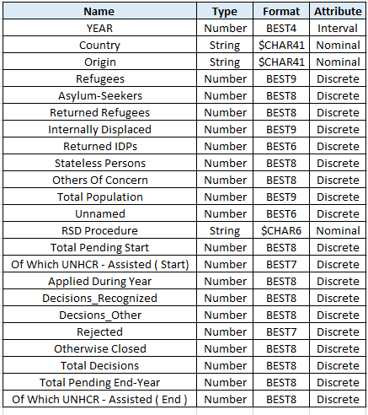

Univariate non-graphical EDA for quantitative data

Figure 1 below shows the population distribution for our quantitative data and the data is validated with zero missing values.   
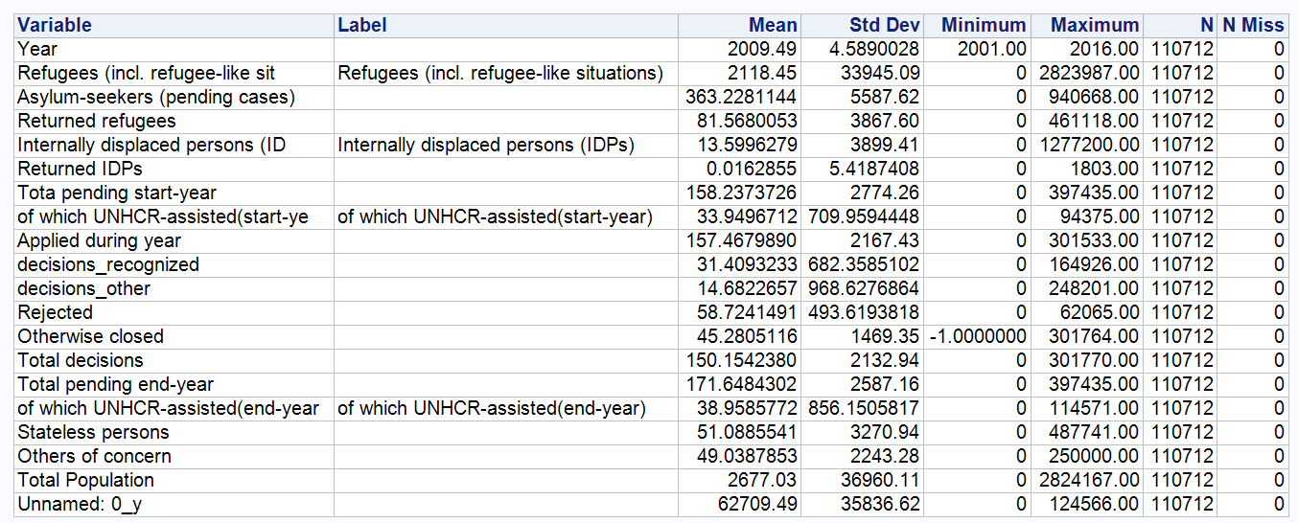

Fig.1:

Univariate non-graphical EDA for categorical data

Figure 2 and 3 below shows the distribution for our three categorical data namely: Country, Origin and RSD procedure type. It is also proven through the chart that there is no missing values as the proportions adds up to 100%.

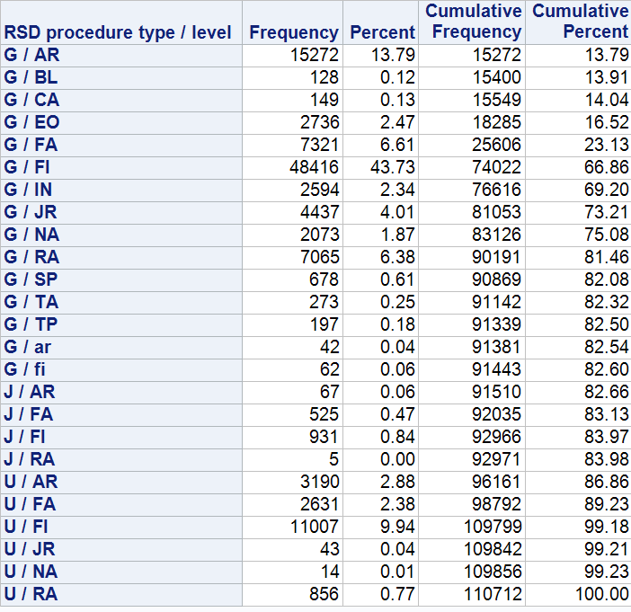

Fig.2: One Way Frequency Chart for RSD Procedure Type



Fig.3: One Way Frequency Chart for Country and Origins

The chart below illustrates the growing problem of refugees as there is an increasing trend and greater number than before of people getting displaced.

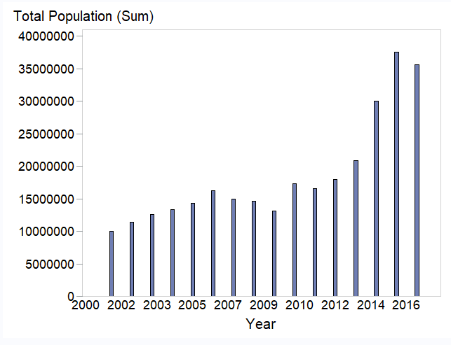

The total number of pending cases is also increasing per year and this means that the asylum seekers will spend more time without a shelter as their cases remain undecided.

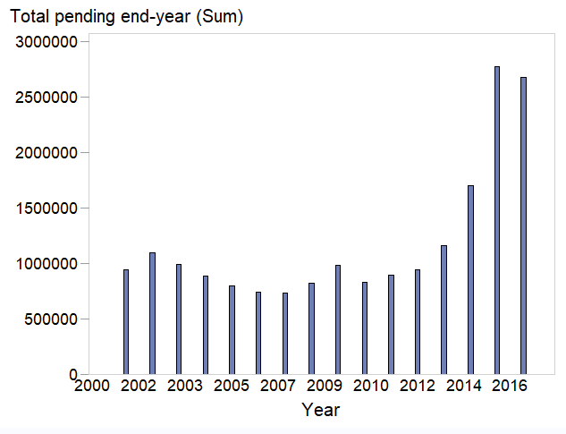

The top ten countries for which refugees prefer are listed below:

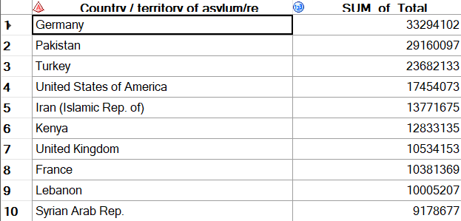

The top ten countries for which refugees are coming from:

