Rick Williams

CIT 230

Topher Reynolds

4th December 2020

Forward Chance Documentation

1. Main Menu – located to the left of the play space, the Menu contains options for controlling the program outside of gameplay

a. Start New Game – will reset the board to start a new game when pressed

b. Load Saved Game – will load a previously saved game, if a saved game is available. If there is no saved game, will display a message “Saved Game Not Found”

c. Save Game – will immediately save the current game. Only one game may be saved at a time. Saving the game will overwrite any previous saves. There is no confirmation dialog, saving will happen immediately after pressing the button. A message will be displayed if the game was saved successfully.

*Dev Note: Confirmation Dialog and multiple saves/pathing to be implemented in future version.*

d. Red Resigns – Red immediately forfeits the game and blue wins by default. Red may resign regardless of whether it is currently their turn or not. Game will automatically restart for a new game upon resignation.

e. Blue Resigns – Same deal as Red Resigns, but blue instead. *- Ed Note: C/V and edit the language from the previous entry, no need to be so short.*

f. Show All Moves – Will toggle the right side display between the game Rules and the Move History of the current game.

g. Exit – Immediately exits the program

*Dev Note: Exit confirmation dialog to be implemented in next version. Save Game Confirm dialog on exit planned to be added in future version.*

1. Game Play –
   1. Setup – Players take turns moving their pieces across the board. The player to go first is determined randomly and will be displayed at the top of the program and by the indicator panel in the play space.

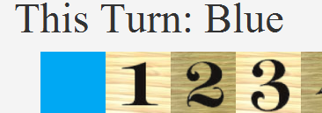

* 1. Movement - Red players will move to the right, and blue players will move to the left. Each piece may only move one space at a time, regardless of the direction of travel. Clicking a piece in the play space will advance that piece one space in the travel direction, as long as it is that players turn. Clicking any other space or the pieces of the opposing team will have no effect.

B7 is clicked:

* 1. Attacking – When it is the players turn, if the clicked piece is on a panel that borders a panel with an opposing player’s piece, the player may choose to attack and claim the opposing player’s piece. Attacks may happen in the travel direction and immediately above or below, but not in the opposite direction. Attacking is the only time a piece may move in a way that is not directly across the board.

Blue may attack in any of the checked directions surrounding the blue piece, as long as a red piece is present on any of the bordering panels. Red may attack in any of the checked directions as long as a blue piece is present on any of the bordering panels.

When a piece is clicked and an attack is possible, you will be asked if you wish to declare an attack.

B4 is clicked:

The blue piece at B4 has the option to attack the red piece on B3 or the red piece on C3. Selecting “Yes” from the attack dialog will allow the player to enter which space they would like to attack.

The blue player may enter the name of either space, B3 or C3, to attack that space.

* 1. Auto Attack – In the previous example, the blue player may attack either B3 OR C4, so when the blue piece at B4 is clicked, the player is asked if they would like to declare an attack. If the player selects “No” at this dialog, the blue piece will automatically attack the space directly in front of it, in this case B3.

* 1. Auto Move - If an attack is available and the space directly in front of the clicked piece is unoccupied, when the piece is clicked the player will be asked to declare an attack in the same manner. Selecting “Yes” will allow the player to enter the panel to be attacked. Selecting “No” will automatically move the player’s piece forward in the travel direction. Selecting “Cancel” will allow the player to select a different piece. In the picture above, the red piece at C3 may capture the blue piece at B2 or choose to move to safety using the auto move feature.
  2. Board Ends – When a player reaches the opposite end of the board, Column 1 or 8, the piece will be moved back to a random panel in the team’s home column. This is 2 for red and 7 for blue. The piece will be dropped onto a random panel and will displace any pieces currently occupying that space. Opposing pieces will be captured, while pieces from the same team will be “killed” by friendly fire and removed from the board.
  3. Dead Pieces – Dead pieces will be displayed at the bottom of the screen in the appropriate space. There is no way to return pieces to play during the course of a game. Pieces will only be restored when a new game is begun.

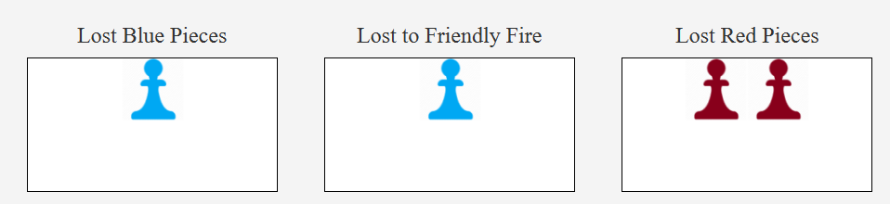

* 1. Turns – A valid turn is any turn in which the player has successfully moved a piece. This may be through moving in the travel direction or attacking an opposing piece. Relocation from reaching the end of the board is considered part of the current turn and the turn does not end until the piece has been relocated. If a player is unable to move, they must resign.
  2. Win Conditions – A player automatically wins if they capture all available pieces of the opposing team. There is a time limit of 200 turns. If 200 turns have passed, the player with more remaining pieces is the winner. If both players have the same number of remaining pieces, then the player who lost less pieces to friendly fire is the winner. If both players have an equal number of remaining pieces, and lost an equal number of pieces to friendly fire, then the player who moved second is the winner. The game will automatically check the win conditions at the end of each turn and declare a winner automatically if possible. Note that the first turn is turn 1, there is no 0 turn. So the 200th turn may be played, but the game will immediately conclude at the beginning of the 201st turn.

1. Reading the Move History – The move history may be toggled via the menu. When it is selected, the complete move history will be displayed in the right pane.

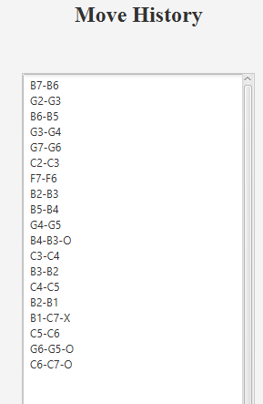

Each line represents a single move. The first named board space is the starting point, and the second named space is the ending point. Lines that include a “O” indicate an opposing piece was captured on the move, while lines that include an “X” indicate that a piece was lost to friendly fire on that move. Note that turns that reach the end of the board occupy two lines, the first reaching the board end, and the next relocating the piece to it’s home row.