Test2aa
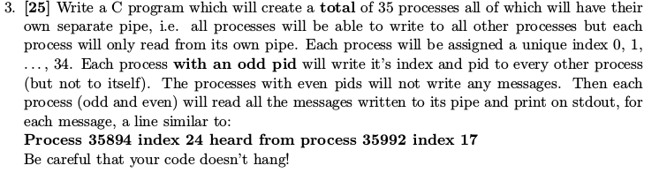
Data Members: Need an array for pipes, a message structure (index and pid), a loop variable, a process indx, a flag to break child out of fork loop, and a temp pid.
Outline:
- set up the pipes (loop)
- start forking (another loop)
  - switch:
    - -1: error trap
    - 0: child, set index and set flag to break out of loop
    - default: parent, set flag to keep forking
  - if child, break out of loop
- outside forkloop – if parent – exit
- if child, gotta do some work
  - close read ends of pipes (except your own – index!)
  - get your pid
  - if your pid is odd (%2)
    - set up message to send
    - write to all other procs (loop, check if index is yours before writing)
  - close all write ends of pipes
  - read all messages (use while(read(...)), and don't forget to flush)
  - outside of read while loop, close your read end of pipe and exit
With comments, blank lines, and includes, this is about 100 lines of code

Test2bb
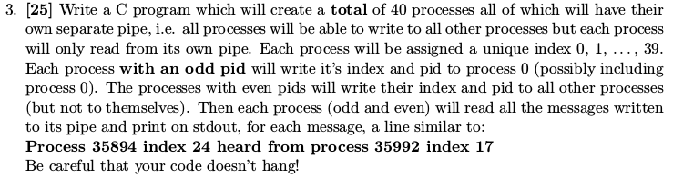
Test2cc
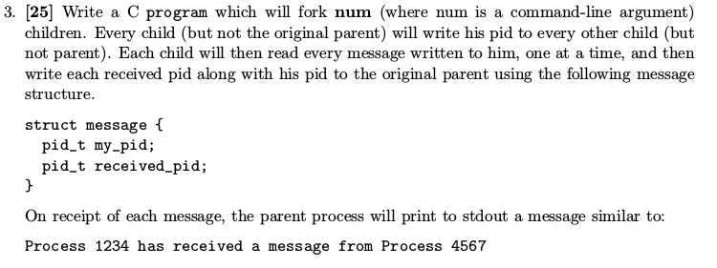
Test2e
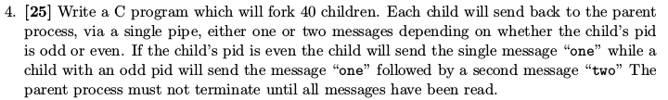

Test2dd
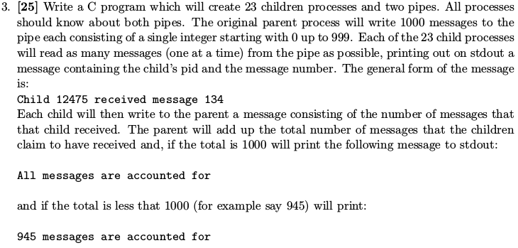
Test2ee same as Test2aa
Test2ff
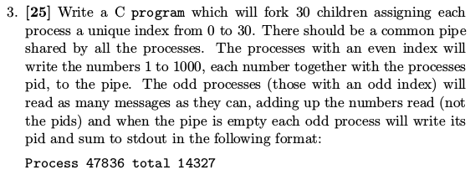

Test2gg
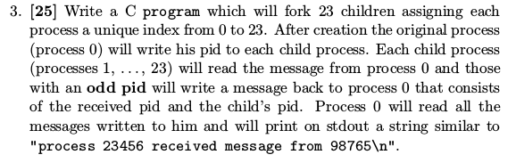
Test2hh same as Test2cc
Test2ii same as Test2aa

Test2jj
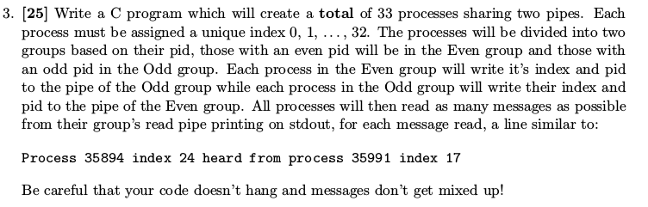
Test2kk.1 similar to Test2aa (only even pid writes this time)
Test2kk.2 same as Test2aa
Test2l
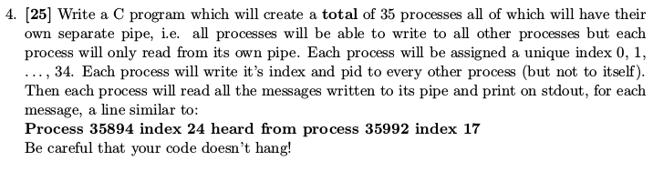
Test2ll same as Test2gg
Test2mm same as Test2cc
Test2nn same as Test2jj

Test2oo
