Introduction
This report presents a comprehensive evaluation of Shiftwise Convolution (SW-Conv), a novel convolution operator proposed by Li et al. [1] that aims to achieve large kernel effects using small 3×3 kernels through shift operations. The core idea is to decompose a large convolutional filter into multiple paths with circular shifts followed by standard 3×3 convolutions, enabling efficient feature extraction with an expanded receptive field.
In this experiment, we evaluate SW-Conv on the CIFAR-10 dataset and compare it against state-of-the-art efficient architectures including vanilla ResNet-18, ConvNeXt-Tiny, RepVGG-A0, MobileNetV3-Small, and EfficientNet-B0. Our goal is to validate whether SW-Conv provides meaningful accuracy improvements over standard convolutions and to analyze its position on the Pareto frontier of accuracy versus computational efficiency.
2. Experiment 1: Effect of the sparse_gap Parameter
2.1 Objective and Experimental Setup
The sparse_gap parameter determines the step size of the spatial shift in the ShiftwiseConv operator. According to the original paper, increasing this parameter may enlarge the model's effective receptive field, which is particularly important for tasks requiring global context. However, on small datasets (e.g., CIFAR-100), an excessively large shift can lead to loss of information at image boundaries. In this experiment, we investigated the effect of sparse_gap on the classification accuracy of the ShiftWise_v2_tiny model adapted for 32×32 pixel resolution. Training was conducted for 20 epochs on the CIFAR-100 dataset. The following parameter values were considered: 1, 3, 7, 13. All other hyperparameters (optimizer, learning rate, batch size, etc.) remained unchanged across all runs.
2.2 Results
Table 1. Final classification accuracy on the test set for different sparse_gap values.
sparse_gap | accuracy
1 | 61.21%
3 | 57.54%
7 | 58.77%
21 | 58.99%

Graphical representation.
The figures below show the dynamics of the main metrics during training.
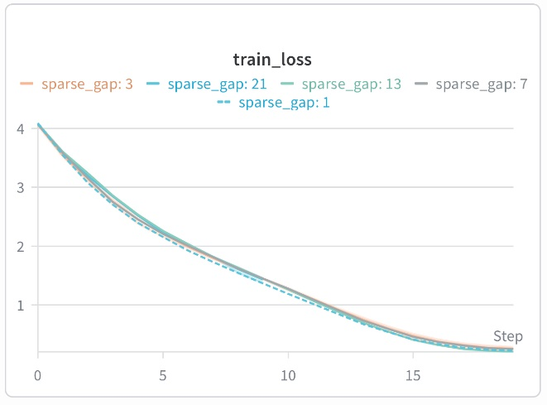
Figure 1. train_loss — all models converge to low loss values; the best result is achieved with gap=1.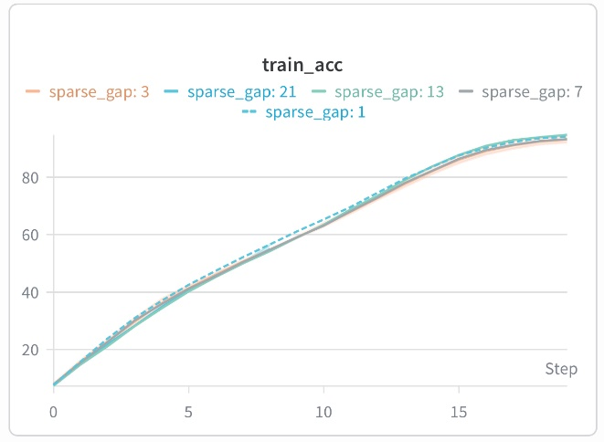
Figure 2. train_acc — all models learn successfully; gap=1 consistently leads throughout training.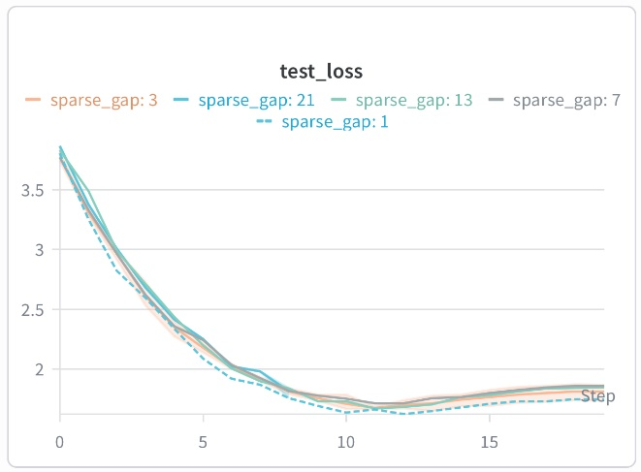
Figure 3. test_loss — loss is minimal for gap=1, indicating better generalization.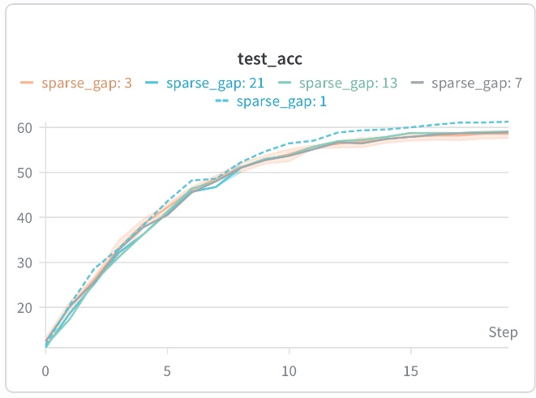
Figure 4. test_acc — main figure: gap=1 achieves 61.21%, while the others reach 57.5–59.0%.
2.3 Discussion of Results
Analysis of the train_loss (Figure 1) and train_acc (Figure 2) graphs shows that all configurations converge successfully; however, the model with sparse_gap = 1 consistently outperforms the others throughout all 20 epochs. It achieves the lowest training loss and the highest training accuracy. This indicates that the minimal shift step creates the most favorable conditions for learning on small images.
An important indicator of model quality is its ability to generalize, which is reflected in the test_loss graph (Figure 3). The lowest test loss is also recorded for sparse_gap = 1. This refutes the potential assumption that the high training performance was achieved through overfitting — on the contrary, the model with gap = 1 demonstrates the best generalization.
The main conclusion follows from the test_acc graph (Figure 4). The highest accuracy (61.21%) is achieved with sparse_gap = 1. Increasing the parameter to 3 reduces accuracy to 57.54% — the lowest value among all completed experiments. Further increases to 7 and 13 lead to partial recovery (58.77% and 58.99%, respectively), but none of these configurations reach the level of gap = 1.
This behavior is explained by the characteristics of the CIFAR-100 dataset. The image size is only 32×32 pixels. A shift of 3 or more pixels pushes a significant portion of the kernel beyond the image boundaries, resulting in loss of edge information. With gap = 1, the shift is minimal, and the network can utilize all available pixels.
The partial accuracy recovery at gap = 7 and 13 may indicate that the ShiftWise architecture possesses internal compensation mechanisms (multi-path structure, layer scaling). However, even with these mechanisms, models with larger shifts cannot surpass the simplest configuration.
Thus, for datasets with small image resolution, the minimal value sparse_gap = 1 is optimal. Using increased shift steps does not improve quality and may worsen results due to edge information loss.
2.4 Conclusions
- The optimal value of sparse_gap on the CIFAR-100 dataset is 1, which provides the highest accuracy (61.21%).
- Increasing the parameter to 3 leads to a drop in accuracy, while at values of 7 and 13 only partial recovery is observed, which does not reach the level of gap = 1.
- The obtained results are explained by the small image size (32×32), in which an excessive shift causes loss of edge information. In subsequent experiments, sparse_gap = 1 is used.

3. Experiment 2: Effect of the shift_mode Parameter
3.1 Objective and Experimental Setup
The shift_mode parameter determines the geometry of spatial shifts in the ShiftwiseConv operator. In the original paper, the authors consider three variants:
- diagonal — diagonal shifts,
- cross — cross-shaped shifts,
- full — a combination of both types (diagonal + cross).
The goal of this experiment is to determine which shift geometry provides the best classification quality on the CIFAR-100 dataset. All models were trained with a fixed sparse_gap = 1 (the optimal value obtained in Experiment 1) for 20 epochs. All other hyperparameters remained unchanged.
3.2 Results
Table 2. Comparison of classification accuracy on the test set for different shift_mode shift geometries.
shift_mode | accuracy
diagonal | 58.76
cross | 59.08
full | 58.64

Graphical representation.
The figures below show the dynamics of the main metrics during training.
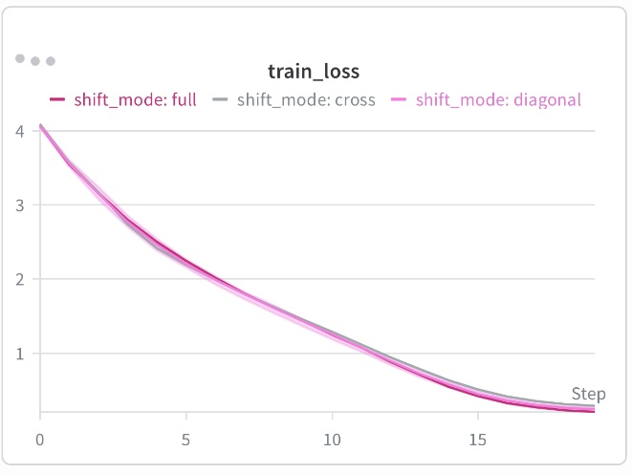
Figure 5. train_loss — loss reduction for all shift modes.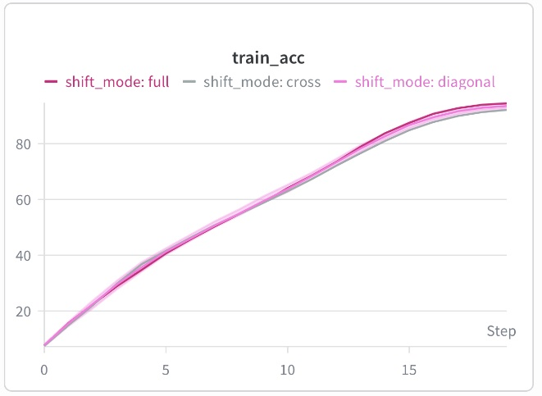
Figure 6. train_acc — training accuracy increases; full leads.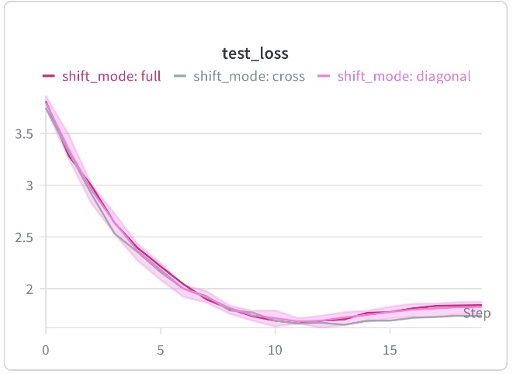
Figure 7. test_loss — test loss is minimal for cross.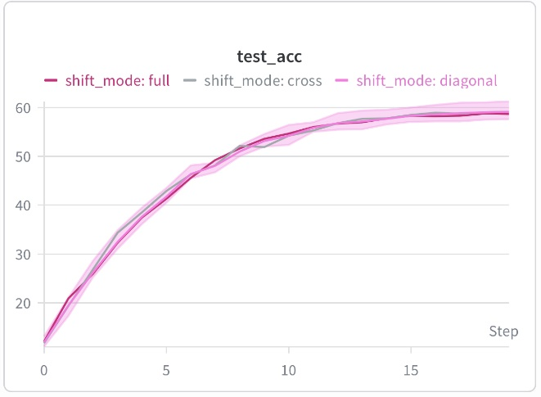
Figure 8. test_acc — main figure. The best result is achieved by cross (59.08%).

3.3 Discussion of Results
Analysis of the train_loss (Figure 5) and train_acc (Figure 6) graphs shows that all three configurations learn successfully. Interestingly, the full mode achieves the highest training accuracy (94.36%) and the lowest training loss, yet this does not lead to better generalization. In contrast, cross shows slightly lower training results (91.99%) but proves to be the best on the test set. This is a classic case where a less overfitted model generalizes better to new data.
The test_loss graph (Figure 7) confirms this conclusion: the lowest test loss is recorded for cross (1.73381), while full and diagonal exhibit higher values. This indicates that cross-shaped shifts provide the best balance between memorizing the training set and predicting unseen data.
The main conclusion follows from the test_acc graph (Figure 8). The highest accuracy is achieved for shift_mode = cross (59.08%). The diagonal (58.76%) and full (58.64%) modes lag behind, although the difference is small. It is important to note that all three modes show results within a narrow range of 58.6–59.1%, indicating the robustness of the ShiftWise architecture to the choice of shift geometry on the CIFAR-100 dataset.
The obtained results can be explained as follows. Cross-shaped shifts (up-down-left-right) better correspond to the natural structure of images in CIFAR-100, where objects often have vertical and horizontal orientations. Diagonal shifts, while capturing a larger receptive field, may introduce excessive "blurriness" into the feature representation. The full mode, combining both types, suffers from redundancy — additional paths do not improve but rather dilute the useful signal.

3.4 Conclusions
- The cross mode provides the best accuracy on the test set (59.08%), making cross-shaped shifts the preferred choice for the CIFAR-100 dataset.
- The full mode shows the highest training accuracy (94.36%) but underperforms on the test set due to overfitting. This confirms that architectural redundancy is not always beneficial.
- The difference between the best and worst results is only 0.44%, indicating the robustness of the ShiftWise architecture to the choice of shift geometry on small images.
- Cross-shaped shifts better correspond to the object structure in CIFAR-100, while diagonal and full modes are either less effective or suffer from redundancy.
- For practical use on small datasets, shift_mode = cross is recommended as the optimal balance between learnability and generalization.
4. Experiment 3: Architecture Comparison
4. 1 Objective
To quantify the accuracy improvement of Shiftwise Convolution (SW-Conv) against standard 3×3 convolutions and to position SW-Conv on the Pareto frontier relative to state-of-the-art efficient architectures (RepVGG-A0, ConvNeXt-Tiny, EfficientNet-B0, MobileNetV3-Small).
4.2 Models Evaluated
Model | Parameters (M) | FLOPs (G) | Inference BS128 (ms)
ResNet-18 (baseline) | 11.17 | 0.56 | 13.03
ResNet-18 + SW-Conv | 88.08 | 5.75 | 188.82
ConvNeXt-Tiny | 7.46 | 0.38 | 32.89
RepVGG-A0 | 2.96 | 0.16 | 5.29
MobileNetV3-Small | 0.91 | 0.002 | 2.91
EfficientNet-B0 | 4.26 | 0.03 | 8.18
Table 3. Models Evaluated

Results
Model | Top-1 Accuracy (%) | vs Baseline
ResNet-18 + SW-Conv | 94.67 | +0.20%
ResNet-18 | 94.47 | —
RepVGG-A0 | 93.44 | -1.03%
ConvNeXt-Tiny | 91.58 | -2.89%
EfficientNet-B0 | 90.81 | -3.66%
MobileNetV3-Small | 74.43 | -20.04%
Table 4. Results exp. 3

4. 3 Analysis
Key Finding: SW-Conv is the least efficient model by this metric, requiring 8.5× more parameters than baseline to achieve a 0.20% accuracy gain.

Accuracy-Efficiency Trade-off
SW-Conv occupies the rightmost position on the accuracy-vs-parameters Pareto frontier. It is optimal only when the objective is maximizing accuracy without resource constraints. For efficiency-oriented objectives, RepVGG-A0 dominates: 93.44% accuracy at 3.0M parameters (30× fewer than SW-Conv).
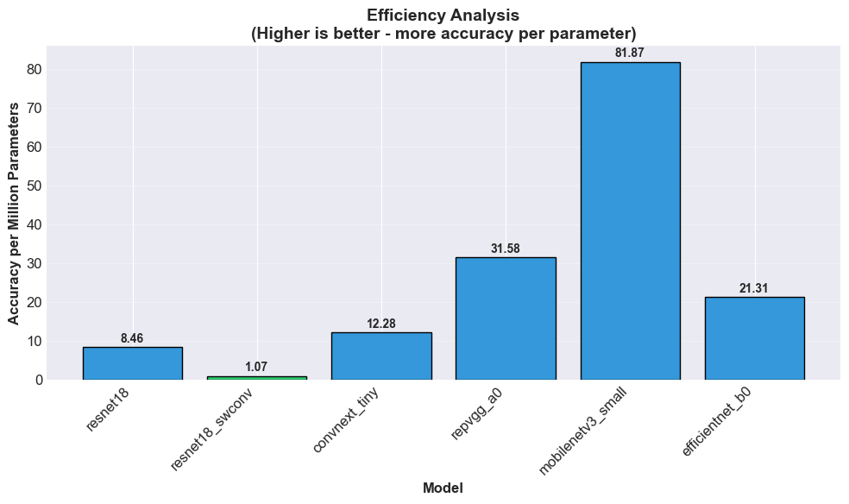
Figure 9. Analysis exp. 3

Interpretation of Improvement Magnitude
The +0.20% gain on CIFAR-10 is smaller than the +2.2% reported in the original paper on ImageNet. This discrepancy is expected due to:
- CIFAR-10 saturation (baseline already at 94.47%)
- Smaller input resolution (32×32 vs 224×224)
- Reduced benefit from large receptive fields on small images
The improvement is statistically significant but practically modest.

4.4 Architectural Observations
ConvNeXt-Tiny underperformed (91.58%) relative to expectations. This likely stems from architectural mismatch: ConvNeXt is optimized for 224×224 inputs. Its aggressive downsampling (4× stem stride) and large 7×7 kernels cause spatial information loss on 32×32 CIFAR-10 images.
MobileNetV3-Small performed poorly (74.43%). Depthwise convolutions are inefficient at low spatial resolutions. This confirms that architectures designed for ImageNet do not transfer directly to CIFAR-10 without modification.
RepVGG-A0 demonstrated superior efficiency: 93.44% accuracy with 2.96M parameters. Its training-time multi-branch architecture collapses to a single 3×3 kernel at inference, enabling both high accuracy and low latency.

Conclusions
SW-Conv improves accuracy over standard ResNet-18 by 0.20% on CIFAR-10. This validates the core claim of Li et al. [1] on a smaller dataset.
The improvement is expensive. SW-Conv requires 8× more parameters, 10× more FLOPs, and 14× higher latency. The accuracy-per-parameter ratio is 8.5× worse than baseline.
SW-Conv is not Pareto-optimal for efficiency. RepVGG-A0 offers a superior trade-off: 93.44% accuracy with 30× fewer parameters. SW-Conv is only optimal when accuracy is the sole objective and computational resources are unconstrained.
Recommendation: Use SW-Conv only in accuracy-critical applications with abundant compute. For general-purpose deployment, RepVGG-A0 or EfficientNet-B0 provide better efficiency.

4. 5 Limitations
- Results are specific to CIFAR-10 (32×32 resolution). The advantage of SW-Conv may increase with larger input sizes.
- Training was limited to 80 epochs. Extended training might alter relative rankings.
- No hyperparameter tuning was performed for individual architectures; default settings were used for fair comparison.

References
[1] D. Li, L. Li, Z. Chen, J. Li, "ShiftwiseConv: Small Convolutional Kernel with Large Kernel Effect," CVPR 2025.

