Meridian Financial
Testing & Security Report
Application #2 · August 2026 · github.com/darrshen97-ui/Meridian

1. Testing approach and coverage
Every feature was tested three ways: an automated suite that runs on each change, manual clicking of each screen and control in a browser, and adversarial inputs designed to break things. The suite now holds 158 backend tests and 13 frontend tests, all passing. Automated coverage includes the whole pipeline end to end — a full provider sync, importing all 117 sample statements, and reconciling 79 statement periods — so a regression anywhere in the chain fails the build rather than waiting to be noticed.
Testing was deliberately hostile rather than confirmatory. The mock provider injects a configurable failure rate and periodic rate-limit responses, so retry and back-off code is genuinely exercised; one test drives sync at a 50% failure rate and asserts the ledger still converges without duplicating a single row.
Feature test checklist
Feature | What was tested | Result
Profile create / sign in | Valid + wrong password, short password, duplicate email, 9 bad attempts | Pass
Profile switching | Switch requires re-authentication; no data bleeds between profiles | Pass
Dashboard | Spending power, month comparison, attention counts, recent activity | Pass
Live sync (SSE) | Sync now, per-account progress, 50% provider failure rate, 429s | Pass
Accounts | Grouping, balances, closed accounts de-emphasised | Pass
Transactions | Search, 5 filters, paging, inline category edit + rollback | Pass
Statement upload | PDF / CSV / OFX, 117 documents, duplicate upload, 16 MB file, .xyz file | Pass
Import preview | Nothing written until confirmed; ambiguous account asks | Pass
Categorization | Rules pass, LLM pass, hallucinated category, model absent | Pass
Review queue | Accept, bulk apply, keyboard j/k/a/Shift+A | Pass
Reconciliation | 79 periods, 13 planted anomalies, resolve action | Pass
AI coach | Grounded answers, 4-call cap, no-data honesty, model absent | Pass
Budgets + simulator | Set/clear target, projection, category with no history | Pass
Settings | Model status, speed test, sync, dev tool, audit log, theme | Pass
Error paths | Unknown API route, server exception, invalid dates, empty body | Pass
Responsive | 1280 px and 375 px on every data-heavy screen | Pass

2. Bugs found and fixed
Ten defects of substance were found and fixed. Three were found by a user running the packaged application on Windows, which is noted honestly below because it is the most useful lesson in this report: the automated suite could not see them, since all three lived in packaging and browser behaviour rather than in application logic.
# | Symptom | Cause | Fix
1 | Downloading the repository produced an app with no interface at all — the server ran, the browser showed a raw JSON error. | The built frontend was excluded by .gitignore as "build output". | Committed the built bundle; a missing interface now returns an explanatory page, not raw JSON.
2 | On Windows the app loaded a blank white page with the correct window title. | Python reads MIME types from the Windows registry, where .js is often mapped to text/plain; browsers strictly MIME-check ES modules and silently refuse them. | Static files are now served from an explicit content-type table instead of the host registry. Reproduced by poisoning the MIME map, then verified fixed.
3 | Blank page again after a rebuild, this time with no error at all. | index.html names content-hashed bundles but was served with no cache headers, so the browser reused an old copy pointing at files that no longer existed. | index.html is sent no-store; hashed assets cache for a year.
4 | Live sync created duplicate accounts for anything a statement import had already created. | Sync matched accounts only by provider key, which statement-created accounts do not have. | Sync now adopts a matching account by mask and type on first run.
5 | An account's ingested transactions vanished from the sync summary when only its balance refresh failed. | One try/except wrapped both operations, so a late failure discarded the earlier success. | Balance failure degrades the entry instead of failing the account.
6 | Unknown /api paths returned an HTML page with status 200. | The single-page-app catch-all route swallowed API paths. | Unknown API paths return a JSON 404.
7 | The local model auto-filed cryptic card descriptors (SQ *, TST*) with high confidence — wrong categories entering the ledger silently. | A small model is overconfident on processor prefixes that hide the real merchant. | Confidence for those descriptors is capped in code, so they can only be filed by the user's own correction.
8 | The model stated incorrect dollar totals in its written answers. | It performed arithmetic instead of quoting the figures the tools had already computed. | Every figure is precomputed and handed to the model; the interface prints the true total regardless of the prose.
9 | Account numbers masked with bullet characters became unreadable to the PDF parser. | The glyph extracts as a placeholder code, which would have broken account matching. | Masks use ASCII, as real statements do.
10 | A rendering crash would have shown a blank screen. | No React error boundary existed. | An error boundary shows a recovery view; a global handler logs the traceback server-side and returns a message that leaks nothing.

3. Security audit
A full audit was run across authentication, data isolation, injection, secret handling, file handling, error disclosure, and the AI data path. One live vulnerability was found and fixed during the audit; the remainder were verified as already controlled, with the specific control named.
Area | Status | Risk | Control in place
Brute-force sign-in | Found in this audit | Nothing limited password guesses against the published demo emails. | Eight failures per email triggers a five-minute lockout, returning 429 — verified by test.
Cross-profile data leakage | Designed against, verified | One profile's data reaching another would be the worst possible failure in a finance app. | Every repository method takes a user ID; a structural test fails the build if any method omits it, and an integration test proves profile A sees zero of profile B's rows on every endpoint.
SQL injection | Audited — none found | User input reaches search, filters and category lookups. | All queries use the SQLAlchemy ORM with bound parameters; no string-built SQL exists in the codebase.
Exposed secrets | Audited — none found | Keys or passwords committed to a public repository. | .env is git-ignored and only .env.example is committed; the session secret is generated on first run and stored with owner-only permissions; no credentials appear in source.
Password storage | In place | Plaintext or weak hashing. | Argon2id with a ten-character minimum and a strength meter.
Session hijacking / CSRF | In place | Token theft via JavaScript or cross-site form posts. | JWT stored in an httpOnly, SameSite=Strict cookie; the token is never readable from JavaScript.
Path traversal | In place | A crafted path escaping the static or upload directory. | Static paths are resolved and checked against the static root; uploaded filenames are stripped to a safe character set and stored under a per-user directory.
Denial of service by upload | Hardened | A very large file exhausting memory or disk. | Uploads over 15 MB are rejected with a specific message.
Information disclosure in errors | Hardened | Stack traces or internal paths shown to the user. | A global handler logs the detail server-side and returns a fixed message — verified by a test that injects an exception carrying a secret string.
Financial data leaving the machine | Core design guarantee | Transactions or balances sent to a third-party model. | The AI layer verifies its endpoint resolves to a loopback address and refuses to run otherwise; the cloud provider is disabled by default and labelled as off-device; every model call is recorded in an audit table.
Prompt injection via transaction text | Mitigated | Malicious text in a merchant name steering the AI into exposing other data. | Tools execute with the authenticated user's ID supplied by the server — the model never receives or can set a user ID — and unknown tool names are rejected.
Network exposure | In place | The finance app reachable from the local network. | The server binds to 127.0.0.1 only.

4. Accessibility
- Full keyboard operation, including a review queue designed for it (j/k to move, a to accept, Shift+A to accept for every matching merchant)
- Visible focus rings on every interactive element, and a skip-to-content link
- prefers-reduced-motion respected globally; motion only ever follows a user action
- Semantic landmarks and labelled controls; live regions for status and error messages
- Per-page document titles, so the browser tab and screen-reader announcement say which screen is open
- Colour is never the only signal — status is always carried by text as well
- Layout verified free of horizontal overflow at 375 px, with tabular figures kept aligned

5. Evidence
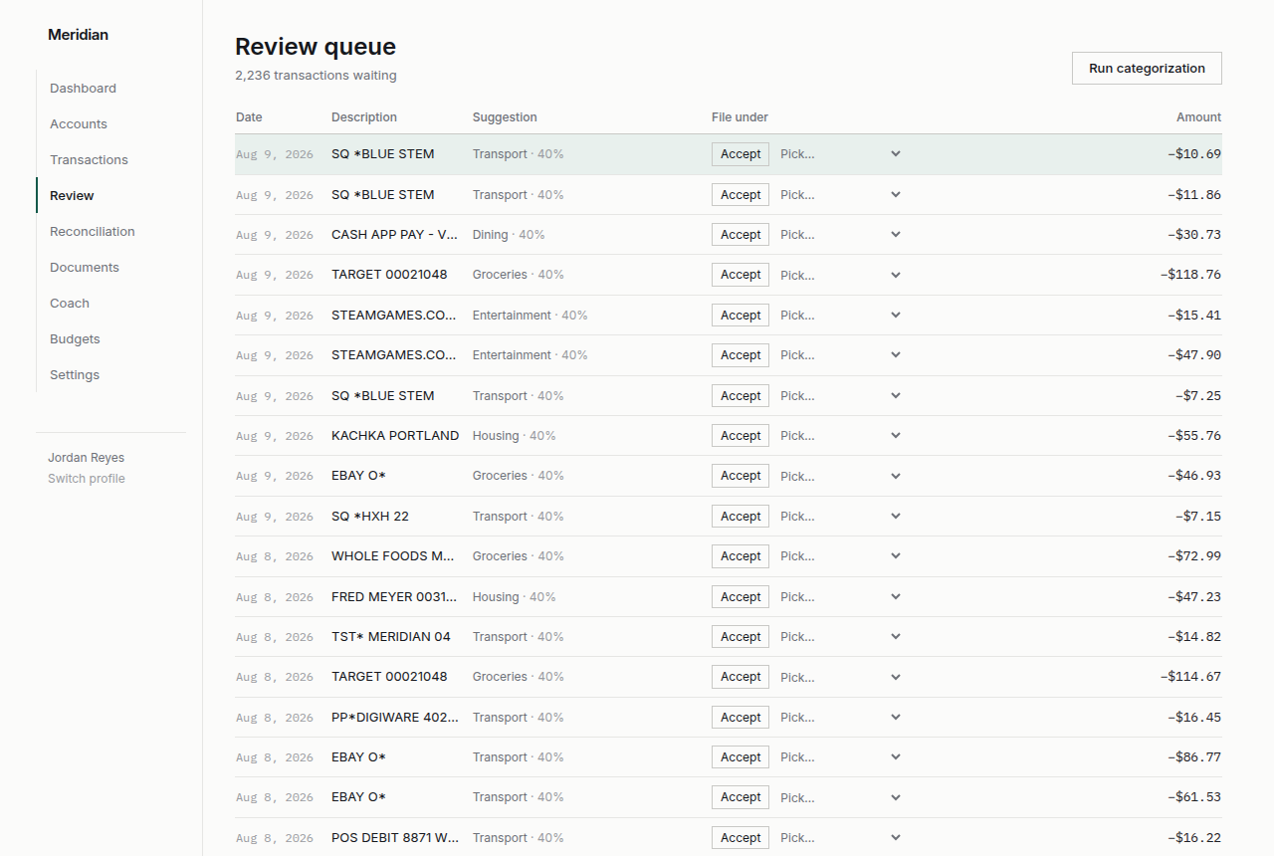
Figure 1. The review queue: low-confidence suggestions are held for a human decision rather than filed silently, and the whole screen is operable from the keyboard.
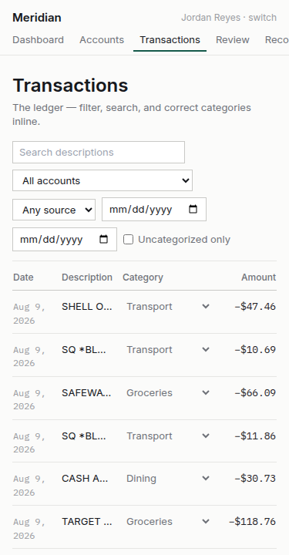
Figure 2. The transaction ledger at 375 pixels — verified free of horizontal overflow.

