Appnovation Pre-Interview Problem  
Darryl Neuschafer – 08/17/2015

**Installing/Configuring Maven**

1. Download and Extract Maven
   1. https://maven.apache.org/download.cgi
2. Add the following to PATH environment variable
   1. C:\Program Files\apache-maven-3.3.3\bin
   2. C:\Program Files\Java\jre7
3. Add the following to JAVA_HOME environment variable
   1. C:\Program Files\Java\jdk1.7.0_45  
      ** To test, run ‘mvn –v’ via cmd line
4. Create Maven project
   1. From cmd line, run the following:
      1. mvn -B archetype:generate -DarchetypeGroupId=org.apache.maven.archetypes -DgroupId=com.appnovation.util -DartifactId=java-url-parser
5. Add plugins to pom.xml
   1. maven-compiler-plugin
   2. maven-jar-plugin
6. Import Maven project into Eclipse

**Write Java Application**

1. Import the URL class which contains methods that allows URL objects to be queried
   1. java.net.url;
2. Create object and assign to a variable
   1. URL exampleURL = new URL("http://docs.oracle.com:80/javase/7/docs/api/java/net/URL.html?name=ClassURL");
3. Return the URL information, as print statements, using the methods from the URL class
   1. System.out.println("Protocol = " + exampleURL.getProtocol());
   2. System.out.println("Host = " + exampleURL.getHost());
   3. System.out.println("Port = " + exampleURL.getPort());
   4. System.out.println("Path = " + exampleURL.getPath());
   5. System.out.println("Query = " + exampleURL.getQuery());
4. Compile Application
   1. mvn compile
5. Install Artifact
   1. mvn install
   2. This will create a jar file
      1. ex: java-url-parser-1.0-SNAPSHOT.jar

**Run/Test Java Application**

1. Modified AppTest.java, that was created by Maven, to utilize the junit framework
2. Created five methods that use assertion statements to test for True/False on each result

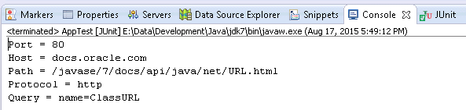

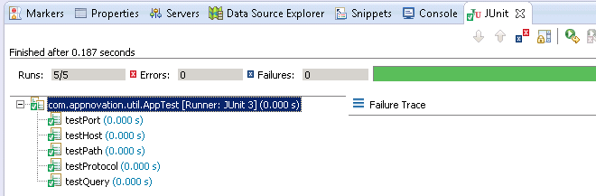

**References**

1. https://maven.apache.org/guides/getting-started/index.html#How_do_I_setup_Maven
2. http://docs.oracle.com/javase/7/docs/api/java/net/URL.html
3. http://junit.org/apidocs/org/junit/Assert.html#assertTrue(boolean)
4. http://www.ntu.edu.sg/home/ehchua/programming/java/JavaUnitTesting.html