title: ‘Testing UOD survey data’ author: “Sabbir Hassan” output: github_document

# Understanding Our differences: Autism Survey Analysis

### Score Map Table:

|  |  |  |  |
| --- | --- | --- | --- |
| q_codes | questions | options | scores |
| Q3a | People autism act same. | True | 0 |
| Q3a | People autism act same. | False | 1 |
| Q3a | People autism act same. | Don’t Know | 0 |
| Q3b | Brain affected by autism. | True | 1 |
| Q3b | Brain affected by autism. | False | 0 |
| Q3b | Brain affected by autism. | Don’t Know | 0 |
| Q3c | People autism strong interest in one topic. | True | 1 |
| Q3c | People autism strong interest in one topic. | False | 0 |
| Q3c | People autism strong interest in one topic. | Don’t Know | 0 |
| Q3d | Bright lights, loud noises don’t bother people autism. | True | 0 |
| Q3d | Bright lights, loud noises don’t bother people autism. | False | 1 |
| Q3d | Bright lights, loud noises don’t bother people autism. | Don’t Know | 0 |
| Q3e | People autism good at reading emotions. | True | 0 |
| Q3e | People autism good at reading emotions. | False | 1 |
| Q3e | People autism good at reading emotions. | Don’t Know | 0 |

### Figure 01

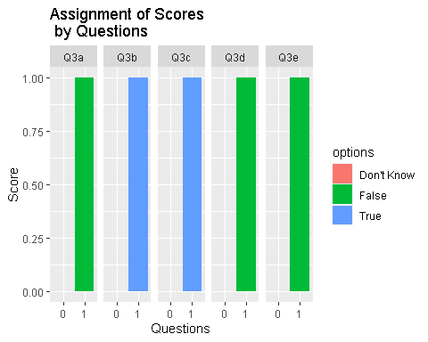

### Generating Table

Converting raw data table into long tables.

|  |  |  |  |
| --- | --- | --- | --- |
| Subject.Id | Schools | Tests | Scores |
| F59 | F | PreScore | 60 |
| F67 | F | PreScore | 40 |
| M47 | M | PostScore | 100 |
| M14 | M | PostScore | 60 |
| F28 | F | PreScore | 30 |

### Figure 02:

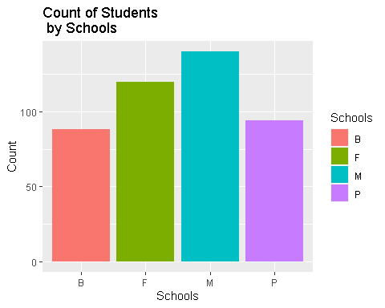

### Figure 03:

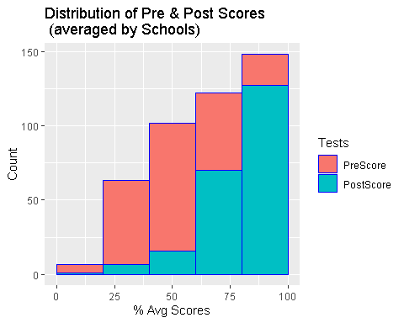

### Figure 04:

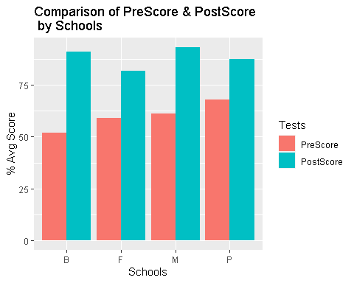

### Figure 05:

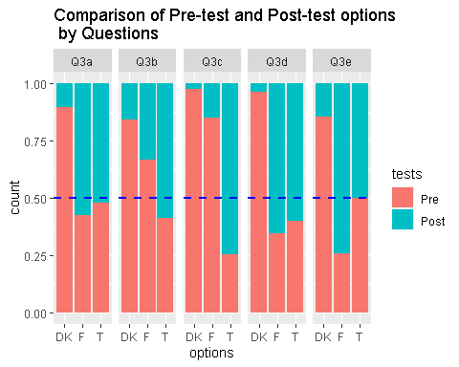

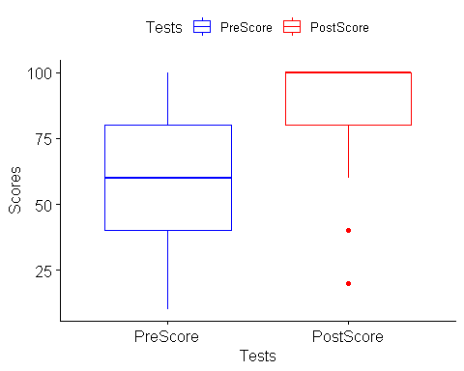

##   
## Paired t-test  
##   
## data: newdata$PostScore and newdata$PreScore  
## t = 15.86, df = 220, p-value < 2.2e-16  
## alternative hypothesis: true difference in means is not equal to 0  
## 95 percent confidence interval:  
## 24.80602 31.84557  
## sample estimates:  
## mean of the differences   
## 28.32579

##   
## Wilcoxon signed rank test  
##   
## data: newdata$PostScore and newdata$PreScore  
## V = 16616, p-value < 2.2e-16  
## alternative hypothesis: true location shift is not equal to 0  
## 95 percent confidence interval:  
## 30.00000 39.99996  
## sample estimates:  
## (pseudo)median   
## 34.99998