***PROJECT***

PROJECT NAME: **MOVIE APP**

DESCRIPTION:

The main use of this application is that we can search for movies and gets the main details of the selected movie.

SCREENSHOTS OF THE APP:

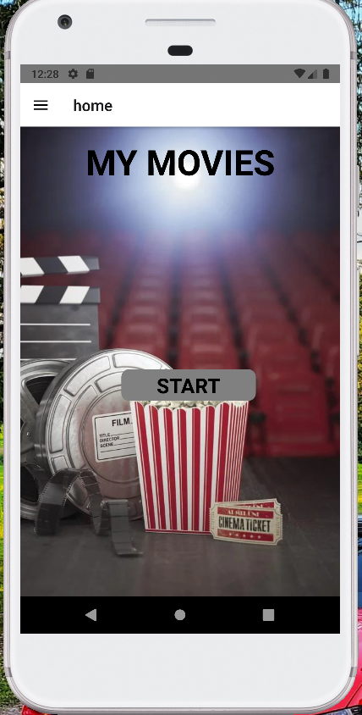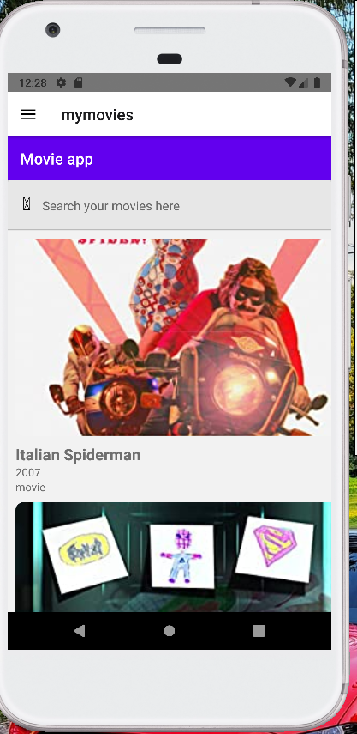

ISSUES THAT FACED:

1. First issue that I faced is mentioning below,

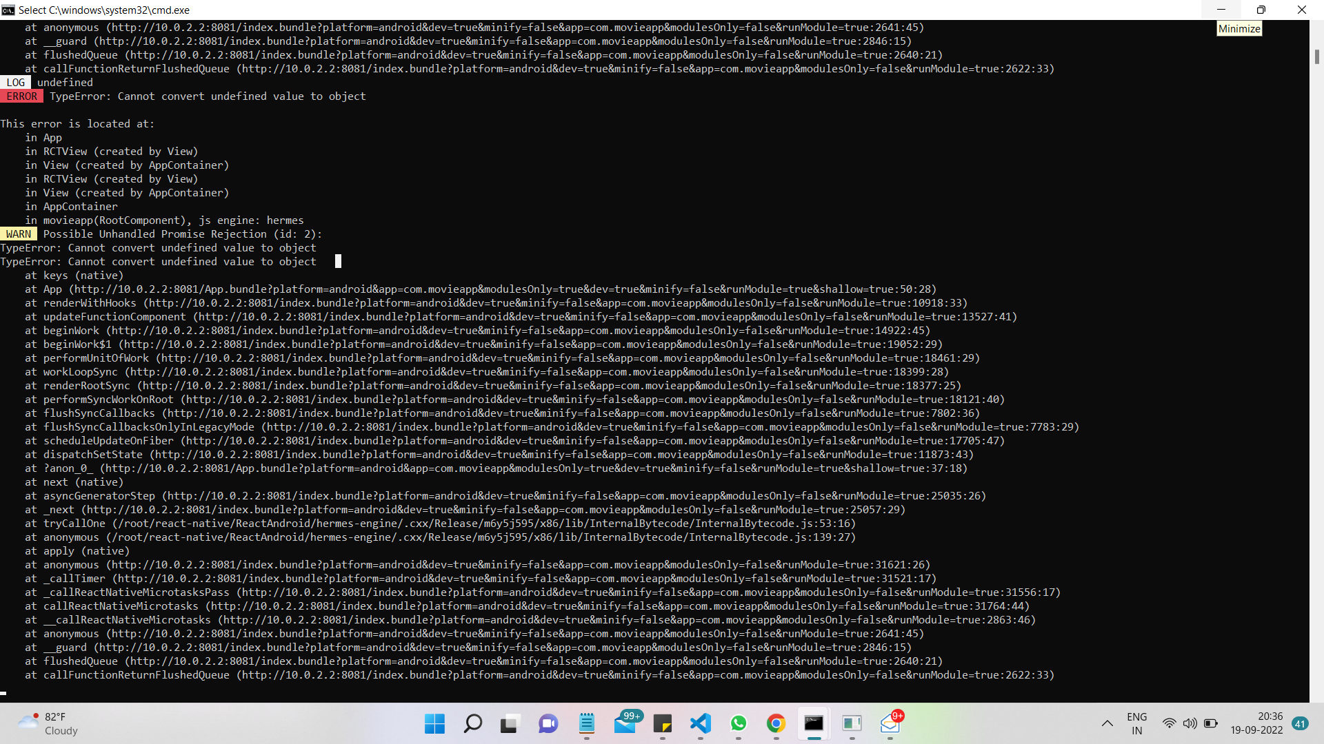

Problem:

Cannot find the object?

Solution:

There is space in between the double quotes while paste the url which I received in the mail.

After clear the space then the app start working.

2)

The issue is happened because I didn’t install the packages for drawer like reanimated, issue is attaching below,

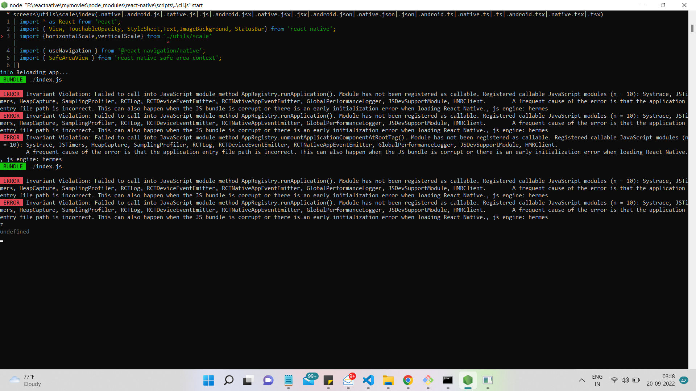

PROBLEM:

Invariation violation?

Solution:

Installed the packaged which needed for drawer

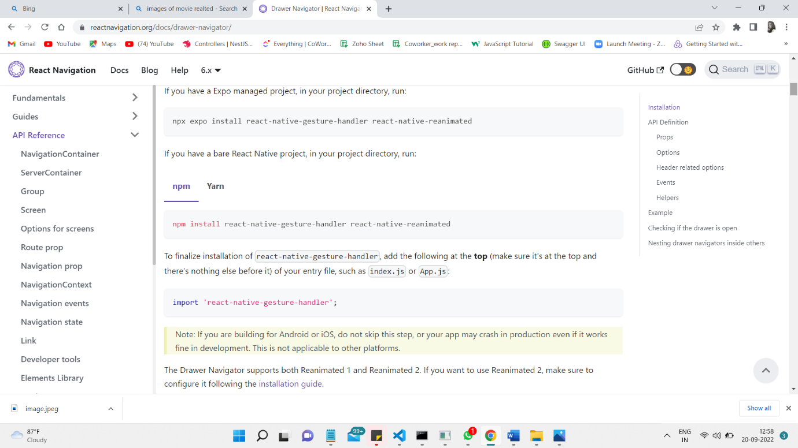

3)PROBLEM:

The issue related to the plugin, after install the reanimated packages we should add one plugin in babel.config but which was not added so the error came to fix the plugin.

Solution:

Add the needed plugin to the babel.config then the app start working

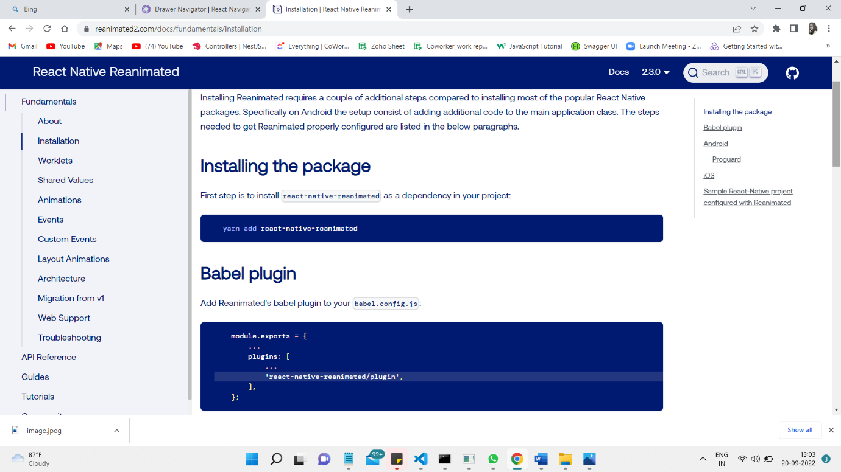

4)

PROBLEM:

Face an issue in the navigation part because of not installing the required packages.

Solution:

Gone through the documentation of react-native navigation and install all the packages that required.

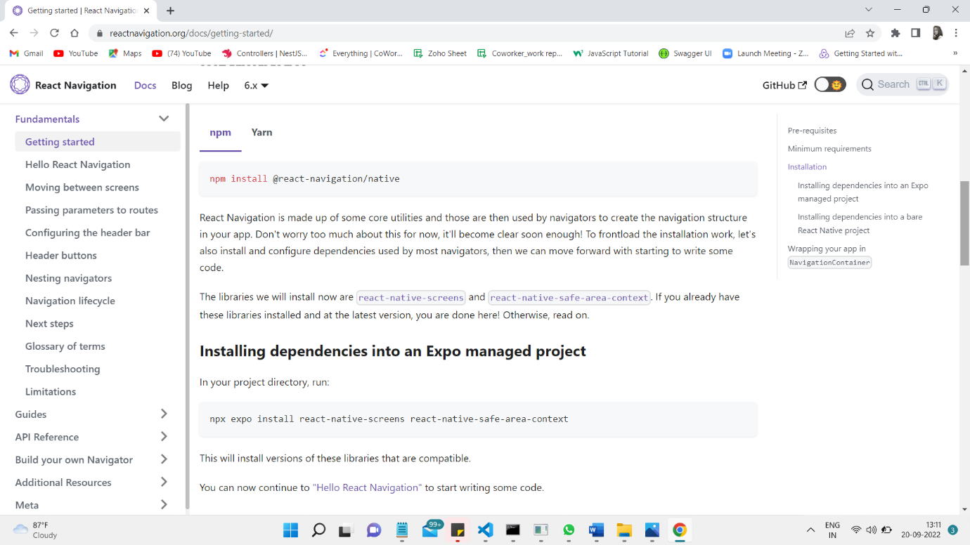

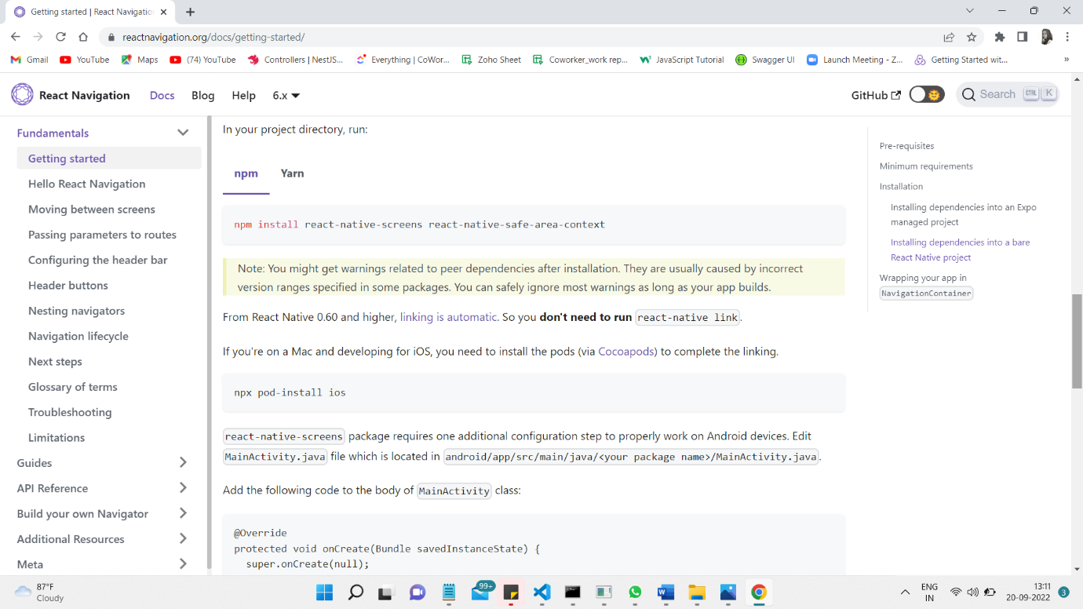

5) PROBLEM:

The property stylesheet doesn’t exist?

Solution:

Import the stylesheet property of react-native

