Game Design Document

Fill up the following document

1. Write the title of your project.

Super Mario Race

1. What is the goal of the game?

Collect the most coins in a certain time frame

1. Write a brief story of your game.

Open-ended story

1. Which are the playing characters of this game?

* Playing characters are the ones who respond to the user based on the input from the user.
* Cars, monkeys, dinos, wizards, etc., are the playing characters in the game.

|  |  |  |
| --- | --- | --- |
| Number | Character Name | What can this character do? |
| 1 | Mario | Can move in all four directions, can collect coins and extra lives by jumping under mystery blocks, can lose a life to Mushroom, can squash Mushroom by jumping on its head |
| 2 | Luigi | Same as Mario |
| 3 |  |  |
| 4 |  |  |
| 5 |  |  |
| 6 |  |  |
| 7 |  |  |
| 8 |  |  |

1. Which are the Non-Playing Characters of this game?

* Non-Playing characters are the ones that don't have an action or behavior when the user interacts with the game.
* Hurdles, stones, bananas, coins, etc., are non-playing characters in the game.

|  |  |  |
| --- | --- | --- |
| Number | Character Name | What can this character do? |
| 1 | Mushroom | Can take 1 life from Mario or Luigi, can be squashed by Mario and Luigi, can randomly move left or right, is spawned in designated areas of the map |
| 2 |  |  |
| 3 |  |  |
| 4 |  |  |
| 5 |  |  |
| 6 |  |  |
| 7 |  |  |
| 8 |  |  |

Draw your imagination of this game. What does this game look like?

* Draw the game either on your computer or on paper.
* Add images of the game scenes to show each of the playing and non-playing characters at least once.

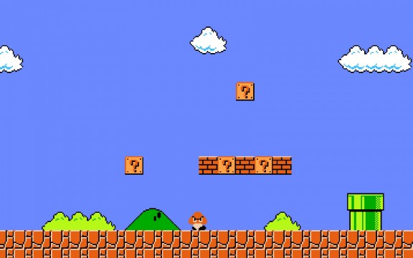

How do you plan to make your game engaging?

By adding Mystery boxes that spawn coins and extra lives, Mushroom randomly spawned to take life from Mario/Luigi