**Project Name: Efficient Shipping System**

**Project Members:**

|  |  |
| --- | --- |
| **PRN No.** | **Name** |
| **210943120009** | **Darshana Agarwal** |
| **210943120034** | **Saurabh Jagadale** |
| **210943120043** | **Kshitij Ghogare** |

**Technology:**

Frontend- ReactJS, Bootstrap, CSS, HTML.

Backend- SpringBoot (Java)

Database- MySQL

Others –

**Roles and Responsibilities:**

|  |  |  |
| --- | --- | --- |
| **Roles And Responsibilities** | | |
| 1 | Role | Frontend & Backend |
| Member Name | **Darshana Agarwal** |
| PRN No | 210943120009 |
| Description | Designing the UI using ReactJS, Bootstrap, CSS, HTML. |
| 2 | Role | Backend & Database |
| Member Name | **Saurabh Jagadale** |
| PRN No | 210943120034 |
| Description | Creating and maintaining technology at the back end. |
| 3 | Role | Database & Backend |
| Member Name | **Kshitij Ghogare** |
| PRN No | 210943120043 |
| Description | Managing the exchange of data between the server and the users. |

**Data Flow Diagram (DFD):**

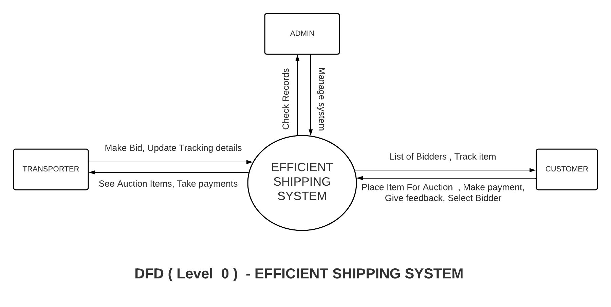

**ERD / Database Tables:**

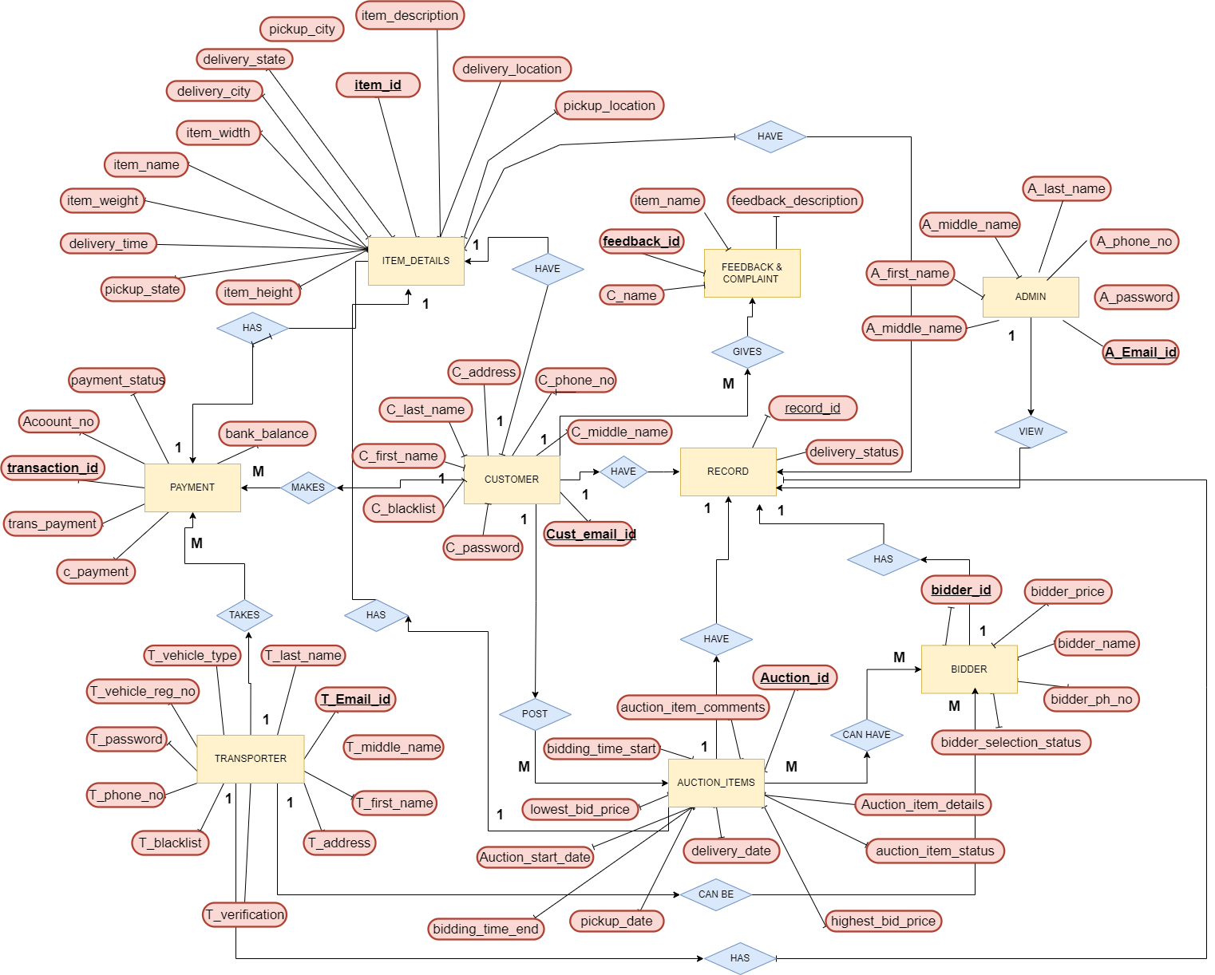

Admin Table:

|  |  |
| --- | --- |
|  |  |
| A_First_Name |  |
| A_Middle_Name |  |
| A_Last_Name |  |
| A_Email_id | PK |
| A_Password |  |
| Admin_ph_no |  |

Transporter Table:

|  |  |
| --- | --- |
|  |  |
| T_First_Name |  |
| T_Middle_Name |  |
| T_Last_Name |  |
| Trans_Email_id | PK |
| T_Password |  |
| Trans_ph_no |  |
| Trans_Address |  |
| Trans_Vehicle_Reg_no | UK |
| Trans_Vehicle_Type |  |
| Trans_Verification | Yes/no(updated by admin) |
| Trans_Blacklist |  |

Customer Table:

|  |  |
| --- | --- |
| C_First_Name |  |
| C_Middle_Name |  |
| C_Last_Name |  |
| Cust_Email_id | PK |
| C_Password |  |
| Cust_ph_no |  |
| Cust_address |  |
| Cust_Blacklist |  |

Auction Item Table:

|  |  |
| --- | --- |
| Auction_item_id | PK |
| Cust_Email_id | FK |
| Auction_item_details |  |
| Auction_Start_date |  |
| Lowest_bid_price |  |
| Highest_bid_price |  |
| Bidding_time_start |  |
| Bidding_time_end |  |
| Pickup_Date |  |
| Delivery_Date |  |
| Auction_item_Comments |  |
| Auction_Item_Status | GotBid /Stillrunning /Doesn’t got any bid(for transporter display) |

Item Details Table:

|  |  |
| --- | --- |
| Item_id | PK |
| Cust_Email_id | FK |
| Item_Name |  |
| Item_Width |  |
| Item_Height |  |
| Item_Weight |  |
| Item_Description |  |
| Pickup Location |  |
| Pickup_State |  |
| Pickup_City |  |
| Auction_item_id | FK (pickup date, delivery date) |
| Delivery_location |  |
| Delivery_State |  |
| Delivery_city |  |
| Delivered_Time |  |

Bidder Table:

|  |  |
| --- | --- |
| Bidder_id | PK |
| Bidding_price |  |
| Trans_Email_id | FK |
| Auction_item_id | FK |
| Bidder_name (Transporter_name) |  |
| Bidder_ph_no. |  |
| Bidder_selection_status | Selected/non-selected |

Feedback & Complaint:

|  |  |
| --- | --- |
| Feedback_id | PK |
| Cust_Email_id | FK |
| Cust_name |  |
| Item_name |  |
| Feedback_Description |  |

Payment Table:

|  |  |
| --- | --- |
| Transaction_id | Pk |
| Account number |  |
| Bank_Balance |  |
| Cust_Email_id | FK |
| Item_id | FK |
| Cust_Name |  |
| Cust_payment |  |
| Trans_Email_id | FK |
| Trans_name |  |
| Trans_payment | Cust_payment - (30%) |
| Payment_status | Successful/notsuccessful |

Record Table:

|  |  |  |  |  |  |
| --- | --- | --- | --- | --- | --- |
| Record_id | PK |  |  |  |  |
| Cust_emailid | FK |  |  |  |  |
| Trans_emailid | FK |  |  |  |  |
| Auction_item_id | FK |  |  |  |  |
| Bidder_Id | FK |  |  |  |  |
| Item_id | FK |  |  |  |  |
| Feedback_id | FK |  |  |  |  |
| Payment_id | FK |  |  |  |  |
| Delivered (Updated by trasporter) |  |  |  |  |  |