MAJOR PROJECT REPORT
on

KANDA
Knowledge-driven Autonomous Navigation and Decision-making Agent

A Multimodal Embodied Robot Agent Powered by Large Language Models
with Hardware Aware Action Generation

Submitted in partial fulfilment of the requirements
for the award of the degree of
Bachelor of Engineering

Department of [Your Department]
[Your Institution Name]
[Academic Year]

Submitted by
[Student Name(s)]
[USN / Roll Number]

Under the guidance of
[Guide Name], [Designation]
[Department], [Institution]

ABSTRACT
Household companion robotics is an emerging domain with significant social relevance, driven by the global increase in elderly populations living alone and the growing demand for accessible assistive technology. While large language model (LLM) reasoning has been integrated into robotic systems such as SayCan and RT-2, these implementations relied on expensive, proprietary hardware platforms inaccessible for broad academic or household deployment. Low-cost systems built on microcontrollers demonstrated voice-based LLM interaction but lacked autonomous navigation capability. A further unresolved issue was the absence of a validated interface between LLM-generated decisions and physical motor execution, creating a safety gap when raw model outputs were applied directly to hardware. This project, named KANDA — Knowledge-driven Autonomous Navigation and Decision-making Agent — was undertaken to address this gap by designing and implementing a two-layer robotic system combining autonomous navigation on commodity embedded hardware with a fully specified LLM reasoning architecture and a hardware-aware safety validation layer.
The project followed an incremental, hardware-first development methodology across two phases. Phase 2, which was fully implemented, built the embodiment layer on an ESP32 microcontroller, integrating three HC-SR04 ultrasonic sensors with voltage divider signal conditioning, a TB6612FNG dual motor driver controlled via Pulse Width Modulation (PWM) using the Arduino core version 3 ledcAttach application programming interface (API), and an SSD1306 Organic Light-Emitting Diode (OLED) display for real-time feedback. A stable power architecture separated regulated microcontroller supply from high-current motor supply to prevent voltage instability. The intelligence layer, designed for Phase 3 on a Raspberry Pi, specified a multimodal context builder combining camera frames, OpenAI Whisper speech transcription, and sensor telemetry into a structured hardware description prompt submitted to a GPT-4 or Gemini LLM API, with a safety validator enforcing hardware-safe parameter ranges before transmitting validated JavaScript Object Notation (JSON) commands to the ESP32 over Universal Asynchronous Receiver-Transmitter (UART). The completed Phase 2 system demonstrated reliable autonomous obstacle avoidance with smooth differential steering and real-time OLED feedback, providing a tested foundation for Phase 3 LLM integration.

CHAPTER 1
INTRODUCTION
1.1 Overview of Project Topic
The project titled KANDA: A Multimodal Embodied Robot Agent Powered by LLMs with Hardware Aware Action Generation was carried out to investigate how large language model reasoning could be meaningfully integrated with a physically embodied robotic platform built on commodity hardware. The word KANDA is an acronym that expands to Knowledge-driven Autonomous Navigation and Decision-making Agent, a title that reflects both the technical ambition of the project and its emphasis on combining physical autonomy with AI-driven reasoning.
The central insight driving the project was that household companion robotics represented a uniquely appropriate domain for LLM integration. Unlike industrial or agricultural robotic applications, where rule-based logic can often handle the full range of expected situations, household companion tasks involve open-ended human interaction, unpredictable conversational inputs, and a wide variety of contextual demands that cannot be pre-programmed. A robot that could converse with an elderly person, adapt its language for a child, remember medication schedules, respond to voice commands for home automation, and detect emergency situations required not just fast sensor processing but genuine contextual reasoning. Large language models were identified as the most appropriate technology for providing this reasoning capability.
At the same time, the project recognised that the existing landscape of LLM-powered robotic systems was dominated by expensive, specialised hardware platforms that were inaccessible for widespread deployment. Research systems such as SayCan and RT-2 demonstrated the feasibility of embodied AI but required hardware investment beyond the reach of most educational, research, and household deployment contexts. KANDA was therefore positioned as a contribution to the democratisation of intelligent robotics, demonstrating that the core capabilities of an LLM-powered companion robot could be realised on commodity components costing a small fraction of research platform costs.
The project followed a structured phased development plan. Phase 1 covered conceptual design, literature review, and architecture planning. Phase 2, which formed the completed portion of this work, built and validated the embodiment layer. Phase 3 defined the intelligence layer integration and was ready to be implemented in the next stage of the project. This report documents all phases in full, with emphasis on the engineering decisions, technical challenges, and solutions developed during Phase 2.
1.1.1 Global Scenario
Globally, the integration of artificial intelligence with physical robotic systems has advanced considerably since the early 2020s. The publication of SayCan by Ahn et al. in 2022 established that large language models could be used to decompose high-level user instructions into robot-executable skill sequences, using the physical affordances of the robot's environment to constrain which actions were feasible. RT-2, published by Brohan et al. in 2023, extended this further by training a vision-language model that could directly output robot action commands from image and text input, effectively eliminating the need for a separate action library. PaLM-E, published by Driess et al. in 2023, demonstrated that embodied sensor data could be included directly in the input context of a large multimodal model, enabling a single unified model to handle both language understanding and physical world interaction.
In parallel, open-source communities have begun exploring LLM integration on commodity hardware. ESP-SparkBot, demonstrated by Espressif in April 2025, showed that an ESP32-S3 microcontroller could be used to build a voice-interactive robot with ChatGPT integration, facial recognition, and smart home connectivity. Seervo, another open-source project, demonstrated that an ESP32 could capture images, send them to a GPT-5 API server, and receive JSON movement commands executed in MicroPython. OpenCastor, a broader framework, showed that multiple hardware platforms including the Raspberry Pi, ESP32, and Arduino could be connected to various LLM providers through a YAML configuration system. These developments confirmed that LLM integration at the commodity hardware level was technically feasible, while also revealing that navigation-capable, companion-focused systems with safety-validated command interfaces remained largely absent from the open-source landscape.
In the companion robotics domain, research published in JMIR Human Factors in 2025 evaluated socially assistive robots integrated with large language models in hospital geriatric units and identified gaps in personalisation, response latency, and accessibility for low-cost deployment. A participatory design study published in Frontiers in Robotics and AI in 2024 engaged older adults in the co-design of conversational companion robots and identified key expectations including active engagement during isolation, memory of previous conversations, and emotional expression. These findings collectively indicated that companion robotics was a high-value, underserved application domain where affordable LLM-powered systems could make a significant contribution.
1.1.2 Societal Relevance
The social relevance of this project was grounded in two major demographic and technological trends. The first was the global increase in the elderly population living alone or with reduced access to regular human caregiving. In many countries, the combination of longer lifespans and declining birth rates has created a growing cohort of older adults who require daily support that family members or professional caregivers cannot always provide. A companion robot capable of conversational interaction, health reminders, and emergency response could address a portion of this gap in a way that was accessible, always available, and not limited by geographic distance from family members.
The second trend was the expansion of home automation and smart device ecosystems, which have made household environments increasingly amenable to robot integration. Existing voice assistants and smart home platforms could already control lights, thermostats, and appliances through natural language commands, but they lacked physical mobility and contextual embodiment. A companion robot that could navigate the home environment, identify the user's location, and interact with both the user and smart home devices represented a significant step toward a fully integrated household AI presence. KANDA was designed with this integration potential in mind, with its two-layer architecture providing the physical navigation capability and the LLM reasoning capacity required for such an integration.
Beyond elderly assistance, the project also addressed the educational context through its child tutoring use case. An affordable companion robot capable of adapting its language and explanation style to a child's level, answering spontaneous questions, and maintaining contextual continuity across a tutoring session could serve as a supplement to formal education in environments where one-on-one teaching time was limited. The availability of such a system on a low-cost hardware platform made it feasible for use in homes across a wide socioeconomic range, contributing to a more equitable distribution of educational technology.
1.1.3 Problem Area
Despite the advances in both large language models and robotic hardware, the specific problem of integrating LLM reasoning with a navigating, low-cost embedded robot for household companion applications remained largely unaddressed. The available LLM-powered robotic systems fell into two categories: expensive research platforms with sophisticated hardware but inaccessible cost structures, and low-cost commodity systems that provided voice interaction but no autonomous navigation capability. Neither category addressed the intersection of navigation, companion use cases, and low-cost reproducibility that KANDA targeted.
A further dimension of the problem was the absence of a validated command interface between LLM output and physical motor execution. Large language models generated text or structured data responses, but they operated without any inherent knowledge of GPIO voltage limits, motor current ratings, PWM resolution, or the mechanical constraints of a specific robot platform. Applying LLM output directly to motor control without a validation layer could produce commands that were physically impossible, outside safe operational ranges, or potentially damaging to hardware. Research on safety guardrails for LLM-enabled robots, such as the RoboGuard system published in 2025, demonstrated that unconstrained LLM commands led to unsafe behaviour in up to 92 percent of worst-case scenarios. This problem was directly addressed in the KANDA design through the safety validation layer specified in the intelligence layer architecture.
The problem area therefore combined three distinct challenges: building a reliable hardware execution platform on commodity components, designing an effective multimodal LLM reasoning pipeline for companion interactions, and creating a validated interface that allowed LLM-generated commands to be safely executed by the physical hardware. These three challenges together defined the scope and contribution of the KANDA project.
1.2 Specific Details of the Project Topic
This project dealt with the design and implementation of an embodied robotic agent intended for indoor household companion use. The topic was specific in its combination of three technical elements that had not previously been integrated in a single open, reproducible system: autonomous navigation on commodity embedded hardware, multimodal LLM reasoning through a Raspberry Pi bridge, and a hardware-aware JSON command protocol with safety validation. The project was not a theoretical study of any one of these elements in isolation, but an engineering effort to combine all three into a functioning system.
The hardware platform selected for the project reflected the constraint of reproducibility and low cost. The ESP32 microcontroller was chosen as the execution unit because of its dual-core processing architecture, 240 MHz clock speed, built-in WiFi and Bluetooth connectivity, 34 available GPIO pins, and support for PWM-based motor control through the Arduino core version 3 API. The ESP32 DevKit form factor was used because of its convenient USB programming interface and the availability of 3.3-volt regulated output for sensor interfacing. The total cost of the complete Phase 2 hardware assembly was significantly lower than any comparable research robot platform.
The intelligence layer was designed around the Raspberry Pi 4 Model B or equivalent, chosen because it ran a full Linux operating system, supported Python 3.9 or later, had a dedicated camera serial interface, USB ports for microphone connection, and hardware UART pins for communication with the ESP32. The planned LLM integration used the OpenAI GPT-4 API or the Google Gemini API, both of which supported multimodal inputs including text and image data. OpenAI Whisper was selected for speech-to-text conversion because of its strong performance on diverse audio conditions without per-request API costs.
A key technical detail of the project was the design of the hardware description prompt. This was a structured natural language string included in every LLM API request that described the robot's physical capabilities in terms the model could reason about. The prompt specified the available movement commands, the valid speed range, the sensor layout, and the current sensor readings. This approach was inspired by the affordance-based reasoning in SayCan but implemented without a separate skill library, relying instead on the LLM's inherent reasoning capability to generate appropriate JSON commands within the described hardware constraints.
1.3 Problem Statement
Affordable and reproducible intelligent companion robots for household use do not currently exist as open, well-documented, navigation-capable systems. While large language model-powered robots have been demonstrated in research, they rely on expensive, proprietary hardware platforms inaccessible for broad deployment. Low-cost platforms built on microcontrollers such as the ESP32 have demonstrated LLM integration for voice interaction, but these systems lack autonomous navigation and are not designed for companion use cases involving elderly users or children. Furthermore, no validated open protocol exists for translating LLM-generated decisions into hardware-safe motor commands for embedded robotic systems, creating a significant safety and reliability gap in the field.
The problem addressed in this project was therefore the absence of an integrated, low-cost robotic system that combined autonomous navigation, multimodal LLM reasoning, and validated hardware-aware action generation for household companion applications. KANDA was designed to address this problem by building a stable embodiment layer on commodity components, demonstrating reliable autonomous navigation, and defining a complete architecture for attaching LLM reasoning to the physical platform through a safety-validated command protocol that constrained all LLM output to hardware-safe operational parameters before execution.
1.4 Objectives
The objectives of the KANDA project were defined to guide development across both phases and to ensure that each deliverable contributed to the overall goal of a hardware-grounded, LLM-powered companion robotic system.
- To design and implement a stable hardware platform using the ESP32 microcontroller, TB6612FNG motor driver, three HC-SR04 ultrasonic sensors with voltage divider signal conditioning, and SSD1306 OLED display, capable of autonomous obstacle avoidance and real-time sensor feedback.
- To design a hardware description prompt that communicates the robot's available sensors and actuators to a large language model as structured natural language context, enabling the LLM to reason about physically feasible actions.
- To build a speech transcription pipeline using OpenAI Whisper that converts microphone input to text for submission to the large language model as part of the multimodal context.
- To integrate a camera capture module that encodes visual frames and includes them in the multimodal LLM API request for scene-aware reasoning about the robot's immediate environment.
- To implement a motor actuation layer on the Raspberry Pi that executes movement commands derived from the parsed LLM JSON response, following validation by a hardware-aware safety checking layer.
- To integrate a text-to-speech module that enables the robot to produce verbal responses returned by the large language model, supporting conversational companion interaction with elderly users and children.
- To evaluate the integrated system in household companion scenarios including elderly assistance, child tutoring, schedule reminders, home automation control, and emergency alerting, measuring response latency, command safety, and interaction quality.
1.5 Scope of the Project
The scope of the present work covered two distinct phases of development. Phase 2, which was fully completed, included the hardware platform design, power architecture, component selection, sensor integration with voltage divider signal conditioning, conflict-free GPIO pin mapping, PWM-based motor control firmware, obstacle avoidance logic, and OLED display feedback. This phase produced a fully functional, standalone autonomous robot capable of navigating an indoor environment without human intervention and without any AI components, providing a stable and tested foundation for Phase 3 integration.
The scope also included the complete architectural design of Phase 3, covering the Raspberry Pi UART bridge, the multimodal context builder, the hardware description prompt design, the LLM API client, the JSON command parser, the safety validator, and the text-to-speech module. Although Phase 3 components were not implemented at the time of this report, their design was sufficiently detailed to constitute a meaningful architectural contribution and to provide an unambiguous implementation roadmap. The firmware for the ESP32 was also designed with Phase 3 in mind, with GPIO pins reserved for future UART communication with the Raspberry Pi.
The scope explicitly excluded large-scale user studies, clinical evaluation of elderly assistance capabilities, deployment in multiple household types, and outdoor or non-domestic environments. The project was also not intended to produce a commercial product or to claim that the system could replace professional caregiving. It was designed as an academic proof-of-concept system demonstrating the feasibility and architecture of a low-cost, LLM-powered companion robot with hardware-aware action generation.
1.6 Methodology
The methodology of the KANDA project was grounded in a hardware-first, incremental integration philosophy. The decision to validate the physical execution layer before introducing any AI components was deliberate and justified by the experience of related projects in which hardware and software failures occurring simultaneously created debugging complexity that was difficult to resolve. By ensuring that each hardware component was verified in isolation before integration with the next, the project maintained a clear chain of accountability for any issue that arose.
Step 1: Literature Review and Domain Selection
A systematic review of related work in embodied AI, LLM-robot integration, companion robotics, and commodity hardware implementations was conducted. Key systems including SayCan, RT-2, PaLM-E, ESP-SparkBot, Seervo, RoboGuard, and companion robot studies from JMIR and Frontiers were examined. The original greenhouse monitoring domain was found to be a poor fit for LLM integration, since agricultural tasks could be adequately addressed by rule-based logic. The domain was revised to household companion robotics, where the need for LLM reasoning was strongly justified by the unpredictability and diversity of human companion interactions.
Step 2: Architecture Design
The two-layer architecture was designed, separating the embodiment layer on the ESP32 from the intelligence layer on the Raspberry Pi. The communication protocol between the two layers was specified as a UART link transmitting JSON-formatted commands from Pi to ESP32 and sensor telemetry from ESP32 to Pi. The hardware description prompt format was designed to provide the LLM with the robot's physical constraints in a structured, predictable way.
Step 3: Hardware Assembly and Power Architecture
The power system was assembled first: lithium polymer battery to battery management system to main switch, with one branch to the buck converter for regulated five-volt ESP32 power, and a second direct branch to the TB6612FNG motor driver for high-current motor supply. All grounds were tied together to form a common reference. Capacitors were placed across motor supply lines to suppress voltage spikes during motor switching.
Step 4: Sensor Integration and Signal Conditioning
Three HC-SR04 sensors were connected with voltage dividers on each ECHO pin. The divider ratio of one-kiloohm plus one-kiloohm was used to reduce the five-volt sensor output to approximately two-point-five volts, safely within the three-point-three volt GPIO input range of the ESP32. Input-only GPIO pins 34, 35, and 32 were selected for the ECHO signals to avoid any conflict with output-capable GPIO functions. Each sensor was tested individually before proceeding.
Step 5: Firmware Development and Integration
The ESP32 firmware was written in C++ using the Arduino framework and Arduino core version 3. GPIO pin assignments were validated against the ESP32 datasheet to avoid strapping pins, internal flash pins, and UART communication pins. The OLED display was initialised with an explicit Wire.begin call specifying GPIO 21 and GPIO 22. PWM was configured using the new ledcAttach API. The complete obstacle avoidance loop was assembled after each subsystem was independently verified.
Step 6: Intelligence Layer Design
The complete Phase 3 pipeline was designed and documented in sufficient detail for immediate implementation in the next project phase. This included the UART bridge firmware additions, the Python multimodal context builder, the LLM API integration, the safety validator specification, and the text-to-speech integration plan.
1.7 Organization of Report
Chapter 2 presents the theoretical and conceptual background of the project, covering embodied AI, large language models in robotics, hardware-aware action generation, companion robotics, and relevant related work. Chapter 3 provides the software requirement specification, describing the complete system product including functional requirements, performance specifications, software and hardware requirements, and design constraints. Chapter 4 presents the high-level design of the system, including design philosophy, architectural strategies, and the overall system architecture. Chapter 5 covers the low-level design, including detailed pin mapping, signal conditioning, firmware architecture, and the LLM command protocol specification. Chapter 6 describes the Phase 2 implementation and testing in detail, including hardware assembly, key engineering decisions, and resolved challenges. Chapter 7 presents the conclusions drawn from the completed work and the future work planned for Phase 3 and beyond.

CHAPTER 2
THEORY AND CONCEPT OF PROJECT
2.1 Introduction to Embodied AI
Embodied artificial intelligence is a paradigm in AI research that holds that genuine intelligence cannot be separated from physical experience. The foundational argument is that a cognitive system which only processes abstract symbols or textual inputs operates in a fundamentally different and more limited way than a system that must perceive, act upon, and respond to a real physical environment. This distinction between embodied and disembodied intelligence has become particularly relevant as large language models have demonstrated impressive reasoning capabilities in text-only domains while remaining unable to act in the physical world without additional robotic integration.
In the context of robotics, embodied AI is realised through the sense-decide-act cycle. The robot continuously reads from its sensors, constructs a representation of its situation, decides on an appropriate action, and executes that action through its actuators. The physical result of the action modifies the environment, which in turn generates new sensory input, closing the loop. This cycle is fundamentally different from a chatbot interaction, where the input and output are both textual and the system has no physical consequences for its responses. An embodied agent is accountable to the laws of physics in a way that a purely language-based agent is not.
KANDA was designed around this embodied AI principle. The ESP32 continuously executed the sense-decide-act-display loop, reading ultrasonic sensor distances, applying movement logic, commanding the motor driver, and updating the OLED. In Phase 2, the decision step was rule-based. In Phase 3, this step was to be replaced by LLM reasoning, transforming the system from a reactive machine into a deliberative agent capable of understanding context, following natural language instructions, and generating responses that were grounded in the robot's actual physical situation.
2.2 Large Language Models in Robotics
Large language models are neural network systems trained on massive text corpora that learn to generate coherent, contextually appropriate natural language continuations of any given input. The introduction of transformer architectures in 2017 and their scaling to billions of parameters enabled capabilities such as few-shot reasoning, chain-of-thought problem solving, code generation, and multimodal understanding that had not been achievable with earlier natural language processing approaches. These capabilities made LLMs attractive as reasoning components in robotic systems, where the robot's physical context could be described in natural language and the LLM could reason about appropriate actions.
The SayCan system, published by Ahn et al. in 2022, was a landmark demonstration of LLM-guided robot behaviour. SayCan used an LLM to score candidate robot skills by their semantic relevance to a user instruction, then multiplied these scores by affordance values representing the robot's physical ability to execute each skill in its current environment. This grounding mechanism prevented the LLM from suggesting actions that were semantically appropriate but physically infeasible. KANDA adopted a related principle through its hardware description prompt, which communicated the robot's physical constraints directly to the LLM before any command was generated.
RT-2, published by Brohan et al. in 2023, advanced the field further by training a single vision-language model on both internet-scale image-text data and robot demonstration data, enabling it to generalise web-acquired knowledge to novel robotic manipulation tasks. While RT-2 operated on a much larger scale than KANDA and required specialised robot hardware, it established the principle that visual grounding was essential for robot intelligence in unstructured environments, motivating the inclusion of a camera module in the KANDA Phase 3 design.
More recent work on safety guardrails for LLM-enabled robots, including RoboGuard published in 2025 and SafeGate proposed in 2026, demonstrated that raw LLM outputs could not be trusted for direct hardware execution. RoboGuard showed that without safety constraints, up to 92 percent of adversarially crafted LLM prompts could lead to unsafe robot behaviour. These findings directly motivated the inclusion of a dedicated safety validation layer in the KANDA architecture, positioned between the LLM API response and the UART transmission to the ESP32.
2.3 Hardware-Aware Action Generation
Hardware-aware action generation refers to the design of an AI-to-robot pipeline in which the output of the reasoning system is explicitly constrained by the physical capabilities and safety parameters of the hardware it controls. In a standard LLM API interaction, the model produces text based solely on the input prompt, with no knowledge of the physical system that will act on the response. For robotic applications, this creates a fundamental mismatch: the LLM may generate semantically valid commands that are physically impossible, out of range, or dangerous for the specific hardware configuration.
KANDA addressed this problem through two complementary mechanisms. The first was the hardware description prompt, which informed the LLM of the available commands, valid parameter ranges, sensor layout, and current sensor readings before asking it to generate an action. By making the hardware constraints part of the LLM's input context, the probability of receiving physically reasonable commands was increased. This approach was analogous to providing an engineer with a system specification before asking for design decisions, rather than asking for decisions in the absence of any specification.
The second mechanism was the safety validator, implemented on the Raspberry Pi as a post-processing step applied to every JSON command before UART transmission. The validator checked that the action field contained a recognised value from the defined command set and that the speed field, if present, fell within the zero-to-two-hundred-and-fifty-five range of the eight-bit PWM resolution. Commands failing validation were discarded and the robot was commanded to stop safely. Together, the hardware description prompt and the safety validator formed the hardware-aware action generation pipeline that distinguished KANDA from simpler LLM-to-motor implementations.
2.4 Companion Robotics for Household Applications
Companion robotics is a field within human-robot interaction research concerned with robots that provide social, communicative, and assistive functions in domestic or healthcare settings. Early companion robots such as PARO, a therapeutic seal robot used in dementia care, demonstrated that robotic companions could provide measurable psychological benefits to elderly users even without sophisticated AI reasoning capabilities. The introduction of large language models to companion robotics has opened the possibility of more natural, adaptive, and contextually aware interactions that earlier systems could not achieve.
Research published in JMIR Human Factors in 2025 evaluated a socially assistive robot integrated with a large language model in a hospital geriatric unit and found positive user perceptions of ease of use, usefulness, and enjoyment. However, the study identified ongoing challenges including response latency, voice quality, and the difficulty of personalising interactions for users with varying cognitive abilities. A participatory co-design study published in Frontiers in Robotics and AI in 2024 engaged 28 older adults in the design of a conversational companion robot and identified the desire for active engagement, memory of previous conversations, privacy protection, and emotional expression as key requirements. These findings directly informed the KANDA companion use case design and evaluation criteria.
The household companion use cases selected for KANDA were chosen to cover a range of interaction types that required different levels of LLM reasoning sophistication. Medication reminders required temporal awareness and personalisation but relatively simple conversational interaction. Child tutoring required adaptive language, unpredictable question handling, and contextual continuity across multiple exchanges. Elderly companionship required empathetic conversational capability and recognition of emotional states. Home automation required natural language command interpretation and integration with external smart home APIs. Emergency alerting required real-time environmental assessment and decision-making under uncertainty. Together, these use cases provided a comprehensive evaluation framework for the Phase 3 intelligence layer.
2.5 Embedded Systems for Robotic Control
The ESP32 microcontroller used in KANDA belongs to the class of embedded systems designed for real-time control applications. Unlike general-purpose computers, embedded systems are optimised for deterministic timing, low power consumption, and direct hardware interfacing. The ESP32's dual-core Xtensa LX6 processor architecture, operating at up to 240 MHz, provided sufficient computational throughput for the sensor reading, PWM generation, OLED rendering, and serial communication tasks required by the embodiment layer, while its large selection of GPIO pins with multiple alternative functions made it suitable for the diverse peripheral requirements of the robot.
The TB6612FNG motor driver used in KANDA was designed specifically for small brushed DC motor control. Its dual H-bridge architecture allowed independent speed and direction control for two motors, which was essential for differential steering. The driver accepted logic-level inputs from the ESP32's 3.3-volt GPIO pins without requiring additional level translation, simplifying the wiring. Its built-in standby mode, activated by pulling the STBY pin high, provided a clean enable/disable mechanism, and its internal protection circuitry guarded against thermal overload and short circuits.
2.6 Summary
This chapter presented the conceptual and technical foundations of the KANDA project across five areas. Embodied AI established the theoretical justification for physical grounding of intelligence. Large language models in robotics provided the context for the planned Phase 3 integration and identified the specific prior systems that KANDA built upon and differentiated from. Hardware-aware action generation explained the design principle behind the hardware description prompt and safety validation layer. Companion robotics for household applications justified the application domain and the specific use cases chosen for evaluation. Embedded systems for robotic control provided the technical background for the hardware components selected for Phase 2. Together, these concepts formed the complete theoretical foundation for the system designed and implemented in the following chapters.

CHAPTER 3
SOFTWARE REQUIREMENT SPECIFICATION FOR KANDA
3.1 Overall Description
The proposed system, named KANDA, was developed as a two-layer embedded robotic platform with a completed hardware execution layer and a fully specified intelligence layer awaiting implementation. The Phase 2 product was a standalone autonomous obstacle-avoidance robot operating entirely on the ESP32 microcontroller with a deterministic firmware loop. The complete product, as defined in this specification, was a household companion robotic agent in which a Raspberry Pi handled multimodal LLM reasoning and transmitted validated JSON commands to the ESP32 for hardware execution through a UART serial interface.
The ESP32 firmware was written in C++ using the Arduino framework. The intelligence layer was specified to be implemented in Python on the Raspberry Pi, using the OpenAI Whisper library for speech transcription, OpenCV or the Raspberry Pi camera module library for visual capture, the OpenAI Python SDK or Google Generative AI SDK for LLM communication, pyttsx3 or gTTS for text-to-speech output, and PySerial for UART communication with the ESP32. The system operated as a closed loop in which sensor and camera data flowed from the ESP32 and Raspberry Pi peripherals to the LLM, and validated commands flowed back to the motor driver.
3.1.1 Product Perspective
KANDA was designed as a self-contained embedded product, not a web service or simulation. The physical robot constituted the product itself, and all intelligence components were either co-located on the Raspberry Pi mounted on the robot or accessed through cloud API calls made by the Pi. This design ensured that the robot could operate as a standalone system in any home environment with WiFi connectivity, without requiring a separate computing device to act as a server or controller.
The product perspective was structured around the hardware safety principle: the ESP32 embodiment layer could function independently of the Raspberry Pi at all times. If the Pi lost power, crashed, or lost internet connectivity, the ESP32 defaulted to its local rule-based obstacle avoidance mode, preventing the robot from becoming stationary or unsafe. This fallback behaviour was a product requirement rather than an optional feature, ensuring that the companion robot remained safe and mobile under all failure conditions.
3.1.2 Product Functions
The primary product function was autonomous navigation in an indoor household environment. The robot continuously sensed distances on three axes, made movement decisions, and controlled motor speed and direction to avoid obstacles and navigate corridors, rooms, and doorways. The second function was natural language interaction, where the robot accepted spoken user input through a microphone, transcribed it using Whisper, incorporated it into the LLM context along with visual and sensor data, and generated both a verbal response through text-to-speech and a movement command.
The third function was multimodal context assembly, where camera frames, microphone audio, and ESP32 sensor telemetry were combined into a structured LLM input containing the hardware description prompt, the current sensor readings, a description of the visual scene, and the transcribed user speech. The fourth function was safety-validated command execution, where every JSON response from the LLM was verified before being transmitted to the ESP32. The fifth function was real-time display feedback, where the ESP32 OLED continuously showed current sensor distances and the active action label.
3.1.3 Constraints
The system was constrained to indoor household environments with flat or near-flat floor surfaces. The HC-SR04 sensors had reliable range only between two and four hundred centimetres, limiting the robot's ability to detect very close obstacles or objects at extreme distances. The two-wheel differential drive chassis provided no lateral movement capability, constraining navigation to forward, backward, and pivot-turn movements. LLM-based reasoning required internet connectivity for cloud API access, though local model deployment on the Raspberry Pi was identified as a future enhancement to remove this constraint.
The safety validator was limited to numerical range checking and did not perform semantic evaluation of whether a command was contextually appropriate. This meant that a LLM command that was within the valid parameter range but contextually inappropriate, such as driving toward a user at maximum speed in a confined space, would not be blocked by the validator alone. Contextual safety was therefore dependent on the quality of the hardware description prompt and the LLM's reasoning capability, rather than on the validator.
3.2 Specific Requirements
3.2.1 Functional Requirements
The system shall read distance measurements from three HC-SR04 ultrasonic sensors at a minimum update rate of ten readings per second per sensor. The system shall drive motor speed using PWM signals at one kilohertz frequency with eight-bit resolution, providing a speed range of zero to two hundred and fifty-five. The system shall display current sensor readings and the active movement decision on the OLED display, refreshing at least ten times per second. The Raspberry Pi shall transmit a validated JSON command to the ESP32 within the response latency requirements specified in section 3.2.2. The ESP32 shall parse and execute the received JSON command within fifty milliseconds of receipt.
The system shall accept spoken user input through a microphone connected to the Raspberry Pi and transcribe it to text using the Whisper speech recognition model. The system shall capture camera frames from the Raspberry Pi camera module and encode them for inclusion in the LLM API request. The LLM API shall receive a structured multimodal input containing the hardware description prompt, current sensor readings, encoded camera frame, and transcribed user speech. The LLM response shall be parsed to extract a JSON command object containing an action field and optional speed field. The safety validator shall verify the action and speed values before any command is transmitted to the ESP32.
3.2.2 Performance Requirements
The obstacle avoidance loop on the ESP32 shall complete a full sense-decide-act-display cycle within one hundred milliseconds under all operating conditions. The complete LLM reasoning cycle, from multimodal context assembly to validated JSON command receipt, shall complete within five seconds under standard WiFi network and cloud API conditions. The safety validator shall complete command verification within ten milliseconds. The text-to-speech module shall begin audio playback within two seconds of receiving the LLM text response. The Whisper transcription shall complete within three seconds for utterances up to ten seconds in duration.
3.2.3 Software Requirements
Table 3.1 — Software and library requirements for the KANDA system
Component | Software / Library | Version
ESP32 Firmware | Arduino IDE + ESP32 Arduino Core | v3.0+
OLED Display | Adafruit SSD1306 + Adafruit GFX | Latest
Pi OS | Raspberry Pi OS (64-bit) | Bookworm+
Language (Pi) | Python | 3.9+
Serial Comms | PySerial | Latest
Speech-to-Text | OpenAI Whisper | Latest
LLM Client | OpenAI Python SDK / Google Gen AI SDK | Latest
Image Capture | OpenCV / Picamera2 | Latest
Text-to-Speech | pyttsx3 / gTTS | Latest

3.2.4 Hardware Requirements
Table 3.2 — Hardware component specifications for the KANDA system
Component | Specification | Purpose
ESP32 DevKit | Dual-core 240MHz, 3.3V, 34 GPIO | Execution microcontroller
TB6612FNG | Dual H-bridge, 1.2A/ch, 15V max | Motor driver
HC-SR04 ×3 | 2–400cm, 5V, 15° beam angle | Distance sensing
SSD1306 OLED | 128×64px, I2C, 3.3–5V | Real-time display
LiPo Battery | 7.4V 2S, ≥2000mAh | Power source
BMS | 2S Li-ion protection board | Battery protection
Buck Converter | 7.4V → 5V, ≥1A | ESP32 power regulation
Raspberry Pi | Pi 4 Model B, ≥2GB RAM | AI compute bridge
Camera Module | Raspberry Pi Camera v2 or HQ | Visual input
Microphone | USB or I2S microphone module | Audio input
Speaker | 3.5mm or USB speaker | TTS audio output

3.2.5 Design Constraints
The primary design constraint was the protection of ESP32 GPIO input pins from the five-volt ECHO signals produced by the HC-SR04 sensors. The ESP32 GPIO pins had a maximum input voltage of 3.6 volts, and applying five volts directly would risk permanent damage to the microcontroller. This was addressed through a voltage divider on each ECHO pin, with component values selected to produce an output of approximately 2.5 volts from a 5-volt input.
A further constraint was the avoidance of ESP32 GPIO pins reserved for internal functions. Pins 0, 2, 12, and 15 were strapping pins whose state at boot time affected the ESP32's flash voltage configuration and boot mode selection. Pins 1 and 3 were the UART0 TX and RX pins used by the Arduino serial monitor during development and reserved for the Raspberry Pi UART bridge in Phase 3. Pins 6 through 11 were connected to the internal SPI flash memory and could not be used for any external peripheral function. All of these pins were excluded from the Phase 2 pin assignment.
3.3 Summary
The KANDA system was specified as a two-layer embedded robotic agent combining a hardware execution layer on the ESP32 and a planned intelligence layer on the Raspberry Pi. The product functions covered autonomous navigation, natural language interaction, multimodal context assembly, safety-validated command execution, and real-time display feedback. The specific requirements established precise performance targets for each system component, defined the software and hardware stack, and identified the key design constraints governing the implementation. The constraint analysis in particular demonstrated the engineering depth of the Phase 2 hardware design, where careful pin selection and signal conditioning decisions were required to build a reliable and safe embedded system.

CHAPTER 4
HIGH LEVEL DESIGN OF THE KANDA SYSTEM
4.1 Design Considerations
4.1.1 General Considerations
Several fundamental considerations shaped the high-level design of the KANDA system. The most important was the principle of hardware independence. The robot had to be capable of safe, useful autonomous operation even when the Raspberry Pi or the LLM API was unavailable. Designing the ESP32 firmware as a complete, standalone obstacle-avoidance system ensured that the robot would never become immobile or potentially dangerous because of a software failure in the intelligence layer. This also made the development process safer, because Phase 3 integration could be tested incrementally without risk of the robot losing basic navigational capability during development.
The second consideration was physical safety through command validation. Since the LLM reasoned about actions in natural language terms without direct knowledge of the robot's hardware specifications, there was no guarantee that its JSON outputs would always fall within the safe operational parameters of the motor system. The design response was to create a dedicated safety validation layer on the Raspberry Pi that verified every command before transmission. This layer was positioned as close as possible to the physical execution point to minimise the risk of unsafe commands reaching the hardware.
The third consideration was cost and reproducibility. The complete bill of materials for the Phase 2 hardware was designed to be available from standard electronics distributors, with no custom components or proprietary modules. The ESP32 and Raspberry Pi were both widely available at low cost and had large communities of developers. The choice of the Arduino framework for ESP32 firmware and Python for the Raspberry Pi intelligence layer reflected this emphasis on widely understood, well-documented technologies that other developers could readily adopt and extend.
4.1.2 Development Methods
The development of KANDA followed an incremental, hardware-first methodology. Each hardware subsystem was assembled, verified, and tested before the next was added. The sequence was: power architecture, ESP32 boot verification, ultrasonic sensor integration, OLED display integration, motor driver integration, and finally the complete obstacle avoidance loop. This sequence was chosen so that each addition had only one new variable, making any failure attributable to the most recently added component.
For the firmware, an iterative development approach was used in which a minimal working sketch was written for each subsystem, tested via serial monitor output, and then merged into the main firmware. This avoided the common debugging problem of introducing multiple features simultaneously and then being unable to identify which feature caused a regression. The final firmware was the result of several iterations of pin assignment refinement, API migration, and logic tuning based on observed robot behaviour.
4.2 Architecture Strategies
4.2.1 Technology Stack
The ESP32 firmware was written in C++ using the Arduino framework because this combination provided a large library ecosystem, a familiar development environment for embedded developers, and strong community support for the ESP32 platform specifically. The Arduino core version 3 for ESP32 was used, which introduced the single-call ledcAttach API for PWM configuration, replacing the two-step ledcSetup and ledcAttachPin sequence from earlier versions. This API was chosen to ensure forward compatibility with future Arduino core updates.
Python was selected for the Raspberry Pi intelligence layer because it provided the widest range of library support for the required components: speech recognition, image capture, LLM API access, text-to-speech, and serial communication. Python's high-level data handling also simplified the JSON parsing and validation logic required for the command interface. The single-language approach on the Pi reduced integration complexity compared to a multi-language architecture.
4.2.2 Future Plans
The KANDA architecture was designed with several future extension paths in mind. The first was the replacement of cloud-based LLM API calls with a locally deployed quantised language model running on the Raspberry Pi, eliminating the internet connectivity requirement and reducing response latency. Models such as quantised versions of Llama or Mistral had been demonstrated to run on Raspberry Pi 4 hardware with acceptable performance for short conversational exchanges, and Raspberry Pi 5 improved on this significantly.
The second extension path was the enhancement of the safety validator to include semantic constraint checking using a lightweight secondary model. A small classifier could evaluate whether the LLM's intended action was contextually appropriate given the sensor readings, providing an additional layer of safety beyond numerical range validation. The third path was the addition of multi-turn conversation memory, enabling the robot to maintain context across multiple interactions with the same user and provide more personalised companion behaviour. The fourth was integration with smart home APIs such as Home Assistant or Google Home, expanding the robot's ability to control household devices as part of its companion function.
4.3 System Architecture
The KANDA system was designed using a two-layer embedded architecture with a bidirectional UART communication bridge between the layers. The first layer, the embodiment layer centred on the ESP32, handled all real-time hardware interaction including sensor reading, motor control, and OLED feedback. The second layer, the intelligence layer centred on the Raspberry Pi, handled all AI pipeline operations including multimodal context assembly, LLM API communication, response validation, and verbal output generation.
The power architecture was designed as an independent subsystem. The lithium polymer battery supplied seven-point-four volts nominal, protected by a battery management system. A main switch controlled power distribution to two branches: a buck converter branch providing regulated five volts to the ESP32 VIN pin, and a direct branch providing full battery voltage to the TB6612FNG motor driver VM pin. This separation prevented the voltage spikes generated by motor switching from propagating back through the power supply to the microcontroller.
Figure 4.1 presents the complete high-level system architecture diagram. Completed Phase 2 components are shown with green colouring, and planned Phase 3 components are shown with grey colouring, clearly communicating the implementation status of each element of the system.
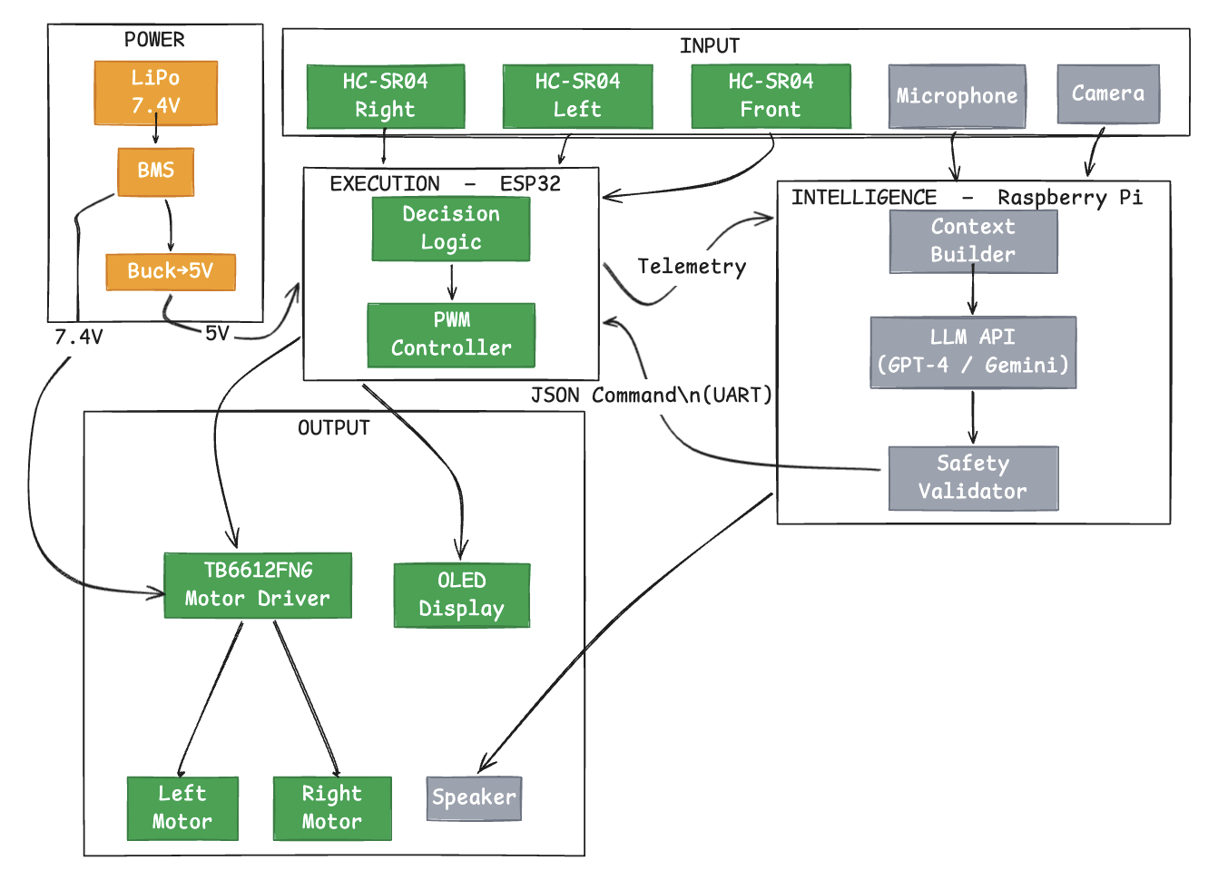
Figure 4.1 — KANDA High-Level System Architecture (green = completed, grey = planned)

CHAPTER 5
LOW LEVEL DESIGN OF THE KANDA EMBODIMENT LAYER
5.1 Pin Mapping and GPIO Assignment
The low-level design of the KANDA embodiment layer required a careful analysis of the ESP32 DevKit GPIO capabilities to produce a conflict-free pin assignment. The ESP32 contained several categories of GPIO pins that had to be handled differently: input-only pins that could not be configured as outputs, strapping pins whose state at boot time affected the chip's configuration, UART pins required for serial communication, and internal flash pins that were permanently reserved. The final pin assignment was the result of iterative refinement and datasheet review.
Table 5.1 — ESP32 GPIO pin assignment for the KANDA Phase 2 embodiment layer
Signal | GPIO | Direction | Notes
TRIG_F (Front sensor) | GPIO 5 | Output | Trigger pulse output
ECHO_F (Front sensor) | GPIO 34 | Input | Input-only pin; 1kΩ+1kΩ divider
TRIG_L (Left sensor) | GPIO 13 | Output | Trigger pulse output
ECHO_L (Left sensor) | GPIO 35 | Input | Input-only pin; 1kΩ+1kΩ divider
TRIG_R (Right sensor) | GPIO 4 | Output | Trigger pulse output
ECHO_R (Right sensor) | GPIO 32 | Input | 1kΩ+1kΩ divider
AIN1 (Motor A dir) | GPIO 18 | Output | TB6612FNG direction bit
AIN2 (Motor A dir) | GPIO 19 | Output | TB6612FNG direction bit
PWMA (Motor A speed) | GPIO 23 | Output | ledcAttach PWM channel
BIN1 (Motor B dir) | GPIO 26 | Output | TB6612FNG direction bit
BIN2 (Motor B dir) | GPIO 27 | Output | TB6612FNG direction bit
PWMB (Motor B speed) | GPIO 14 | Output | ledcAttach PWM channel
SDA (OLED I2C) | GPIO 21 | I/O | Wire.begin(21, 22) required
SCL (OLED I2C) | GPIO 22 | Output | I2C clock line
TX (Pi UART bridge) | GPIO 1 | Output | Phase 3 – reserved
RX (Pi UART bridge) | GPIO 3 | Input | Phase 3 – reserved

5.2 Avoided GPIO Pins
Table 5.2 — ESP32 GPIO pins avoided and reasons for exclusion
GPIO | Reason Avoided
0 | Strapping pin — controls boot mode; HIGH = normal boot, LOW = download mode
2 | Strapping pin — must be LOW during flash download
12 | Strapping pin — controls flash voltage (VDD_SDIO); incorrect state damages flash
15 | Strapping pin — controls JTAG interface and UART debug output enable
6–11 | Internal SPI flash connection — using these pins causes system crash
36 | GPIO36 (VP) — observed instability during testing; avoided as precaution

5.3 Power Architecture
The power architecture was designed around three principles: stable regulated supply for the microcontroller, direct high-current supply for the motors, and physical protection for the battery. The lithium polymer battery was selected at 7.4 volts nominal (two-cell configuration) to provide sufficient headroom above the five-volt ESP32 supply for the buck converter to regulate cleanly, while also providing the higher voltage that improved motor torque.
Table 5.3 — KANDA power architecture: stages, components, and voltage levels
Stage | Component | Voltage In | Voltage Out | Notes
1 | LiPo Battery | — | 7.4V | 2S configuration, 2000mAh min
2 | BMS | 7.4V | 7.4V | Overcharge, overdischarge protection
3 | Main Switch | 7.4V | 7.4V | Physical power cutoff
4 | Buck Converter | 7.4V | 5V | Feeds ESP32 VIN pin
5 | TB6612FNG VM | 7.4V | 7.4V | Direct battery feed for motors
6 | ESP32 3V3 out | 5V | 3.3V | Internal regulator for sensors/OLED

5.4 Signal Conditioning
Each HC-SR04 ECHO pin produced a five-volt pulse when the ultrasonic echo was received. The ESP32 GPIO input pins had a maximum rated input voltage of three-point-six volts. Connecting the ECHO pin directly would have applied a signal forty percent above the rated maximum, risking damage to the ESP32 GPIO circuitry. A voltage divider was therefore required on each of the three ECHO lines.
The voltage divider was implemented using two resistors in series from the ECHO pin to ground, with the ESP32 GPIO pin connected at the midpoint. With two equal resistors R, the output voltage was ECHO_voltage times R divided by 2R, producing exactly half the input voltage. With a five-volt input, the output was two-point-five volts. The ideal resistor value of two kiloohms was not available at the time of assembly, and two one-kiloohm resistors in series were used instead, producing an identical voltage division ratio. This substitution demonstrated the engineering principle that functional equivalence is achievable through component substitution when the electrical behaviour is preserved.
5.5 Firmware Architecture
The ESP32 firmware was structured as a single-file Arduino sketch with clearly separated sections for configuration constants, peripheral function definitions, and the main loop. All tunable parameters were defined as preprocessor constants at the top of the file, enabling easy adjustment of obstacle thresholds and speed values without modifying the control logic.
The readDistance function used the pulseIn function with a thirty-millisecond timeout to measure the duration of the ECHO pulse. The timeout prevented the sensor reading from blocking the main loop when no echo was received, which could occur if the surface in front of the sensor was angled such that the ultrasonic pulse was reflected away from the receiver. A return value of negative one indicated a measurement timeout, which the decision logic treated as an absence of obstacle at that position.
The motor control functions, forward, backward, left, right, slightLeft, slightRight, and stopMotors, were each implemented as short functions that set the AIN and BIN direction pins and called setSpeed to write the PWM values. The physical direction of the motors had been reversed in code by swapping the AIN and AIN2 logic values, correcting for the fact that both motors were mounted facing inward on the robot chassis, which caused them to spin in opposite absolute directions for the same pin logic.
5.6 LLM Command Protocol
The JSON command protocol between the Raspberry Pi and the ESP32 was designed to be minimal, unambiguous, and verifiable. Each command was a JSON object with two fields: action and speed. The action field accepted one of seven defined string values corresponding to the available movement functions. The speed field accepted an integer between zero and two hundred and fifty-five. Commands that contained unrecognised action values or out-of-range speed values were rejected by the safety validator.
Table 5.4 — KANDA LLM JSON command protocol: action values and motor behaviours
Action Value | Motor Behaviour | Use Case
forward | Both motors forward at speed | Standard navigation
backward | Both motors reverse at speed | Backing away from obstacle
left | Left motor reverse, right forward | Pivot turn left
right | Left motor forward, right reverse | Pivot turn right
slight_left | Left motor at 50%, right at 100% | Gentle left correction
slight_right | Left motor at 100%, right at 50% | Gentle right correction
stop | Both motors off | Safe state / pause

Figure 5.1 presents the complete low-level design diagram showing the signal paths, component connections, and communication interfaces of the KANDA system.
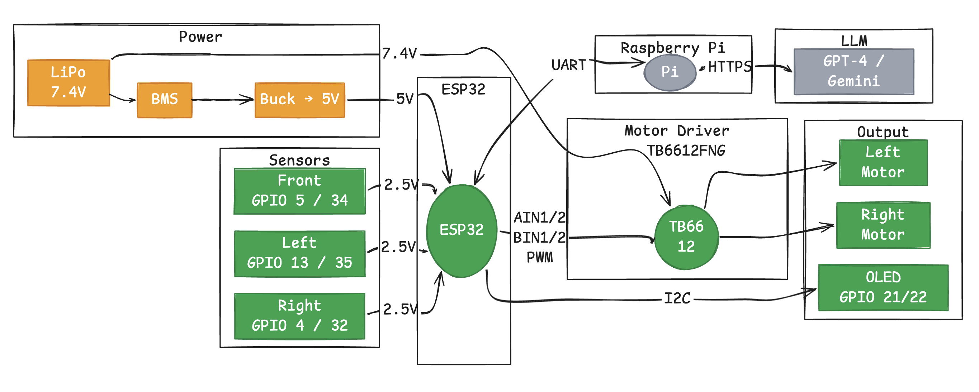
Figure 5.1 — KANDA Low-Level Design: Pin Mapping, Signal Conditioning, and Interfaces

CHAPTER 6
PHASE 2 IMPLEMENTATION AND TESTING OF KANDA
6.1 Phase 2 Hardware Implementation
The Phase 2 implementation proceeded through the incremental sequence defined in the methodology. The power architecture was assembled and verified first. The buck converter output was measured with a multimeter to confirm a stable five-volt output before the ESP32 was connected. The battery management system was tested for correct cutoff behaviour by monitoring the output voltage as the battery was discharged to the cutoff threshold. After confirming stable power delivery, a minimal blink sketch was flashed to the ESP32 to verify USB programming connectivity and basic operation.
The three ultrasonic sensors were then connected, one at a time, with voltage dividers on each ECHO pin. Each sensor was tested individually using a short sketch that printed distance readings to the serial monitor at one-second intervals. Readings were verified to be accurate within approximately one centimetre for distances between five and one hundred and fifty centimetres, with degraded accuracy beyond that range. The voltage at each ECHO-to-GPIO connection point was measured with a multimeter during active sensing to confirm that the divider was producing the expected two-point-five-volt signal.
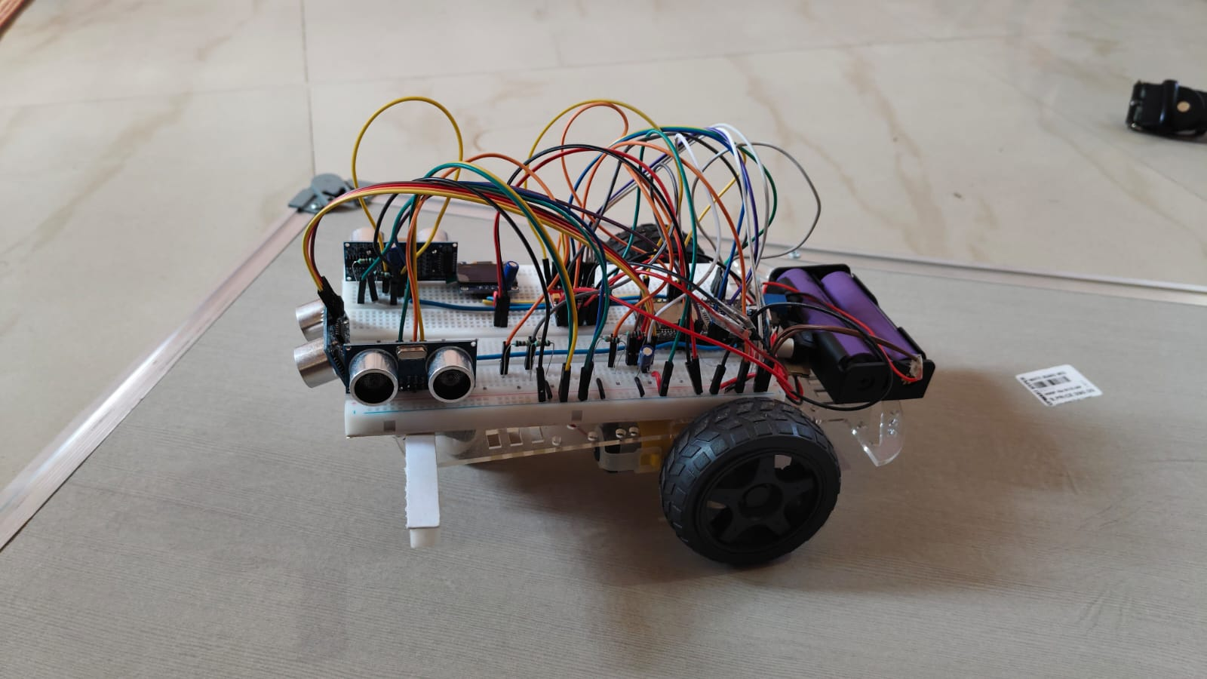
Figure 6.1 — KANDA Phase 2: Front view showing HC-SR04 sensors, differential drive wheels, and assembled chassis
The SSD1306 OLED display was connected to GPIO 21 (SDA) and GPIO 22 (SCL) and tested with a static text sketch. An important discovery during this step was that the ESP32 Arduino framework did not default the I2C bus to pins 21 and 22 without an explicit Wire.begin(21, 22) call in the setup function. Without this call, the display failed to initialise even though the wiring was correct. After adding the explicit initialisation call, the display functioned reliably with the Adafruit SSD1306 library at I2C address 0x3C.
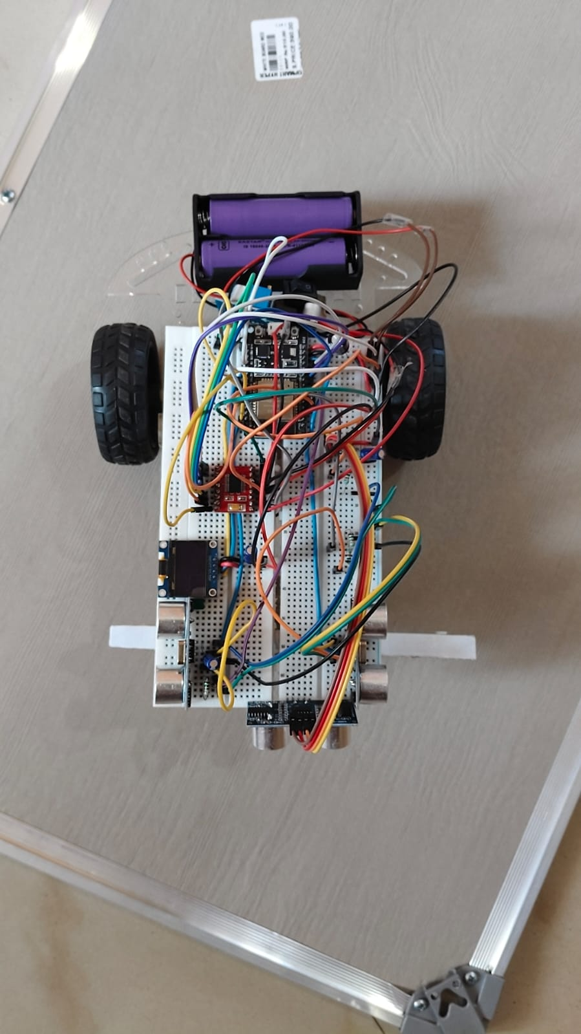
Figure 6.2 — KANDA Phase 2: Top view showing ESP32 DevKit, TB6612FNG motor driver, OLED display, and battery pack
The TB6612FNG motor driver was connected and the motor control functions were tested in isolation before integration with the sensor loop. Each of the seven movement functions was tested by observing wheel rotation direction and speed for ten seconds, comparing the result to the expected behaviour from the TB6612FNG truth table. Forward movement was initially observed to move the robot in the reverse direction, which was corrected by swapping the AIN1 and AIN2 logic values in the forward and backward functions, reflecting the inward-facing motor mounting on the chassis.
6.2 Key Engineering Decisions and Problem Resolutions
The most significant hardware challenge during Phase 2 was the identification of the correct voltage divider component values. The ideal two-kiloohm series resistor was not available in the component inventory at the time of assembly. Rather than delaying the build, two one-kiloohm resistors were connected in series to form a two-kiloohm equivalent. The resulting voltage division was mathematically identical to a single two-kiloohm resistor because the ratio of the series combination to the lower half of the divider was the same. This decision was validated by measuring the output voltage and confirmed to be safe for the ESP32 GPIO inputs.
The second significant challenge was encountered during firmware compilation after upgrading to ESP32 Arduino core version 3. The existing firmware used the ledcSetup and ledcAttachPin functions for PWM configuration, which had been removed in the version 3 API. The compiler produced errors on these calls that initially appeared to be library or IDE issues. After reviewing the ESP32 Arduino core version 3 migration documentation, it was found that both functions had been replaced by a single ledcAttach function that accepted the pin number, frequency, and resolution as arguments. The firmware was updated accordingly, and the PWM output was confirmed to be correct through oscilloscope measurement of the PWMA and PWMB pins.
The third challenge was the identification and resolution of GPIO pin conflicts. An initial pin assignment used GPIO 36 for one of the ECHO signals. During testing, the readings from this pin were observed to be unstable, producing intermittent false distance measurements that did not correspond to the actual sensor output. GPIO 36 was a known problematic pin on some ESP32 DevKit boards because of its connection to the internal ADC1 circuit. The ECHO signal was reassigned to GPIO 32, which produced stable and consistent readings.
6.3 Obstacle Avoidance Behaviour Validation
The complete obstacle avoidance loop was tested in a corridor environment with walls on both sides and obstacles placed at various positions and distances. The robot demonstrated reliable front obstacle detection at the twenty-centimetre threshold, stopping promptly and turning away from the obstacle based on the relative left and right distances. The side correction logic, which applied differential speed reduction when a wall was within fifteen centimetres on either side, produced smooth steering corrections that prevented the robot from scraping along walls.
The OLED display was confirmed to update correctly in real time, showing the current front, left, and right distances and the active movement decision label matching the observed robot behaviour. Serial monitor output was cross-referenced with the OLED display to confirm that both output channels showed identical sensor readings and decisions. The loop was confirmed to run at the specified ten-hertz rate without blocking.
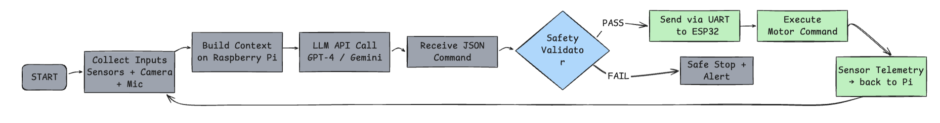
Figure 6.3 — KANDA sense-decide-act flow: Phase 2 rule-based loop (green) and Phase 3 LLM-driven loop (grey)
6.4 Phase 3 Design Status
At the time of submission, the Phase 3 implementation had not been started, but the complete architectural design, software specification, and hardware component list were finalised and documented. The ESP32 firmware had been prepared for Phase 3 integration by reserving GPIO pins 1 and 3 for the Raspberry Pi UART bridge and leaving them unassigned in the Phase 2 pin map. The JSON command parsing logic was designed and documented in the protocol specification, ready to be implemented in the ESP32 firmware as an additional mode activated when a Raspberry Pi connection was detected.
The Raspberry Pi Python AI pipeline was fully specified in the software requirement specification and low-level design chapters. The sequence of initialising the Whisper model, opening the camera stream, setting up the UART connection, and entering the main context-build-query-validate-command loop was defined with sufficient detail that implementation could begin immediately after Phase 2 testing was complete. The hardware description prompt template was drafted and included in the project documentation.

CHAPTER 7
CONCLUSION AND FUTURE WORK
7.1 Conclusion
The KANDA project successfully completed Phase 2 of its two-phase development plan, delivering a fully functional, stable, and validated embodiment layer for an LLM-powered household companion robot. The ESP32-based hardware platform demonstrated autonomous obstacle avoidance, smooth differential steering, real-time OLED feedback, and robust sensor readings in an indoor environment. The power architecture was designed and validated to provide stable regulated power to the microcontroller while supplying high-current motor power directly from the battery, preventing voltage instability during motor operation.
The project demonstrated that a hardware-first, incremental development methodology was effective for building complex robotic systems from commodity components. Each hardware subsystem was verified independently before integration, maintaining a clear chain of responsibility for any issue that arose and ensuring that the final integrated system was built on a foundation of individually validated components. This approach also produced better-documented hardware designs, since each subsystem was described in terms of its individual verification results before being combined with others.
The architectural separation between the ESP32 execution body and the Raspberry Pi reasoning brain was demonstrated to be a sound engineering choice. It provided hardware safety through the fallback to rule-based operation during any AI layer failure, enabled independent development and testing of both layers, and created a clean interface boundary through which the intelligence layer could be upgraded without modifying the embodiment layer firmware. The JSON command protocol with safety validation provided a structured, verifiable interface that constrained all LLM output to hardware-safe values before execution.
The revision of the application domain from greenhouse monitoring to household companion robotics was a critical decision that strengthened the project's academic contribution. Greenhouse monitoring tasks were largely solvable by rule-based sensor logic, providing weak justification for LLM integration. Household companion tasks, including elderly assistance, child tutoring, medication reminders, home automation, and emergency alerting, required the contextual reasoning, natural language adaptability, and personalisation that only an LLM-based system could provide. This domain change aligned the technical architecture with a compelling social need and produced a stronger, more defensible research contribution.
7.2 Future Work
The immediate priority for future work was the implementation of Phase 3. This required the physical mounting of the Raspberry Pi on the robot chassis, the UART wiring connection to GPIO 1 and 3 of the ESP32, and the installation of the Python AI pipeline on the Pi. The multimodal context builder, LLM API client, safety validator, and text-to-speech module were all fully specified and ready to be coded. The first Phase 3 milestone was to establish a reliable UART data link between the Pi and the ESP32 and verify that JSON commands transmitted from the Pi were correctly parsed and executed by the ESP32 firmware.
The second area of future work was the evaluation of the companion use cases in household settings. A structured evaluation protocol would be designed covering at minimum three scenarios: an elderly assistance interaction, a child tutoring session, and a medication reminder delivery. Each scenario would be evaluated for response latency, command safety validation accuracy, speech recognition quality, and user interaction naturalness. This evaluation would provide the evidence base for any publication arising from the project.
Longer-term future work included the deployment of a quantised local LLM on the Raspberry Pi to remove the internet connectivity requirement, the addition of multi-turn conversation memory for personalised interactions, the integration with smart home APIs for extended home automation capability, and the development of a semantic safety validation layer that evaluated the contextual appropriateness of commands in addition to their numerical validity. A user study with elderly participants was also planned to validate the companion use cases against real-world requirements.

REFERENCES

[1] M. Ahn, A. Brohan, N. Brown, J. Chiang, O. Cortes et al., "Do As I Can, Not As I Say: Grounding Language in Robotic Affordances," in Proc. 6th Conf. on Robot Learning (CoRL), Auckland, New Zealand, 2022, pp. 287-318.
[2] A. Brohan, N. Brown, J. Carbajal, Y. Chebotar, J. Dabis et al., "RT-2: Vision-Language-Action Models Transfer Web Knowledge to Robotic Control," in Proc. 7th Conf. on Robot Learning (CoRL), Atlanta, GA, 2023, pp. 2165-2183.
[3] D. Driess, F. Xia, M. S. M. Sajjadi, C. Lynch, A. Chowdhery et al., "PaLM-E: An Embodied Multimodal Language Model," in Proc. 40th Int. Conf. on Machine Learning (ICML), Honolulu, HI, 2023, pp. 8469-8488.
[4] Z. Yang, Y. Liu, X. Chen and R. Shu, "RoboGuard: Safety Guardrails for LLM-Enabled Robotic Systems," arXiv:2503.07885 [cs.RO], Mar. 2025.
[5] X. Liu, Z. Wang and H. Chen, "SafeEmbodAI: Safety Validation Mechanisms for Mobile Robot Navigation with Large Language Models," arXiv:2409.01630 [cs.RO], Sep. 2024.
[6] J. Shen, Y. Zhang, L. Chen and W. Huang, "Acceptability and Usability of a Socially Assistive Robot Integrated With a Large Language Model for Enhanced Human-Robot Interaction in a Geriatric Care Institution: Mixed Methods Evaluation," JMIR Human Factors, vol. 12, no. 1, p. e58553, 2025.
[7] M. Pinto, A. Costa and R. Sousa, "Integrating a Large Language Model Into a Socially Assistive Robot in a Hospital Geriatric Unit: Two-Wave Comparative Study," JMIR Human Factors, vol. 12, no. 2, p. e61207, 2025.
[8] L. Fischer, T. Weiss and K. Schulz, "Recommendations for Designing Conversational Companion Robots With Older Adults Through Foundation Models," Frontiers in Robotics and AI, vol. 11, p. 1342876, 2024.
[9] Espressif Systems, "ESP-SparkBot: Large Language Model Robot Powered by ESP32-S3," Espressif Systems Technical Report, Shanghai, China, 2025.
[10] A. Radford, J. W. Kim, T. Xu, G. Brockman, C. McLeavey and I. Sutskever, "Robust Speech Recognition via Large-Scale Weak Supervision," in Proc. 40th Int. Conf. on Machine Learning (ICML), Honolulu, HI, 2023, pp. 28492-28518.
[11] Espressif Systems, "ESP32 Technical Reference Manual," Rev. 5.2, Espressif Systems, Shanghai, China, 2024.
[12] Toshiba Semiconductor, "TB6612FNG Dual DC Motor Driver IC Datasheet," Rev. 2.0, Toshiba Electronic Devices and Storage Corporation, Tokyo, Japan, 2020.
[13] Solomon Systech, "SSD1306 OLED Dot Matrix Driver with Controller Datasheet," Rev. 1.1, Solomon Systech Ltd., Hong Kong, 2008.
[14] J. S. Albus, "Outline for a Theory of Intelligence," IEEE Trans. Syst., Man, Cybern., vol. 21, no. 3, pp. 473-509, May/Jun. 1991.
[15] R. A. Brooks, "Intelligence Without Representation," Artif. Intell., vol. 47, no. 1-3, pp. 139-159, Jan. 1991.

