THE DOOMED DICE CHALLENGE- Part A [SOLUTION]

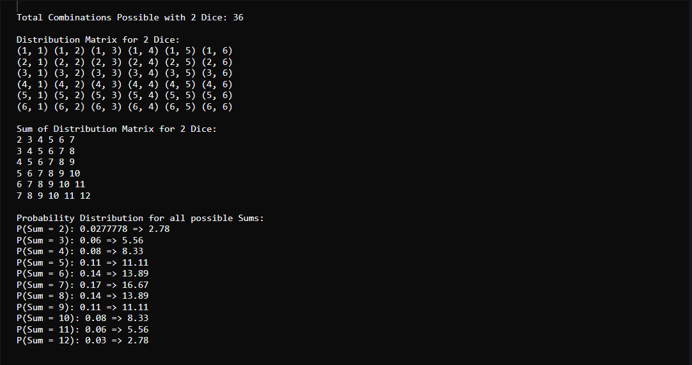

THE DOOMED DICE CHALLENGE- Part B [SOLUTION]

