# **Why is Wordpress the best choice for b2b Business ? 12 Benefits of using WordPress:**

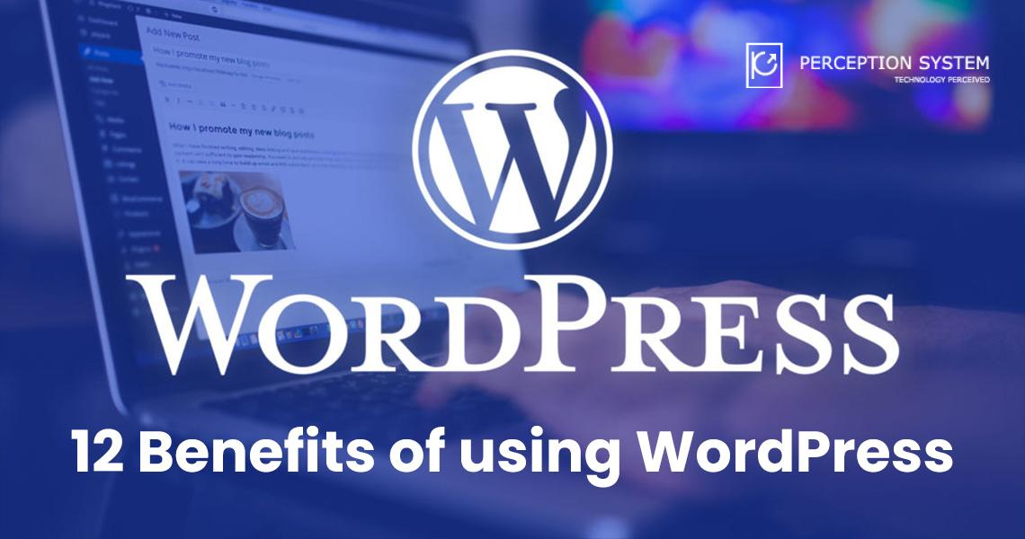

WordPress is a content management system which lets a user have his own website up and running with basic knowledge of how a website works. But, if you are a newbie in the field of websites, then it is best to hire WordPress developers or [WordPress development agency](https://www.perceptionsystem.com/) to get your website professionally built.

Thousands of websites around the world are powered by WordPress. Let us look at the benefits WordPress has to offer:

1. Simplicity: WordPress is simple and easy to use. With ready-made WordPress templates, you can build a website in its most basic form without coding.
2. Stability: WordPress provides a lot of stability and innovation, hence your website is the latest and updated regularly.
3. Easy design options: With a lot of design options and readymade themes, it is easier to have a website design of your choice.
4. Flexibility: With a lot of free plugins that integrate seamlessly with WordPress, you can extend the functionality of your website.
5. SEO: SEO is important when you are dealing with a website’s ranking factors. This becomes effortless when you are working with a WordPress website. Merely using heading tags and the right keywords can bring you a lot of traffic.
6. Content Management: You can create roles like editor, writer, and others to be assigned to various people. This makes the management and publishing of the content easier.
7. WordPress Community: People in the WP community are always there to assist you round the clock if you are stuck somewhere.
8. Responsiveness: With the responsiveness, you can make sure your website is visible on various devices and platforms.
9. Scalability: With changing and growing business requirements, you can be sure to have a website that grows along with it.
10. Efficiency: To publish a website, you just need images, graphics, and content and it is ready to go in a day or two.
11. API Support: WordPress allows integration to various APIs which can extend the functionality of the website, significantly.
12. Open-Source: Thousands of developers can modify and evolve the platform to make it more advantageous and beneficial.

Wrapping it up:

Perception systems is a WordPress development agency that provides various packages for [Hire for WordPress development services.](https://www.perceptionsystem.com/wordpress-development-company.html)

Planning to have a WordPress website? contact us for a consultation.