**Problem 1: Read the instructions carefully and answer accordingly. If there is any need to insert some data then do that as well.**   
  
a) Navigate and List:   
a. Start by navigating to your home directory and list its contents. Then, move into a directory named "LinuxAssignment" if it exists; otherwise, create it.   
  
  
  
b) File Management:   
a. Inside the "LinuxAssignment" directory, create a new file named "file1.txt". Display its contents.

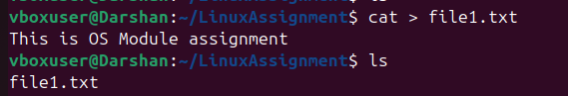   
  
c) Directory Management:

a. Create a new directory named "docs" inside the "LinuxAssignment" directory.  
  
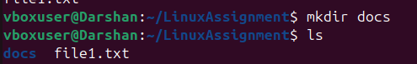

d) Copy and Move Files:

a. Copy the "file1.txt" file into the "docs" directory and rename it to "file2.txt".



