Installation

1) Download burp suite community edition and mozilla Firefox

2) Install both normally next next krke on windows

3) Go to firefox, go to settings, search network settings. Open network settings and Select Manual proxy and following settings

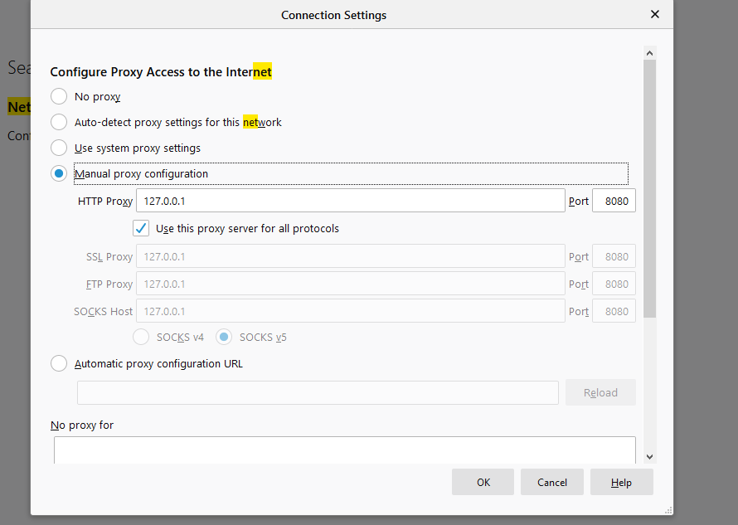

4) Click Ok and save

5) Open burp suite application, temporary project next and come to dashboard.

6) Let the burp suite application be open, Go to firefox, enter <http://burp>

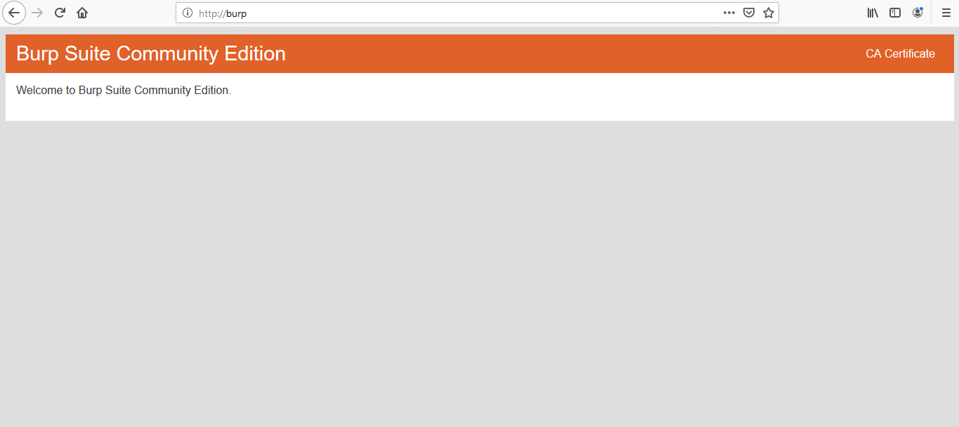

7) This will open

8) Click on CA certificate. Download the Certificate.

9) Open the settings of firefox. Search for Certificate Manager. Go to the authorities tab. Click on Import. Go to the folder where you have downloaded the certificate and open it.

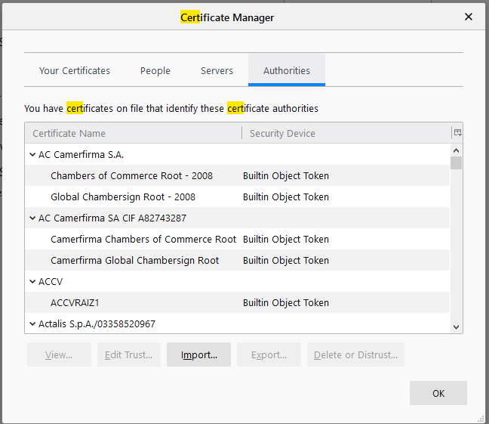

10) Once you open this dialog box will appear. Check both the fields and click Ok.

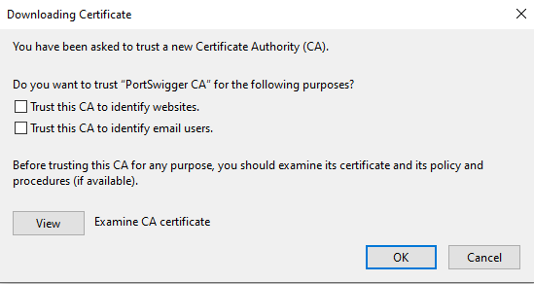

11) Select the target website. Select any one website where you the following options: a) Login b) Resetting the password c) Cookies

A) Select the target

1. After installation and setup of CA certificate go back to burp suite
2. Go to the proxy tab
3. Turn off the inception
4. Go to the browser
5. Go to/ Load /Reload the target website
6. Go back to the Burp Suite application and on the left side your target website will be listed. Select your target website to select your target.

B) Proxy

1. Select a target based on above steps
2. Go to your browser, load a login page and fill in some login details. Do not submit those details at this step.
3. Go back to the Proxy tab and switch the interception on
4. Now go back to the web browser and submit your credentials.
5. All this data sent through the request will be intercepted in the proxy tab in the burp suite
6. From here we can view various details such as HTTP History and Web sockets history in various formats such as raw, parameters, headers and hex.
7. If you see the request is valid you can forward the trapped/intercepted request else you can drop the request.

C) Intruder

1. Intercept a request based on the above steps
2. Right click on it and Send it to the intruder
3. Then follow the video

<https://www.youtube.com/watch?v=BaN89Te85W4>

Time 9:06 – 12:55

E) Repeater

<https://www.youtube.com/watch?v=BaN89Te85W4>

Time 16:02 – 17:30

F) Decoder

1. Intercept a request from a website through the proxy tab
2. Right click and forward it to the decoder
3. Then follow video

<https://www.youtube.com/watch?v=qJy8k1RCwdc>

Time 2:16 – 5:03

G) Sequencer

1. Intercept a request from a website through the proxy tab
2. Then follow the video

<https://www.youtube.com/watch?v=kNSAhKiXctA>

Time – 2:21 – End of video