1)

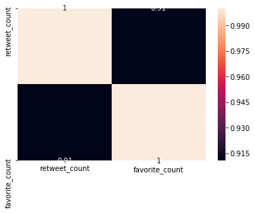

2)

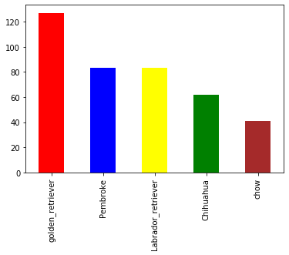

3)

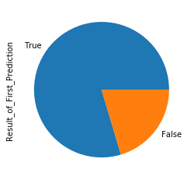

4)

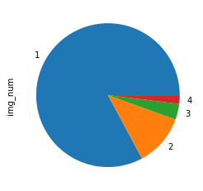

**Insights**

Graph 1 -

so as we can see in the first image there is the comparison between the retweet count and the favourite count the value 0.91 indicates that there is a very high amount of correlation between the retweet count and the favourite count,the with the help of the retweet count and the favourite Kaun one can try to determine that if a tweet is a trending tweet or if it is not attending feat so this is a very vital information which we can try to understand from the heat map which we have plotted

Graph2-

over here we have tried to show a comparison between the various breed of the dog that have been obtained in the first prediction your we can try to analyse that we have the top five breed of the dog with respect to their accounts so the x-axis contains the names of the breed of the dog and the y-axis contains the count of each and every breed we can try to understand that the top five breach or your are the Golden Retriever dog Pembroke the labrador retriever and the Shuru so these are the top five breeds of the dogs that are present in the current data set when we try to obtain office prediction and this gives as an idea of how well the data has been distributed among the various values of the dog

Graph3-

here we have tried to showcase that what has been the result of the first prediction that we have tried to obtain we have try to understand that how many values have been turned out to be as two values and how many values have turned out to be a false value so we have tried to obtain the amount of crown and their trip to plot a pie chart on your and as we can observe easily with the help of the pie chart that the number of True values are really significantly high as compared to the false values

Graph4-

in this particular graph we have try to understand that what are the count of a particular number of images that have been attached to a particular to eat as we know that the maximum count can be 4 number of images with a particular to eat so we have tried to obtain that how many images have been attached with a particular tweet as we can observe very easily with the help of a pie chart that one dominates the complete data set followed by two then 3 and then 4