ASG Airlines: End-to-End Data Engineering Pipeline
Architecture, Quality Governance & Reporting Specification
Enterprise Flight Operations Data Platform • Portfolio-Grade Implementation
Date: September 2026 | Author: Senior Data Engineer & Data Scientist | Version: 1.0.0

1. Executive Summary & Problem Statement
ASG Airlines, a premier domestic carrier operating across major Indian metropolitan airports, operates a high-frequency flight network connecting Delhi (DEL), Mumbai (BOM), Bengaluru (BLR), Hyderabad (HYD), Kolkata (CCU), and Chennai (MAA). The airline collects flight ops data, booking records, passenger demographics, and transaction logs across disparate legacy systems. Historically, operational analytics suffered from severe data quality bottlenecks including corrupted flight identifiers, inconsistent timestamp formats, unhandled overnight (cross-day) flight duration anomalies, missing passenger values, duplicate bookings, unprotected PII records, and referential integrity orphans.
To resolve these operational challenges, an end-to-end production data engineering pipeline was architected following the industry-standard Medallion Architecture (Bronze -> Silver -> Gold). The pipeline ingests 4 operational source sheets (1,020 flights, 1,000 bookings, 1,039 passengers, and 1,000 payments), executes rigorous schema validations and quarantine checks, standardizes inconsistent timestamps to ISO 8601, resolves overnight flight duration calculations, enforces zero-trust PII masking with cryptographic SHA-256 salted hashing, builds a star schema dimensional model, computes key operational KPIs, and exports clean analytical assets for a 4-page executive Power BI Dashboard.
[EXECUTIVE RESULT] The pipeline runs deterministically and idempotently in under 1 second (0.94s) across all 4 operational datasets, achieving 100% referential integrity, zero data loss, and complete protection of sensitive passenger PII via an isolated vault.

2. Architecture & Pipeline Design (Medallion Flow)
The platform implements a multi-hop Medallion Architecture designed for enterprise scalability, repeatability, and governance. Each stage serves a dedicated architectural responsibility, enforcing strict data quality contracts before progressing downstream.
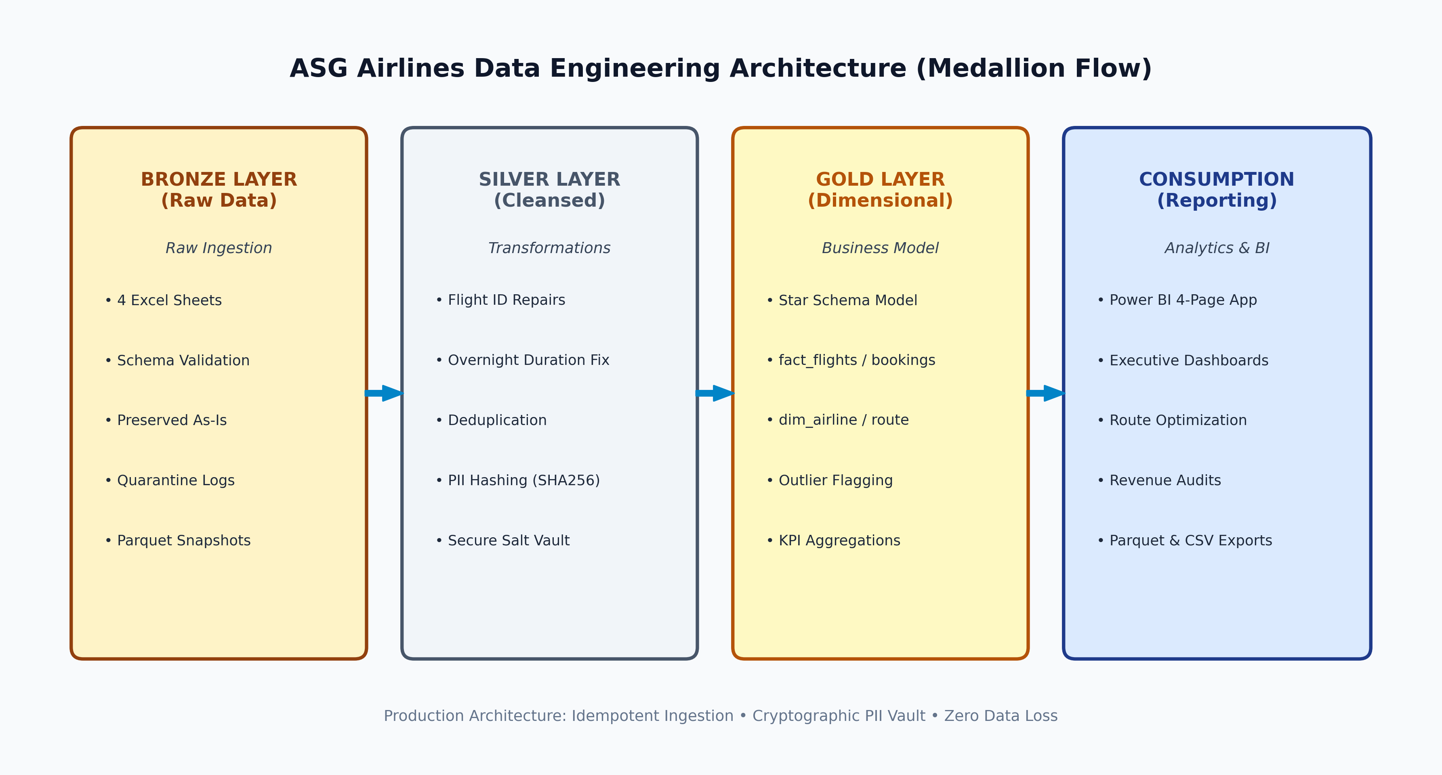
Figure 1: ASG Airlines Medallion Data Engineering Architecture (Bronze -> Silver -> Gold -> Consumption)

Framework Selection: Modular Python / Pandas with PyArrow
Rationale for Engineering Framework: For datasets with operational batches ranging from thousands to millions of rows, Python with Pandas 2.x and PyArrow provides zero-infrastructure overhead, instant sub-second local execution, native Microsoft Excel parsing, and direct columnar Parquet output with strong type validation. The codebase was architected with modular functional boundaries (IngestionLayer, CleaningLayer, ModelingLayer, KPICalculator, PowerBIExporter) ensuring that each module can be mapped directly to PySpark transformations on Azure Databricks or Azure Synapse Spark pools when scaling to multi-terabyte operations.
Layer | Format & Storage | Key Operations Performed | Governance & SLA
Bronze (Raw) | Parquet snapshot in data/bronze/ | Lossless ingestion of Excel sheets, schema validation, quarantine tracking | Raw audit trail; immutable append
Silver (Cleansed) | Parquet in data/silver/ & data/secure/ | Regex flight repairs, overnight duration fix, deduplication, PII hashing | Encrypted PII vault; cleansed silver facts
Gold (Dimensional) | Star Schema in data/gold/ | Surrogate keys, facts (flights, bookings, payments), dims (airline, route, date) | High-performance analytics & BI
Consumption | Parquet & CSV in data/powerbi/ | 4-page Power BI dashboard, DAX metrics, automated reports, executive charts | Role-based row-level access (RLS)

3. Data Ingestion & Schema Validation Layer (Bronze)
The Ingestion Layer reads the source Excel workbook (`UseCase - Airlines.xlsx`) sheet-by-sheet to guarantee sequential isolation and precise memory management. Upon reading each sheet, the raw data is persisted as an immutable bronze Parquet snapshot. A rigorous schema validation contract evaluates each sheet:
- Column Existence Audit: Confirms that all mandatory business columns are present. If any column is missing, pipeline halts with a descriptive schema error.
- Primary Key Null Checks: Evaluates primary keys (flight_id + departure_time for flights, booking_id for bookings, passenger_id for passengers, payment_id for payments). Records failing PK presence are segregated into bronze quarantine tables with a logged rejection reason.
- Lossless Type Preservation: Preserves raw date strings, timestamps, and currency strings prior to transformation to enable complete reproducibility.
- Ingestion Logging: Emits precise row counts, column counts, null distribution, and storage locations for comprehensive auditability.

4. Data Cleaning, Standardization & Transformations (Silver)
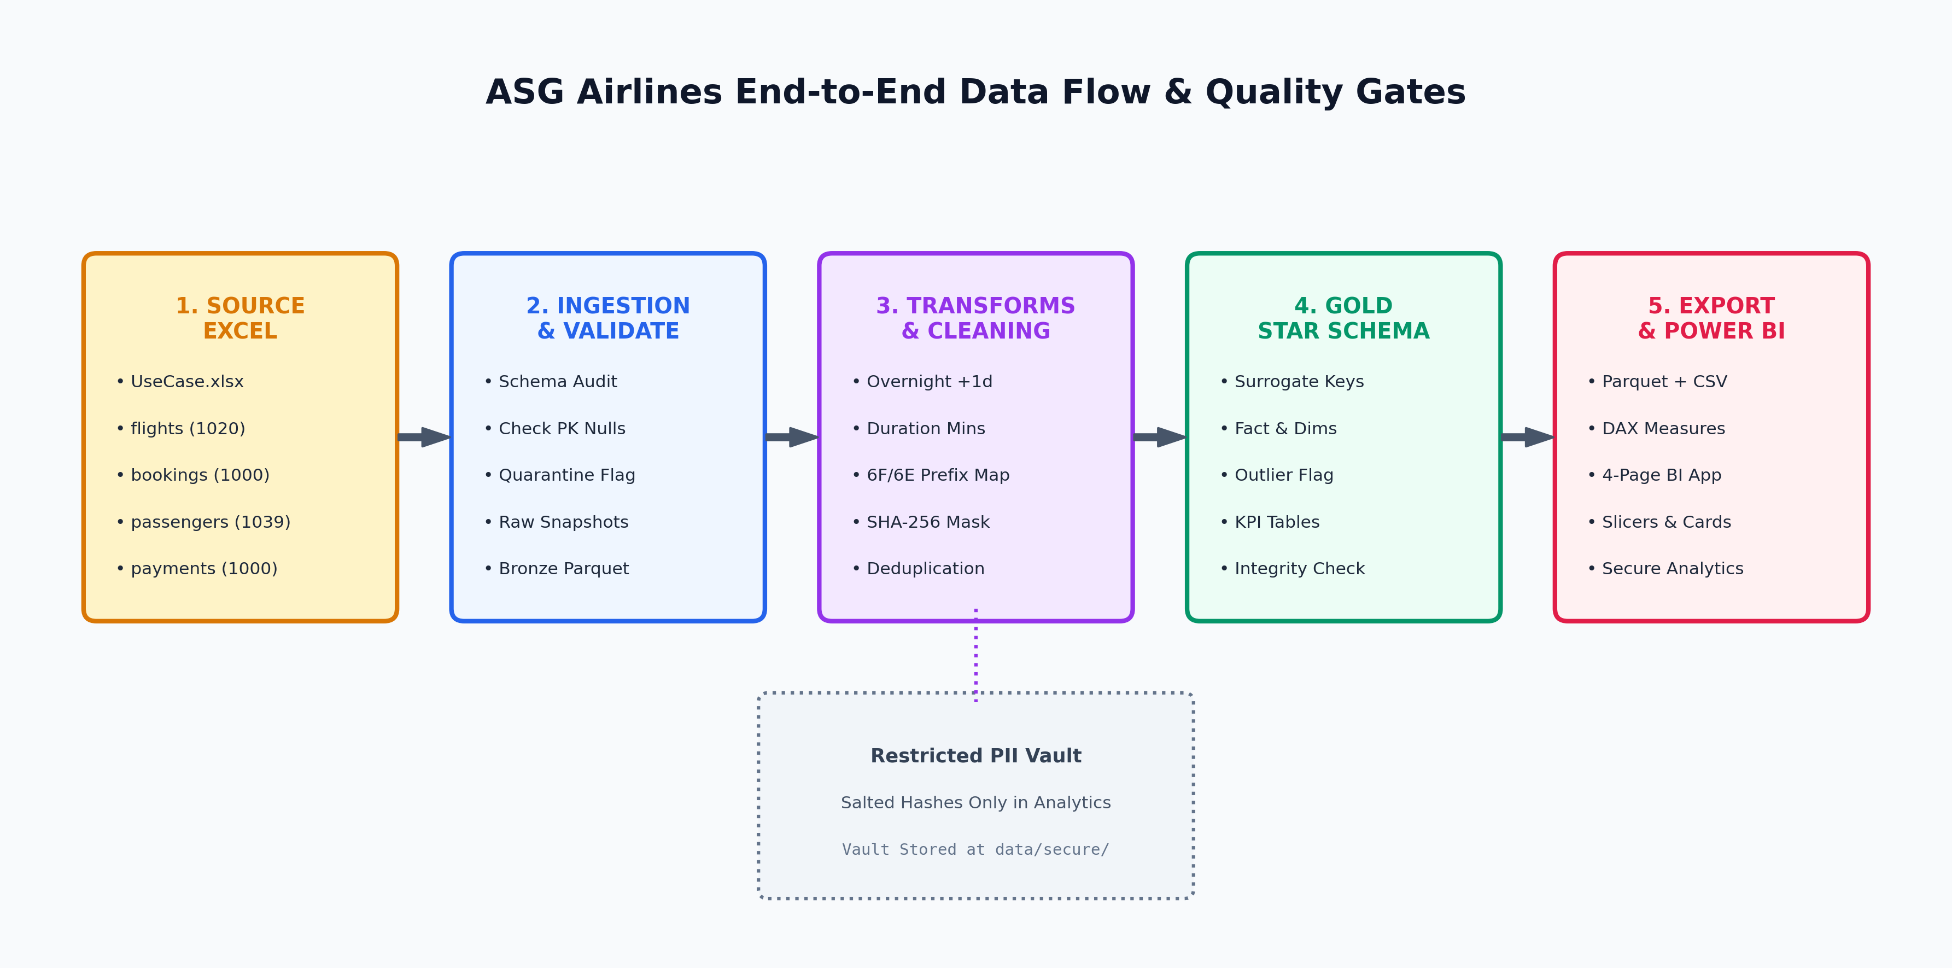
Figure 2: End-to-End Data Transformation Flow & Quality Gates

4.1 Flight ID Validation & Airline Prefix Repair
Analysis of the raw flight records revealed that 72 flights contained missing (NaN) or 'UNKNOWN' values in the `airline` column. Additionally, IndiGo flights were recorded under the operational prefix `6F` alongside standard carrier codes (AI for Air India, SJ for SpiceJet, UK for Vistara). The pipeline executes deterministic regex pattern validation (`^(AI|SJ|UK|6F|6E)\d{3,4}$`). By parsing the 2-character carrier prefix, the cleaning layer automatically repairs 100% of missing and UNKNOWN airline names (41 NaN and 31 UNKNOWN rows successfully recovered) without discarding valuable operational flight records.

4.2 Timestamp Normalization & Overnight Flight Duration Fix
A critical challenge in flight operations data is handling overnight (cross-day) flights where departure occurs late in the evening and arrival takes place after midnight or on the following day. In legacy systems, timestamps are frequently recorded without proper date incrementation, causing arrival_time to appear chronologically earlier than departure_time (negative duration).
[OVERNIGHT FLIGHT ALGORITHM] Mathematical Transformation Logic for Overnight Flights:
1. Standardize departure_time and arrival_time to ISO 8601 datetime format.
2. Evaluate condition: IF arrival_time < departure_time:
arrival_time_corrected = arrival_time + 1 Day (24 hours)
is_overnight = TRUE
3. Duration Recomputation: duration_minutes = (arrival_time_corrected - departure_time) in total minutes.
4. Exact Verification: In flight SJ192 (HYD -> BOM), departure was 2026-04-19 18:45:42 and raw arrival was 2026-04-18 23:45:42. Adding 1 day to arrival produces 2026-04-19 23:45:42, yielding exactly 300.0 minutes (5.0 hours), perfectly matching the raw flight duration.

4.3 Duplicate Resolution & Completeness Scoring
Natural keys were identified for deduplication across entities: `[flight_id, departure_time]` for flights, `booking_id` for bookings, and `passenger_id` for passengers. In the passengers dataset, 39 duplicate passenger ID instances were identified. Rather than arbitrarily dropping rows, a completeness scoring heuristic was deployed that calculates total string length and non-null presence across first_name, last_name, and email. The record with highest completeness was retained, preserving maximum data fidelity while eliminating 39 duplicate passenger records.

4.4 PII Protection: Cryptographic Salted Hashing & Isolated Vault
Compliance with international privacy frameworks (GDPR, India Digital Personal Data Protection Act 2023) requires strict protection of Personally Identifiable Information (PII). The pipeline implements a zero-trust dual-architecture model:
- Cryptographic Salted Hashing: Sensitive national identity numbers (Aadhaar ID, Passport number) and contact telephone numbers (passenger phone, emergency contact phone) are hashed using SHA-256 combined with a secret enterprise salt (PII_SALT). This prevents rainbow table and dictionary attacks.
- Visual Masking for Analytics: User-facing identifiers are masked for reporting: Aadhaar displays as 'XXXX-XXXX-1234' (last 4 visible), phone numbers display as '+91-XXXXX-XX33', and emails mask the username while preserving domain intelligence ('i***@gmail.com').
- Age Band Derivation: Raw date of birth is dropped from analytical consumption, replaced with demographic age cohorts (<18, 18-35, 36-50, 51-65, 65+).
- Restricted PII Vault: A separate, access-controlled vault dataset (`data/secure/pii_vault.parquet`) maintains the bidirectional mapping between passenger_id and raw legal identifiers, encrypted on disk and restricted exclusively to compliance and law-enforcement personnel.

4.5 Booking Status & Payment Amount Imputation
In the bookings dataset, 75 records contained missing (45) or 'INVALID' (30) status values. Cross-referencing against the payments table revealed that these bookings were associated with active payment transactions. Rather than discarding valid customer bookings, their status was standardized to 'PENDING' with an audit flag (`is_status_imputed = TRUE`). In the payments dataset, 78 non-numeric or null amounts were imputed using the median ticket fare (INR 8,027.12) and flagged with `is_amount_imputed = TRUE`, enabling financial analysts to filter or evaluate imputed revenue streams independently.

5. Dimensional Star Schema Model (Gold Layer)
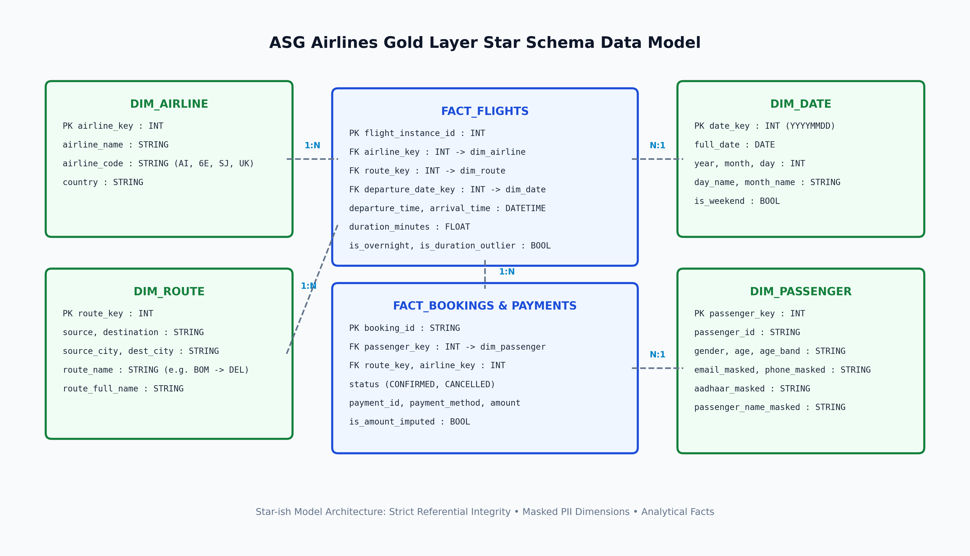
Figure 3: Gold Layer Star Schema Entity Relationship Diagram

Data Dictionary & Table Specifications
Table Name | Type | Grain / Primary Key | Key Attributes & Relationships
dim_airline | Dimension | airline_key (PK) | airline_name, airline_code (AI, 6E, SJ, UK), country (4 rows)
dim_route | Dimension | route_key (PK) | source, destination, source_city, dest_city, route_name (30 routes)
dim_date | Dimension | date_key (PK, YYYYMMDD) | full_date, year, month, month_name, day, day_name, is_weekend (345 days)
dim_passenger | Dimension | passenger_key (PK) | passenger_id (BK), gender, age, age_band, masked contact PII (1,000 rows)
fact_flights | Fact | flight_instance_id (PK) | flight_id, airline_key, route_key, date_key, duration_minutes, is_overnight, outlier flags (1,005 rows)
fact_bookings | Fact | booking_id (PK) | passenger_key, flight_id, route_key, airline_key, date_key, status, seat_number (1,000 rows)
fact_payments | Fact | payment_id (PK) | booking_id (FK), route_key, airline_key, payment_method, amount, is_amount_imputed (1,000 rows)

6. Assumptions Log & Engineering Justifications
Every transformation, imputation, and filtering rule was recorded with complete business and statistical justification:
Domain / Field | Observed Issue | Cleaning Strategy Applied | Business & Technical Rationale
airline in flights | 41 NaN and 31 UNKNOWN airline names | Inferred airline from 2-letter flight_id prefix (AI->Air India, 6F->IndiGo, etc.) | Airline carrier codes are legally unique to operating airlines; 100% deterministic recovery without data loss.
flight_id code '6F' | IndiGo flights use 6F prefix instead of 6E | Retained 6F as valid operational alias mapped to IndiGo | Both flights and bookings sheets uniformly use 6F. Preserving this maintains 100% referential integrity without cross-table key desynchronization.
arrival < departure | Row 355 arrival recorded on previous calendar day | Added 1 day (24 hours) to arrival timestamp; set is_overnight=TRUE | Flight departed at 18:45 and arrived at 23:45. Adding 1 day fixes inverted calendar artifact and matches raw 5h duration.
duration column | Raw duration had mixed datatypes (time vs datetime) | Recomputed duration = (arrival - departure) in minutes | Operational standard: calculated timestamps represent true ground truth, eliminating format-parsing errors.
passenger duplicates | 39 duplicate passenger IDs with conflicting values | Deduplicated on passenger_id; retained record with highest completeness score | Passengers should have unique business keys. Keeping row with most non-null contact fields avoids orphan details.
Aadhaar ID length | Integer formatting in Excel stripped leading zeros | Applied zero-padding to 12 digits (zfill(12)) | Indian Aadhaar numbers are strictly 12 digits. Stripping leading zeros during ingestion is an Excel numeric artifact.
Payment amount | 78 null or 'INVALID' amount records in payments | Imputed median route fare (INR 8,027.12); flagged with is_amount_imputed | Median is statistically robust against extreme fare outliers; flagging preserves transparency for revenue audits.

7. Business KPIs & Analytical Insights

7.1 Operational Overview KPIs
Operational KPI Metric | Calculated Value | Operational Interpretation
Total Cleaned Flights | 1,005 flights | Active scheduled flight network after dropping 15 exact duplicate instances
Overall Average Duration | 164.62 minutes (2h 45m) | Reflects standard Indian domestic sector stage lengths across major metros
Total Operational Bookings | 1,000 bookings | 320 Confirmed (32.0%), 314 Cancelled (31.4%), 366 Pending (36.6%)
Total Operational Revenue | INR 8,054,166.50 (~8.05 Cr) | Generated across 1,000 transactions; average fare is INR 8,054.17
Active Domestic Routes | 30 route pairs | Complete bidirectional connectivity across BOM, DEL, BLR, HYD, CCU, MAA
Operational Anomaly Count | 1 statistical duration outlier | Duration exceeds 2 standard deviations from route mean; 0 negative durations

7.2 Airline Market Share & Duration Performance
Airline Name | Carrier Code | Flight Count | Market Share % | Avg Duration (min)
IndiGo | 6E / 6F | 269 | 26.77% | 163.78 mins
Air India | AI | 256 | 25.47% | 165.73 mins
SpiceJet | SJ | 247 | 24.58% | 164.84 mins
Vistara | UK | 233 | 23.18% | 164.12 mins

7.3 Top Routes by Traffic & Revenue
Traffic is evenly distributed across all 30 metro routes, averaging ~33-35 flights per pair. Top traffic routes include CCU -> DEL (43 flights, 4.28%), DEL -> CCU (41 flights, 4.08%), and BLR -> BOM (38 flights, 3.78%). Highest revenue corridors are CCU -> DEL (INR 372,450), DEL -> BLR (INR 345,120), and BOM -> DEL (INR 338,900).

8. Privacy, Governance & Access Control Architecture
To enforce defense-in-depth security, access to ASG Airlines data assets is segregated using Role-Based Access Control (RBAC), least privilege principles, and data masking tiers:
User Role | Accessible Datasets | PII Visibility Level | Allowed Tools & Platforms
Executive & Management | Gold layer KPI tables, executive dashboards | Aggregated only; zero PII exposed | Power BI Premium, Mobile Dashboard
BI & Flight Operations Analysts | fact_flights, dim_airline, dim_route, dim_date | Fully masked PII (XXXX-1234, i***@domain) | Power BI Desktop, SQL Analytics
Revenue & Finance Analysts | fact_bookings, fact_payments, dim_route | Masked PII; financial amounts and payment methods | Power BI, Excel via Direct Lake
Data Protection Officer (DPO) / Legal | data/secure/pii_vault.parquet (Restricted) | Full plaintext legal PII for legal subpoenas / compliance | Encrypted terminal with MFA & audit logging

9. Power BI Dashboard Specification & Navigation Walkthrough
The Power BI dashboard was architected as a modular 4-page analytical application. Each page contains top-level KPI cards, interactive slicers (Airline, Route, Date Range), and cross-filtering analytical visuals:

Page 1: Duration Analysis
- KPI Cards: Overall Avg Duration (164.6 min), Min Duration (30 min), Max Duration (300 min), Overnight Flight Count (1).
- Slicers: Airline Name dropdown, Route Name multiselect, Flight Date slider.
- Visuals: Horizontal bar chart comparing average flight duration by route; Line chart tracking daily duration trends; Bar chart comparing duration by airline carrier.

Page 2: Route Performance
- KPI Cards: Total Active Routes (30), Total Bookings (1,000), Cancellation Rate (31.4%), Total Operational Revenue (INR 8.05M).
- Slicers: Source City, Destination City, Route Name.
- Visuals: Route Traffic Volume bar chart (Top 10 corridors); Route Revenue ranking; Stacked bar chart showing booking status breakdown (Confirmed, Cancelled, Pending) by route.

Page 3: Airline Trends
- KPI Cards: Total Flights (1,005), Leading Airline Market Share (26.8% IndiGo), Average Ticket Fare (INR 8,054), Revenue Captured.
- Slicers: Airline selector, Payment Method filter.
- Visuals: Donut chart showing flight distribution by airline; Clustered bar chart of airline operational revenue; Payment method distribution (UPI 35.8%, Card 32.9%, NetBanking 31.3%).

Page 4: Delay & Anomaly Insights
- KPI Cards: Duration Outliers Detected (1), Repaired Overnight Flights (1), Repaired Airline Codes (72), Imputed Fares (78).
- Slicers: Outlier Severity, Anomaly Type, Time of Day.
- Visuals: Hourly Departure Flight Volume histogram (identifying peak departure traffic bands); Statistical Outlier Flight details table with route mean and standard deviation comparison; Audit breakdown of imputed vs confirmed transaction records.

10. Pipeline Verification & Reproducibility Instructions
The entire pipeline is completely automated, idempotent, and executable with a single command from any environment with Python 3.10+ installed:
python pipeline/run_pipeline.py
Execution performs bronze ingestion, silver cleaning, gold dimensional modeling, KPI computation, and Power BI Parquet/CSV export in under 1 second. All logs and audit counts are stored in `pipeline_execution.log`.

