# LockedMe Project submission By

# Darshan H Jethwa

Date of Submission: 04-september-2022

Source Code GitHub Link:

<https://github.com/darshan-jethwa/Phase1_project_LockedMe>

(Reference link for source code and project related files)

**LockedMe Project Source code:**

package simplilearnPhaseOneProject;

import java.io.File;

import java.io.FileWriter;

import java.util.Scanner;

public class LockedMe {

static final String projectpath="E:\\Simplilearn\\full stack java dev\\project\\phase 1 project LockedMe\\LockedMefile";

public static void main(String[] args) {

Scanner obj = new Scanner(System.in);

int ch;

displayMenu();

System.out.println("Enter your choice:");

ch=Integer.parseInt(obj.nextLine());

switch(ch)

{

case 1: getAllFiles();

break;

case 2: createFiles();

break;

case 3: deleteFiles();

break;

case 4: searchFiles();

break;

case 5: System.exit(0);

break;

default: System.out.println("Invalid Option");

break;

}

while(ch>0);

}

public static void displayMenu()

{

System.out.println("***************************************************");

System.out.println("\tWelcome to LockedMe.com Secure your file Here");

System.out.println("\tDeveloper Name: Darshan Jethwa");

System.out.println("***************************************************");

System.out.println("\t1. Display all the files");

System.out.println("\t2. Add a new file");

System.out.println("\t3. Delete a file");

System.out.println("\t4. Search a file");

System.out.println("\t5. Exit");

System.out.println("***************************************************");

}

public static void getAllFiles()

{

File[] listOfFiles = new File(projectpath).listFiles();

//if the folder is empty

if(listOfFiles.length==0)

System.out.println("No files exist in the directory");

else

{

for(var l:listOfFiles)

{

System.out.println(l.getName());

}

}

}

public static void createFiles()

{

try

{

Scanner obj = new Scanner (System.in);

String fileName;

int linesCount;

System.out.println("Enter file name:");

fileName=obj.nextLine();

System.out.println("Enter how many lines you want to add in file");

linesCount=Integer.parseInt(obj.nextLine());

FileWriter fw = new FileWriter(projectpath+"\\"+fileName);

for(int i=1;i<=linesCount;i++)

{

System.out.println("Enter file content line:");

fw.write(obj.nextLine()+"\n");

}

System.out.println("File Created Successfully");

fw.close();

}

catch (Exception ex)

{

System.out.println("Some error occured.");

}

}

public static void deleteFiles()

{

Scanner obj = new Scanner(System.in);

try

{

String fileName;

System.out.println("Enter file name to be deleted:");

fileName=obj.nextLine();

File fl = new File(projectpath+"\\"+fileName);

if(fl.exists())

{

fl.delete();

System.out.println("File deleted successfully");

}

else

{

System.out.println("File do not exist");

}

}

catch(Exception Ex)

{

System.out.println("Some error occured");

}

}

public static void searchFiles()

{

Scanner obj = new Scanner(System.in);

try

{

String fileName;

System.out.println("Enter file name to be searched:");

fileName=obj.nextLine();

File fl = new File(projectpath+"\\"+fileName);

if(fl.exists())

{

System.out.println("File is available");

}

else

{

System.out.println("File is not available ");

}

}

catch(Exception Ex)

{

}

}

}

Source code end here

# Screen Shots of LockedMe Project

**1. Welcome Screen :**

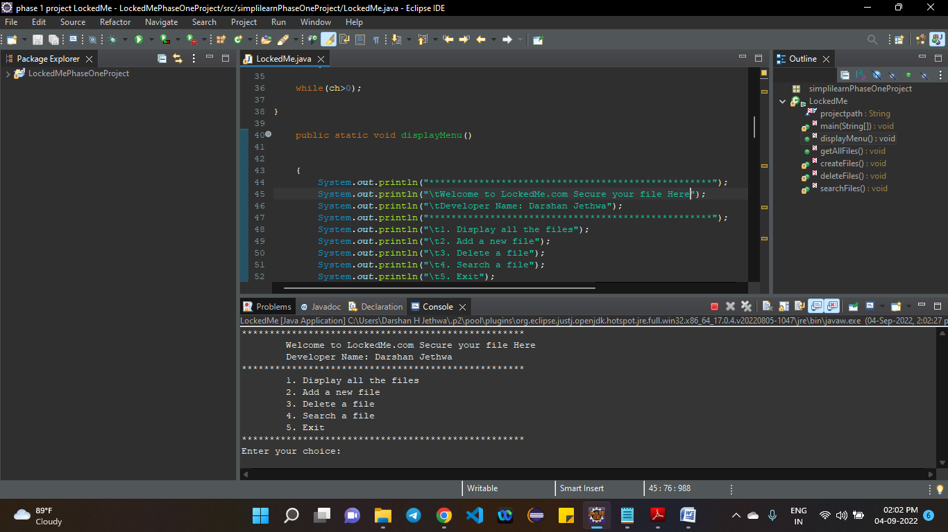

**2. Getting All Files :**

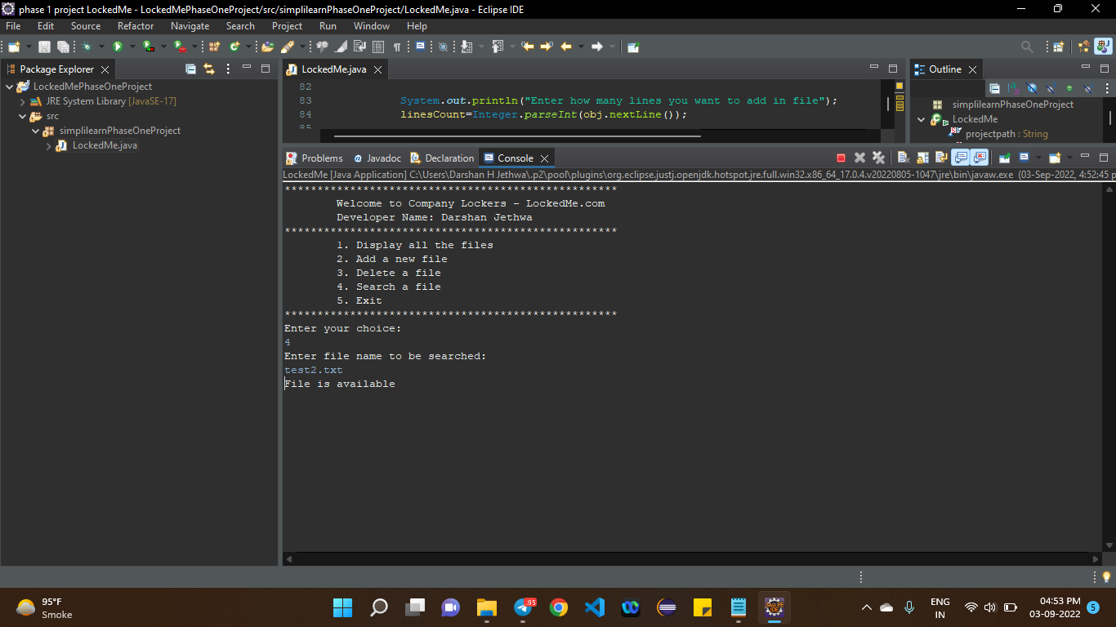

Figure 1 when file exist in file path

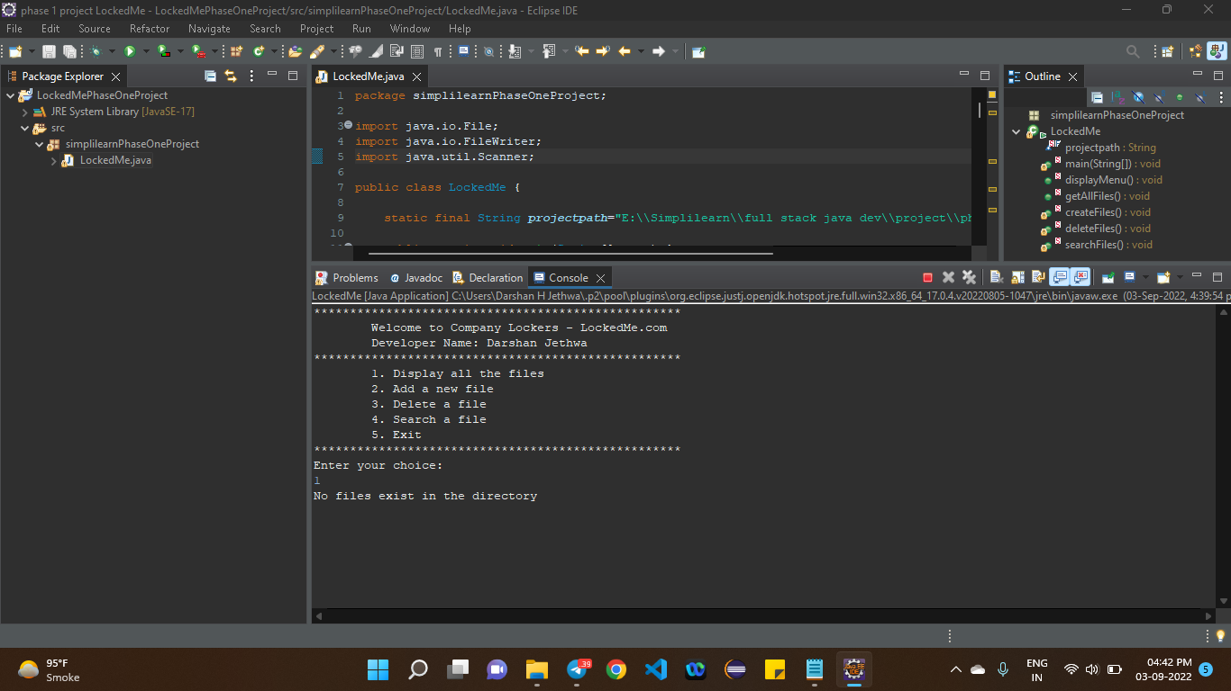

Figure 2 when file does not exist in file path

**3. Add new file :**

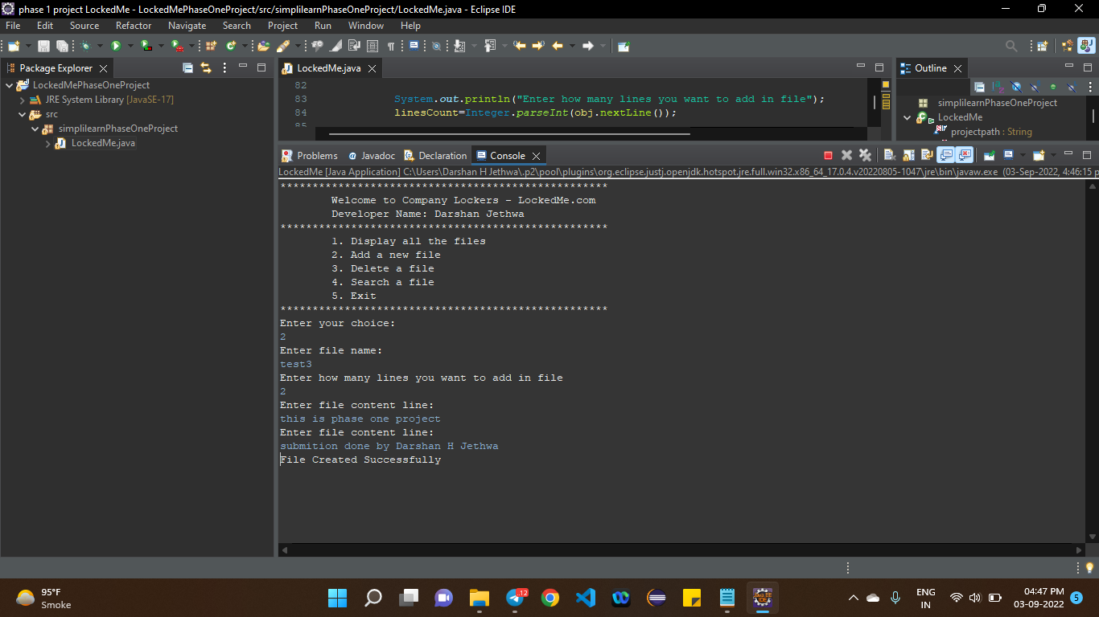

Figure 3 Add new file

**4. Delete a file:**

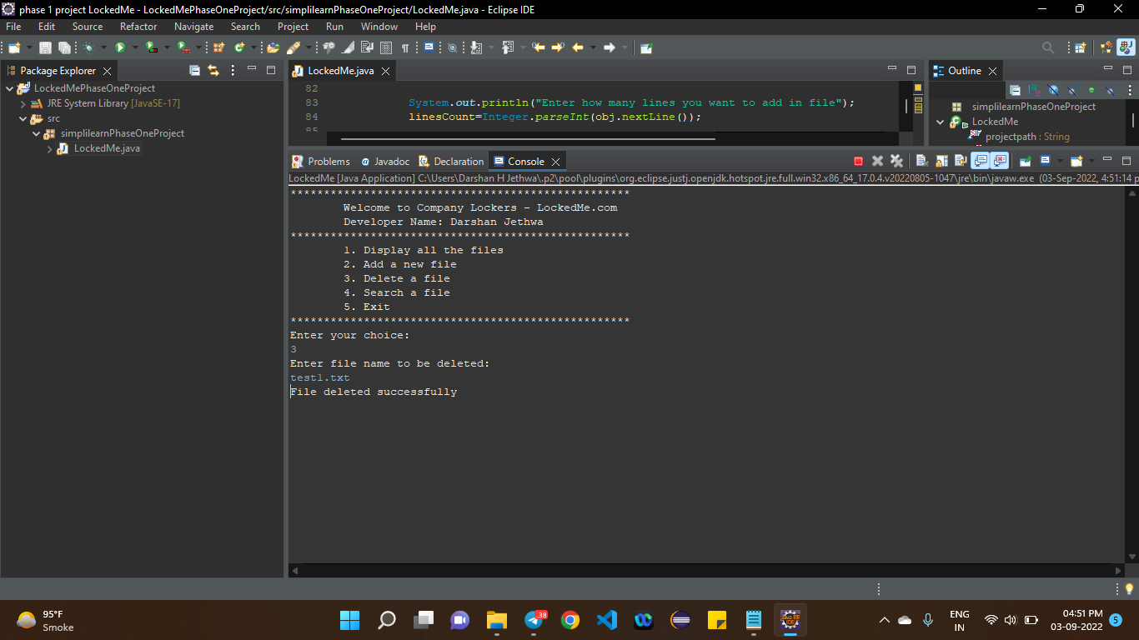

Figure 4 delete a file

**5. Search file:**



Figure 5 search result when file available

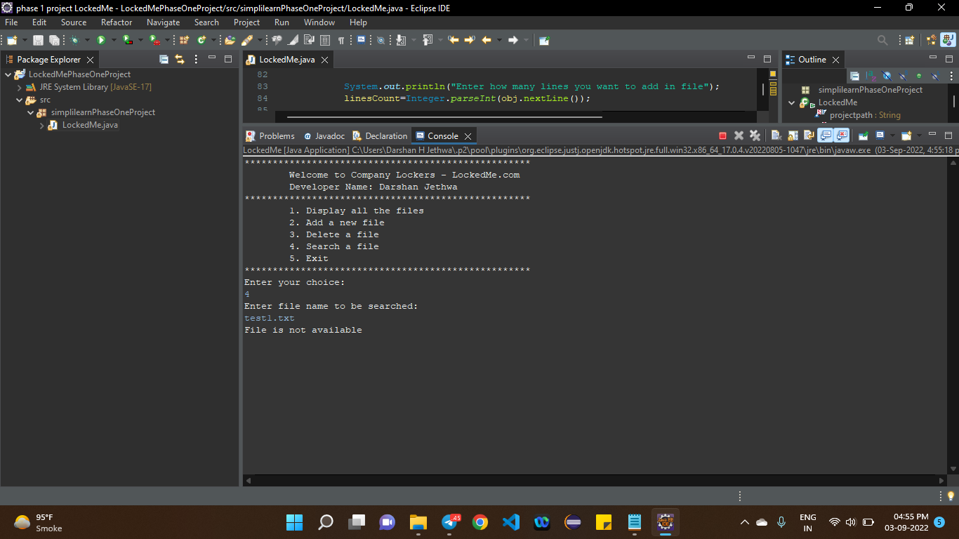

Figure 6 search result when file not available

**6. Exit:**

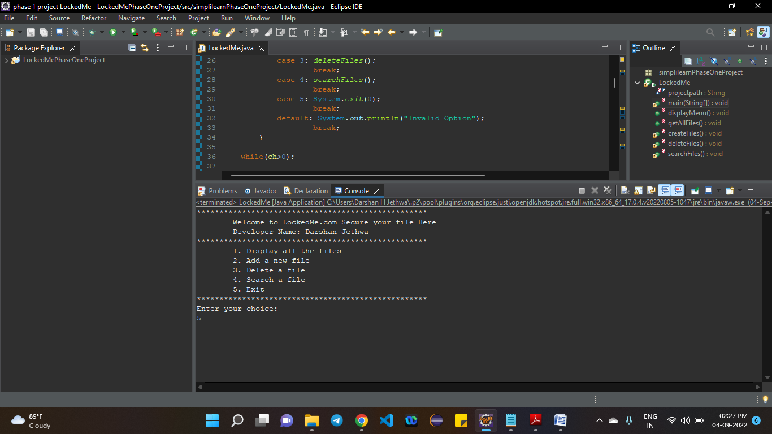

Figure 7 exit from app

# Thank You

**Simplilearn Phase 1 Project**

**Submission by**

**Darshan H. Jethwa**