Save Rtab map using Octomap Server:
Rtab map is a real-time appearence based map, it will save automatically to rtabwebserver in db format once mapping process completed.

To build Rtab mapping in simulator we need to follow below processes

Running the Gazebo simulator with robot and world
$ roslaunch rbcar_sim_bringup rbcar_complete.launch
Note: This launch file will calls the rbcar robot inside a gazebo environment.

Running the rtab mapping node
$ roslaunch rbcar_navigation rtabMapping.launch rtabmap_args:="--delete_db_on_start"
Note: This launch file calls the rtabmap_ros node with default parameters. The parameters need to be filled accurately in order build the 3D map of environment.
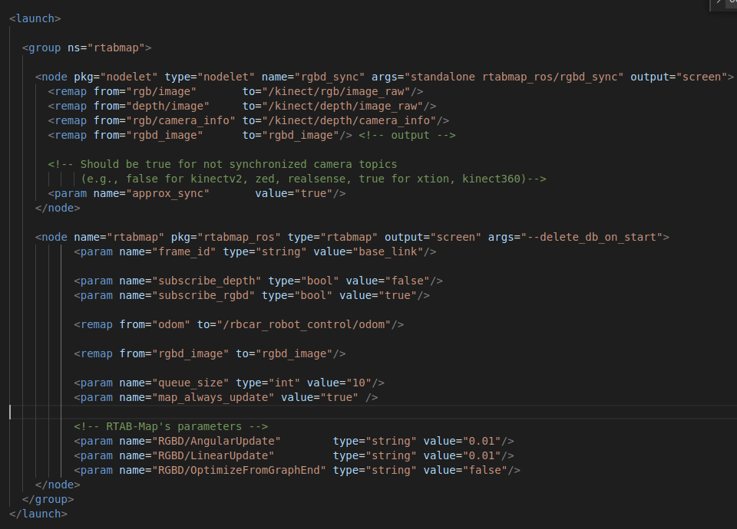

Teleop the rbcar by using keyboard teleop script.
rbcar_ws/src/rbcar_sim-kinetic-devel/ackermann-drive-teleop-master/scripts$ python keyop.py
Note: Navigate into keyop .py script located folder and run it using python command

If you observe rostopic list, we can see the octomap(Pointcloud2 message format) topic is publishing under the namespace of rtabmap. This topic contains the same message format as octomap node publishing the its 3D map data.
So we know how to save 3D octomap using octomap server node. Here also the same concept we need to follow to save octomap publishing by rtab map node.

Run octomap saver node to save map
$ rosrun octomap_server octomap_saver -f rtabmap
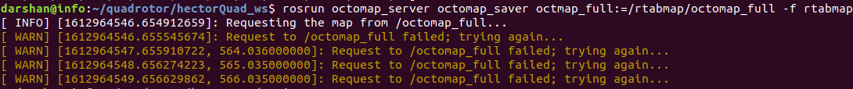
If you see on terminal, the octomap_saver node requesting octomap_full topic but rtab publishing same topic with rtabmap namespace. So you can either edit on command line or go inside the octomap_saver.cpp code replace octomap_full topic param by rtabmap/octomap_full.
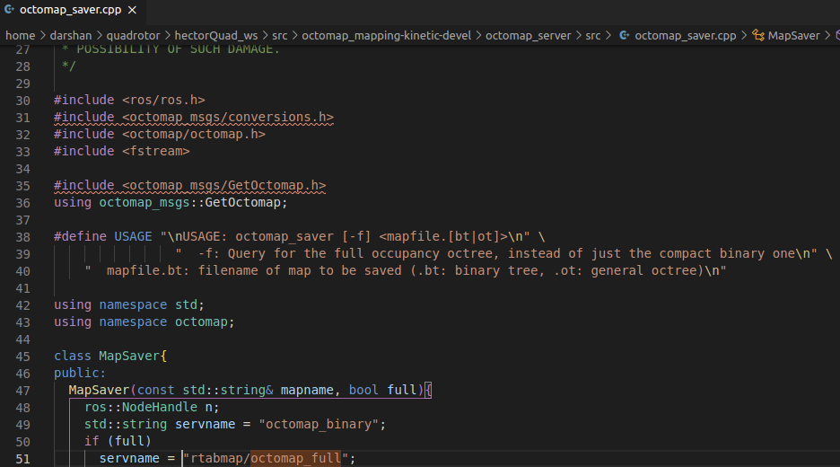
Finally compile package and run below command to save the rtab map publishing octomap in .bt format.
$ rosrun octomap_server octomap_server_node rtabmap.bt

Way to build Rtab mapping

Running the Gazebo simulator with robot and world
$ roslaunch rbcar_sim_bringup rbcar_complete.launch
Note: This launch file will calls the rbcar robot inside a gazebo environment.

Running mapping launch file
$ roslaunch rbcar_navigation demo_localization.launch localization:=false
Note: If u set Localisation param as false, it will internal calls the –delete_db_on_start param and deleted the previous built map on rtabweb server. Or if u want save the building new map to different location in that case add the new map name on below param
<arg name="database_path" default="~/.ros/rtabmap.db"/>

Also if you dont want to use scan data topic, set the below param as false
<param name="subscribe_scan" type="bool" value="false"/>

If all other param set correctly and if u were not get any error on terminal and start the mapping operation, u will see the terminal like below
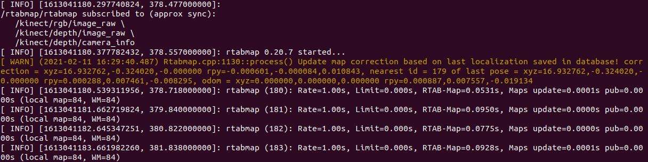
Launch the Rviz
$ rviz
Note: Select below topics:
1. Fixed Frame - map
2. Pointcloud2 - /rtabmap/cloud_map --> displays 3D pointcloud data
Here select Color Transformer -- AxisColor
3. Robot model
4. MapGraph --> displays the path travelled by robot
5. Map - /rtabmap/proj_map --> displays 2D map

Teleop the rbcar by using keyboard teleop script.
rbcar_ws/src/rbcar_sim-kinetic-devel/ackermann-drive-teleop-master/scripts$ python keyop.py
Note: Navigate into keyop .py script located folder and run it using python command

Saving Map.
Once the map building process completed, the next is to saving the map.
Map saving can be done in 2 ways,
1. shutdown the mapping launch file it will automatically saves the map on its Rtabserver path defined in the launch file.
2. If you wan to save 3D map using octomap server pkage follow below step
$ rosrun octomap_server octomap_server_node rtabmap.bt

Mapping:

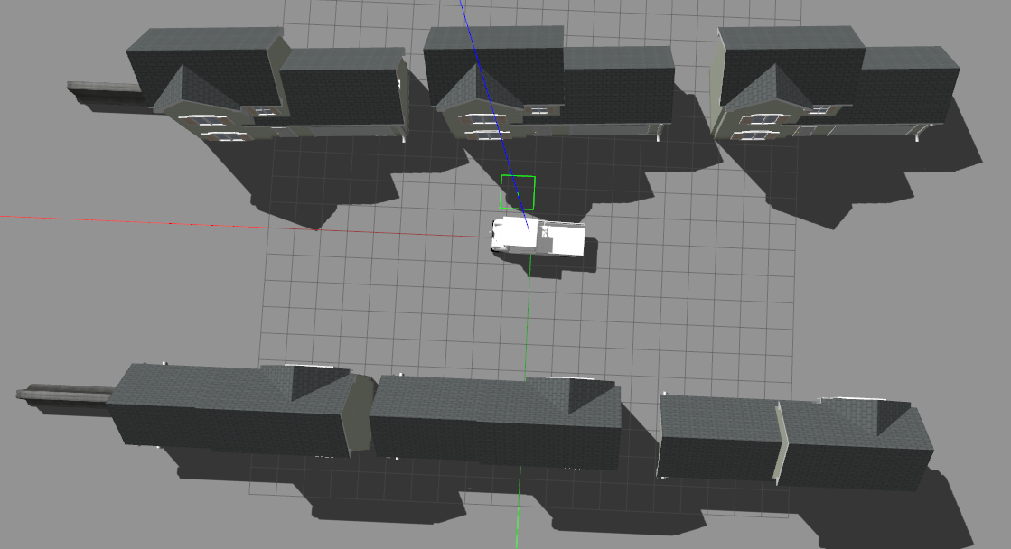
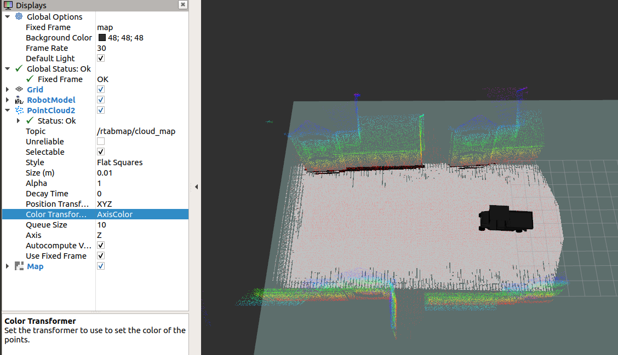

Way to localize using Rtab

Running the Gazebo simulator with robot and world
$ roslaunch rbcar_sim_bringup rbcar_complete.launch
Note: This launch file will calls the rbcar robot inside a gazebo environment.

Runing the above Rtab mapping launch with setting localization param true
$ roslaunch rbcar_navigation demo_localization.launch localization:=true
Note: If u set Localisation param as true, it will internal deactivates the –delete_db_on_start param and calls the previously built map stored on rtabweb server. Or if u want call your own Rtab map from particular location then set the below param for location
<arg name="database_path" default="~/.ros/rtabmap.db"/>

U will also see on terminal that showing map loading from location
This launch file helps to localize the robot on loaded map using visual odometry technique. So once robot and map loaded correctly, move the robot front and back some to get env and feature and localize in it.

Launch the Rviz
$ rviz
Note: Select below topics:
1. Fixed Frame - map
2. Pointcloud2 - /rtabmap/cloud_map --> displays 3D pointcloud data
Here select Color Transformer -- AxisColor
3. Robot model
4. MapGraph --> displays the path travelled by robot
5. Map - /rtabmap/proj_map --> displays 2D map
6. PoseWithCovarience -- /rtabmap/localization_pose --> This will dispalys the robot exact location according to rtab algorithm on Map.

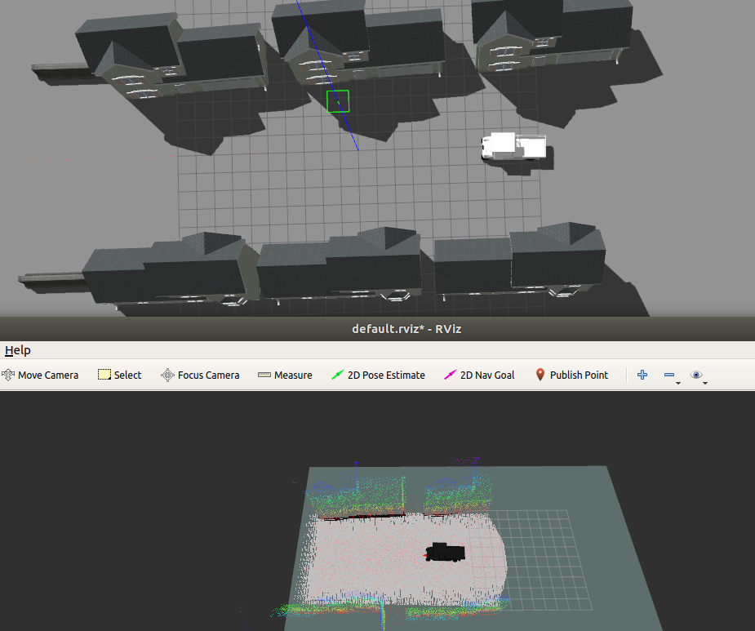
Localization:

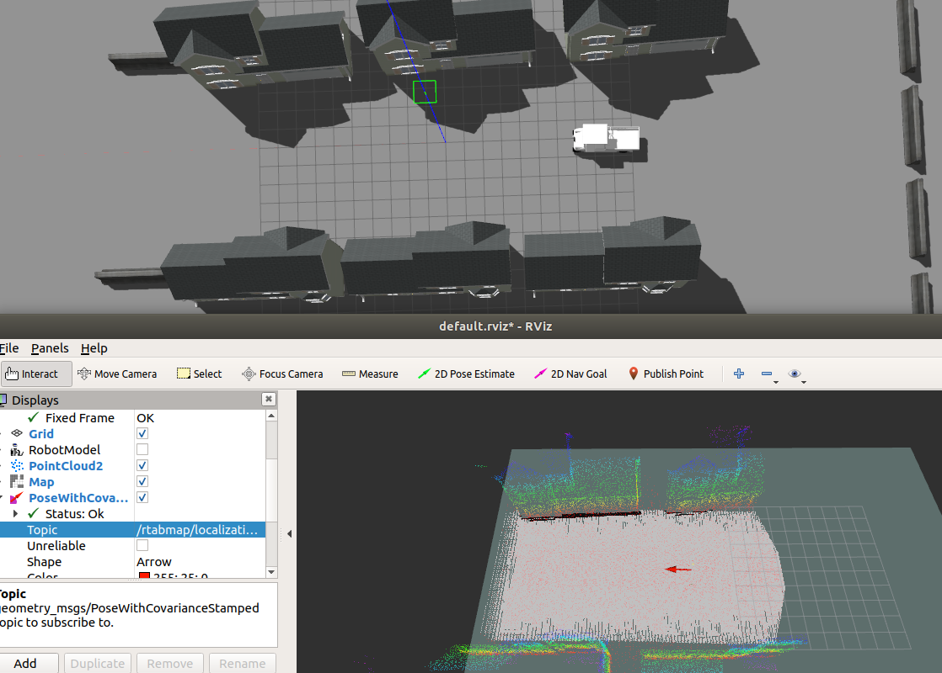

Rtab mapping and localization used launch file:

<launch>
<arg name="database_path" default="~/.ros/rtabmap.db"/>
<arg name="rgbd_odometry" default="false"/>
<arg name="localization" default="true"/>
<arg name="simulation" default="true"/>
<arg name="sw_registered" default="false"/>
<arg if="$(arg localization)" name="args" default=""/>
<arg unless="$(arg localization)" name="args" default="--delete_db_on_start"/>

<arg if="$(arg simulation)" name="rgb_topic" default="/kinect/rgb/image_raw"/>
<arg unless="$(arg simulation)" name="rgb_topic" default="/kinect/rgb/image_raw"/>
<arg if="$(arg simulation)" name="depth_topic" default="/kinect/depth/image_raw"/>
<arg unless="$(arg simulation)" name="depth_topic" default="/kinect/depth/image_raw"/>
<arg name="camera_info_topic" default="/kinect/depth/camera_info"/>
<arg name="wait_for_transform" default="0.2"/>
<!--
robot_state_publisher's publishing frequency in "turtlebot_bringup/launch/includes/robot.launch.xml"
can be increase from 5 to 10 Hz to avoid some TF warnings.
-->
<!-- Navigation stuff (move_base) -->
<include unless="$(arg simulation)" file="$(find turtlebot_bringup)/launch/3dsensor.launch">
<arg if="$(arg sw_registered)" name="depth_registration" value="false"/>
<arg unless="$(arg sw_registered)" name="depth_registration" value="true"/>
</include>
<!-- <include file="$(find turtlebot_navigation)/launch/includes/move_base.launch.xml"/> -->
<!-- Mapping -->
<group ns="rtabmap">

<node name="rtabmap" pkg="rtabmap_ros" type="rtabmap" output="screen" args="$(arg args)">
<param name="database_path" type="string" value="$(arg database_path)"/>
<param name="frame_id" type="string" value="base_footprint"/>
<param name="wait_for_transform_duration" type="double" value="$(arg wait_for_transform)"/>
<param name="subscribe_depth" type="bool" value="true"/>
<param name="subscribe_scan" type="bool" value="false"/>
<param name="map_negative_poses_ignored" type="bool" value="true"/>

<!-- When sending goals on /rtabmap/goal topic, use actionlib to communicate with move_base -->
<param name="use_action_for_goal" type="bool" value="true"/>
<remap from="move_base" to="/move_base"/>
<!-- inputs -->
<remap from="scan" to="/scan"/>
<remap from="rgb/image" to="$(arg rgb_topic)"/>
<remap from="depth/image" to="$(arg depth_topic)"/>
<remap from="rgb/camera_info" to="$(arg camera_info_topic)"/>

<!-- Fix odom covariance as in simulation the covariance in /odom topic is high (0.1 for linear and 0.05 for angular) -->
<param unless="$(arg rgbd_odometry)" name="odom_frame_id" value="odom"/>
<param unless="$(arg rgbd_odometry)" name="odom_tf_linear_variance" value="0.001"/>
<param unless="$(arg rgbd_odometry)" name="odom_tf_angular_variance" value="0.001"/>
<!-- output -->
<remap from="grid_map" to="/map"/>
<!-- RTAB-Map's parameters: do "rosrun rtabmap rtabmap (double-dash)params" to see the list of available parameters. -->
<param name="RGBD/ProximityBySpace" type="string" value="true"/>
<param name="RGBD/OptimizeFromGraphEnd" type="string" value="false"/>
<param name="Kp/MaxDepth" type="string" value="4.0"/>
<param name="Reg/Strategy" type="string" value="0"/>
<param name="Icp/CorrespondenceRatio" type="string" value="0.3"/>
<param name="Vis/MinInliers" type="string" value="15"/>
<param name="Vis/InlierDistance" type="string" value="0.1"/>
<param name="RGBD/AngularUpdate" type="string" value="0.1"/>
<param name="RGBD/LinearUpdate" type="string" value="0.1"/>
<param name="RGBD/ProximityPathMaxNeighbors" type="string" value="0"/>
<param name="Rtabmap/TimeThr" type="string" value="0"/>
<param name="Mem/RehearsalSimilarity" type="string" value="0.30"/>
<param name="Reg/Force3DoF" type="string" value="true"/>
<param name="GridGlobal/MinSize" type="string" value="20"/>

<!-- localization mode -->
<param if="$(arg localization)" name="Mem/IncrementalMemory" type="string" value="false"/>
<param unless="$(arg localization)" name="Mem/IncrementalMemory" type="string" value="true"/>
<param name="Mem/InitWMWithAllNodes" type="string" value="$(arg localization)"/>
</node>
<!-- Odometry : ONLY for testing without the actual robot! /odom TF should not be already published. -->
<node if="$(arg rgbd_odometry)" pkg="rtabmap_ros" type="rgbd_odometry" name="rgbd_odometry" output="screen">
<param name="frame_id" type="string" value="base_footprint"/>
<param name="wait_for_transform_duration" type="double" value="$(arg wait_for_transform)"/>
<param name="Reg/Force3DoF" type="string" value="true"/>
<param name="Vis/InlierDistance" type="string" value="0.05"/>
<remap from="rgb/image" to="$(arg rgb_topic)"/>
<remap from="depth/image" to="$(arg depth_topic)"/>
<remap from="rgb/camera_info" to="$(arg camera_info_topic)"/>
</node>
</group>
</launch>

