What is SQL?

Diff btwn SQL and SQL-SERVER/mysql

Why we use SQL?

1. CREATE DATABASE Feb142022

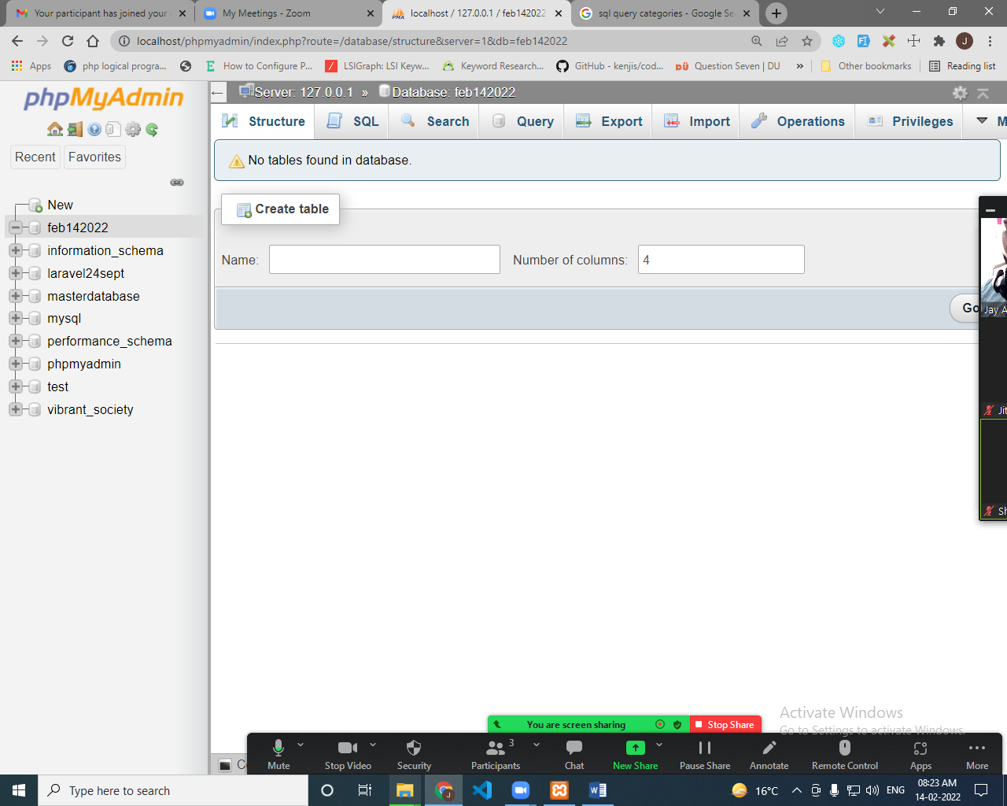

[CREATE](http://localhost/phpmyadmin/url.php?url=https://dev.mysql.com/doc/refman/8.0/en/create-table.html) [TABLE](http://localhost/phpmyadmin/url.php?url=https://dev.mysql.com/doc/refman/8.0/en/create-table.html) usseerd (userid [int](http://localhost/phpmyadmin/url.php?url=https://dev.mysql.com/doc/refman/8.0/en/numeric-types.html" \t "mysql_doc));

[DROP](http://localhost/phpmyadmin/url.php?url=https://dev.mysql.com/doc/refman/8.0/en/drop-table.html) [TABLE](http://localhost/phpmyadmin/url.php?url=https://dev.mysql.com/doc/refman/8.0/en/drop-table.html) usseerd;

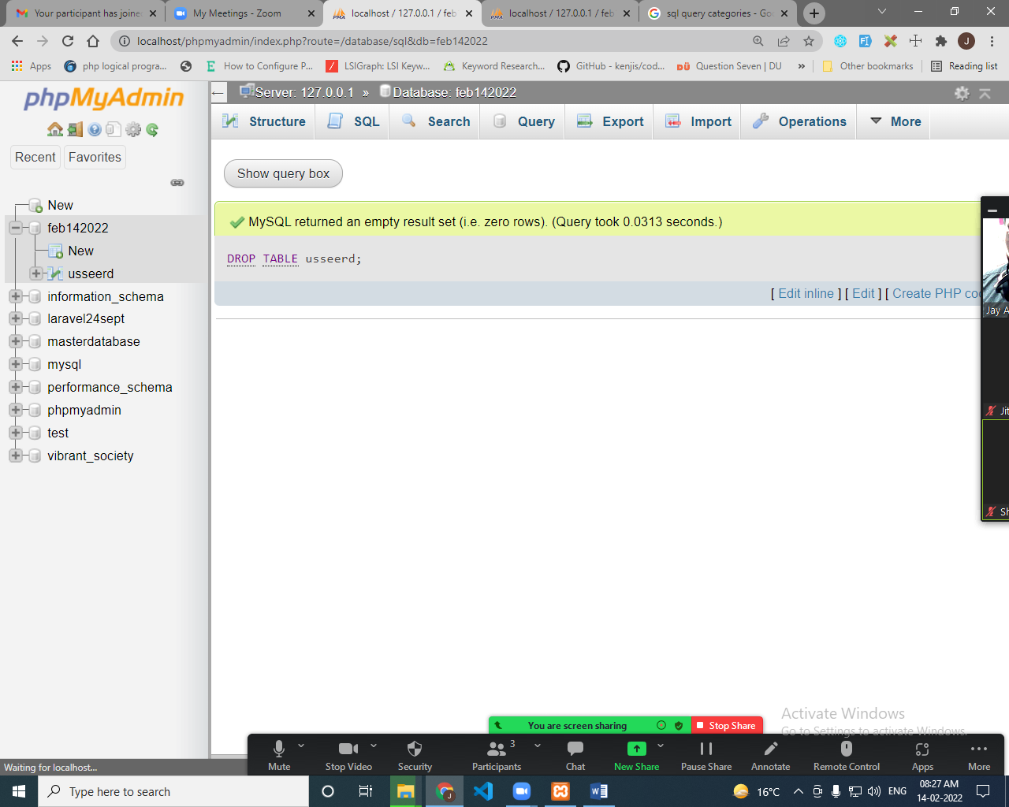

[ALTER](http://localhost/phpmyadmin/url.php?url=https://dev.mysql.com/doc/refman/8.0/en/alter-table.html) [TABLE](http://localhost/phpmyadmin/url.php?url=https://dev.mysql.com/doc/refman/8.0/en/alter-table.html) users ADD address [text](http://localhost/phpmyadmin/url.php?url=https://dev.mysql.com/doc/refman/8.0/en/string-types.html);

[ALTER](http://localhost/phpmyadmin/url.php?url=https://dev.mysql.com/doc/refman/8.0/en/alter-table.html) [TABLE](http://localhost/phpmyadmin/url.php?url=https://dev.mysql.com/doc/refman/8.0/en/alter-table.html) users CHANGE mobile mobile\_no [varchar](http://localhost/phpmyadmin/url.php?url=https://dev.mysql.com/doc/refman/8.0/en/string-types.html" \t "mysql_doc)(50);

[ALTER](http://localhost/phpmyadmin/url.php?url=https://dev.mysql.com/doc/refman/8.0/en/alter-table.html) [TABLE](http://localhost/phpmyadmin/url.php?url=https://dev.mysql.com/doc/refman/8.0/en/alter-table.html) users DROP mobile\_no;

INSERT INTO users VALUES (1,"text","123","Male","abc")

INSERT INTO users VALUES (1,"text","123","Male","abc"), (2,"test","456","Female","xyz")

[TRUNCATE](http://localhost/phpmyadmin/url.php?url=https://dev.mysql.com/doc/refman/8.0/en/truncate-table.html) [TABLE](http://localhost/phpmyadmin/url.php?url=https://dev.mysql.com/doc/refman/8.0/en/truncate-table.html) users;

[ALTER](http://localhost/phpmyadmin/url.php?url=https://dev.mysql.com/doc/refman/8.0/en/alter-table.html) [TABLE](http://localhost/phpmyadmin/url.php?url=https://dev.mysql.com/doc/refman/8.0/en/alter-table.html) `users` CHANGE `userid` `userid` [INT](http://localhost/phpmyadmin/url.php?url=https://dev.mysql.com/doc/refman/8.0/en/numeric-types.html)(11) [NOT](http://localhost/phpmyadmin/url.php?url=https://dev.mysql.com/doc/refman/8.0/en/logical-operators.html#operator_not) NULL AUTO\_INCREMENT;

[INSERT](http://localhost/phpmyadmin/url.php?url=https://dev.mysql.com/doc/refman/8.0/en/insert.html) INTO `users` (`userid`, `username`, `password`, `gender`, `address`) [VALUES](http://localhost/phpmyadmin/url.php?url=https://dev.mysql.com/doc/refman/8.0/en/miscellaneous-functions.html#function_values) (NULL, 'test', '456', 'Male', 'checking');

[INSERT](http://localhost/phpmyadmin/url.php?url=https://dev.mysql.com/doc/refman/8.0/en/insert.html) INTO `users` ( `password`, `gender`, `address`,`username`) [VALUES](http://localhost/phpmyadmin/url.php?url=https://dev.mysql.com/doc/refman/8.0/en/miscellaneous-functions.html#function_values) ( 'test', '456', 'Male', 'checking');

[DELETE](http://localhost/phpmyadmin/url.php?url=https://dev.mysql.com/doc/refman/8.0/en/delete.html) FROM users;

**INSERT INTO `users` ( `password`, `gender`, `address`,`username`) VALUES ( 'test', '456', 'Male', 'checking'),( 'test', '456', 'Male', 'test'),( 'test', '456', 'Male', 'data');**

**DELETE FROM users WHERE userid = 1**

[UPDATE](http://localhost/phpmyadmin/url.php?url=https://dev.mysql.com/doc/refman/8.0/en/update.html) users [SET](http://localhost/phpmyadmin/url.php?url=https://dev.mysql.com/doc/refman/8.0/en/set.html) username="test";

**UPDATE users SET username="new data" WHERE userid = 5**