Table of Contents

Introduction 2

Introduction to Project 2

Aims and Objective 2

Aims 2

Objective 2

Tools Used 2

Wireframe 3

Development 4

HTML 4

CSS 4

Conclusion 5

What we used? 5

What we learned? 5

Problems we faced? 5

How we solved the problem? 5

How the project could be better? 5

# Introduction

## Introduction to Project

The target for this e-commerce platform designed and developed is a watch store dealing in various types of watches.

## Aims and Objective

### Aims

* To develop a working e-commerce platform for selling watches of different types.
* To provide a natural, visually appealing, and efficient online shopping platform for user while showcasing technical proficiency in the field of web development

### Objective

1. User-Oriented Design:
   1. Create a user friendly and visually appealing interface for better user experience.
2. Features Implemented:
3. Technology Utilization:
   1. HTML5: For sematic web structure.
   2. CSS3: For styling and layout to create visually appealing design.

## Tools Used

1. Visual Studio Code: For writing and editing code
2. Google Chrome: For testing and viewing the ecommerce platform as we develop
3. GitHub: For code sharing and version control
4. Instagram: For team communication and coordination
5. Balsamiq Wireframes: For creating wireframes

# Wireframe

1. Home Page:

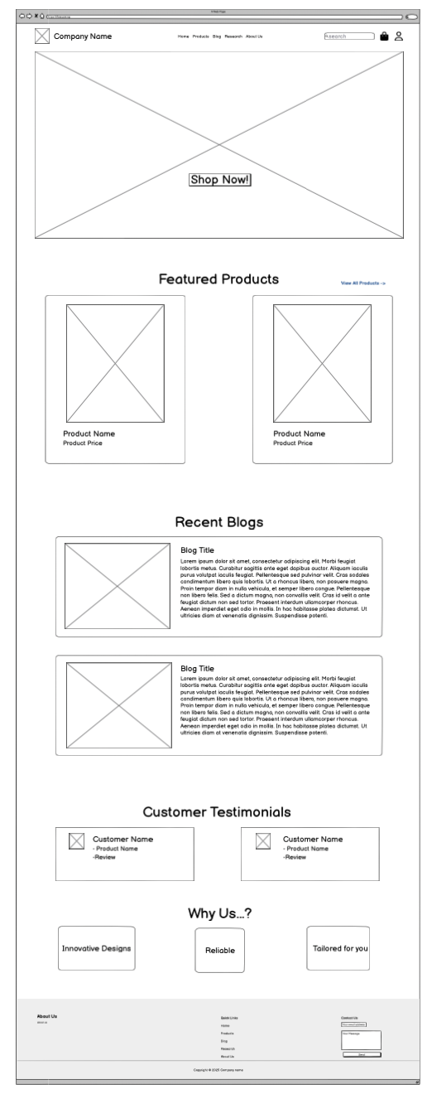

1. Products Page:

1. Blog Page:

1. About Us:

# Development

## HTML

## CSS

# Conclusion

## What we used?

## What we learned?

## Problems we faced?

## How we solved the problem?

## How the project could be better?