Lloyds Banking Group – Customer Churn Analysis Report

1. Introduction
The objective of this project was to analyse customer behaviour and identify factors that contribute to customer churn. Exploratory Data Analysis (EDA) and preprocessing techniques were applied to prepare the data for future machine learning model development.

2. Datasets Used
- Customer Demographics
- Transaction History
- Customer Service
- Online Activity
- Churn Status
These datasets were merged using CustomerID to create a complete dataset for analysis.

3. Exploratory Data Analysis (EDA)
- Performed descriptive statistical analysis.
- Checked missing values and data quality.
- Analysed customer churn patterns using visualisations.
- Identified trends in spending and login behaviour.
- Performed correlation analysis to understand feature relationships.
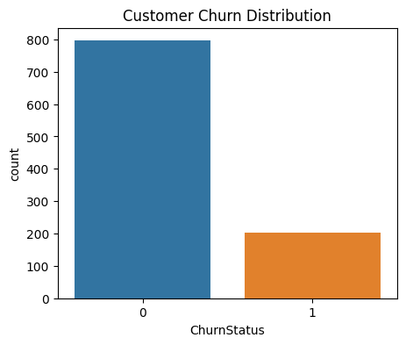
Figure 1: Customer churn distribution showing churned and retained customers.
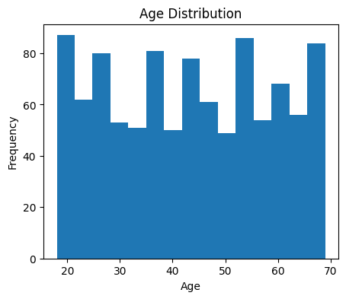
Figure 2: Age distribution of customers.
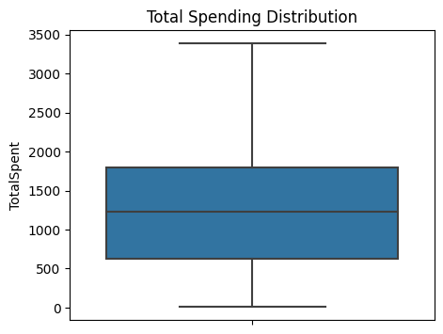
Figure 3: Total spending distribution and outlier analysis.
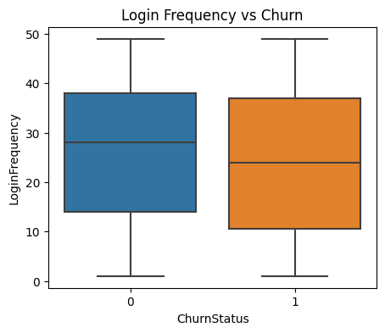
Figure 4: Relationship between login frequency and churn status.
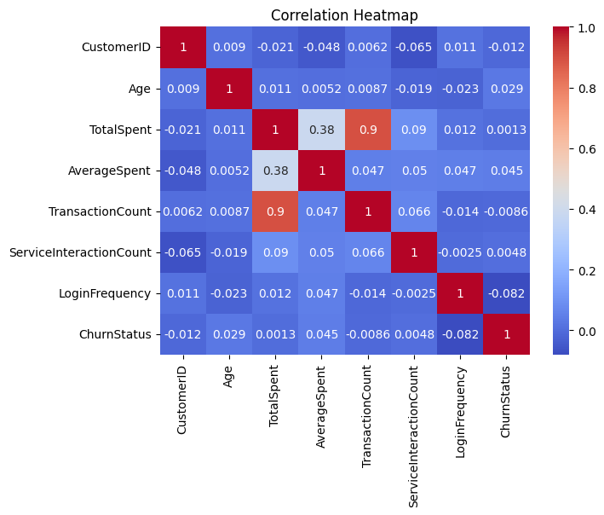
Figure 5: Correlation heatmap of numerical variables.

4. Data Cleaning and Preprocessing
- Handled missing values using imputation techniques.
- Aggregated transaction and service interaction data.
- Detected outliers using boxplots.
- Encoded categorical variables using one-hot encoding.
- Standardised numerical variables using StandardScaler.

5. Key Findings
- Customers with lower login frequency appeared more likely to churn.
- Transaction behaviour and spending patterns may influence customer retention.
- Customer service interactions may indicate dissatisfaction.
- Customer engagement metrics are useful predictors for churn analysis.

6. Conclusion
The project successfully analysed customer churn data using EDA and preprocessing techniques. The final cleaned dataset is now suitable for machine learning model development and can help Lloyds Banking Group improve customer retention strategies.

