MONGODB

PROJECTION OPERATORS:

Projection operators in MongoDB are used to include or exclude specific fields from the documents returned by a query. The basic projection operator is `{ field: 1 }` to include a field and `{ field: 0 }` to exclude a field. MongoDB also provides several special projection operators such as `$slice`, which limits the number of elements in an array that are returned. The `$elemMatch` operator is used to project the first matching element from an array based on a specified query. The `$meta` projection operator allows you to include metadata about the query, such as the text score. Lastly, the `$` operator is used to project a single element from an array that matches a specified condition.

AGENDA:

UNDERSTANDING PROJECTION:

Create and demonstrate how projection operators ($, $elematch and $slice) would be used in the MongoDB.

LET’S TAKE NEW DATASET:

New Candidates dataset.

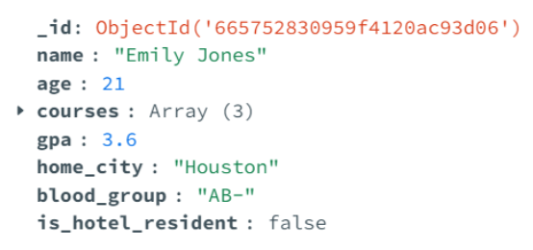

RETRIVE NAME,AGE AND GPA:

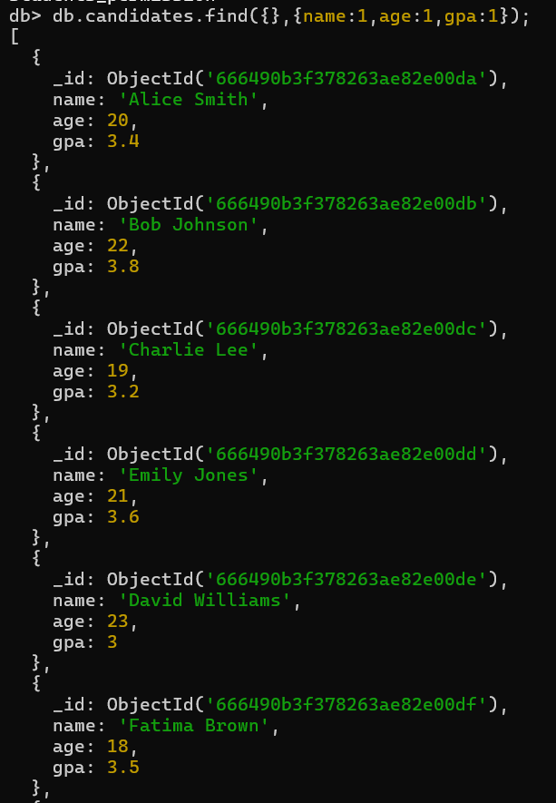

In this MongoDB query, `db.candidates.find({},{name:1,age:1,gpa:1})`, the `find` method is used to retrieve documents from the `candidates` collection. The first argument, `{}`, is an empty query filter, meaning all documents in the collection are selected. The second argument, `{name:1, age:1, gpa:1}`, is a projection that specifies only the `name`, `age`, and `gpa` fields should be included in the output, while excluding other fields. The result is a list of documents where each document contains only the `_id`, `name`, `age`, and `gpa` fields. The output includes details of candidates such as Alice Smith, Bob Johnson, and Charlie Lee, displaying their names, ages, and GPAs, providing a concise view of this specific subset of data from the collection.

VARIATION:EXCLUDE FIELDS:

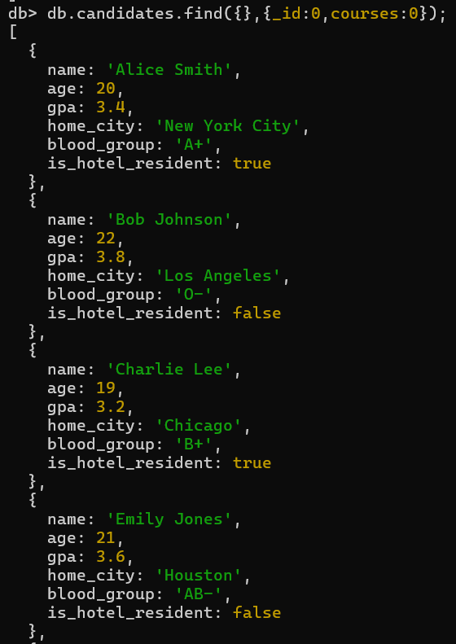

In this MongoDB query, `db.candidates.find({},{_id:0,courses:0})`, the `find` method retrieves documents from the `candidates` collection, and the projection part specifies the exclusion of the `_id` and `courses` fields. The first argument, `{}`, is an empty query filter, meaning all documents in the collection are selected. The second argument, `{_id:0, courses:0}`, indicates that the `_id` and `courses` fields should be excluded from the results. The resulting documents include fields such as `name`, `age`, `gpa`, `home_city`, `blood_group`, and `is_hotel_resident`, providing detailed information about each candidate without displaying their `_id` and `courses` fields. This allows for a more focused view of the relevant data, which can be useful for analysis or reporting purposes. The output includes candidates like Alice Smith, Bob Johnson, and Charlie Lee, showing their personal details and academic performance while omitting their unique identifiers and enrolled courses.

PROJECTION OPERATOR($elemMatch):

`$elemMatch` is a query operator in MongoDB that selects documents containing an array field with at least one element that matches all the specified query criteria.

Find candidates enrolled in “Computer Science” with specific projection:

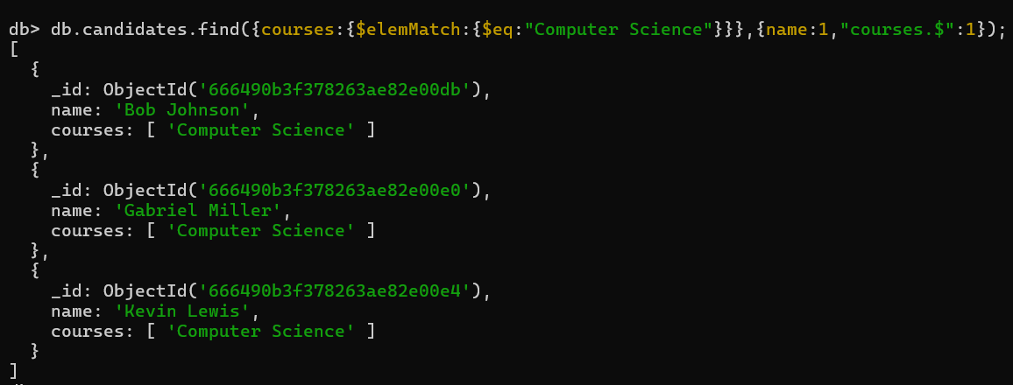

The MongoDB query retrieves documents from the `candidates` collection where the `courses` array includes the element "Computer Science". The query is structured to filter and project specific fields. The filter condition `{ courses: { $elemMatch: { $eq: "Computer Science" } } }` ensures that only documents with "Computer Science" as one of the courses are selected. The projection `{ name: 1, "courses.$": 1 }` includes only the `name` field and the specific array element from the `courses` array that matched the filter condition.

In the output, each document contains the candidate's `_id` (included by default), `name`, and an array with just the "Computer Science" course. This focused output is useful for identifying which candidates are enrolled in "Computer Science" while excluding other courses they might be taking. For example, the result includes candidates like Bob Johnson, Gabriel Miller, and Kevin Lewis, each showing "Computer Science" as the matched course. This query helps in pinpointing specific course enrollments efficiently within the dataset.

LET’S TAKE NEW DATASET:

New players dataset.

$elemMatch:

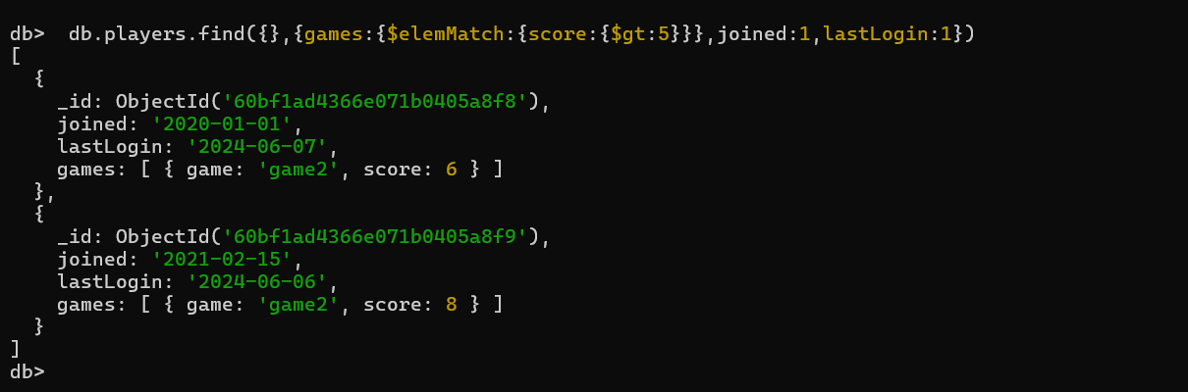

This MongoDB query searches the `players` collection for documents where the `games` array contains at least one subdocument where the `score` is greater than 5. For each matching document, it projects the `joined` and `lastLogin` fields along with the `games` array containing only the subdocument that matches the condition (`score` greater than 5).

In the result, you have two documents that match the query:

1. Player1 (`_id`: '60bf1ad4366e071b0405a8f8'): This player joined on '2020-01-01' and last logged in on '2024-06-07'. They have one game (`game2`) with a score of 6.

2. Player2 (`_id`: '60bf1ad4366e071b0405a8f9'): This player joined on '2021-02-15' and last logged in on '2024-06-06'. They have one game (`game2`) with a score of 8.

The query uses the `$elemMatch` projection operator to ensure that only the matching subdocument within the `games` array is included in the result. This helps to avoid returning the entire `games` array when only a specific subdocument is of interest.

PROJECTION OPERATOR($slice):

`$slice` is a projection operator in MongoDB that limits the number of elements returned in an array field projection.

Retrieve all candidates with first two courses:

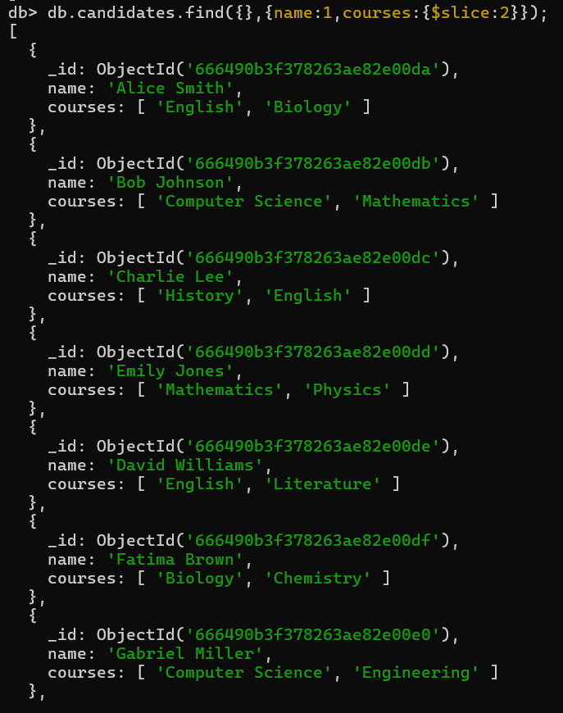

This MongoDB query retrieves documents from the `candidates` collection, projecting only the `name` and `courses` fields. However, it limits the number of elements returned in the `courses` array to 2 using the `$slice` projection operator.

The result includes each candidate's name along with an array containing the first two courses from their `courses` array. For example:

- Alice Smith is taking 'English' and 'Biology'.

- Bob Johnson is studying 'Computer Science' and 'Mathematics'.

- Charlie Lee is enrolled in 'History' and 'English'.

- Emily Jones is pursuing 'Mathematics' and 'Physics'.

- David Williams is studying 'English' and 'Literature'.

- Fatima Brown is taking 'Biology' and 'Chemistry'.

- Gabriel Miller is enrolled in 'Computer Science' and 'Engineering'.

- Hannah Garcia is studying 'History' and 'Political Science'.

- Isaac Clark is pursuing 'English' and 'Creative Writing'.

- Jessica Moore is studying 'Biology' and 'Ecology'.

- Kevin Lewis is taking 'Computer Science' and 'Artificial Intelligence'.

- Lily Robinson is enrolled in 'History' and 'Art History'.

The `$slice` operator helps to limit the number of elements returned in an array projection, useful for scenarios where you want to retrieve a subset of elements from an array field.