RAM Type | Speed(MT/s) | Voltage | Typical Use Cases
DDR3 | 800–2133 MT/s | 1.5 V (1.35 V for DDR3L) | Older desktops, laptops, and legacy systems
DDR4 | 1600–3200 MT/s | 1.2 V | Mainstream desktops, laptops, gaming PCs, and workstations
DDR5 | 4800–8400+ MT/s | 1.1 V | Modern gaming PCs, content creation, AI workloads, high-performance desktops, and latest servers
Day~3
- Create a comparison table listing the main differences between DDR3, DDR4, and DDR5 RAM, including speed, voltage, and typical use cases.

- Open your laptop or desktop (with power disconnected), locate the RAM slots, and take a clear photo of the installed RAM module. Reinstall the RAM module and verify that your system boots up successfully.<br><br><em><strong>Hint:</strong> Refer to your device manual or a trusted YouTube guide if unsure about RAM removal and installation steps.</em>

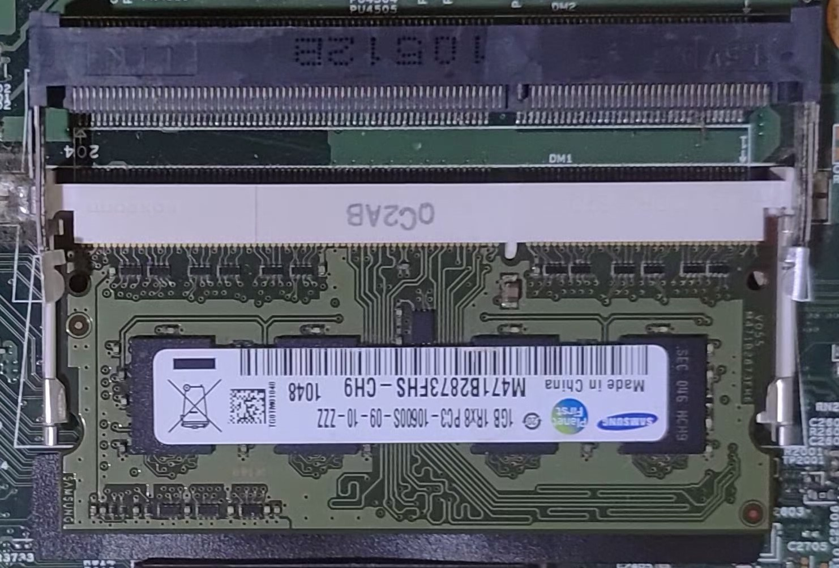
1.)Shut down the computer completely.
2.) Disconnect power (and remove the battery if it's removable).
3.) Open the laptop/desktop case according to the manufacturer's instructions.
4.) Locate the RAM module(s). They are long, narrow circuit boards installed in memory slots on the motherboard.
5.) Take a clear photo showing the installed RAM.
6.) Remove the RAM:
- Gently push the retaining clips outward.
- The RAM module should pop up (laptop) or release (desktop).
- Carefully pull it out by the edges.
7.) Reinstall the RAM :
- Align the notch in the RAM with the slot.
- Press firmly until the retaining clips lock into place.
8.) Reassemble the system.
9.) Reconnect power and start the computer.
10.) Verify successful boot by confirming that the operating system loads normally.

RAM DETAILS OF MY LAPTOP: DDR4 ASUS VIVOBOOK HMA81GS6DJR8N-XN
MANUFACTURER’S: Hynix
RAM DETAILS IN PHOTO: SAMSUNG 1GB DDR3 SO-DIMM LAPTOP RAM,PC3-10600S(1333MHz),MODEL:M471B2873FHS-CH9.

- List three key differences between HDD, SSD, and NVMe storage types, and for each, name one app or use case (from apps you use daily) that would benefit most from that storage type.
Feature | HDD | SSD | NVMe SSD
Speed | Slow (80–160 MB/s) | Fast (500–550 MB/s) | Very Fast (2,000–7,000+ MB/s)
Technology | Mechanical spinning disk | Flash memory (SATA interface) | Flash memory (PCIe interface)
Cost & Performance | Cheapest, high capacity | Moderate cost and performance | Highest performance, more expensive
Storage Type- | Daily App / Use Case
HDD- | Storing movies, photos, and backup files.
SSD- | Using Google Chrome, Microsoft Office, and everyday applications.
NVMe SSD- | Gaming, Adobe Photoshop, and video editing software.
4.) Remove the storage drive (HDD or SSD) from your system, take a photo of the connector type (SATA, M.2, or NVMe), and reinstall the drive. Confirm that your device recognizes the storage after reassembly.<br><br><em><strong>Constraint:</strong> Only perform this task if you have access to a device you are allowed to open. If not, find and share a YouTube video link showing the process for your laptop/PC model.</em>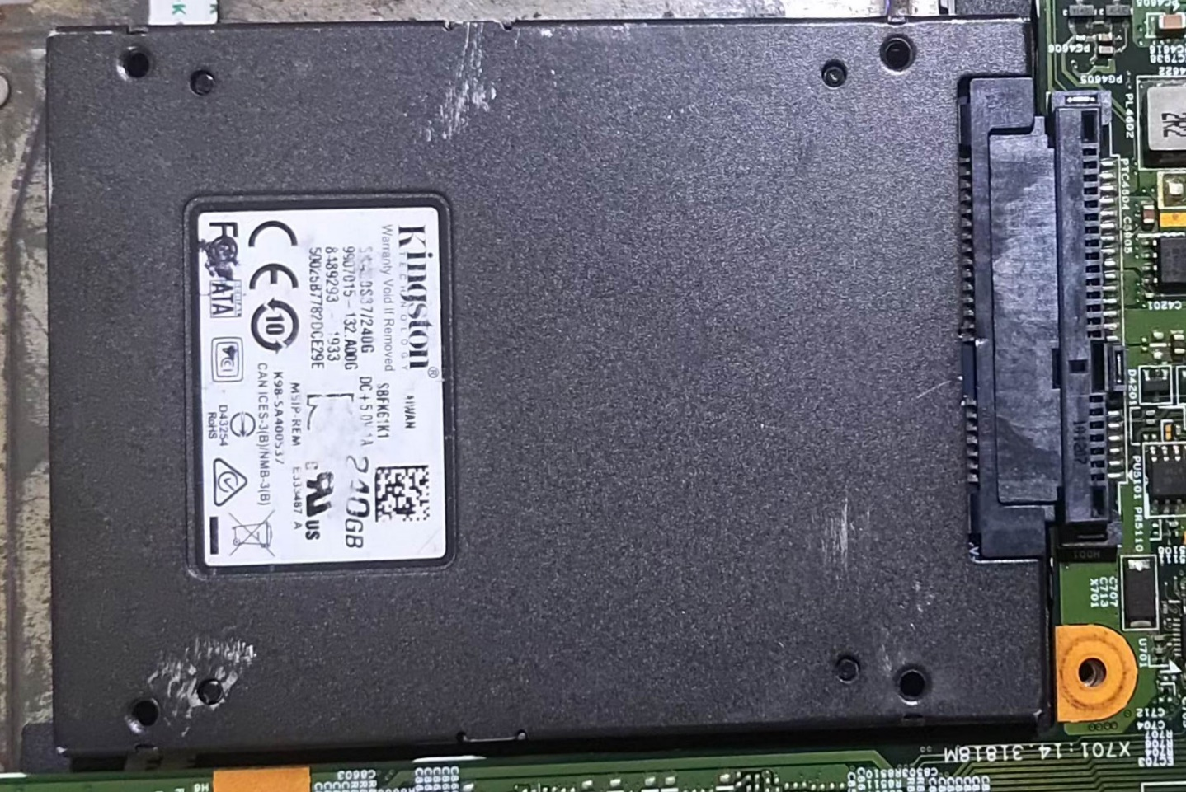
~ Laptop Model: ASUS VivoBook X515DA
~ Storage Type: M.2 NVMe SSD (primary storage)
~ Connector Type: M.2 NVMe (PCIe)
~ confirmation:-
After removeing the storage drive and reinstall the storage drive I recognized that my storage drive is assemble completely and works good.

The end…..

