- Day-2~
- Draw a labeled diagram of an ATX motherboard and mark at least 8 different slots and ports (such as RAM slots, PCIe slots, SATA ports, USB headers, CPU socket, power connector, etc.).

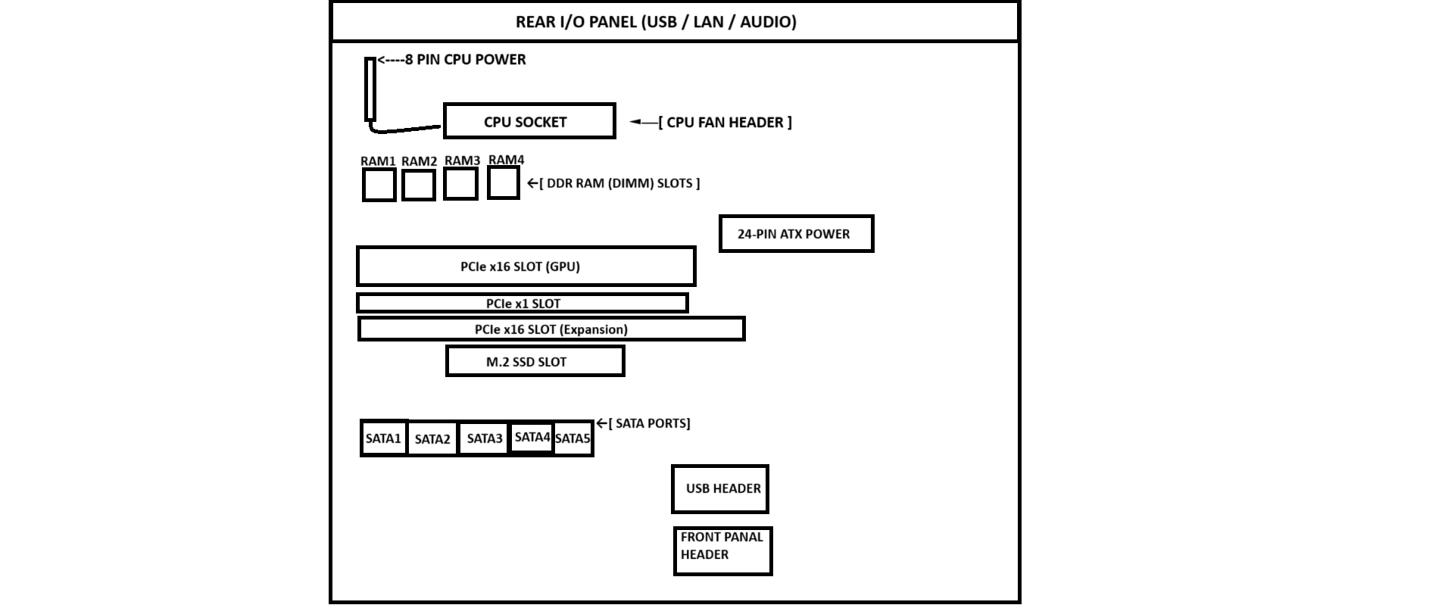

- Research and list 3 popular CPU socket types (for example: LGA1151, AM4, LGA1200) and name one compatible CPU model for each.
A CPU socket is a special connector on the motherboard that holds the processor and allows it to communicate with other computer components. Since different processors are designed differently, each one requires a specific socket type. Here are three commonly used CPU sockets and an example of a processor that works with each one:
- Socket AM5
  - Brand: AMD
  - Details: AM5 is AMD’s latest desktop socket. It supports newer Ryzen processors and modern technologies such as DDR5 memory and PCIe 5.0.
  - Compatible CPU: AMD Ryzen 7 7700X
- Socket LGA 1700
  - Brand: Intel
  - Details: LGA 1700 is used by Intel’s 12th, 13th, and 14th generation processors. It was introduced to support higher performance and newer hardware features.
  - Compatible CPU: Intel Core i5-13600K
- Socket LGA 1151
  - Brand: Intel
  - Details: LGA 1151 was a widely used socket for Intel’s 6th, 7th, 8th, and 9th generation processors. It became popular because of its long support period.
  - Compatible CPU: Intel Core i7-9700K
- Explain in your own words the primary functions of the CPU and the chipset on a motherboard, and describe how they work together when you open a music app like Spotify

1. Primary Functions of the CPU and the Chipset
• CPU (Central Processing Unit):
- I think of the CPU as the main processor of the computer.
- Its job is to execute instructions, perform calculations, and manage the tasks of different programs.
- Whenever I open an application or use software, the CPU processes the required data and makes sure the program runs correctly.
• Chipset:
- I consider the chipset as the communication manager of the motherboard.
- It helps different hardware components communicate with the CPU.
- The chipset controls data transfer between the CPU, RAM, storage devices, USB ports, audio devices, and other motherboard components.

2. How They Work Together When I Open Spotify
When I open Spotify on my computer, the CPU and chipset work together in the following way:
1. Opening the Application:
I click on the Spotify icon using my mouse. The input is received by the chipset and passed to the CPU so it can start the application.
2. Accessing the Data:
The CPU recognizes the request and asks the chipset to retrieve the Spotify program files from the SSD or HDD.
3. Loading into RAM:
The chipset transfers the required files from storage into RAM because RAM can be accessed much faster than a storage drive.
4. Running Spotify:
The CPU reads the program data from RAM and processes the instructions needed to launch Spotify. After a few moments, the Spotify window appears on the screen.
5. Streaming and Playing Music:
When I select a song, the CPU processes the music data while the chipset helps move the audio information to the sound hardware. The sound is then played through my speakers or headphones.

- Find a clear photo of a real motherboard (from the internet or your own device), and identify at least 5 different ports or slots by circling them and labeling each one.
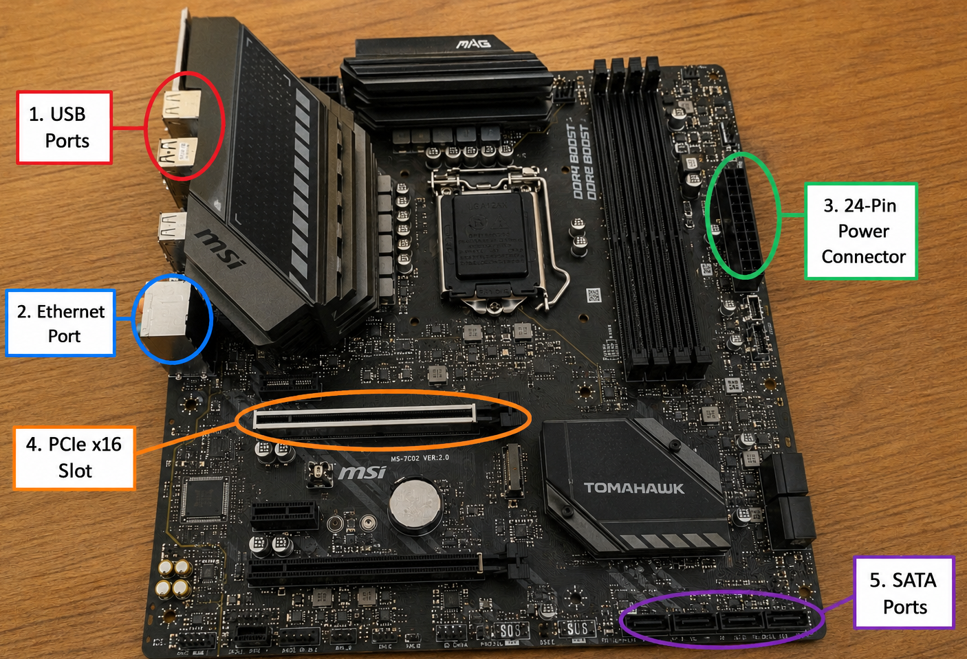

THE END/……

