- Day ~ 1
- Draw a labeled diagram of a desktop PC, clearly marking the motherboard, CPU, RAM, GPU, and both HDD and SSD storage components.

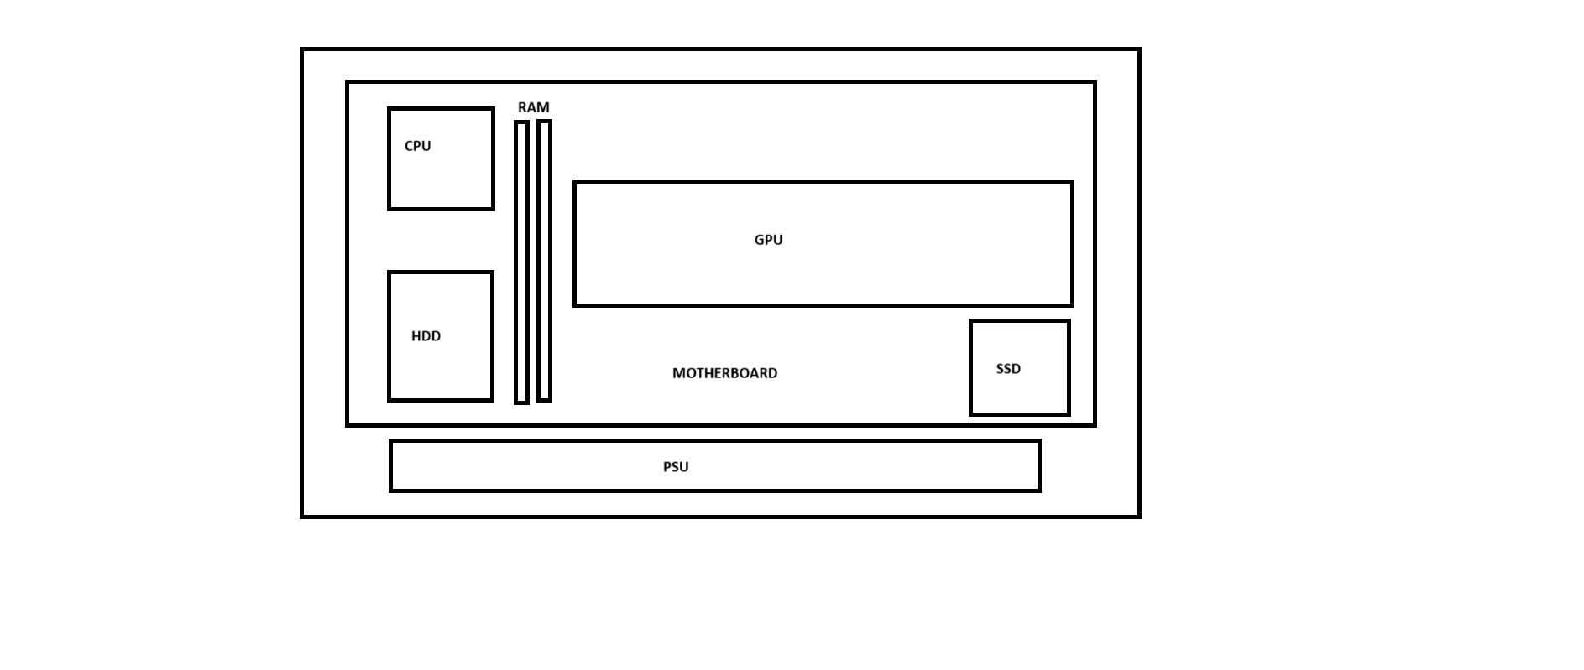

- Create a comparison table showing the main differences between HDD and SSD storage in terms of speed, durability, and typical use cases.<br><br><em><strong>Hint:</strong> Think about which one is faster, which is more shock-resistant, and where you would usually find each type (laptop, gaming PC, etc.).</em>

Feature | SSD (Solid State Drive) | HDD(Hard Disk Drive)
Speed | SSD has much faster data read/write speeds. | HDD has slower data read/write speeds
Shock Resistance | SSD is highly resistant to shock and vibration | HDD can be easily damaged by shocks or drops.
Power Comsumption | SSD consumes less power | HDD consumes more power
Typical Use Cases | Used in laptops,gaming PCs,high perfromance, and smartphone | Used in desktop PCs,backup storage,and large file storage.
Boot Time | SSD start the computer quickly | HDD takes longer to start the computer.
Durability | SSD is more durable because it has no moving parts | HDD is less durable due to its moving mechanical parts.
Noice | SSD opration silently | HDD produces noice while operating .
Storage Capacity | SSD is usually more expensive for the same storage capacity. | HDD is available in large capacities.

- Write a short explanation (2-3 sentences each) describing the role of the CPU, RAM, and GPU in running a game like PUBG or Free Fire on a PC.

CPU (Central Processing Unit):~
The CPU acts as the brain of the computer, handling game logic, player actions, physics calculations, and communication between different hardware components. In games like PUBG or Free Fire, a faster CPU helps maintain smooth gameplay, especially when many players and objects are active at the same time.
RAM (Random Access Memory):~
RAM temporarily stores game data that the CPU and GPU need to access quickly while the game is running. Having enough RAM allows the game to load maps, textures, and player information efficiently, reducing lag, stuttering, and loading times.
GPU (Graphics Processing Unit):~
The GPU is responsible for rendering images, animations, lighting effects, and visual details displayed on the screen. In PUBG or Free Fire, a powerful GPU improves graphics quality and frame rates, making the game look smoother and more responsive.
- Imagine you want to upgrade your PC to run the latest version of FIFA smoothly. List which hardware components you would consider upgrading and explain why for each.

To run the latest version of FIFA smoothly, I would consider upgrading the following hardware components:
- GPU (Graphics Processing Unit):~
The GPU has the biggest impact on gaming performance. Upgrading to a more powerful graphics card can improve frame rates, support higher graphics settings, and provide smoother gameplay with better visual quality.
- CPU (Central Processing Unit):~
A faster CPU helps process game logic, player movements, AI, and background tasks more efficiently. Upgrading the CPU can reduce performance bottlenecks and improve overall game responsiveness.
- RAM (Random Access Memory):~
Increasing RAM allows the game and operating system to store and access more data quickly. More RAM can reduce lag, improve multitasking, and help the game run smoothly, especially when other applications are open.
- Storage Drive (SSD):~
Replacing a traditional hard drive with a Solid-State Drive (SSD) can significantly reduce game loading times and improve system performance. Games launch faster, and updates are installed more quickly.
- Power Supply Unit (PSU):~
If upgrading to a high-performance CPU or GPU, a stronger and more reliable PSU may be needed to provide sufficient power and ensure system stability.
- Cooling System:~
Better cooling helps keep components at safe temperatures during long gaming sessions. Upgrading cooling can prevent overheating and maintain consistent performance.

The end/…..

