Day~4

- Open your own laptop or desktop (or use an online PC hardware simulator if you don't have access to a real system) and identify the GPU model installed. Write down the GPU's brand, model number, and whether it is integrated or dedicated.

:-Details of GPU’s model installed in my laptop or desktop :-
GPU brand : AMD
GPU Model : AMD Radeon™ RX Vega10 Graphics
GPU Type : Integrated GPU

:~

- Take a clear photo or screenshot of the cooling system (fan, heatsink, or liquid cooling setup) inside your PC or from a PC hardware simulator. Label the main cooling components and briefly describe their function.
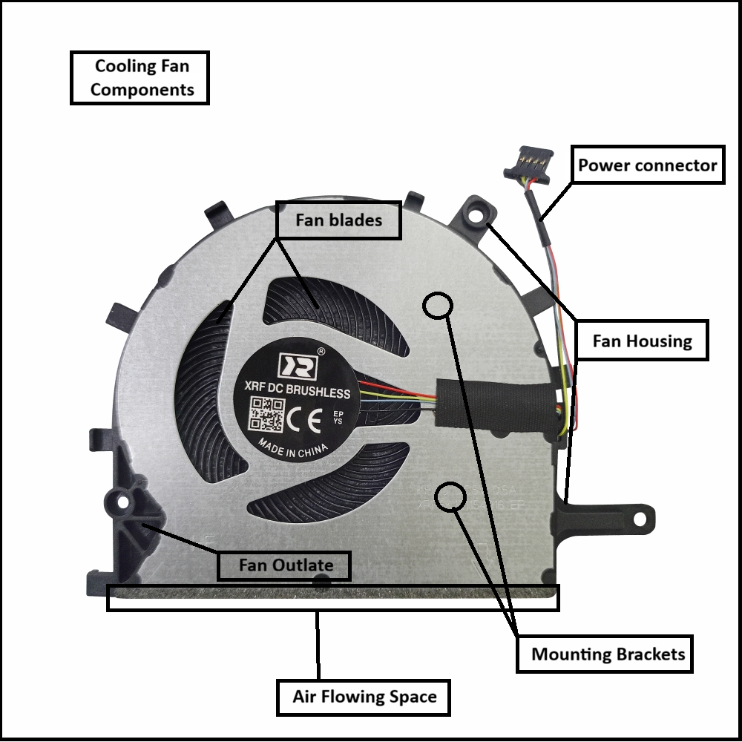
- Create a comparison table listing at least 3 differences between air cooling and liquid cooling systems for GPUs, including factors like cost, efficiency, and maintenance.

Factor | Air Cooling | Liquid Cooling
Cost | Cheaper and widely available. | More expensive due to extra components.
Efficiency | Good cooling for normal use. | Better cooling for heavy workloads and gaming.
Maintenance | Easy to maintain; mainly dust cleaning. | Requires more maintenance and monitoring.

- Imagine you are building a gaming PC for streaming IPL matches and playing graphics-heavy games. Choose between air cooling and liquid cooling for your GPU, and justify your choice in 3-4 sentences based on your research.

Choice: Liquid Cooling for GPU
If I were building a gaming PC for streaming IPL matches and playing graphics-intensive games, I would choose liquid cooling for the GPU.
- Streaming and gaming simultaneously put a heavy load on the graphics card, causing it to generate a significant amount of heat.
- Liquid cooling is more efficient at removing heat compared to traditional air cooling systems.
- By keeping the GPU at lower temperatures, liquid cooling helps maintain stable performance during long gaming and streaming sessions.
- Lower temperatures also reduce the risk of thermal throttling, which can cause the GPU to slow down when it gets too hot.
- Another advantage is that liquid cooling systems are generally quieter because they do not require fans to run at very high speeds.
- This creates a better experience while gaming, streaming, or watching IPL matches without excessive fan noise.
- Although liquid cooling is more expensive and requires slightly more maintenance, the improved cooling performance makes it a worthwhile investment.
- Therefore, for a high-performance gaming and streaming PC, I believe liquid cooling is the better choice because it offers superior cooling, quieter operation, and more consistent performance.

The End…….

