~Day-2
- In Cisco Packet Tracer, set up a simple network with one DHCP server and two client PCs. Configure the DHCP server to assign IP addresses automatically, then verify on each PC that it receives a different IP address from the DHCP pool.

Cisco Packet Tracer: DHCP Server with Two Client PCs:
Step 1: Add Devices
- 1 × Server
- 1 × Switch (2960)
- 2 × PCs (PC0 and PC1)
Step 2: Connect Devices
- Server → Switch (Copper Straight-Through)
- PC0 → Switch (Copper Straight-Through)
- PC1 → Switch (Copper Straight-Through)
Step 3: Configure the Server
- Click Server → Desktop → IP Configuration.
- Set:
  - IP Address: 192.168.1.2
  - Subnet Mask: 255.255.255.0
  - Default Gateway: 192.168.1.1
Step 4: Enable DHCP
- Go to Server → Services → DHCP.
- Turn DHCP Service = On.
- Create a DHCP Pool:
Setting | Value
Pool Name | LAN
Default Gateway | 192.168.1.1
DNS Server | 8.8.8.8
Start IP Address | 192.168.1.100
Subnet Mask | 255.255.255.0
Maximum Users | 50
- Click Add.
Step 5: Configure the PCs
For PC0 and PC1:
- Go to Desktop → IP Configuration.
- Select DHCP.
Step 6: Verify IP Addresses
Device | Assigned IP Address (Example)
PC0 | 192.168.1.100
PC1 | 192.168.1.101
Verification
Both PCs receive different IP addresses automatically from the DHCP pool.
Conclusion:
The DHCP server successfully assigned unique IP addresses to both client PCs, confirming that automatic IP address allocation is working correctly.

- Draw a sequence diagram (hand-drawn or digital) that clearly shows each step of the DHCP process: Discover, Offer, Request, and Acknowledge, labeling the sender and receiver at each stage.<br><br><em><strong>Hint:</strong> Use arrows to show the direction of each message between client and server.</em>

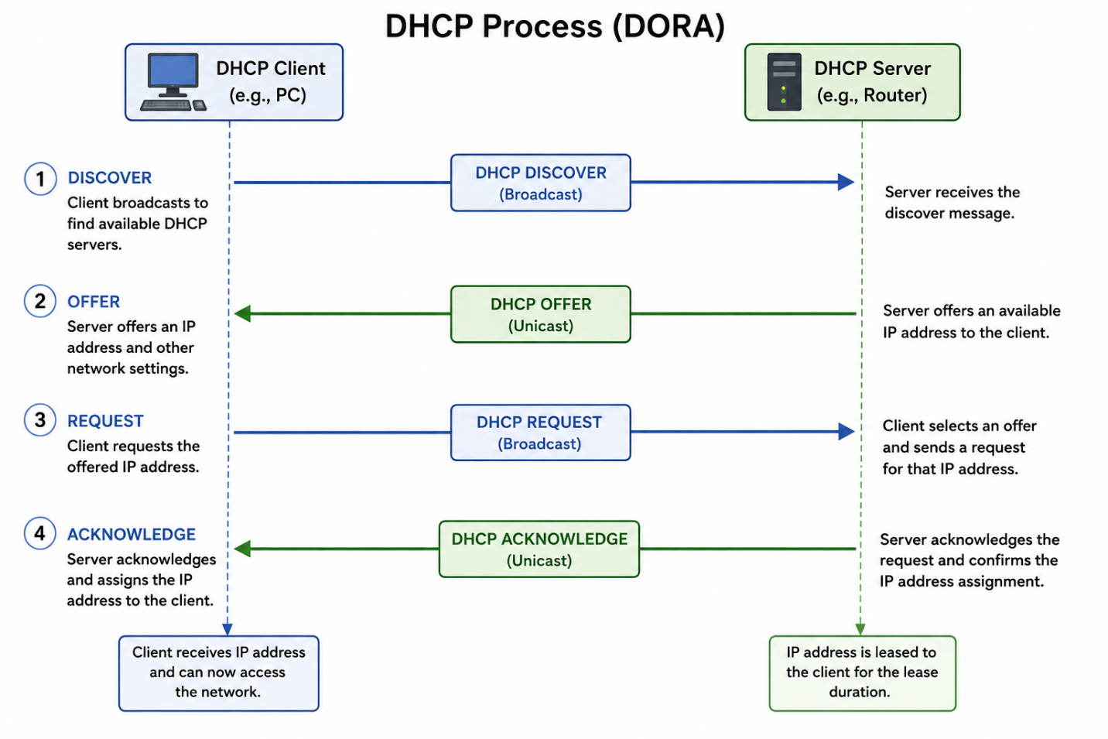
DHCP Process
- Discover: Client broadcasts a request to find a DHCP server.
- Offer: DHCP server offers an available IP address.
- Request: Client requests the offered IP address.
- Acknowledge (ACK): Server confirms the assignment and sends the network configuration (IP address, subnet mask, gateway, DNS).
Scenario:DHCP Process (DORA)
A student brings a laptop to the college computer lab and connects it to the Wi-Fi. Since the laptop does not have an IP address, it starts the DHCP process.
- Discover: The laptop broadcasts a DHCP Discover message to find a DHCP server.
- Offer: The DHCP server replies with an available IP address (e.g., 192.168.1.100) and network settings.
- Request: The laptop sends a DHCP Request message asking to use the offered IP address.
- Acknowledge (ACK): The DHCP server confirms the request and assigns the IP address.
Result: The laptop receives a valid IP address, subnet mask, default gateway, and DNS server, allowing it to access the Internet and websites such as Google, YouTube, and Instagram.

- Change the DHCP pool range on your Cisco Packet Tracer DHCP server so that only one IP address is available. Add two PCs and observe what happens when both try to get an IP address. Take a screenshot of the result and explain in 2-3 lines why only one PC succeeds.
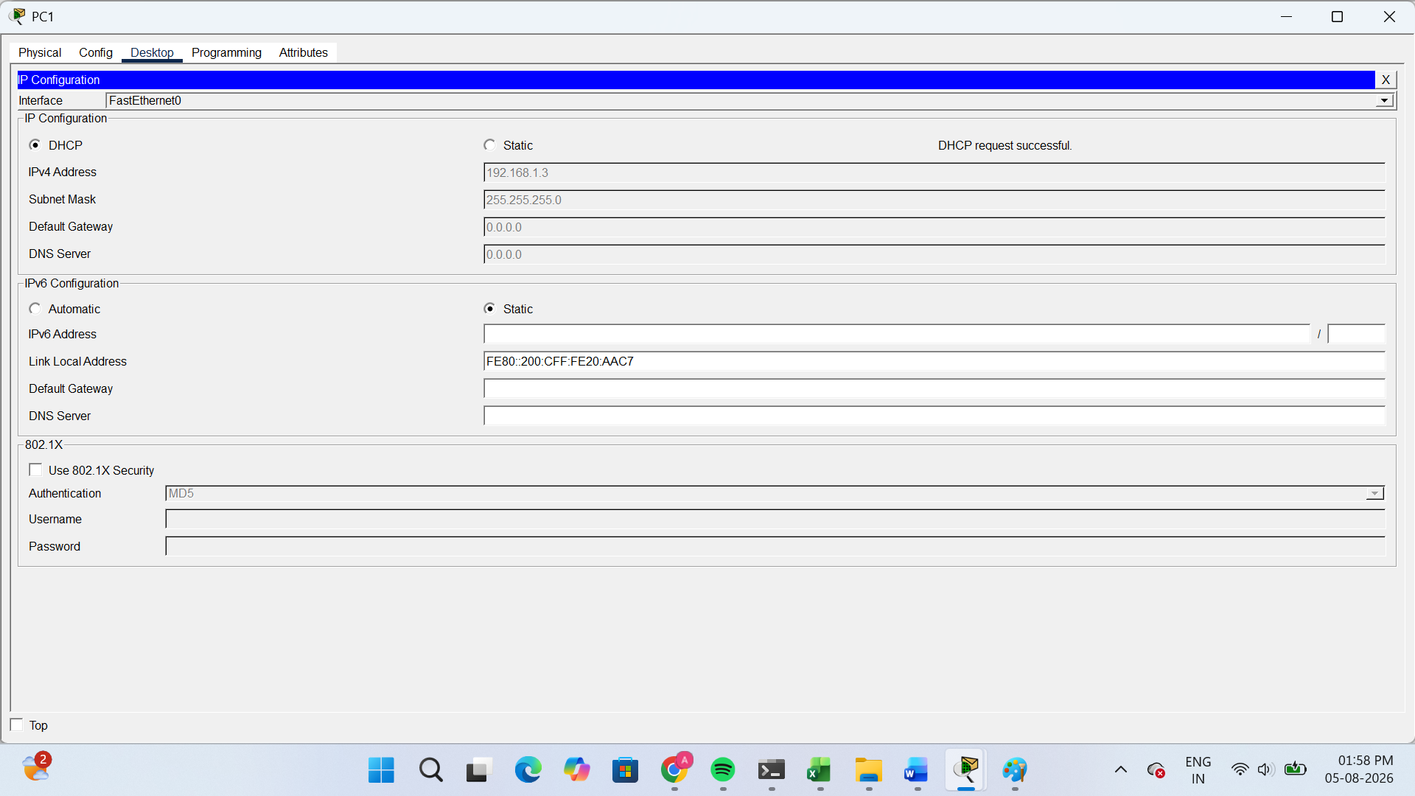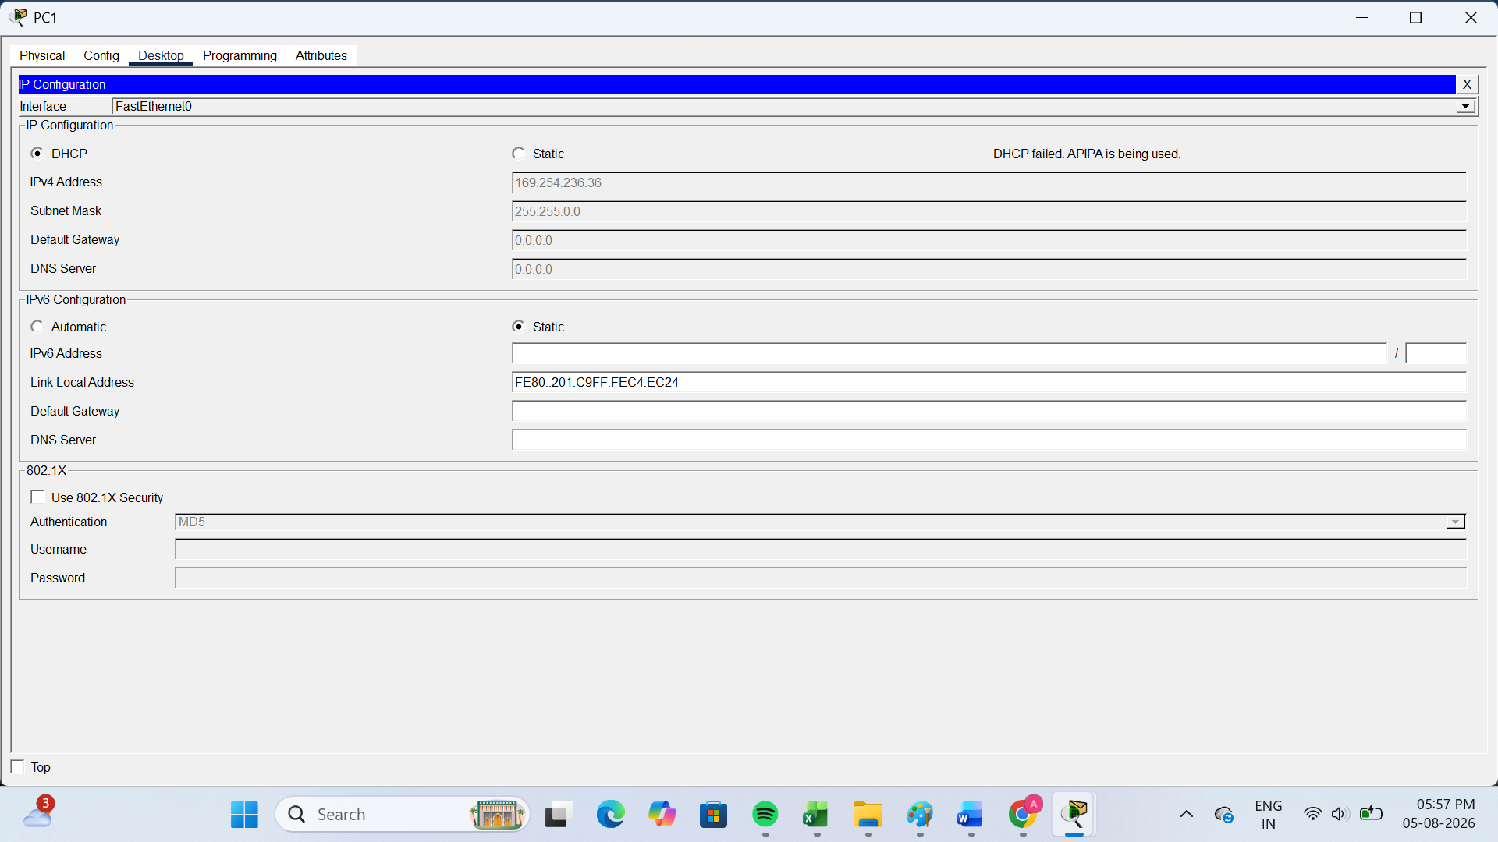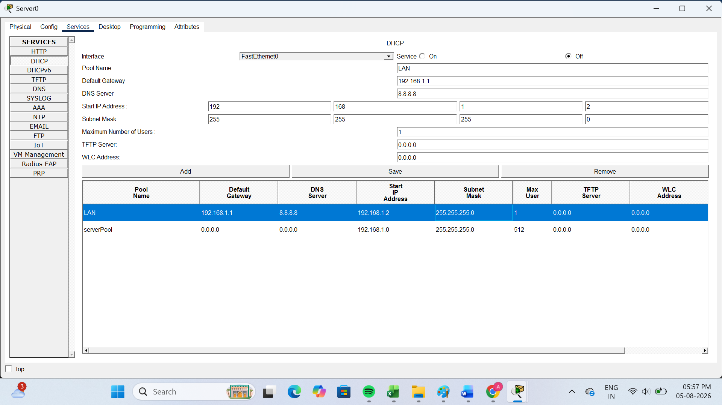
Observation:
- PC0 successfully received IP address 192.168.1.2.
- PC1 failed to obtain an IP address because no IP addresses were left in the DHCP pool.
Explanation (2–3 lines):
The DHCP pool was configured to provide only one IP address. The first PC obtained the available IP address successfully. When the second PC requested an IP address, the DHCP pool had no free addresses remaining, so the DHCP request failed.

- Simulate a Zomato-style restaurant WiFi scenario in Cisco Packet Tracer: configure a DHCP server to provide IP addresses to both a laptop and a smartphone (use a generic PC as smartphone). Show the assigned IPs and explain why DHCP is useful in this situation.

Scenario: Zomato Restaurant Wi-Fi Using DHCP (Cisco Packet Tracer)
Scenario:
A restaurant like Zomato Cafe provides free Wi-Fi to customers. A laptop and a smartphone (represented by a generic PC in Packet Tracer) connect to the restaurant's Wi-Fi. A DHCP server automatically assigns IP addresses to both devices.
Network Setup:
- 1 Server (DHCP Server)
- 1 Switch
- 1 Laptop (PC0)
- 1 Smartphone (PC1 - Generic PC)
DHCP Server Configuration:
Setting | Value
Server IP | 192.168.10.2
Subnet Mask | 255.255.255.0
Default Gateway | 192.168.10.1
DHCP Pool | RestaurantWiFi
Start IP | 192.168.10.100
Maximum Users | 20
DNS Server | 8.8.8.8
Assigned IP Addresses:
Device | IP Address | Status
Laptop (PC0) | 192.168.10.100 | Assigned by DHCP
Smartphone (PC1) | 192.168.10.101 | Assigned by DHCP
Why DHCP is Useful:
- DHCP automatically assigns IP addresses, so customers do not need to configure network settings manually.
- Each device receives a unique IP address, preventing IP conflicts.
- It makes managing many customer devices on the restaurant Wi-Fi easy, fast, and efficient.
Conclusion:
In a Zomato-style restaurant Wi-Fi network, the DHCP server automatically assigns IP addresses such as 192.168.10.100 to the laptop and 192.168.10.101 to the smartphone, allowing both devices to access the Internet without manual configuration.

THE END……

