~1.
1. Install Windows Server on VirtualBox or VMware
Aim: To install Windows Server on a virtual machine and verify that it starts successfully.
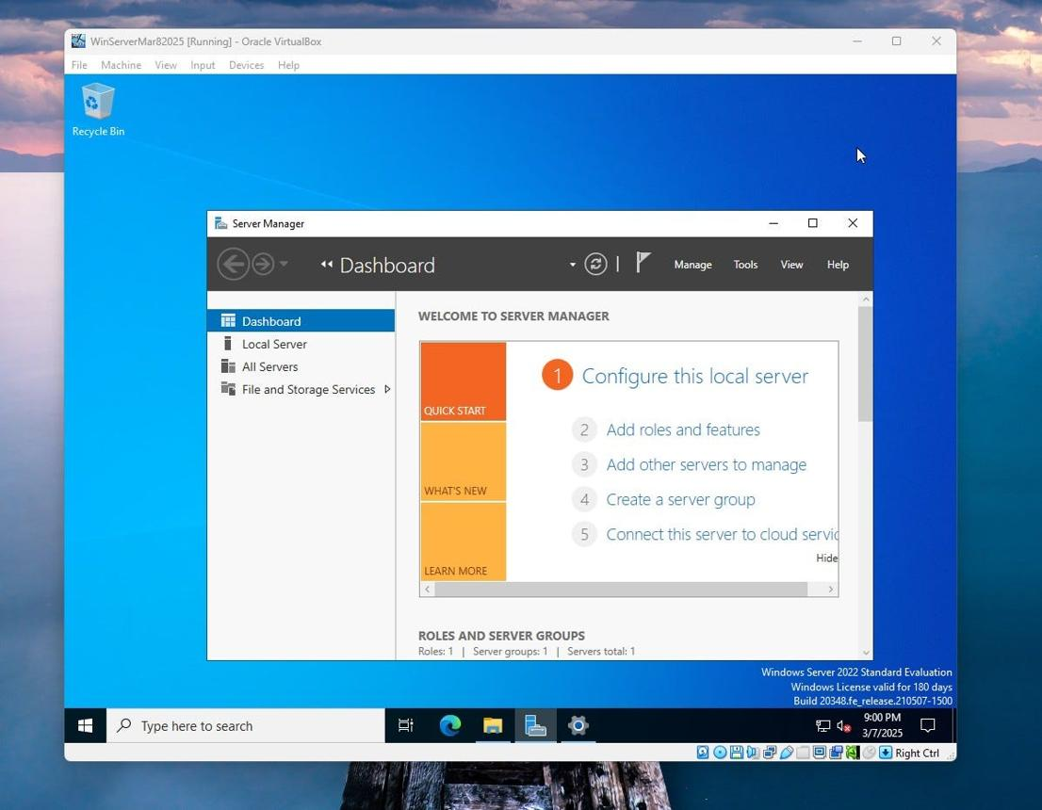
Procedure
- Download a Windows Server evaluation ISO from Microsoft's official evaluation center.
- Install and open Oracle VirtualBox or VMware Workstation.
- Create a new virtual machine and name it WindowsServer-AD.
- Select the appropriate Windows Server 64-bit operating system type.
- Assign suitable RAM and CPU resources according to your computer's capacity.
- Create a virtual hard disk and attach the Windows Server ISO.
- Start the VM and follow the Windows Setup wizard.
- Select the edition and installation option required for your lab. The Desktop Experience option provides a graphical interface.
- Accept the license terms, select the virtual disk, and complete the installation.
- Set the Administrator password when prompted and sign in.
Screenshot 1: Capture the Windows Server desktop after installation, preferably with Server Manager visible.
Screenshot 1 — Installation completed
Paste your actual VM desktop screenshot here.
2. Install the Active Directory Domain Services (AD DS) role
Aim: To add the AD DS server role using Server Manager.
Microsoft's official guide: Install Active Directory Domain Services.

Microsoft Learn
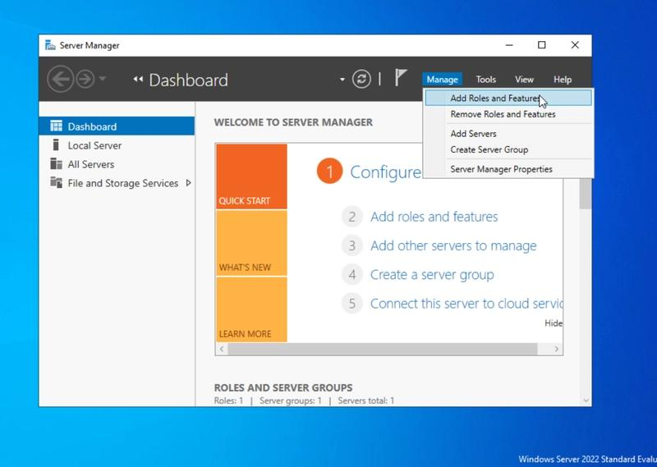
Step 1 — Open Server Manager
Open Server Manager, click Manage, then select Add Roles and Features.
Screenshot 2: Server Manager with the menu open.
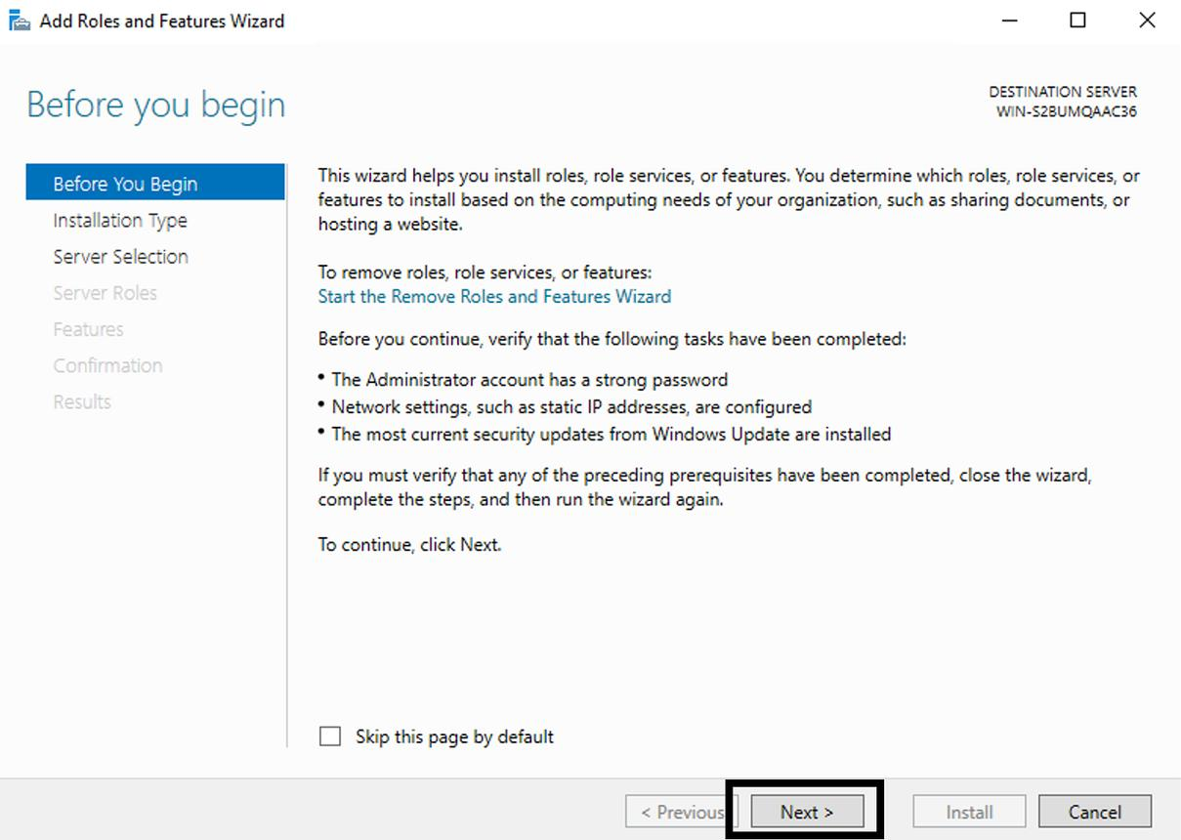
Step 2 — Before You Begin
Read the introductory information and click Next.
Screenshot 3: Before You Begin page.
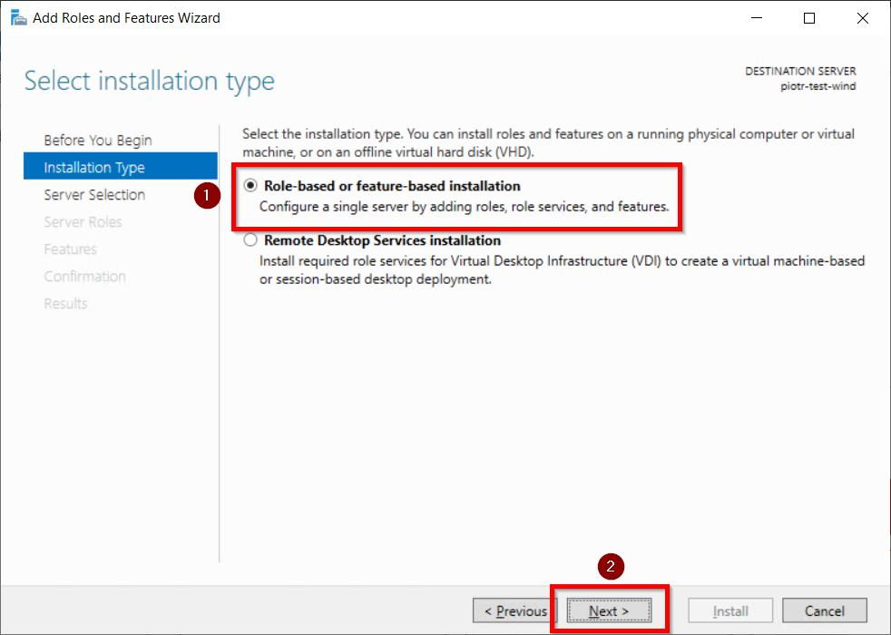
Step 3 — Select Installation Type
Select Role-based or feature-based installation and click Next.
Screenshot 4: Installation type selected.
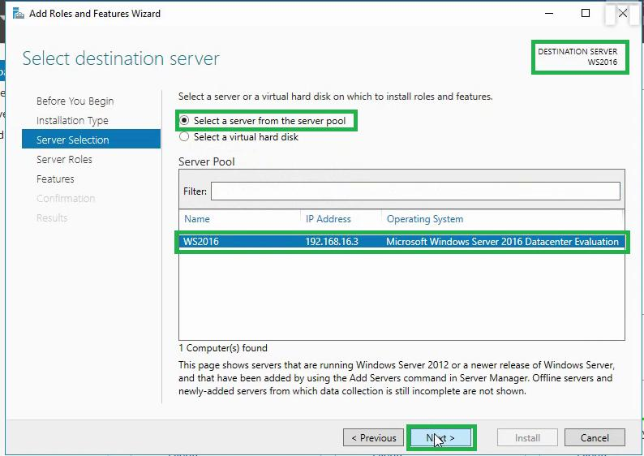
Step 4 — Select Destination Server
Select your local server from the server pool and click Next.
Screenshot 5: Destination server selected.
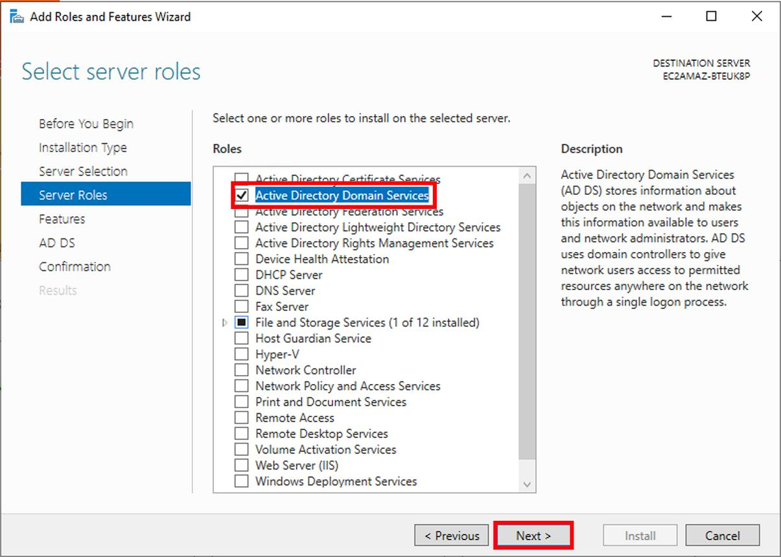
Step 5 — Select Server Roles
Check Active Directory Domain Services (AD DS). When prompted, click Add Features, then click Next.
Screenshot 6: AD DS selected.
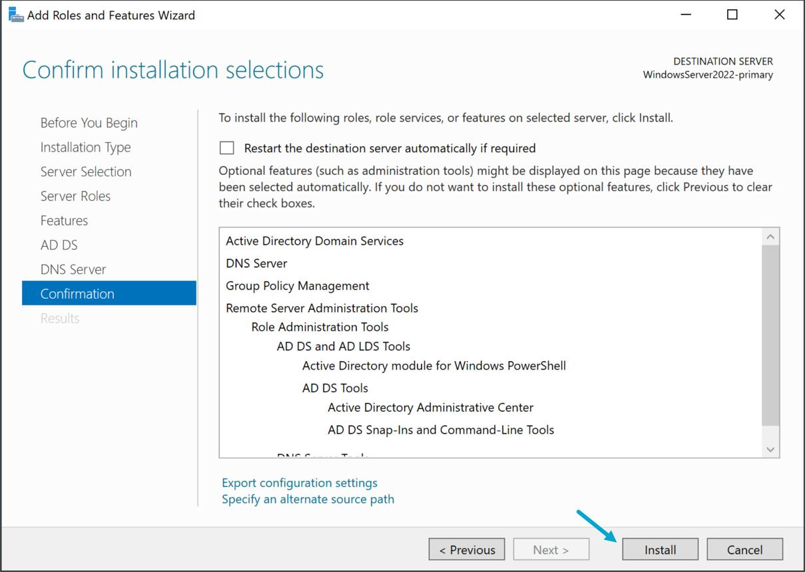
Step 6 — Confirm and Install
Continue through the Features and AD DS information pages. Click Install on the confirmation page.
Screenshot 7: Installation confirmation or progress.
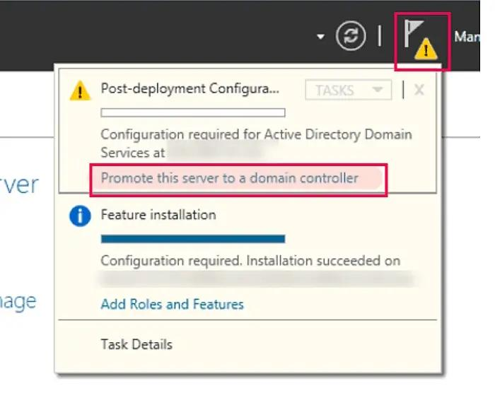
Step 7 — Verify Installation
Wait for the installation to finish. On the Results page, confirm success and click Promote this server to a domain controller.
Screenshot 8: Installation succeeded and promotion link visible.
Result: The AD DS role and its management tools are installed. The server is not yet a domain controller; that requires the next configuration stage.
3. Promote Windows Server to a Domain Controller
Aim: To create a new Active Directory forest with the root domain mycollege.local.
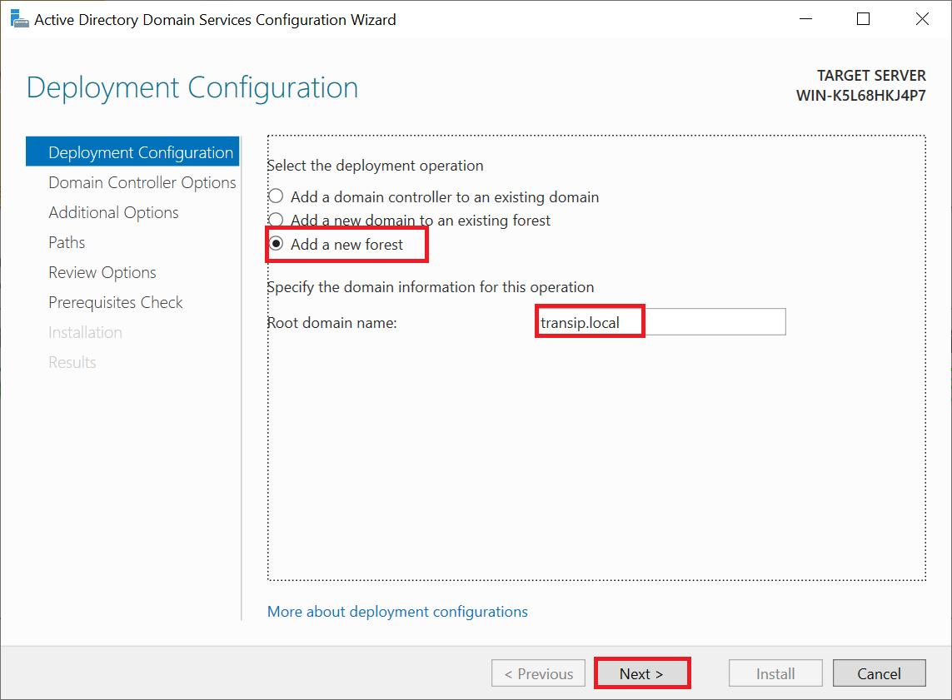
Step 1 — Deployment Configuration
Select Add a new forest and enter mycollege.local as the Root domain name. Click Next.
Screenshot 9: New forest configuration.
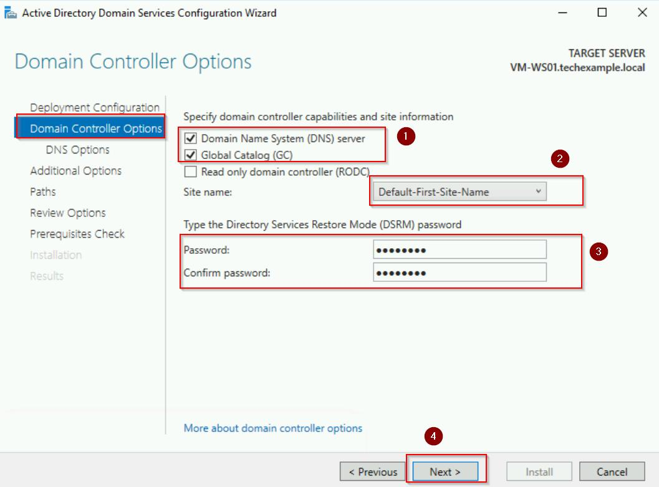
Step 2 — Domain Controller Options
Select the available forest and domain functional levels. Keep DNS Server and Global Catalog (GC) selected. Enter and confirm a Directory Services Restore Mode (DSRM) password.
Screenshot 10: Domain controller options. Do not include the password in your screenshot.
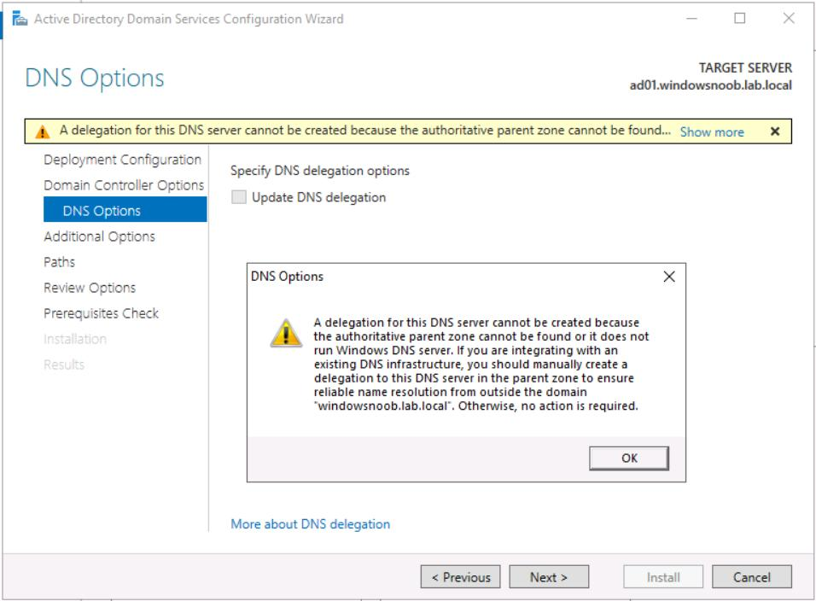
Step 3 — DNS Options
Review the DNS delegation warning, if shown. For a standalone lab forest without a parent DNS zone, leave Create DNS delegation unselected and click Next.
Screenshot 11: DNS options page.
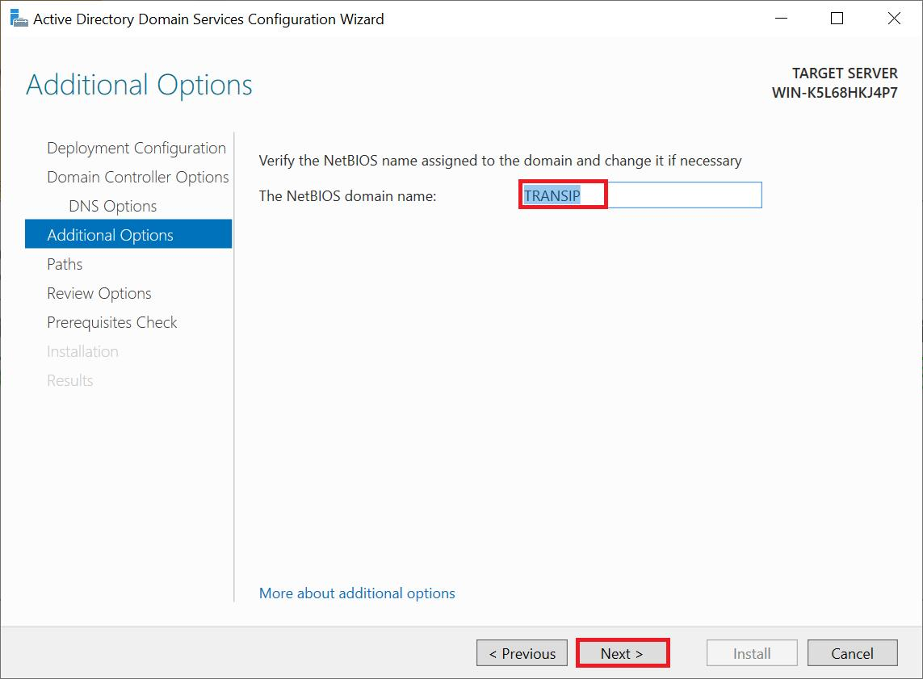
Step 4 — Additional Options
Review the automatically generated NetBIOS domain name, usually MYCOLLEGE. Click Next.
Screenshot 12: NetBIOS name.
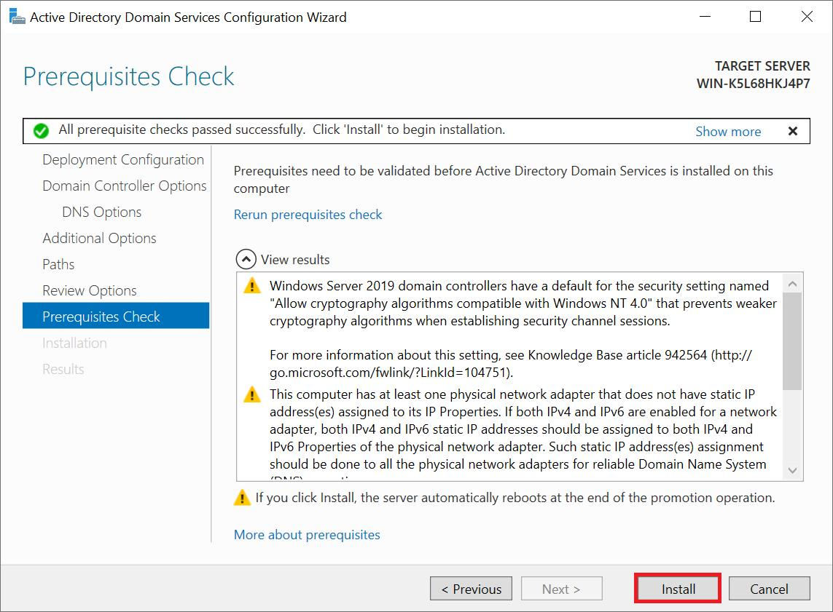
Step 5 — Paths and Prerequisites
Accept the default database, log-file and SYSVOL paths. Review the options, run the prerequisite check, and click Install if it passes.
Screenshot 13: Prerequisite check or final configuration options.
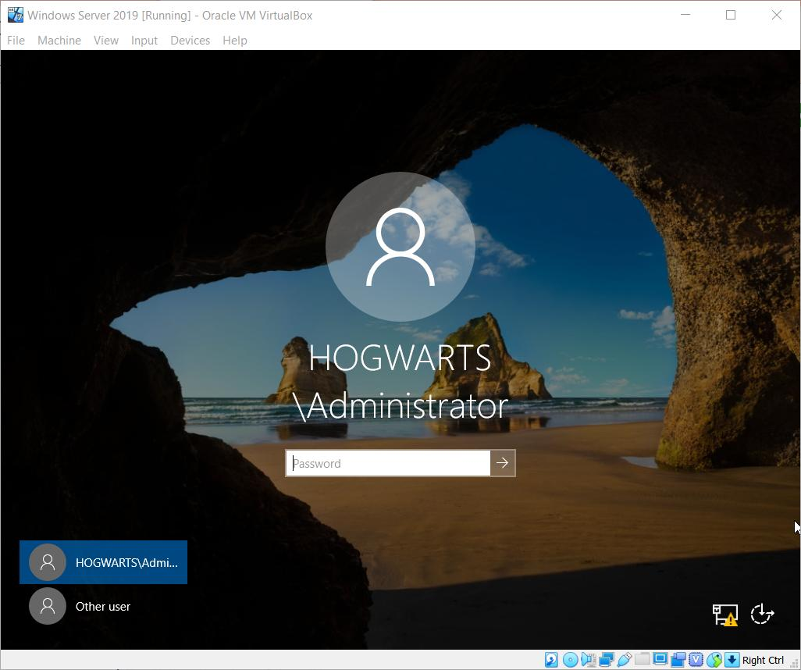
Step 6 — Restart and Verify
The server restarts. Sign in using the domain Administrator account, such as MYCOLLEGE\Administrator, and verify that Server Manager shows AD DS.
Screenshot 14: Successful domain controller promotion.
Configuration options selected
Option | Selected value
Deployment operation | Add a new forest
Root domain | mycollege.local
DNS Server | Enabled
Global Catalog | Enabled
Read-only domain controller | Not selected
DNS delegation | Not selected
NetBIOS name | MYCOLLEGE
Database, logs and SYSVOL | Default paths
DSRM password | Set a secure password
Functional levels | Use compatible available defaults
Note: Functional levels and available choices depend on the Windows Server version. Record the actual values shown by your wizard.
Result: The server is promoted to a domain controller for the new forest. DNS is configured as part of the process.

Microsoft Learn
+1
4. Create two users and one group in Active Directory Users and Computers
Aim: To create two Active Directory user accounts and add both users to a common security group.
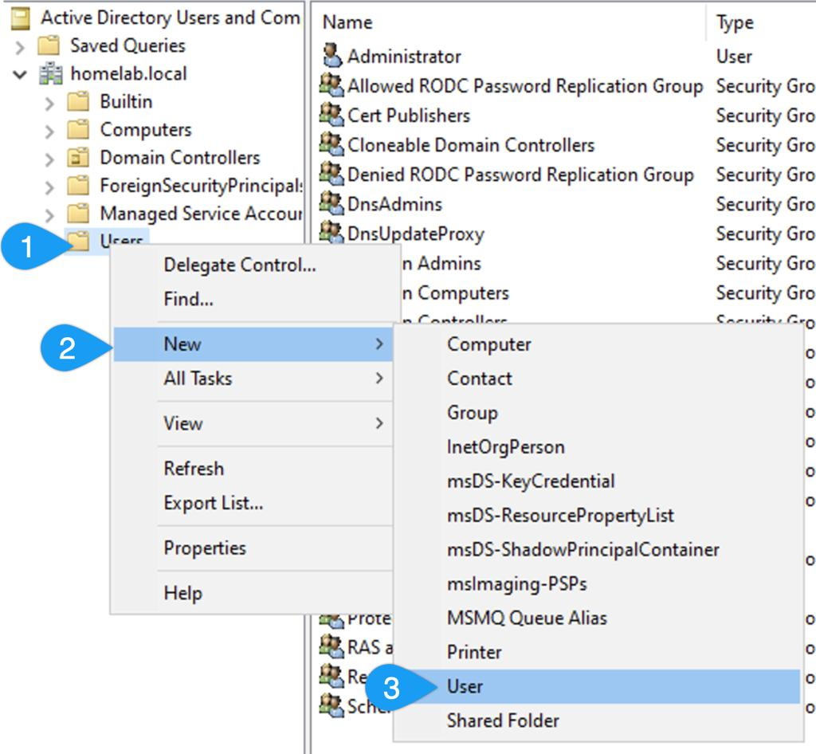
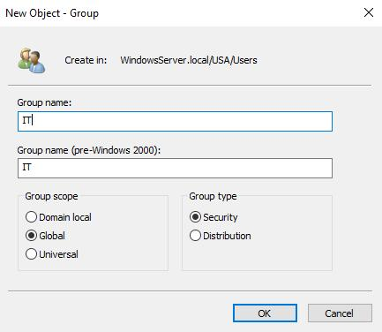
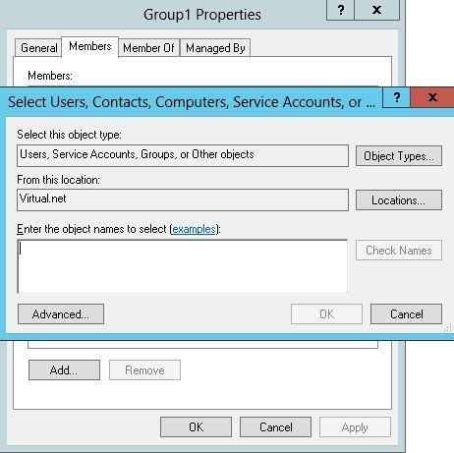
5
Step 1 — Open ADUC
- Open Server Manager → Tools → Active Directory Users and Computers.
- Expand mycollege.local.
- Click the built-in Users container.
Screenshot 15: ADUC showing the domain and Users container.
Step 2 — Create the first user
- Right-click Users and select New → User.
- Enter the details:
- First name: Rahul
- Last name: Patel
- User logon name: rahul.patel
- Click Next, set a lab password, and confirm it.
- Choose the appropriate password options for your lab and click Next → Finish.
Screenshot 16: Rahul Patel listed in the Users container.
Step 3 — Create the second user
Repeat the same procedure with these details:
- First name: Priya
- Last name: Shah
- User logon name: priya.shah
Click Next → Finish.
Screenshot 17: Both user accounts visible in ADUC.
Step 4 — Create a group
- Right-click the Users container.
- Select New → Group.
- Enter the group name: IT_Students.
- Select Group scope: Global.
- Select Group type: Security.
- Click OK.
Screenshot 18: The IT_Students group visible in ADUC.
Step 5 — Add both users to the group
- Right-click IT_Students and select Properties.
- Open the Members tab.
- Click Add.
- Enter rahul.patel; priya.shah or enter each account separately using Check Names.
- Click OK, then Apply → OK.
Screenshot 19: The Members tab displaying both users.
Final verification
Your ADUC structure should contain the following:
mycollege.local
Users
Rahul Patel (rahul.patel)
Priya Shah (priya.shah)
IT_Students — Security Group
Members:
- Rahul Patel
- Priya Shah
Result: Two user accounts and one security group have been created, and both users have been assigned to IT_Students.
Conclusion
In this practical, Windows Server was installed on a virtual machine, the AD DS role was added, and the server was configured as a domain controller for a new forest. Two user accounts were created in Active Directory Users and Computers, and both were added to a security group.
Important: The report describes the expected procedure. Mark each task complete only after performing it and capturing your own screenshots.

