~2.
1. Create the EventPlanners OU
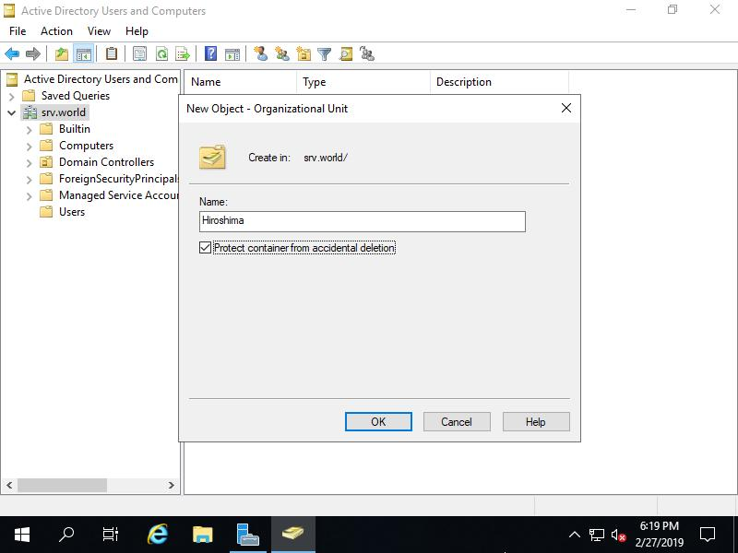

Procedure:
- Open Server Manager → Tools → Active Directory Users and Computers.
- Expand your domain, for example, mycollege.local.
- Right-click the domain name and select New → Organizational Unit.
- Enter EventPlanners.
- Keep Protect container from accidental deletion enabled.
- Click OK.
Screenshot 1: Capture ADUC showing the newly created EventPlanners OU.
2. Create three IPL-inspired user accounts
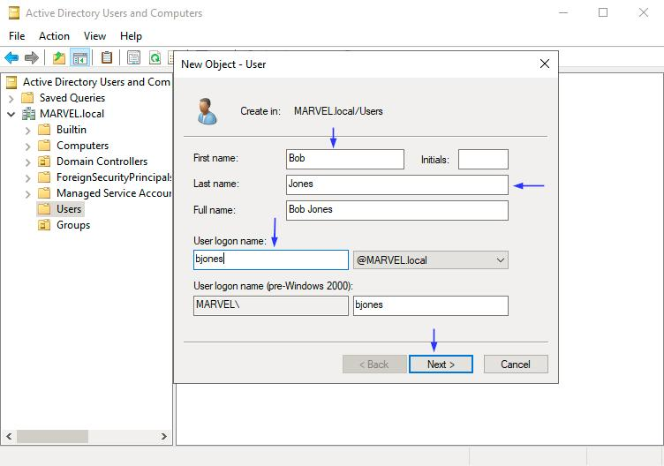

Open the EventPlanners OU, right-click it, and select New → User.
Create these accounts:
First name | Username | Inspiration
Virat | viratk | Virat Kohli
Dhoni | msdhoni | MS Dhoni
Hardik | hardikp | Hardik Pandya
For each account:
- Enter the first name and username.
- Click Next.
- Set a unique, strong password. Use a long password with a mix of character types; don't reuse your personal password.
- Enable User must change password at next logon.
- Click Next → Finish.
Screenshot 2: Capture all three user accounts inside the EventPlanners OU. Do not include passwords in screenshots.
3. Create the FestTicketManagers security group
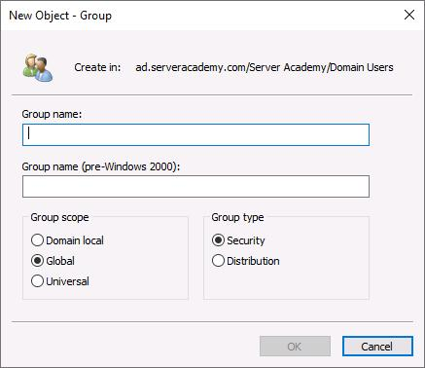

Procedure:
- Right-click the EventPlanners OU.
- Select New → Group.
- Enter the group name FestTicketManagers.
- Set Group scope to Global.
- Set Group type to Security.
- Click OK.
Add all three users
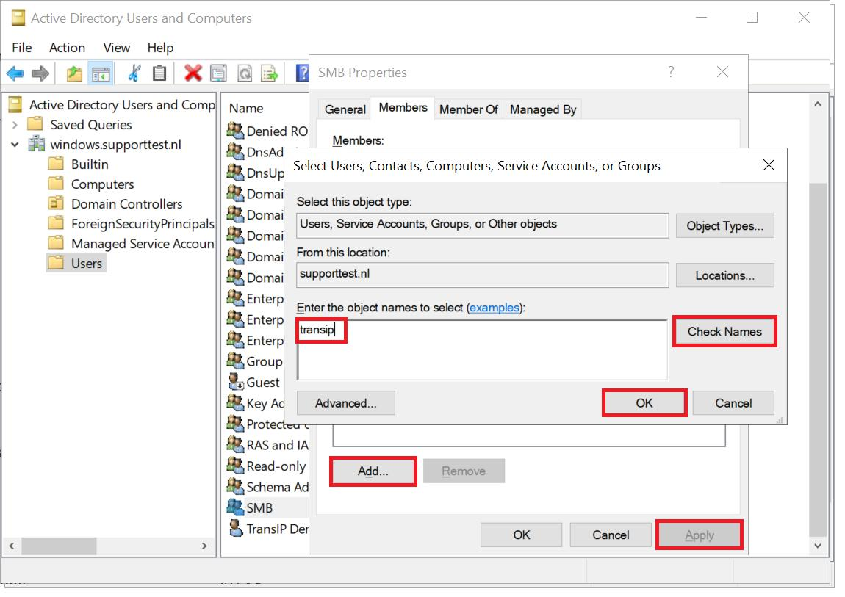

- Right-click FestTicketManagers and select Properties.
- Open the Members tab.
- Click Add.
- Enter viratk, msdhoni, and hardikp (you can add them together or one at a time).
- Click Check Names → OK → Apply → OK.
Screenshot 3: Capture the group's Members tab showing all three accounts.
4. Rename one user and update the description
For this example, rename viratk to your own first name, Darshan.
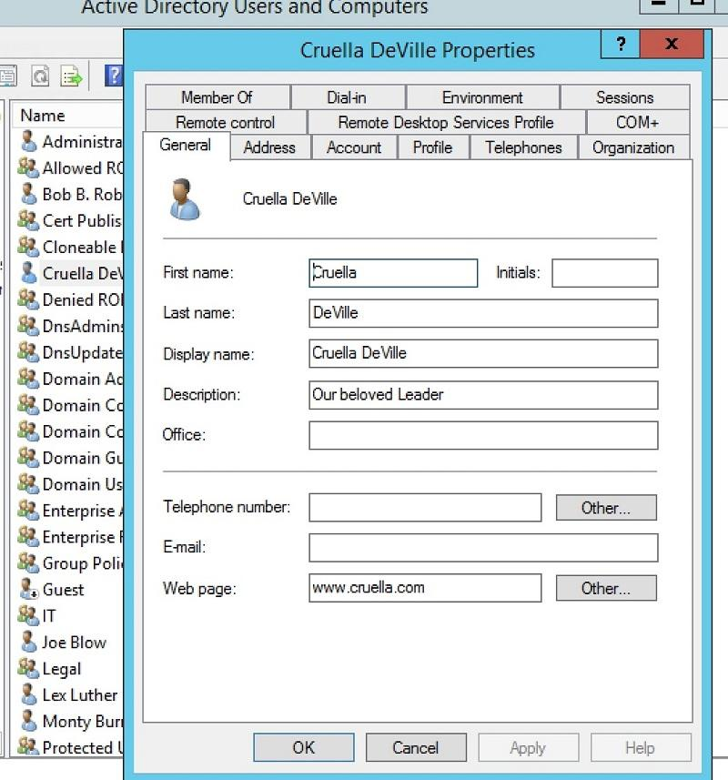
Procedure:
- Inside EventPlanners, right-click the viratk account.
- Select Rename.
- Enter Darshan as the new display name and confirm.
- If prompted, update the user's name fields as required.
- Right-click the renamed account and select Properties.
- On the General tab, enter this in the Description field:
Social Media Manager for College Fest
7. Click Apply → OK.
Screenshot 4: Capture the renamed user's properties showing the updated description.
Note: Renaming a user does not necessarily change the account's logon username. If your instructor expects the username itself to change, update the User logon name on the Account tab as well. The user remains a member of the group when the same AD account is renamed.
Final verification
Your expected structure should look like this:
mycollege.local
EventPlanners
Darshan — Social Media Manager for College Fest
msdhoni
hardikp
FestTicketManagers — Global Security Group
The group membership should include all three user accounts, including the renamed account.
Conclusion
The EventPlanners OU was created to organize college fest team accounts. Three IPL-inspired user accounts were added, each configured to change their password at the next logon. A Global Security Group named FestTicketManagers was created, all three users were added to it, and one account was renamed with the required description.

