~3.
1. Create PasswordPolicyDemo and enforce minimum password length
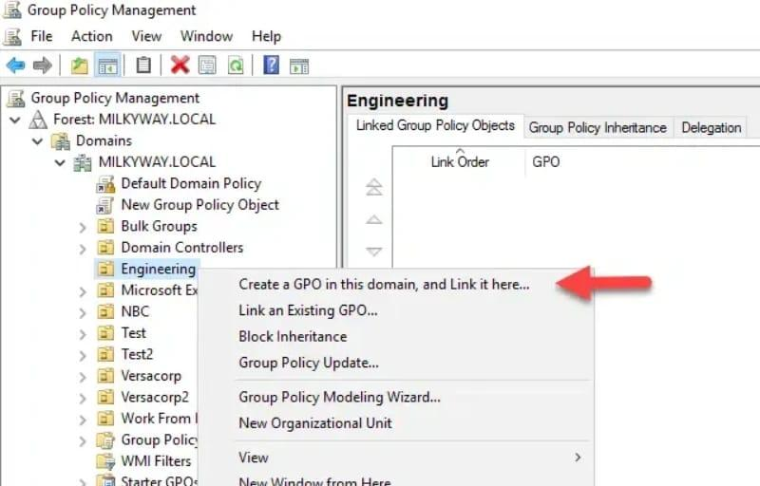
Procedure
- On the Domain Controller, open Server Manager → Tools → Group Policy Management.
- Expand Forest → Domains → your domain (for example, mycollege.local).
- Right-click Group Policy Objects and select New.
- Enter the name PasswordPolicyDemo and click OK.
- Right-click the new GPO and select Edit.
- Navigate to:
Computer Configuration → Policies → Windows Settings → Security Settings → Account Policies → Password Policy
- Double-click Minimum password length.
- Enable the setting and enter 8 characters.
- Click Apply → OK.
- Link the GPO to your test OU by right-clicking the OU in GPMC, selecting Link an Existing GPO, and choosing PasswordPolicyDemo.
Screenshot 1: Capture the Minimum password length setting showing 8 characters.
Important: Password policies configured under Computer Configuration → Security Settings → Account Policies normally apply to domain accounts when configured in the domain's policy scope. For consistent domain-wide password and lockout enforcement, configure these settings in the domain's password policy or use a fine-grained password policy. Linking an ordinary GPO only to a user OU does not reliably enforce the domain account policy for those users.
2. Restrict Control Panel access for users in a specific OU
Create a separate GPO named ControlPanelRestriction so the restriction can be managed independently.
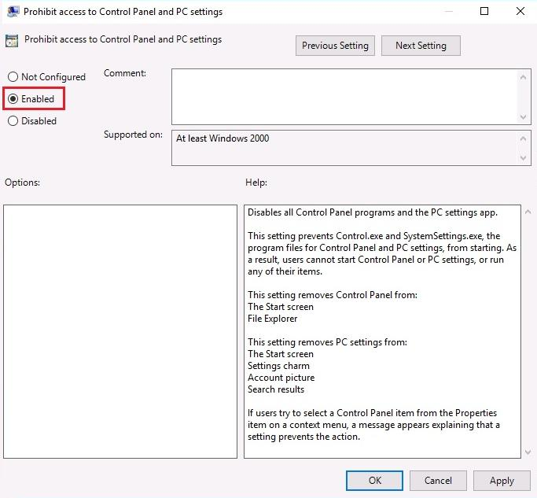

Procedure
- Open Group Policy Management.
- Right-click Group Policy Objects → New.
- Name the GPO ControlPanelRestriction.
- Right-click it and select Edit.
- Navigate to:
User Configuration → Policies → Administrative Templates → Control Panel
- Open Prohibit access to Control Panel and PC settings.
- Select Enabled, then click Apply → OK.
- Link this GPO to the OU containing the users you want to restrict.
Screenshot 2: Capture the policy editor showing the setting as Enabled.
Expected impact: Users covered by this policy cannot open Control Panel or Windows PC Settings through the normal user interface. This helps prevent ordinary users on shared lab computers from changing system settings.
3. Configure account lockout after three failed attempts
Configure the lockout settings
Edit PasswordPolicyDemo and navigate to:
Computer Configuration → Policies → Windows Settings → Security Settings → Account Policies → Account Lockout Policy
Configure these values:
Account lockout threshold
3 invalid attempts
Locks the account after three unsuccessful attempts.
Account lockout duration
10 minutes
The account remains locked for ten minutes before it can unlock automatically, subject to other account settings.
Reset account lockout counter after
10 minutes
Resets the failed-attempt counter after ten minutes without another failed attempt.
For each setting, open it, select Define this policy setting, enter the required value, and click Apply → OK.
Important domain-policy requirement
Account lockout and domain password policies should be configured in a GPO linked at the domain root, or through an appropriate fine-grained password policy. A GPO linked only to an OU does not normally enforce these Account Policies for domain user accounts.
To meet the intended outcome:
- Keep the GPO named PasswordPolicyDemo.
- Link it to the domain root for domain password and lockout settings, with appropriate permissions and scope.
- Link ControlPanelRestriction to the specific user OU.
If your instructor specifically requires a GPO linked to the test OU, document that link as requested, but verify the effective domain password and lockout policy separately.
Update Group Policy on the client
On the domain-joined Windows client:
- Sign in with a test account.
- Open Command Prompt as Administrator.
- Run:
gpupdate /force
4. Wait for the update to finish. Sign out and back in if prompted.
Verify using gpresult
Run:
gpresult /r
To generate a detailed HTML report:
gpresult /h "%USERPROFILE%\Desktop\gpresult.html"
Open the report and inspect the applied Group Policy Objects. User and computer policies appear in separate sections, so check the relevant section for each GPO.
Screenshot 3: Capture the command output or HTML report showing the applied GPOs.
Test account lockout
Use a disposable test account, not your normal administrator account.
- Confirm that the client can contact the domain controller.
- At the sign-in screen, enter the test account's username and an incorrect password three times.
- Check whether the account is locked.
- Wait ten minutes, then try signing in with the correct password.
- If necessary, check the account's lockout status in Active Directory Users and Computers.
Screenshot 4: Capture the lockout message or other verification result, without exposing passwords.
Note that gpupdate /force refreshes policy but does not itself prove that the password or lockout settings are effective. Check the resultant policy on the domain controller as well.
4. GPO settings documentation table
Use this table in your practical report.
No. | GPO / Policy setting | Configured value | Expected impact on users
1 | PasswordPolicyDemo — Minimum password length | 8 characters | Requires new or changed passwords for domain accounts to meet the minimum length when the effective domain password policy is configured correctly.
2 | ControlPanelRestriction — Prohibit access to Control Panel and PC settings | Enabled | Prevents users in the targeted OU from accessing Control Panel and PC Settings through the normal interface.
3 | PasswordPolicyDemo — Account lockout threshold | 3 invalid attempts | Locks an account after three unsuccessful sign-in attempts when the effective account lockout policy applies.
4 | PasswordPolicyDemo — Account lockout duration | 10 minutes | Keeps a locked account unavailable for the configured duration before automatic unlocking.
5 | PasswordPolicyDemo — Reset account lockout counter after | 10 minutes | Resets the failed-attempt counter after the specified interval without another failed attempt.
6 | Group Policy update | gpupdate /force | Refreshes applicable Group Policy settings on the client; it does not independently guarantee that every policy has taken effect.
7 | Policy verification | gpresult /r or gpresult /h | Shows applied Group Policy Objects and helps identify whether the intended policies are in scope.

