~4.
1. Create and share the MusicShare folder
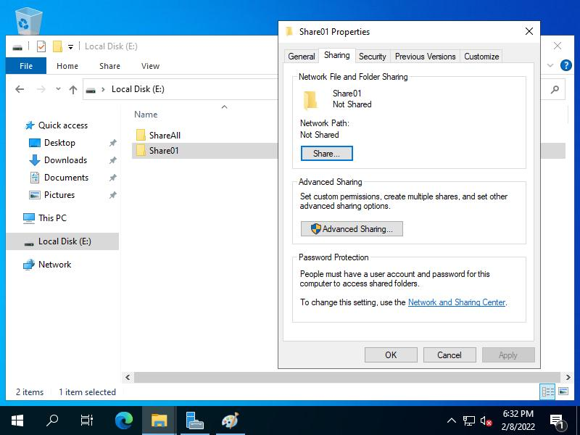

Procedure
- Sign in to your Windows Server VM.
- Open File Explorer → This PC → D:.
- Create a new folder named MusicShare.
- Right-click MusicShare and select Properties → Sharing → Share.
- Use the Share Wizard to select the users or groups you want to share with.
- Complete the wizard, then open Properties → Sharing → Advanced Sharing to review the share settings.
Screenshot 1: Show D:\MusicShare and its Sharing properties.
Note: If the VM has no D: drive, add a virtual disk in VirtualBox/VMware and initialize it in Disk Management before creating the folder.
2. Configure NTFS permissions for Student1 and Student2
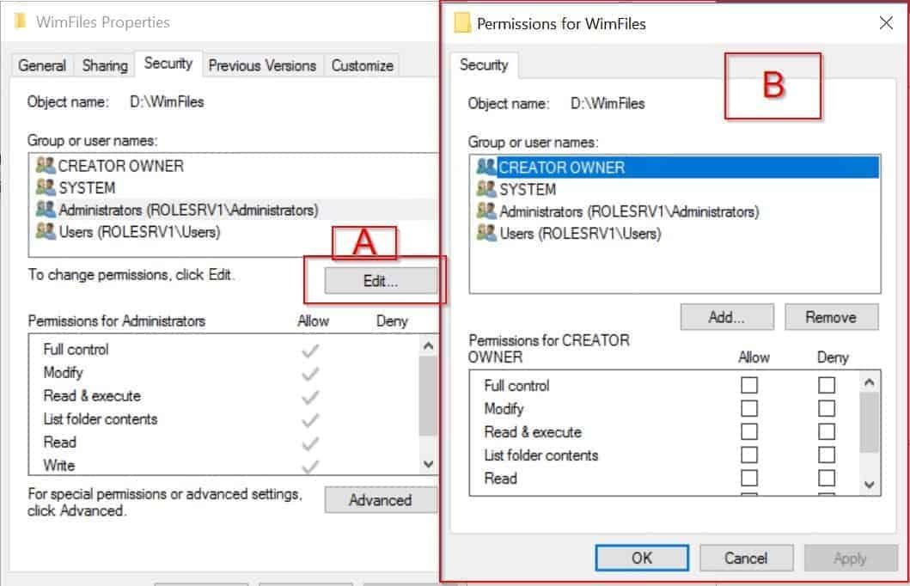

Procedure
- Right-click D:\MusicShare and select Properties → Security → Edit.
- Click Add and enter Student1.
- Grant Student1 Modify, Read & execute, List folder contents, Read, and Write. Modify provides the required read/write access, including creating and deleting files.
- Click Add and enter Student2.
- Grant Student2 Read & execute, List folder contents, and Read only.
- Ensure neither user receives additional permissions through another group that would undermine these restrictions.
- Click Apply → OK.
Use the domain or local account names appropriate to your setup, and click Check Names when adding them.
Screenshot 2: Capture the Security tab showing Student1 and Student2 with their respective permissions.
User | NTFS permission | Expected access
Student1 | Modify | Read, create, edit, and delete files
Student2 | Read & execute | View and open files; cannot modify or delete them
3. Configure share permissions for MusicLovers
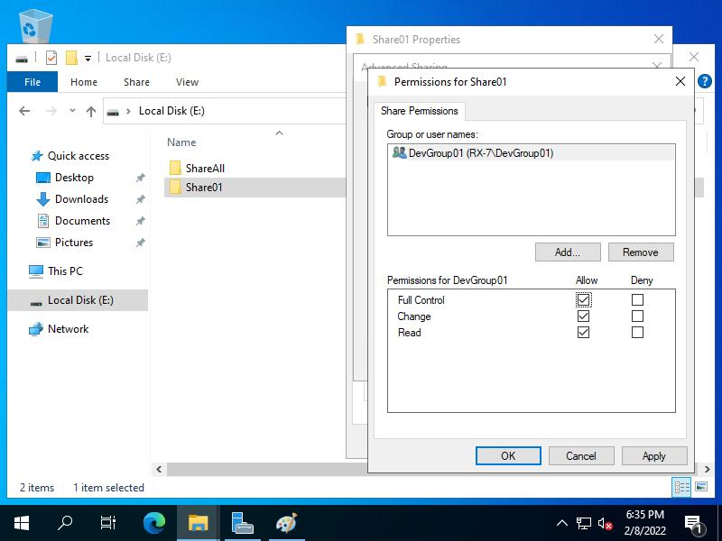

Procedure
- Create a security group named MusicLovers in Active Directory, if it does not already exist.
- Add both Student1 and Student2 to MusicLovers. This is necessary for both accounts to access the share.
- Right-click D:\MusicShare and select Properties → Sharing → Advanced Sharing.
- Check Share this folder and set the share name to MusicShare.
- Click Permissions.
- Remove Everyone if it is listed.
- Click Add, enter MusicLovers, and select Check Names → OK.
- Grant MusicLovers the Change and Read permissions. Do not grant Full Control unless your lab specifically requires it.
- Click Apply → OK to save the changes.
Screenshot 3: Capture the Share Permissions dialog showing only MusicLovers with Change and Read allowed.
Important: Remove other share-level entries that would grant access to unintended users. Administrators may retain access through administrative privileges. NTFS and share permissions work together: the effective access over the network is limited by whichever layer is more restrictive.
4. Test access as Student1 and Student2
Before testing, create a sample file such as song.txt inside D:\MusicShare using an administrator account. Verify that both users are members of MusicLovers.
Access the share from the client using its network path, for example:
\\ServerName\MusicShare
Replace ServerName with your actual server hostname or IP address.
Test A — Student1 copies a file into MusicShare
- Sign in to the client as Student1.
- Open the network share.
- Copy a test file from the client and paste it into \\ServerName\MusicShare.
- Check whether the file appears in the shared folder.
Expected result: The copy should succeed because Student1 has NTFS Modify permissions and the MusicLovers group has share-level Change permission.
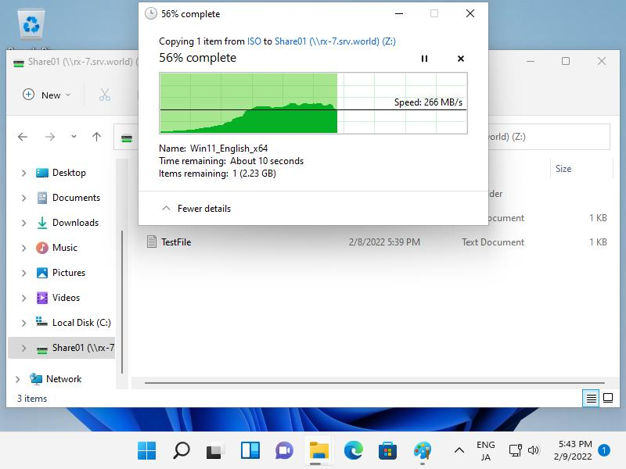

Screenshot 4: Show the copied file in the shared folder or the actual error message.
Test B — Student2 attempts to delete a file
- Sign in as Student2.
- Open the same network share.
- Right-click song.txt or another test file and select Delete.
- Record the result.
Expected result: The deletion should fail because Student2 has only NTFS Read permissions and lacks the Modify/Delete rights required to remove the file. Student2 can still read and open files.
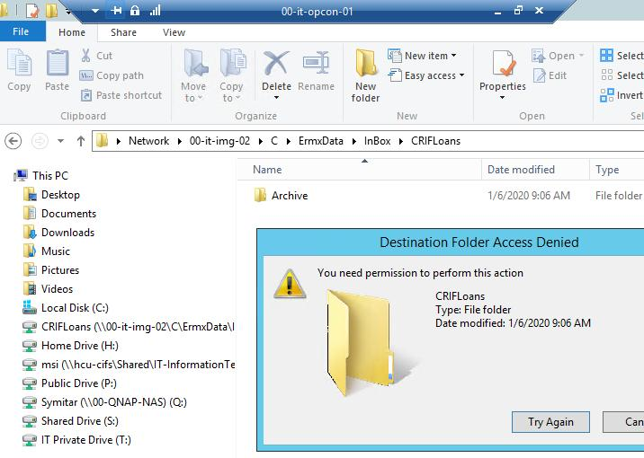

Screenshot 5: Capture the actual deletion error or other observed result.
If the results differ from expectations, check group membership, inherited NTFS permissions, share permissions, and whether the user has signed in again after being added to the group.
Final results table
Test | User | Action | Expected result | Reason
1 | Student1 | Copy a file into MusicShare | Success | NTFS Modify and share Change permissions permit writing.
2 | Student2 | Open or read a file | Success | NTFS Read permission permits viewing files.
3 | Student2 | Delete a file | Denied | Read-only NTFS access does not permit deletion.
4 | Unapproved user | Access the share | Denied | The user is not granted share access through MusicLovers.
Conclusion:
The MusicShare folder was configured with separate NTFS and network share permissions. Student1 can read and modify files, while Student2 can read files but cannot delete them. Share permissions restrict network access to the MusicLovers group, and the effective permissions are determined by the combined share and NTFS restrictions.

