~5.
1. Install Windows Server
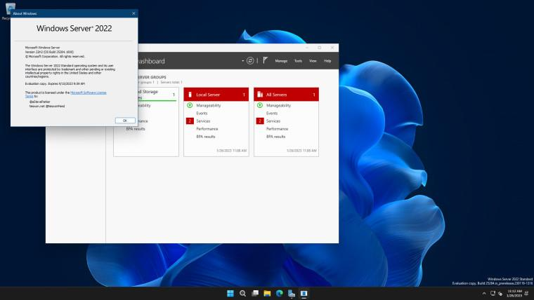

- Install VirtualBox or VMware Workstation.
- Download a Windows Server evaluation ISO from the official Microsoft Evaluation Center.
- Create a VM named MusicStream-Server, allocate suitable RAM, CPU and virtual disk space, and attach the ISO.
- Install Windows Server with Desktop Experience so you have a graphical interface.
- Set the Administrator password and sign in.
Screenshot 1: Capture the installed Windows Server desktop with Server Manager open.
2. Create the musicstream.local domain and users
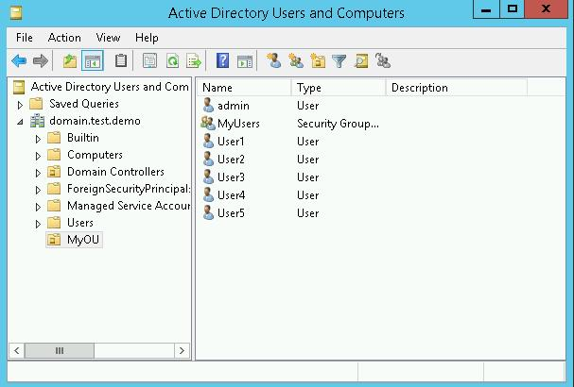

A. Install AD DS
- Open Server Manager → Manage → Add Roles and Features.
- Select Role-based or feature-based installation and your local server.
- Select Active Directory Domain Services (AD DS) and accept the required features.
- Click Next → Install.
- Once installed, select Promote this server to a domain controller.
B. Create a new domain
- Select Add a new forest.
- Enter the root domain name: musicstream.local.
- Keep DNS Server and Global Catalog selected.
- Set a secure DSRM password.
- Accept the appropriate functional levels and default database, log and SYSVOL paths.
- Run the prerequisite check and click Install.
- After the server restarts, sign in with the domain Administrator account.
C. Create the two user accounts
Open Server Manager → Tools → Active Directory Users and Computers.
Under musicstream.local, use the built-in Users container or create an OU named Users if your assignment requires a separate OU.
Right-click the target container and choose New → User. Create:
Display name | User logon name
Arijit Singh | arijit.singh
Neha Kakkar | neha.kakkar
Set strong, separate passwords for both accounts and finish the wizard.
Screenshot 2: Capture ADUC showing both user accounts and the musicstream.local domain.
3. Configure the Control Panel restriction using Group Policy
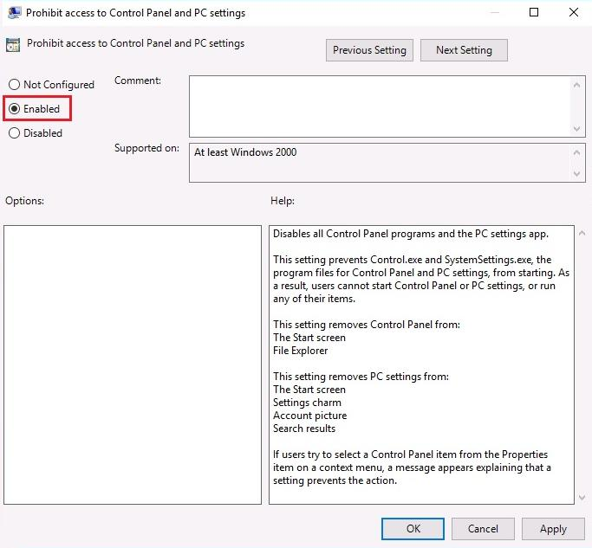

A. Create and link the GPO
- Open Server Manager → Tools → Group Policy Management.
- Expand Forest → Domains → musicstream.local.
- Create an Organizational Unit (OU) named Users if you have not already created it. Move both user accounts into this OU.
- Right-click Group Policy Objects → New and name the GPO BlockControlPanel.
- Right-click the GPO and select Edit.
- Navigate to:
User Configuration → Policies → Administrative Templates → Control Panel
- Open Prohibit access to Control Panel and PC settings.
- Select Enabled, then click Apply → OK.
- Right-click the Users OU, select Link an Existing GPO, and select BlockControlPanel.
Note: The built-in Active Directory Users container is not an OU and cannot have a GPO linked directly to it. Create an actual OU named Users for this assignment.
B. Capture before-and-after evidence
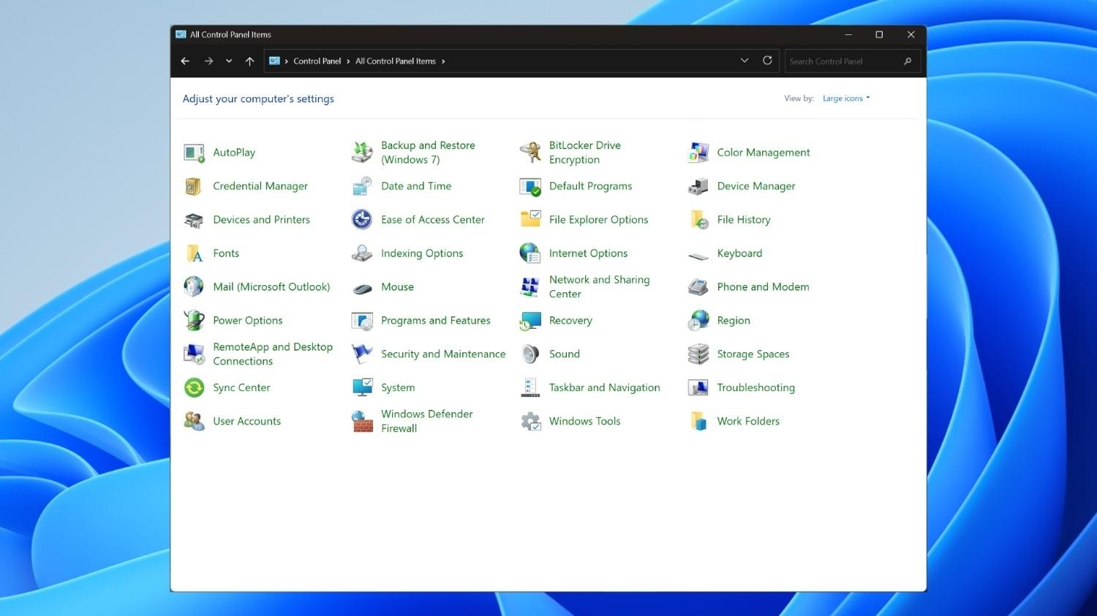
Screenshot 3 — Before
Sign in as a test user before applying the policy and open Control Panel. Capture the open Control Panel window.
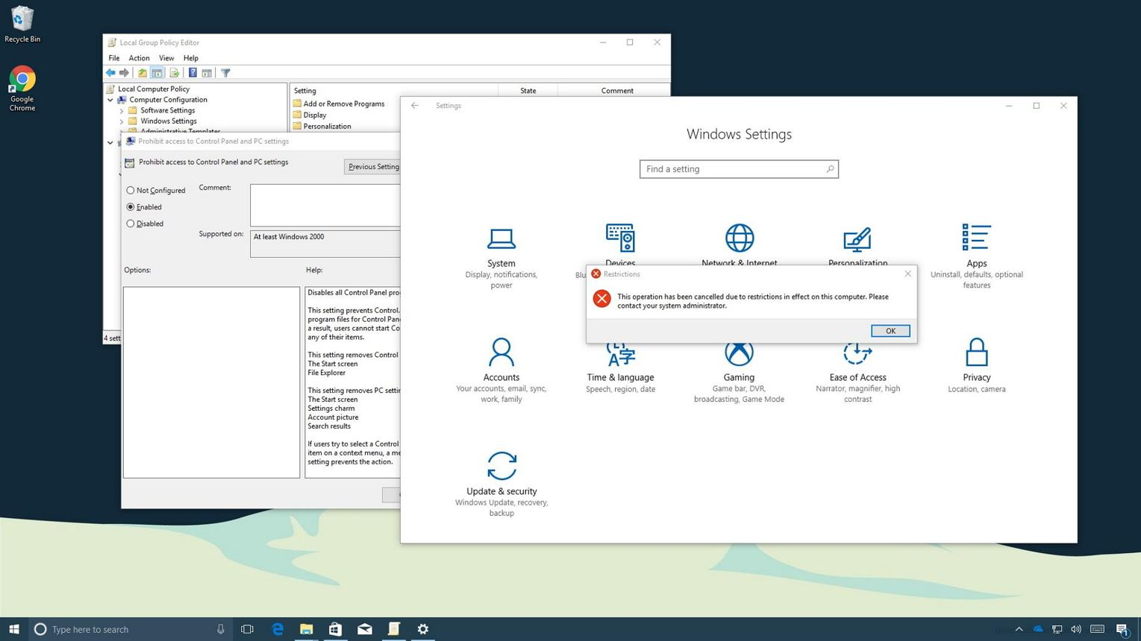
Screenshot 4 — After
Apply the policy, sign in again as the test user, and attempt to open Control Panel. Capture the actual restriction message or observed result.
To refresh the policy on a domain-joined client, open Command Prompt and run:
gpupdate /force
gpresult /r
The policy should appear under the applied User Settings section. If you are testing on the server itself, ensure the test user is signing in interactively to the domain-joined machine and that the policy is in scope.
4. Share the Playlists folder with different permissions
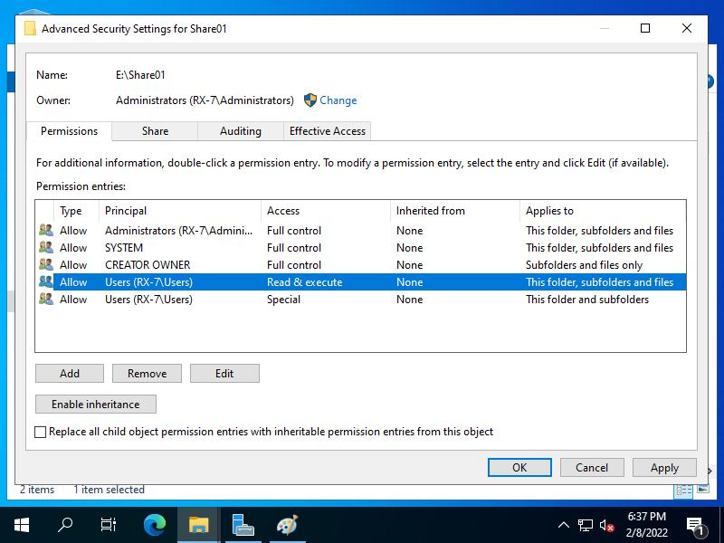
server-world.info
A. Create the folder
- Open File Explorer and create D:\Playlists.
- If there is no D: drive, create and initialize a second virtual disk first.
- Right-click the folder and select Properties → Sharing → Advanced Sharing.
- Check Share this folder and set the share name to Playlists.
- Click Permissions and remove Everyone if present.
- Add arijit.singh and neha.kakkar. Grant Arijit Change and Read, and Neha Read.
- Apply the settings.
B. Configure NTFS permissions
Open Properties → Security → Edit.
User | NTFS permissions | Expected access
arijit.singh | Modify, Read & execute, List folder contents, Read, Write | Can create, edit, read and delete files
neha.kakkar | Read & execute, List folder contents, Read | Can open and read files, but cannot edit or delete them
Ensure neither user receives broader access through another group or inherited permission that defeats the intended restrictions. Keep necessary administrator and SYSTEM permissions.
C. Test the shared folder
From a domain-joined client, use:
\\ServerName\Playlists
Replace ServerName with the actual server hostname or IP address.
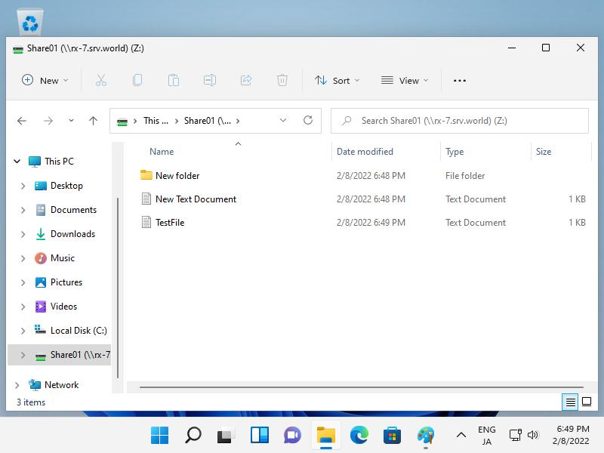
Screenshot 5 — Arijit Singh
Sign in as arijit.singh. Create a text file named playlist.txt, open it, add a line, save it, and capture the result.
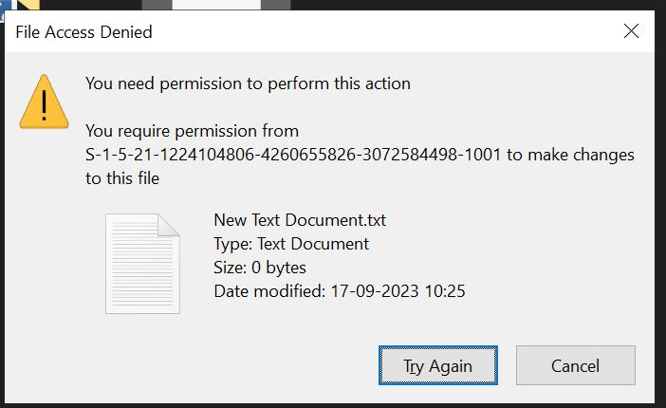
Screenshot 6 — Neha Kakkar
Sign in as neha.kakkar. Open and read playlist.txt, then attempt to edit and save it. Record the actual result and capture any permission error.
Expected results: Arijit's file creation and editing should succeed. Neha should be able to read the file, but saving modifications should be denied. If you are testing on the same client, sign out and sign back in as each account, and ensure the network share is using that account's credentials.
5. Short practical report
The following is a report draft you can use after performing the tasks and confirming the results.
Windows Server and Active Directory Practical Report: MusicStream
Objective
To install Windows Server in a virtual machine, create the musicstream.local domain, configure user accounts and Group Policy, and share a folder with different permissions for two users.
Configuration and Implementation:
1. Windows Server Installation
Windows Server was installed in a virtual machine using VirtualBox or VMware. After installation, the server was started and Server Manager was opened to configure the required server roles.
2. Active Directory Domain and Users
The Active Directory Domain Services role was installed, and the server was promoted to a domain controller for the new forest musicstream.local. Two user accounts, arijit.singh and neha.kakkar, were created in the Users organizational unit.
3. Group Policy Configuration
A Group Policy Object named BlockControlPanel was created and linked to the Users OU. The policy named “Prohibit access to Control Panel and PC settings” was enabled to restrict users from accessing these settings. The policy was refreshed and its application was checked using gpupdate /force and gpresult /r.
4. Shared Folder and Permissions
A folder named Playlists was created on the D: drive and shared over the network. Share permissions and NTFS permissions were configured to give arijit.singh read/write access and neha.kakkar read-only access.
5. Testing and Challenge
The two user accounts were used to test access to the shared folder. Arijit was expected to create and edit files, while Neha was expected to read files but not modify them.
One possible challenge was ensuring that share permissions and NTFS permissions worked together correctly. This can be addressed by checking both permission layers, removing unintended access entries, and verifying the effective access using each user's account.
Conclusion
This practical demonstrates Windows Server installation, Active Directory domain management, Group Policy configuration, and network folder sharing. It shows how different user permissions can be used to restrict system settings and protect shared files in a college or organizational environment.
Evidence
Attach screenshots of the installed server desktop, Active Directory users, the GPO before and after application, and the shared-folder tests. Replace expected outcomes with the actual results obtained during testing.

