Project Name : Pharmacy Drug Management System

Technologies Used:

1. Node JS

2. Java Script

3. CSS

4. HTML

5. Mysql

6. Bootstrap

Step 1 : When you first open the website you will be directed to the Index Page which will give you three options Login. Register As Customer, Register As Vendor (In our case we are logging in as vendor ):

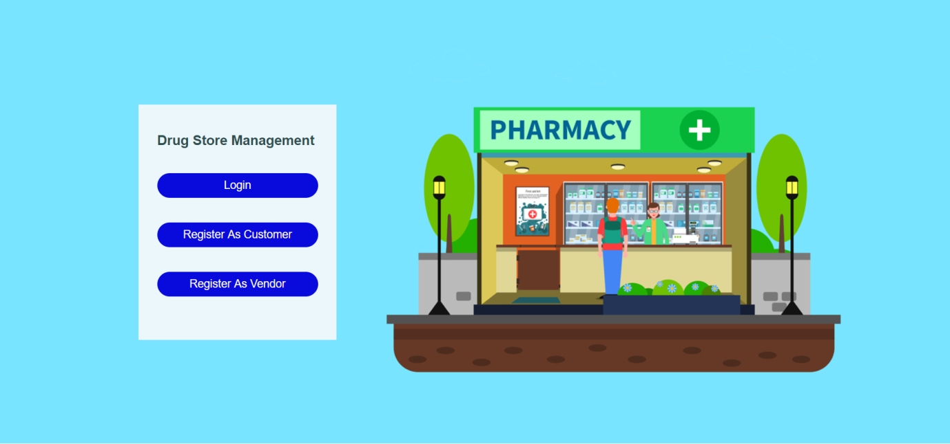

Step2: We Click on the Login Button and then we will be directed to the Below screen which gives us option to select whether we want to login as a Customer or as a vendor

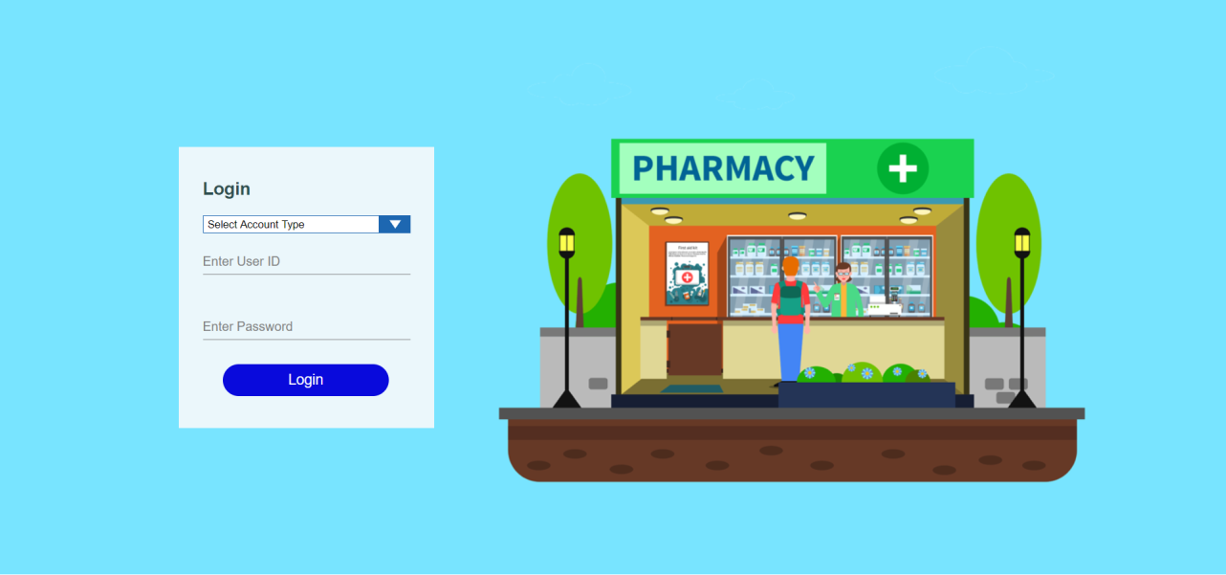

Step 3 : After Logging in we will get to the vendor homepage which is shown as below:

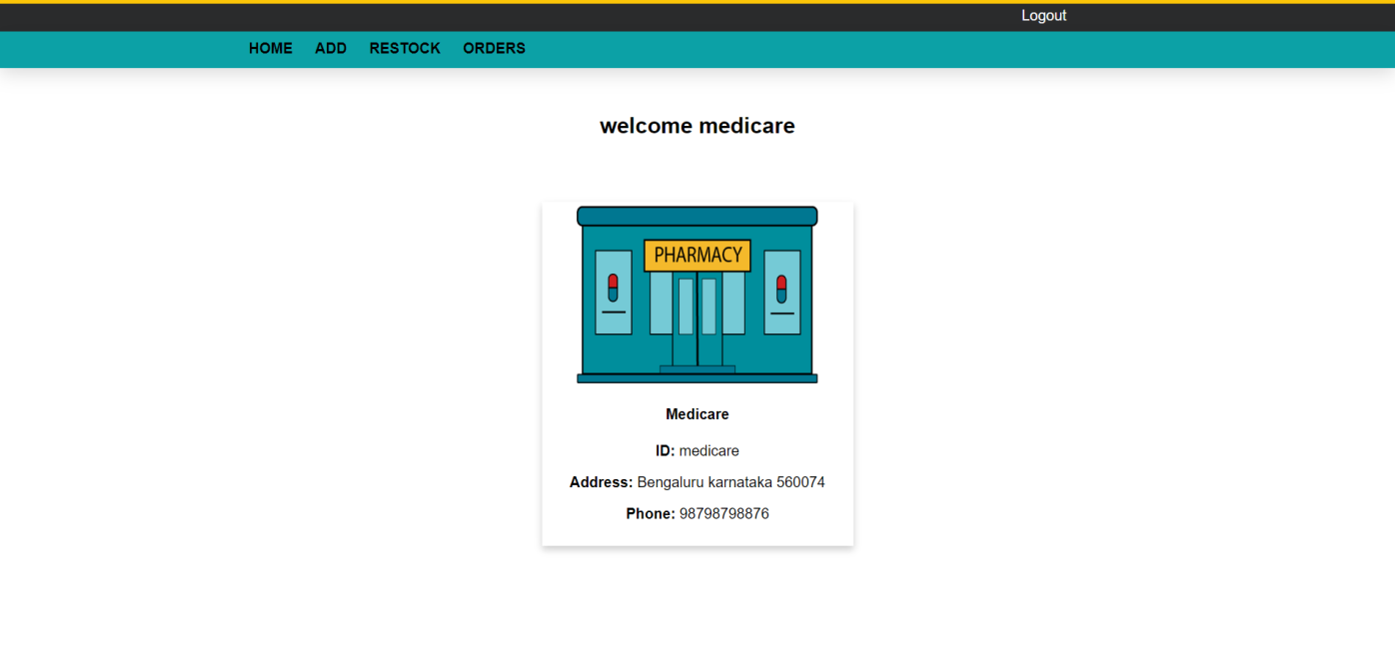

Step 4 : Now we can see do many things as adding medicines,checkinthe sales of medicines and getting the information on the quantity of the medicines as shown below .

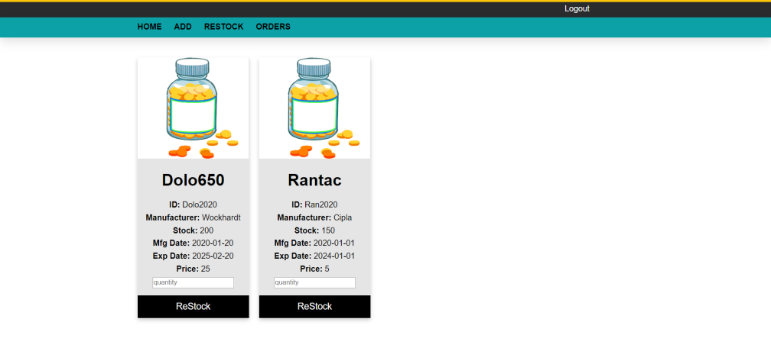

Step 5: Finally you logout using the logout button at the top:

