**DEPARTMENT OF COMPUTER SCIENCE AND ENGINEERING**

**SCHOOL OF ENGINEERING**

**PROJECT REPORT**

**RFID LOCK USING ARDUINO**

# A PROJECT REPORT

***Submitted by***

***Akash S (Reg.No:22011102006)***

***B A Saran (Reg.No:22011102012)***

***Darshan S (Reg.No:22011102014)***

***Jabin Joshua S (Reg.No:22011102027)***

**B.Tech CSE(IoT-A)**

**Introduction to Internet of Things and Laboratory**

# SHIV NADAR UNIVERSITY CHENNAI

MAY 2023

ABSTRACT

The Near Field Communication Radio Frequency Identification Lock using Arduino is an IoT-based system designed to provide secure access control to a specific area using Near Field Communication (NFC) and Radio Frequency Identification (RFID) technologies. The system consists of an Arduino board, an NFC reader module, an RFID reader module, and a servo motor. The NFC reader is used to communicate with smartphones that have NFC capabilities, while the RFID reader is used to identify authorized RFID tags or cards. Once an authorized device or tag is detected, the servo motor unlocks the door, allowing access to the designated area. The system is also connected to the internet through Wi-Fi, enabling remote monitoring and control of the lock. The project showcases the potential of the Arduino platform in developing innovative IoT applications and highlights the importance of secure access control in modern-day security systems.

INTRODUCTION

Radio Frequency Identification (RFID) technology is gaining popularity for its versatility in a wide range of applications. RFID door lock systems are one of the most common applications of this technology, providing reliable, contactless access control with trackable data. In this paper, we explore the benefits of RFID door lock systems for commercial security deployments, highlighting how they offer more security, convenience, and cost-effectiveness compared to traditional locks and keys.

**Overview**

**RFID Technology and Access Control**

An RFID door lock system consists of RFID tags, antennas, an RFID reader, and a transceiver, all of which work together to create a complete system. The user's credential (usually a keycard or fob with an RFID chip) contains unique identifying information called a tag. When the user comes within proximity of an RFID reader, the reader's signal locates the information stored on the user's RFID tag and sends it through antennas and transceivers to authorize the tag in the access control system. Once read, the system will either accept or deny the request to unlock the door. Data from an RFID-enabled system is automatically stored, making it possible to track entry activity in an access control system.

**Objectives of RFID Door Lock Systems**

**Contactless Entry Experience**

One of the most significant benefits of RFID door lock systems is their contactless entry experience. Unlike traditional locks and keys, RFID technology uses radio frequency to send and receive data, so there's no need to swipe a card or enter a key for it to work. This touchless entry experience is becoming more popular as it removes a common touch point and offers greater convenience for users. Using an RFID door lock for business can actually improve the employee experience, making the building safer and more efficient.

**Easy to Configure**

Configuring an RFID entry system is primarily digital, making it much easier to adjust settings and make changes compared to cutting new keys and retooling locks. On a cloud-based system, configuring settings like unlock time, proximity, and permissions can be done remotely, and reflected in your system instantly. Cloud systems also enable instant software updates, which automatically run as soon as they are available, further simplifying the maintenance process.

**More Secure**

RFID tags used in modern key card and fob credentials are highly encrypted, providing added security for your system. Unlike swipe cards and older models of RFID cards that are easily cloned and copied, DESFire EV2 128-bit AES cryptographic cards are equipped with digitally signed identifiers that make it extremely difficult to copy cards , and help prevent criminals from intercepting signals and skimming data. This added security makes RFID door lock systems an ideal choice for businesses looking to protect their property and assets.

**Increased Awareness**

Data is automatically read and stored on RFID devices, making RFID door entry systems a powerful analytics tool for any business. The technology is an important asset when it comes to logging activity, as the system can record every time the RFID reader communicates with a tag. For example, an RFID access control system will track each user's authorized entry as well as failed unlock attempts, giving admins a clear picture of who entered the facility, which door they used, and when the entry event occurred. This data can be used to audit security issues and streamline operations across any size organization.

**Low-Maintenance Cost**

Another key benefit of RFID door lock systems is their low-maintenance cost. RFID key cards and fobs can be reprogrammed, so instead of replacing credentials, businesses can simply reconfigure them as needed. New RFID credentials are also fairly inexpensive, and businesses can usually save by ordering them in bulk. Similarly, when RFID card readers need a software update, you usually don't need to replace the entire system. Service fees and costs of RFID door access control will vary depending on the provider and size of the deployment, but RFID door lock systems remain.

**LITERATURE SURVEY :**

This 4 papers explores the implementation of RFID lock systems using Arduino. It provides an overview of the existing research, methodologies, and applications in this field. RFID locks with Arduino are popular due to affordability, flexibility, and easy integration. This survey analyzes relevant literature to understand the current state of RFID lock systems using Arduino, including hardware, software, security, and future research. It is a valuable resource for researchers and developers interested in RFID lock systems implemented with Arduino.

This survey focuses on RFID lock systems, which have gained significant attention due to their convenience and security features. RFID locks utilize Radio Frequency Identification technology to enable access control through the use of RFID tags or cards. The survey aims to provide a comprehensive overview of existing research and developments in RFID lock systems, covering topics such as system architecture, authentication mechanisms, integration with other technologies, and security considerations. By analyzing the literature, this survey offers valuable insights into the advancements, challenges, and potential future directions in the field of RFID lock systems, catering to researchers, practitioners, and individuals interested in implementing or enhancing such systems.

**MOTIVATION:**

RFID (Radio Frequency Identification) technology has become increasingly popular in recent years due to its ability to provide secure and convenient access control solutions.

By undertaking a project to develop an RFID lock, to get the opportunity to learn about the technology behind RFID, including the communication protocols, circuit design, and software development. This project can also help to develop valuable skills in project management, problem-solving, and teamwork.

Furthermore, an RFID lock project has practical applications and can be useful for future projects or career opportunities. It can also demonstrate student’s abilities to potential employers or graduate schools.

Overall, developing an RFID lock for a college project can be a challenging and rewarding experience that can help to gain knowledge and skills that can be applied in various fields and settings.

PIN DIAGRAM :

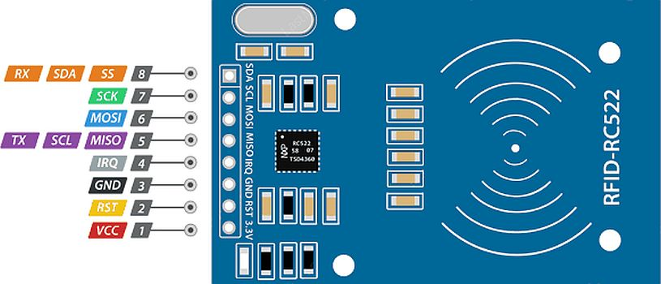

Pin Diagram of Module : RFID-RC522

BLOCK DIAGRAM :

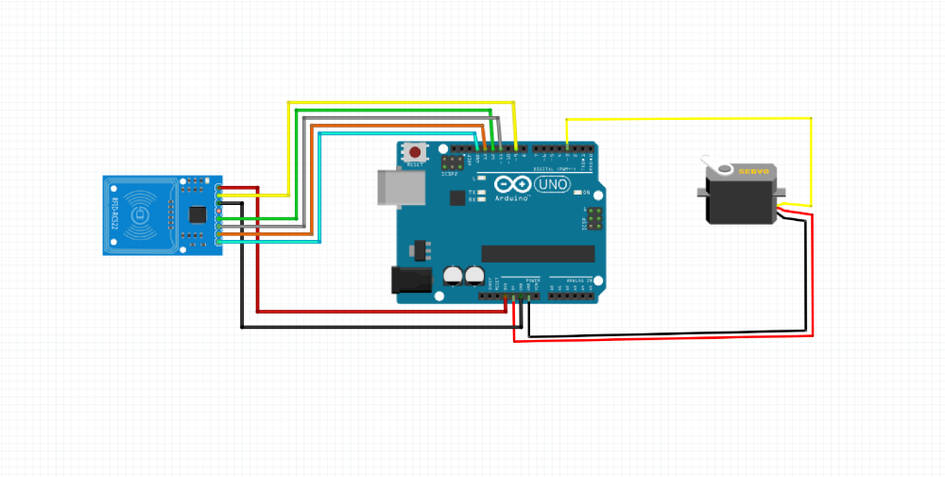

CIRCUIT DIAGRAM:

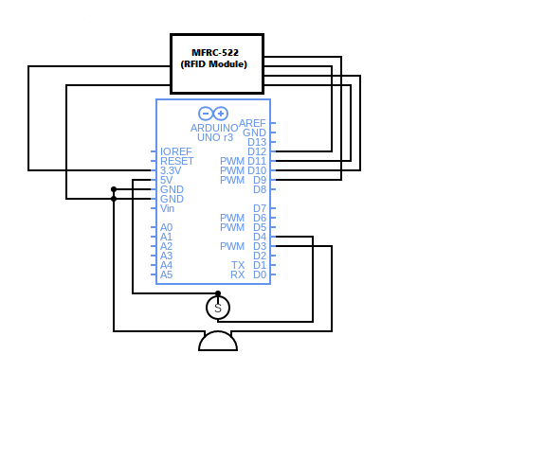

**SOFTWARE USED :** Arduino IDE

**HARDWARE SPECIFICATIONS:**

1. RFID Senosr RC 522
2. Servo motor SG-90
3. Arduino UNO
4. I2C Module
5. LCD Display(16x2)

**Code**

**OUTPUT:**

Initial Setup :

The RFID Lock system is connected to the Laptop(as a power source) in the initial.

Access Authorized :

When the RFID Module is tapped with a NFC tag it opens the Lock as the UID(Unique Identification) Value is registered in the Arduino Uno.

And prints “ Authorized Access” as given below.

Access Denied :

When the RFID Module is tapped with a NFC card it does not open the Lock as the UID(Unique Identification) Value is not registered in the Arduino Uno code.

And prints “Access Denied”.

**APPLICATIONS**

1. **Access Control:** RFID locks are commonly used for access control in buildings, offices, hotels, and residential complexes. Instead of traditional key-based locks, RFID locks use RFID cards or key fobs to grant access to authorized individuals. This offers convenience, enhanced security, and the ability to track access activities.
2. **Automotive Industry:** RFID locks can be utilized in vehicles for keyless entry and ignition systems. With an RFID-enabled key fob, the vehicle can be unlocked and started without physically inserting a key. This technology offers convenience and enhances the security of the vehicle.
3. **Asset Tracking:** RFID locks can be used for tracking and securing valuable assets in industries such as logistics, warehousing, and healthcare. Assets, such as containers, pallets, or medical equipment, can be fitted with RFID tags. These tags are read by RFID locks placed at entry or exit points, allowing real-time tracking and monitoring of the assets.
4. **Cabinets and Lockers:** RFID locks can be installed in cabinets, lockers, or storage units to provide secure access control. This is commonly seen in gyms, workplaces, educational institutions, and libraries, where individuals can use their RFID cards or key fobs to unlock and access their assigned lockers or storage spaces.
5. **Supply Chain and Inventory Management:** RFID locks can be used in warehouses and distribution centers to track inventory movement. By placing RFID locks at various checkpoints, it becomes possible to monitor the movement of goods, improve inventory accuracy, and enhance supply chain efficiency.
6. **Data Center Security:** RFID locks are employed to secure access to data centers, server rooms, or IT equipment. Authorized personnel can use RFID cards or badges to gain entry into restricted areas, ensuring only authorized individuals have physical access to critical infrastructure.

**INFERENCE**

It can be inferred that RFID lock systems using Arduino are becoming increasingly popular for secure access control applications. These systems typically use an RFID reader to identify authorized users and a servo motor to lock or unlock the door. The Arduino board is used to control the operation of the system, and Wi-Fi connectivity is often included for remote monitoring and control.

The implementation of RFID lock systems using Arduino is relatively simple and cost-effective, making it an attractive option for a variety of applications. These systems can be customized to meet specific requirements, and the modular nature of the Arduino platform makes it easy to add additional features or functionality as needed.

Overall, the literature suggests that RFID lock systems using Arduino are a promising solution for secure access control in various settings, including homes, offices, and industrial facilities. With further research and development, these systems are likely to become even more sophisticated and versatile in the future.

**CONCLUSION**

In this study, a digital security system contains door lock system using passive RFID is been implemented. A centralized system is being deployed for controlling and transaction operations. The door locking system functions in real time as when the user put the tag in contact with the reader, the door open and the check-in information is stored in central server along with basic information of the user. RFID technology is used to provide solution for secure access of a space while keeping record of the user.

**FUTURE STEPS**

**Integration with cloud-based services:** Adding cloud connectivity to the RFID lock system using Arduino can enable users to remotely monitor and control the lock system from anywhere in the world. This can be accomplished by integrating the system with cloud-based services such as AWS IoT, Google Cloud IoT, or Microsoft Azure IoT.

**Biometric authentication:** Incorporating biometric authentication technologies, such as fingerprint or facial recognition, into the RFID lock system can enhance security and reduce the risk of unauthorized access.

**Battery backup:** Providing a battery backup to the RFID lock system can ensure that the system remains functional during power outages or other disruptions.

**Real-time alerts:** Adding real-time alert functionality to the RFID lock system can enable users to receive notifications when the door is locked or unlocked, or when an unauthorized access attempt is detected.

**Multi-factor authentication:** Incorporating multiple layers of authentication, such as RFID and password or PIN, can increase the security of the RFID lock system and reduce the risk of unauthorized access.

**Integration with other IoT devices:** Integrating the RFID lock system with other IoT devices, such as cameras, sensors, or alarms, can provide a more comprehensive security solution for homes, offices, or industrial facilities.

**REFERENCES**:

IEEE Papers:

[1] Z. Pala and N. Inanc, "Smart Parking Applications Using RFID Technology," 2007 1st Annual RFID Eurasia, Istanbul, Turkey, 2007, pp. 1-3, doi: 10.1109/RFIDEURASIA.2007.4368108.

[2] Lan Zhang, Huaibei Zhou, Ruoshan Kong and Fan Yang, "An improved approach to security and privacy of RFID application system," Proceedings. 2005 International Conference on Wireless Communications, Networking and Mobile Computing, 2005., Wuhan, China, 2005, pp. 1195-1198, doi: 10.1109/WCNM.2005.1544256.

[3] D. P. Villame and J. S. Marciano, "Carrier suppression locked loop mechanism for UHF RFID readers," 2010 IEEE International Conference on RFID (IEEE RFID 2010), Orlando, FL, USA, 2010, pp. 141-145, doi: 10.1109/RFID.2010.5467234.

[4] X. Zhang, V. Lakafosis, A. Traille and M. M. Tentzeris, "Performance analysis of "fast-moving" RFID tags in state-of-the-art high-speed railway systems," 2010 IEEE International Conference on RFID-Technology and Applications, Guangzhou, China, 2010, pp. 281-285, doi: 10.1109/RFID-TA.2010.5529918.

Websites:

1. Arduino website: https://www.arduino.cc/

2. IEEE website: <https://ieeexplore.ieee.org/Xplore/home.jsp>