IoT Based Smart Driver Safety System
Submitted by

DARSHAN R RA2411047020049
NADEEMUL HAQ RA2411047020044

Under the guidance of
Dr. MOHAN. M
(Assistant Professor, Department of CSE w/s in AIML)

21CSC205P/DATA BASE MANAGEMENT SYSTEM
PROJECT REPORT
V SEMESTER/III YEAR
COMPUTER SCIENCE AND ENGINEERING WITH SPL.IN AI
FACULTY OF ENGINEERING AND TECHNOLOGY



SRM INSTITUTE OF SCIENCE AND TECHNOLOGY RAMAPURAM, CHENNAI
OCTOBER 2026

CERTIFICATE
This is to certify that the project report entitled “IoT-Based Smart Driver Safety and Driving Behavior Monitoring System Using ESP32 and Machine Learning” is a bona fide record of the project work carried out by [Student Name], [Register Number], under the guidance of [Guide Name], in partial fulfillment of the requirements for the award of the Bachelor of Technology degree in Artificial Intelligence.
The work presented in this report has been prepared in accordance with the academic requirements of the institution. Statements concerning implementation status, experimental testing and measured performance are limited to evidence available at the time of report preparation.
Project Guide: ____________________ Head of Department: ____________________
Date: ____________________ Place: ____________________

DECLARATION
The undersigned declares that this project report is prepared for academic evaluation and that the technical description is intended to represent the specified IoT-based driver safety system. No experimental result, hardware measurement, machine-learning metric, photograph or repository URL has been fabricated. Where actual project evidence was unavailable during preparation, the report identifies the information as “[To be filled with actual experimental value]”, “[To be filled with actual configuration]”, or as a proposed design element.
Signature: ____________________
Name: [To be filled]
Date: ____________________

ACKNOWLEDGEMENT
The successful development of an IoT and machine-learning project requires support across embedded systems, data engineering, software development and academic guidance. The project team acknowledges the support of the institution, department, project guide, laboratory staff and peers who contribute to the learning environment required to undertake such interdisciplinary work.
Special acknowledgement is due to the open technical ecosystems surrounding ESP32 development, inertial sensing, Python-based APIs, MongoDB and React, as well as the scholarly community whose work on driver behavior recognition informs the methodology used in this report.

ABSTRACT
Road safety depends not only on vehicle technology and road infrastructure but also on the manner in which vehicles are operated. Risky driving patterns such as excessive speed, harsh braking, sudden acceleration and sharp steering events can be monitored through a combination of inertial and positioning sensors. This project proposes an IoT-based smart driver safety and driving behavior monitoring system built around an ESP32 microcontroller, MPU6050 inertial measurement unit, GPS module, local buzzer/LED indicators, Wi-Fi communication, a FastAPI backend, MongoDB storage, a machine-learning classification layer and a React-based dashboard.
The embedded unit is designed to acquire three-axis acceleration, three-axis angular velocity and GPS information. The measurements are preprocessed into physically meaningful features and evaluated using threshold-based event detection. Detected events are transmitted over Wi-Fi to the backend, stored for historical analysis and supplied to an ML model for classification into SAFE, MODERATE or RISKY behavior. A safety score is computed from event penalties and can be visualized together with live telemetry, event history and trip information.
The report intentionally distinguishes design methodology from experimentally verified performance. During inspection of the available project workspace, no identifiable source code, hardware test logs, project-specific dataset, measured ML metrics or authentic dashboard screenshots for this driver-safety project were found. Consequently, this report provides the complete technical design, implementation methodology, data schema, evaluation plan and result templates without inventing measurements. Actual experimental results must be inserted after hardware integration and controlled road or test-track evaluation.
The architecture is modular and suitable for later extension with OBD-II/CAN data, edge inference, mobile applications, MQTT, larger real-world datasets and additional safety functions such as drowsiness detection.
Keywords: Internet of Things, ESP32, MPU6050, GPS, driver behavior, machine learning, FastAPI, MongoDB, React, safety score, intelligent transportation.

TABLE OF CONTENTS
A Word-compatible table-of-contents field is inserted conceptually through the heading structure. After opening the generated document in Microsoft Word or LibreOffice, update the Table of Contents to populate exact page numbers.
- Chapter 1 – Introduction
- Chapter 2 – Literature Survey
- Chapter 3 – Existing System / Existing Algorithm
- Chapter 4 – Proposed System
- Chapter 5 – Implementation
- Chapter 6 – Results and Discussion
- Chapter 7 – Conclusion and Future Work
- References
- Appendix
- Abbreviations

LIST OF FIGURES
Figure 4.1. Overall System Architecture
Figure 4.2. Hardware Block Diagram
Figure 4.3. ESP32–MPU6050–GPS Connection Concept
Figure 4.4. End-to-End System Workflow
Figure 4.5. Driving Event Detection Flow
Figure 4.6. Machine-Learning Pipeline
Figure 4.7. Logical MongoDB Data Architecture
Figure 4.8. Dashboard Architecture / Screen Concept

LIST OF TABLES
Table 2.1. Comparative Analysis of Selected Literature
Table 3.1. Existing and Proposed System Comparison
Table 4.1. Functional Layers
Table 4.2. Event Detection Design Rules
Table 4.3. Mathematical Variables
Table 5.1. Hardware Requirements
Table 5.2. Software Requirements
Table 5.3. Dataset Feature Schema
Table 5.4. Proposed API Contract
Table 5.5. MongoDB Collections
Table 6.1. Experimental Test Matrix
Table 6.2. Experimental Results Template
Table 6.3. ML Performance Template
Table 6.4. Literature-Based Comparison

ABBREVIATIONS / ACRONYMS
Abbreviation | Meaning
IoT | Internet of Things
ESP32 | Espressif ESP32 family microcontroller/SoC
GPS | Global Positioning System
IMU | Inertial Measurement Unit
API | Application Programming Interface
ML | Machine Learning
REST | Representational State Transfer
HTTP | Hypertext Transfer Protocol
JSON | JavaScript Object Notation
I2C | Inter-Integrated Circuit
UART | Universal Asynchronous Receiver/Transmitter
GPIO | General-Purpose Input/Output
UI | User Interface
UX | User Experience
RF | Random Forest
SVM | Support Vector Machine
KNN | K-Nearest Neighbors
F1 | F1-score
TP | True Positive
TN | True Negative
FP | False Positive
FN | False Negative
OBD-II | On-Board Diagnostics II
CAN | Controller Area Network
CNN | Convolutional Neural Network
API | Application Programming Interface
IMU | Inertial Measurement Unit

CHAPTER 1 – INTRODUCTION

1.1 Background of the Project
Road transportation is a cyber-physical environment in which human decisions, vehicle dynamics, road conditions, traffic and external disturbances interact continuously. Driver behavior is therefore an important factor in road safety research. Conventional safety systems tend to concentrate on vehicle-level protection, while a complementary class of systems focuses on observing driving behavior itself. Driving style recognition research has examined how sensor measurements and machine-learning techniques can be used to characterize driver behavior and support intelligent transportation applications [1].
Risky behavior may appear as repeated speeding, abrupt longitudinal acceleration or deceleration, aggressive cornering, unstable motion, or combinations of several events. A monitoring system that can detect such patterns can provide feedback to a driver, generate historical trip analytics and support safety-oriented decision making. Research on smartphone-based sensing demonstrates that accelerometers, gyroscopes and GPS can provide useful signals for braking, acceleration and turning analysis, while also highlighting challenges related to sensor orientation, sampling and noisy observations [2], [3].
The Internet of Things provides an architectural framework for connecting physical sensing devices to software services. In the proposed system, an ESP32-based embedded unit acts as the edge sensing node. The MPU6050 supplies inertial measurements, while a GPS module supplies position and speed information. Local alerts are provided through a buzzer or LED. Wi-Fi connects the embedded node to a backend service, where data can be validated, stored and analyzed. The resulting information can be exposed through a web dashboard.
The system therefore combines embedded sensing, wireless communication, backend processing, persistent storage and machine learning. The design is intentionally modular: the embedded layer does not need to perform the entire analytics workload, and the dashboard is separated from hardware-specific code. This separation makes the system easier to test and extend.

1.2 Problem Statement
A driver safety monitoring solution is required that can continuously observe selected driving parameters, detect potentially risky events, provide immediate local feedback and maintain a historical record for analytics. Conventional approaches may be fragmented: a GPS tracker can report location but not necessarily characterize inertial behavior; a simple threshold alarm can detect a single event but may not provide a longer-term behavior classification; and a cloud dashboard without edge feedback may delay immediate driver notification.
The problem addressed by this project is the design of a low-cost, connected monitoring platform that integrates inertial sensing and GPS information and transforms them into event-level and trip-level safety information. The system must remain transparent about uncertainty because sensor noise, vehicle mounting, road geometry and network interruptions can affect the measurements.

1.3 Motivation
The motivation for the project comes from the need to make driver-behavior analytics accessible at the prototype and educational level. Commercial telematics platforms can integrate many vehicle signals, but a B.Tech project benefits from a self-contained architecture whose sensing and communication paths can be understood and modified. ESP32 provides Wi-Fi connectivity and is designed for IoT applications [4]. The MPU6050 combines three-axis acceleration and three-axis angular-rate sensing in a compact device [5]. Together with GPS, these components provide a practical foundation for a connected driving-monitoring prototype.
Another motivation is the opportunity to combine deterministic event rules with machine learning. Threshold rules are interpretable and useful for immediate alerts, whereas ML can capture combinations of features that may not be represented by a single threshold. Literature indicates that driving-event recognition benefits from preprocessing and careful treatment of noisy or orientation-dependent sensor data [2], [3], [6].

1.4 Aim of the Project
The aim is to design and implement a hardware-integrated IoT system that acquires vehicle motion and GPS data using an ESP32-based sensing node, detects risky driving events, transmits telemetry to a backend, stores historical data, classifies overall driving behavior using machine learning and presents a safety score through a web dashboard.

1.5 Objectives
- Develop an ESP32-based sensing system for continuous acquisition of inertial and positioning data.
- Acquire acceleration and gyroscope measurements from the MPU6050.
- Obtain GPS-derived position, time and speed information from the selected GPS module.
- Detect overspeeding, harsh braking, sudden acceleration and sharp turns using calibrated event rules.
- Provide local alerts using a buzzer and/or LED when a configured event is detected.
- Transmit telemetry and event information through Wi-Fi to a FastAPI backend.
- Store telemetry, trips, events and predictions in MongoDB for historical analysis.
- Construct a machine-learning pipeline for classification into SAFE, MODERATE and RISKY behavior.
- Calculate a transparent safety score based on event penalties and/or model-supported analytics.
- Provide a React dashboard for live status, trip history, events, GPS information and safety analytics.

1.6 Scope of the Project
The current scope covers a prototype-level hardware and software stack. Hardware scope includes the ESP32, MPU6050, GPS, local alert devices and power arrangements. Software scope includes embedded firmware, network communication, FastAPI services, MongoDB storage and a React dashboard. The ML scope includes preprocessing, feature engineering, supervised classification and evaluation using standard classification metrics.
The project does not claim integration with the vehicle CAN bus, engine ECU, braking controller or certified automotive safety systems. It also does not claim that the proposed thresholds are universally valid for all vehicles, road types or driving environments. Such parameters require calibration against a sufficiently diverse real-world dataset.

1.7 Contributions of the Project
- An integrated sensing architecture combining inertial and GPS measurements.
- A modular IoT pipeline from embedded telemetry to backend analytics.
- An interpretable event-detection layer for common driving-risk events.
- A machine-learning layer for higher-level behavior classification.
- A trip-level safety score designed to summarize event history.
- A dashboard-oriented data model for live and historical visualization.
- A documented evaluation framework that separates measured results from proposed methodology.

1.8 Organization of the Report
Chapter 1 establishes the motivation, objectives and scope. Chapter 2 reviews research on driver behavior recognition, inertial sensing, GPS-based monitoring and machine learning. Chapter 3 describes existing approaches and their limitations. Chapter 4 presents the proposed architecture, algorithms, mathematical model and workflows. Chapter 5 describes implementation requirements, dataset handling, APIs, storage and user-interface design. Chapter 6 defines the experimental setup and provides result templates while preserving academic integrity where measurements are unavailable. Chapter 7 summarizes the work and presents limitations and future enhancements. The appendices provide implementation-oriented material.

CHAPTER 2 – LITERATURE SURVEY

2.1 Introduction
The literature survey establishes the technical foundation for the proposed driver-safety system. The review focuses on how driving behavior can be inferred from motion and positioning sensors, how machine learning has been applied to event recognition, and what practical challenges arise when sensing is performed from a device mounted inside a vehicle.

2.2 Review of Existing Research
Castignani et al. examined smartphone-based driving analytics and described a pipeline in which device orientation, inertial measurements and GPS can be combined to detect braking, acceleration and cornering patterns. Their work is especially relevant to this project because it emphasizes the importance of orientation correction and sensor fusion rather than assuming that raw accelerometer axes directly correspond to vehicle axes [2].
Bengler et al. and related intelligent-transportation research emphasize the importance of understanding human driving behavior in advanced driver-assistance and connected-vehicle environments. A survey by Dehzangi et al. reviews driving-style recognition methods and highlights machine-learning approaches for characterizing driver style [1]. Such research motivates the use of a classification layer above individual event detectors.
A later review of smartphone sensing for driving behavior identifies both opportunities and challenges. Low-cost mobile sensing enables large-scale data collection, but sampling rate, preprocessing, privacy, security, data quality and methodological consistency can affect the reliability of the resulting models [3]. These observations directly influence the design of the present system: the report treats sensor orientation, missing values, network gaps and false positives as first-class engineering concerns.
Research on robust driving-event recognition has explored filtering, feature extraction and classifiers such as Random Forest and Artificial Neural Networks. One study reports that filter selection can materially affect turn-detection performance, illustrating why preprocessing should be evaluated rather than treated as a trivial step [6]. Another study used motion sensors and a physical model with Kalman filtering and adaptive time windows to improve behavior recognition [7].
An Indian driver smartphone-sensor dataset has also been published for machine-learning research, demonstrating the availability of data containing accelerometer and gyroscope measurements for driver-behavior modeling [8]. Such public datasets can be useful when project-specific hardware data are insufficient, but a model trained on a public smartphone dataset should not automatically be described as validated for a particular ESP32/MPU6050 mounting configuration. Sensor characteristics, placement and sampling behavior can differ.
Recent work on harsh braking and harsh acceleration has used high-resolution telematics together with contextual data and imbalanced machine-learning methods. This supports the broader view that event occurrence is influenced by multiple factors and that class imbalance should be considered during model development [9].

2.3 Comparative Analysis of Previous Methods
Author / Year | Method | Sensors | Communication | ML / Analytics | Advantages | Limitations
Dehzangi et al., 2018 [1] | Driving-style recognition survey | Multiple vehicle/sensor modalities | Varies | ML survey | Broad taxonomy and research direction | Survey rather than a single deployable prototype
Castignani et al., 2017 [2] | Smartphone driving analytics | Accelerometer, gyroscope, GPS | Mobile device | Rough-set / rule learning | Handles device reorientation; detects multiple events | Smartphone-specific; controlled and free-driving conditions
Smartphone sensing review, 2021 [3] | Literature framework | Smartphone sensors | Mobile/crowdsensing | Data mining / ML | Identifies end-to-end challenges | Highlights unresolved data-quality and privacy issues
Driving event recognition, 2023 [6] | Filtered motion signals | Accelerometer, gyroscope | Local recording | RF + ANN | Robustness and filtering analysis | Performance varies across unseen conditions
Model-based recognition, 2016 [7] | Physical model + filtering | 9-axis motion sensor | Local | Statistical learning | Explicit physical modeling and filtering | More complex sensing configuration
Indian driver dataset, 2022 [8] | Dataset construction | Accelerometer, gyroscope | Smartphone | Dataset for ML | Relevant regional driving data | Not identical to the proposed hardware
Harsh event analysis, 2024 [9] | Naturalistic telematics | Smartphone telematics + context | Telematics | XGBoost / SHAP | Handles imbalanced harsh events | Requires richer contextual data

2.4 Research Gap
The reviewed work indicates that no single sensing modality completely solves the driver-behavior problem. GPS is useful for speed and location but is affected by signal conditions and may not represent short-duration vehicle dynamics. Inertial sensors capture motion but are sensitive to mounting orientation and vibration. Machine learning can combine features but depends strongly on representative labels and data quality.
The project therefore targets an educationally accessible integration point: a dedicated ESP32 sensing node, an IMU, GPS, local alerts, networked storage, a backend analytics layer and a dashboard. The contribution is not claimed as a new state-of-the-art driver-recognition algorithm. Instead, the engineering contribution is the integration of these components into a modular IoT architecture and the definition of an evaluation methodology suitable for a B.Tech prototype.

2.5 Summary
The literature supports the feasibility of inertial and GPS sensing for driving-event analysis while emphasizing preprocessing, orientation handling, contextual variation and careful evaluation. These findings are reflected in the proposed system architecture and its limitations.

CHAPTER 3 – EXISTING SYSTEM / EXISTING ALGORITHM

3.1 Existing System
Existing driver-monitoring approaches can be grouped into traditional driver observation, smartphone-based sensing, commercial telematics and research-oriented vehicle instrumentation. Traditional approaches rely heavily on human observation and cannot provide continuous quantitative analytics. Smartphone solutions reduce hardware cost but introduce mounting and orientation problems. Commercial telematics can access richer vehicle signals but may require proprietary hardware or vehicle interfaces.
GPS tracking systems provide route, speed and location information and are widely used for fleet management. However, GPS alone does not reliably capture all short-duration events. A sudden steering movement, for example, may be better reflected in angular-rate or lateral-acceleration signals than in the position trace.

3.2 Existing Algorithm / Methodology
Threshold-based methods are common because they are simple and interpretable. A speed threshold can identify overspeeding. A longitudinal acceleration threshold can identify hard acceleration or braking. A lateral acceleration or yaw-rate threshold can identify aggressive turns. Threshold systems are attractive for embedded implementations because they require limited computational resources.
Rule-based classification can aggregate events over a trip. For example, a driver with few events can be labeled SAFE, while repeated severe events can move the driver toward MODERATE or RISKY. The limitation is that fixed rules may not generalize across vehicles, road types or traffic conditions.
Machine-learning methods provide an alternative by learning relationships among multiple features. Common candidates include Logistic Regression, Decision Trees, Random Forest, Support Vector Machines, KNN and neural networks. The final model should be selected empirically using a held-out dataset rather than assuming a particular classifier will always be superior.

3.3 Limitations of Existing System
- High cost or proprietary nature of some telematics systems.
- Limited access to vehicle-specific signals in low-cost prototypes.
- Single-sensor systems can miss complementary information.
- Immediate feedback is often separated from historical analytics.
- Rule-based systems may be sensitive to fixed thresholds.
- ML systems can fail when training data do not represent new drivers or road conditions.
- Network connectivity can interrupt cloud synchronization.

3.4 Challenges in Existing Approach
Challenge | Technical Effect | Mitigation in Proposed Design
Sensor noise | False event detections | Filtering, windowing and calibration
GPS uncertainty | Speed/location errors | Validity flags, smoothing and sensor cross-checking
Device orientation | Axis interpretation changes | Mounting convention and orientation-aware features
Road conditions | Events may be road-induced | Contextual logging and conservative thresholds
Network loss | Missing cloud telemetry | Local buffering / retry strategy
Class imbalance | Biased ML model | Stratified split, class weights or resampling
False positives | Driver trust decreases | Event persistence, multi-sensor confirmation

CHAPTER 4 – PROPOSED SYSTEM

4.1 Proposed Methodology
The proposed methodology uses a layered IoT architecture. The ESP32 periodically reads the MPU6050 and GPS module. The raw measurements are validated and transformed into features such as acceleration magnitude, angular-rate magnitude, longitudinal/lateral components where orientation permits, speed, short-window mean, variance and event counts. The embedded node can generate immediate local alerts for high-confidence threshold events. Telemetry is transmitted to a FastAPI service using Wi-Fi.
The backend validates incoming JSON payloads, adds server-side timestamps where required, stores telemetry and events in MongoDB and invokes the ML inference pipeline. The model output is combined with event-level information to generate a trip-level behavior class. The React dashboard retrieves the current and historical data through backend APIs.
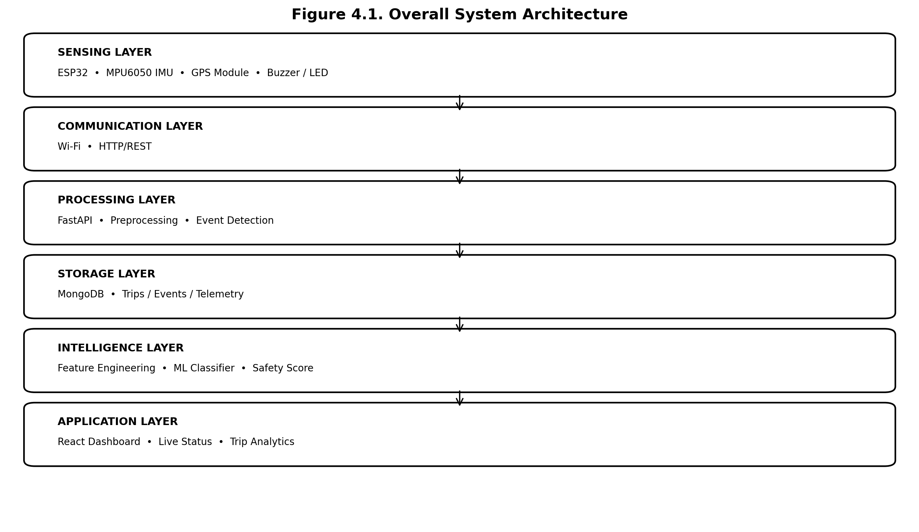
Figure 4.1. Overall System Architecture

4.2 Proposed Architecture
The architecture contains six logical layers. The sensing layer interfaces with physical phenomena. The communication layer transports telemetry. The processing layer validates and interprets data. The storage layer maintains trip history. The intelligence layer produces model outputs and safety scores. The application layer visualizes results.
Layer | Components | Primary Responsibility
Sensing | ESP32, MPU6050, GPS, buzzer/LED | Acquire motion/position data and generate local alerts
Communication | Wi-Fi, HTTP/REST | Transport telemetry to backend
Processing | FastAPI, preprocessing, event detection | Validate, transform and classify incoming data
Storage | MongoDB | Persist drivers, trips, telemetry, events and predictions
Intelligence | Feature engineering, ML model, scoring | Infer behavior class and compute safety score
Application | React dashboard | Present live status, trip history and analytics
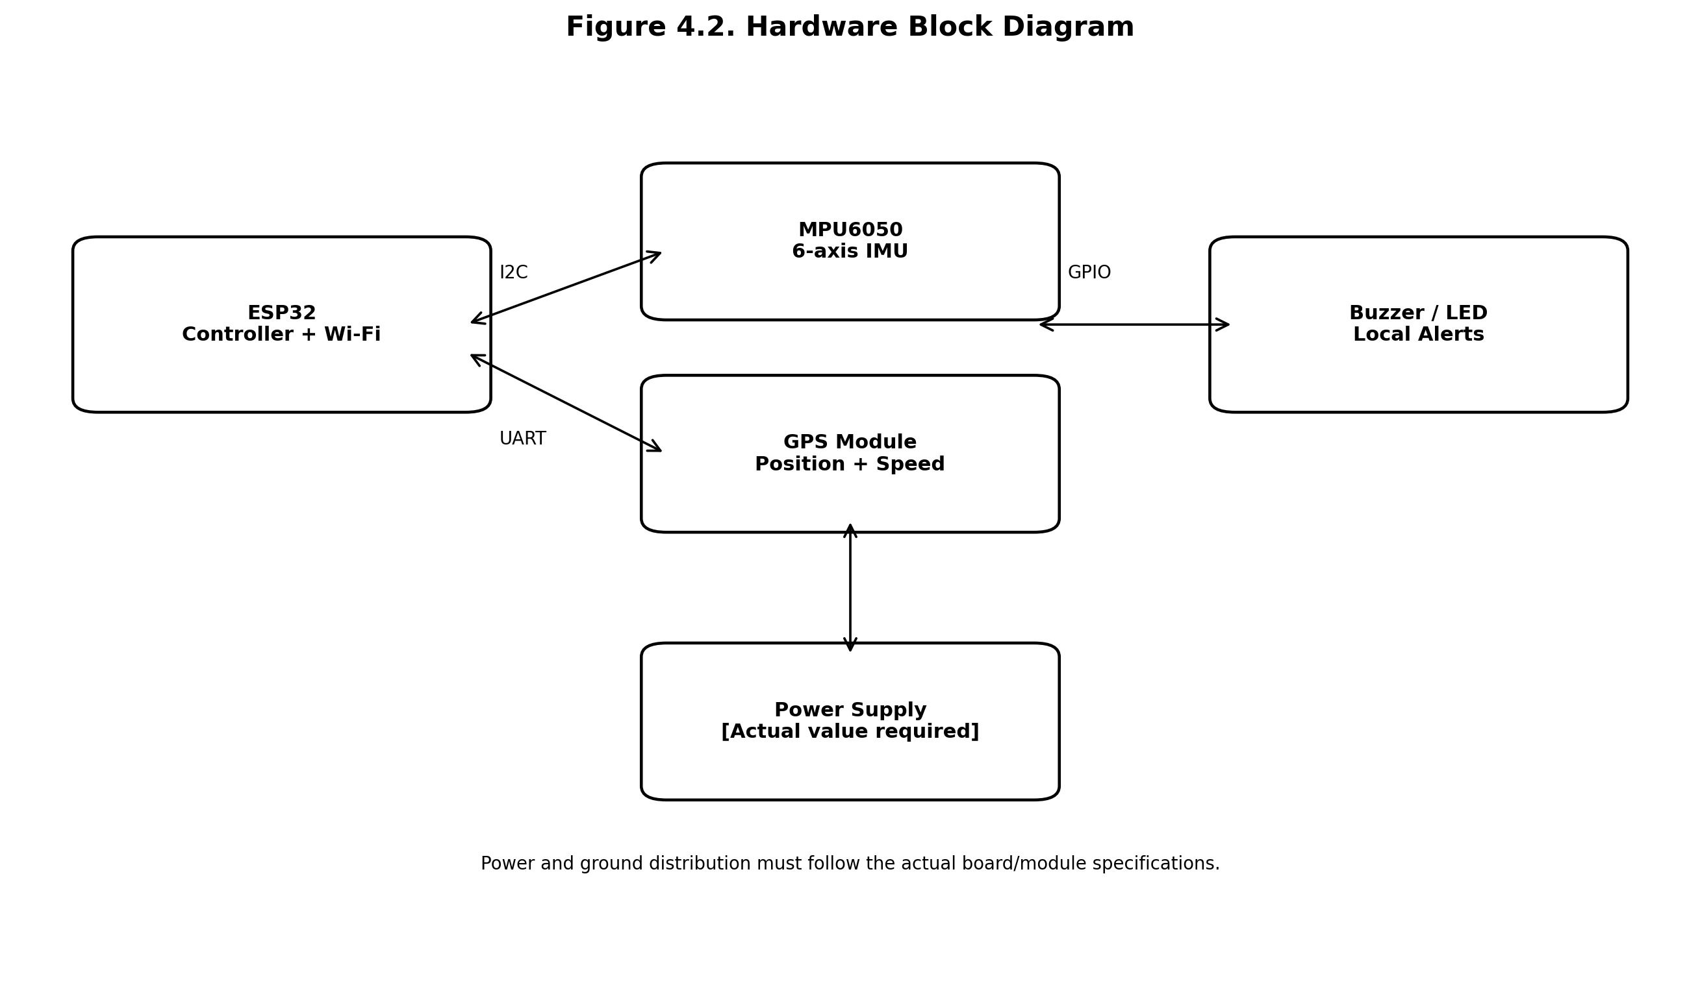
Figure 4.2. Hardware Block Diagram
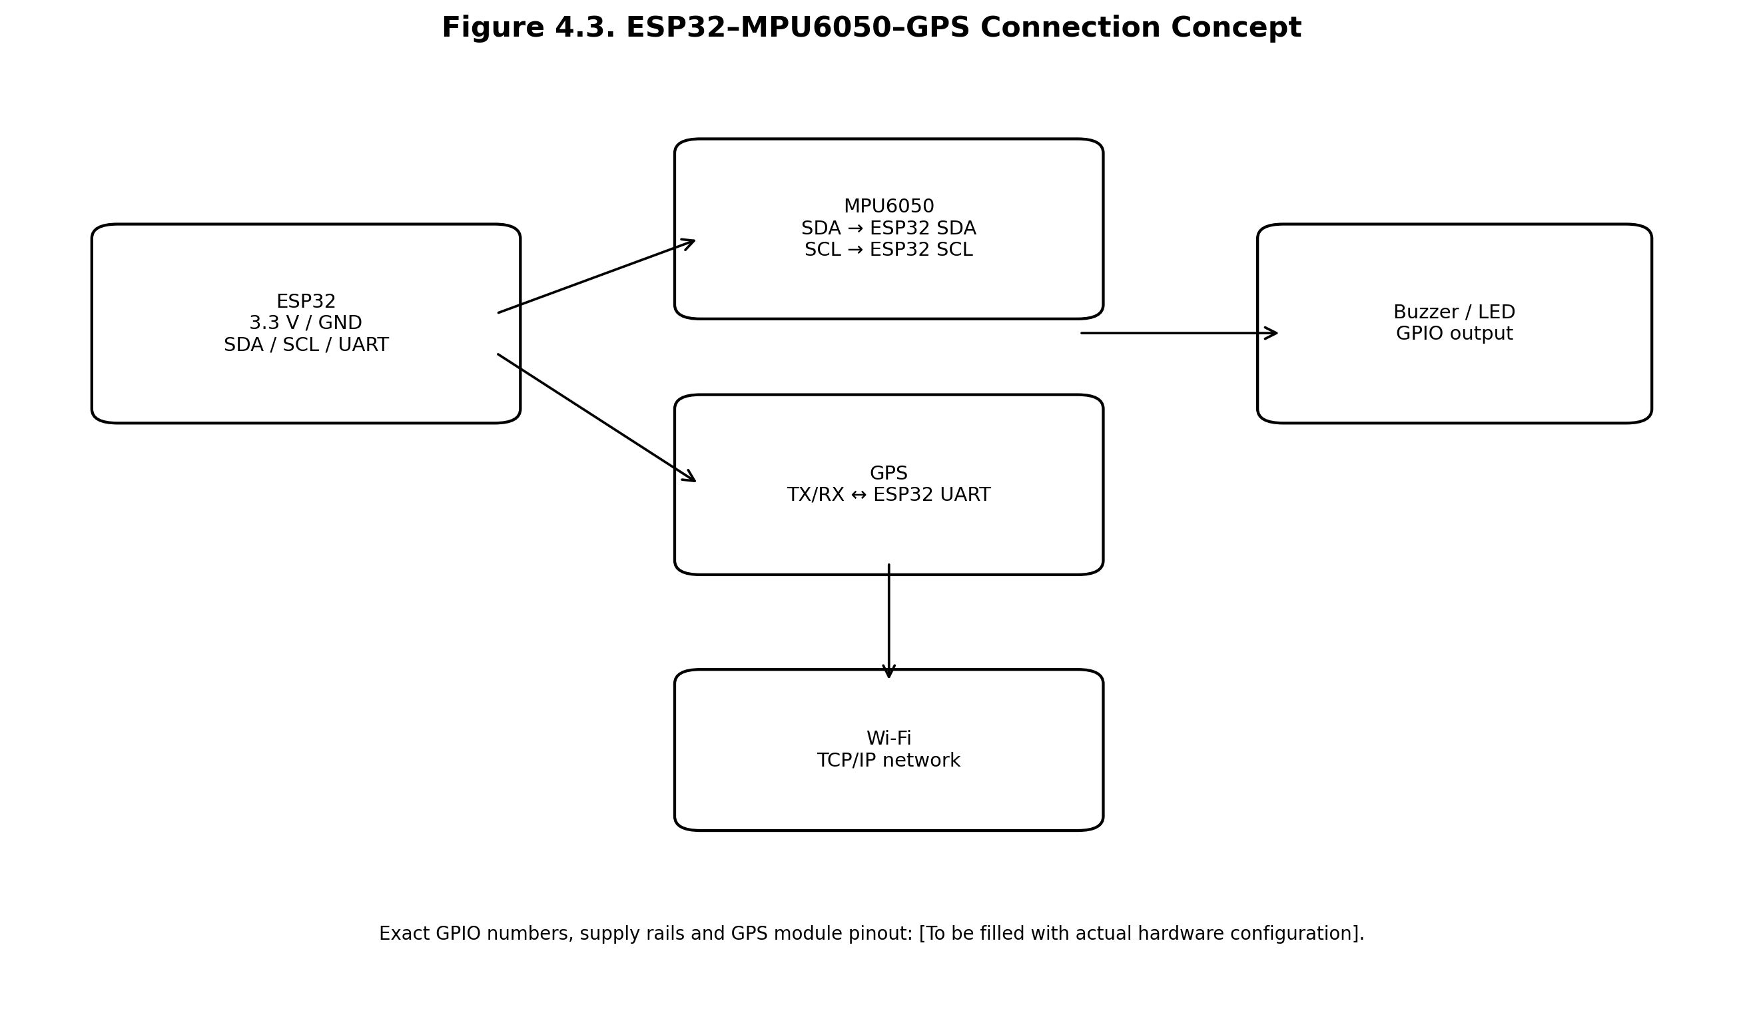
Figure 4.3. ESP32–MPU6050–GPS Connection Concept

4.3 System Components / Modules

ESP32
ESP32 is used as the embedded controller and wireless gateway. Espressif documentation describes the ESP32 as a 2.4-GHz Wi-Fi and Bluetooth SoC and provides Arduino support for IoT development [4], [10]. The project uses the ESP32 primarily for sensor acquisition, local decision making and network communication. The exact development-board variant must be recorded from the physical hardware before final submission.

MPU6050
The MPU6050 provides a three-axis accelerometer and three-axis gyroscope. The manufacturer specification identifies programmable accelerometer ranges of ±2 g, ±4 g, ±8 g and ±16 g and gyroscope ranges of ±250, ±500, ±1000 and ±2000 degrees/second, with digital filtering and I2C communication [5]. The selected full-scale range and filter configuration must be recorded from the actual firmware.

GPS Module
The GPS module provides latitude, longitude, time and speed-related information. Because the exact GPS module was not identified in the project workspace, the final report must replace the generic description with the actual module model, UART baud rate, update rate and antenna configuration.

Buzzer / LED
A buzzer and/or LED provides immediate local indication. A short audible or visual notification can be generated when a high-confidence event is detected. Alert frequency should be limited to avoid distraction and nuisance alarms.

Backend
FastAPI is a Python web framework designed for API development using type hints and standards-based OpenAPI/JSON Schema support [11]. In this project it provides telemetry ingestion, trip/event retrieval and ML inference endpoints. Exact endpoint paths must be taken from the final source repository if available.

Database
MongoDB is a document-oriented database that stores records as BSON documents and supports flexible document structures [12]. Its model is appropriate for heterogeneous telemetry records and nested event/prediction structures, provided that indexes and data-retention policies are designed appropriately.

Machine-Learning Model
The model should be selected after evaluating the available labeled data. A practical first candidate is Random Forest because it can represent nonlinear feature interactions, is relatively interpretable through feature importance and does not require extensive scaling for tree-based inputs. However, this is a methodological recommendation, not a claim that Random Forest was actually trained in the unavailable project workspace.

Dashboard
React is used as the proposed frontend framework. React organizes user interfaces as reusable components and provides hooks and APIs for stateful web applications [13]. The dashboard can contain cards for safety score and behavior class, live telemetry, event history, GPS route and historical trip analytics.

4.4 Proposed Algorithm
The event detector combines GPS and inertial signals. Speed is compared against a configured road or project limit. Longitudinal acceleration is evaluated for positive and negative extremes. Lateral acceleration and/or yaw rate are used to detect aggressive turning. Event persistence can be applied so that a single noisy sample does not immediately create an event.
Algorithm 1: Driver Safety Monitoring
INPUT: speed, ax, ay, az, gx, gy, gz, timestamp
1. Validate sensor ranges and timestamp.
2. Compute acceleration and angular-rate magnitudes.
3. Apply filtering / sliding-window feature extraction.
4. If speed exceeds configured limit for persistence interval:
register OVERSPEED event.
5. If longitudinal acceleration < braking threshold:
register HARSH_BRAKING event.
6. If longitudinal acceleration > acceleration threshold:
register SUDDEN_ACCELERATION event.
7. If lateral acceleration or yaw rate exceeds turning threshold:
register SHARP_TURN event.
8. Aggregate event severity and frequency.
9. Generate ML feature vector and infer behavior class.
10. Compute safety score from calibrated penalties.
11. Emit local alert for configured high-confidence events.
12. Transmit telemetry/event/prediction record to backend.
OUTPUT: event records, safety score, SAFE/MODERATE/RISKY class
The actual axis mapping must be determined by mounting orientation. For example, assuming ax is always the vehicle's longitudinal axis without calibration would be unsafe because the device may be mounted at an angle.

4.5 Mathematical Model / Equations
The acceleration magnitude can be computed as:
a = √(aₓ² + aᵧ² + a_z²)
where aₓ, aᵧ and a_z are the three accelerometer components after conversion to consistent units. Similarly, angular-rate magnitude can be expressed as:
g = √(gₓ² + gᵧ² + g_z²)
A simple score formulation is:
Safety Score = max(0, 100 − Σᵢ Pᵢ)
where Pᵢ is the penalty associated with event i. A more useful implementation can make the penalty depend on event type, severity and frequency. The actual penalty weights must be calibrated and recorded; they must not be presented as experimentally validated unless measured.
For a feature x, standardization can be expressed as z = (x − μ)/σ, where μ is the training-set mean and σ is the training-set standard deviation. The training statistics must be computed only from training data and reused unchanged during inference.
Classification metrics are defined as follows:
Accuracy = (TP + TN) / (TP + TN + FP + FN)
Precision = TP / (TP + FP)
Recall = TP / (TP + FN)
F1 = 2 × Precision × Recall / (Precision + Recall)
Symbol | Meaning
TP | Correct positive prediction
TN | Correct negative prediction
FP | Incorrect positive prediction
FN | Incorrect negative prediction

4.6 System Workflow
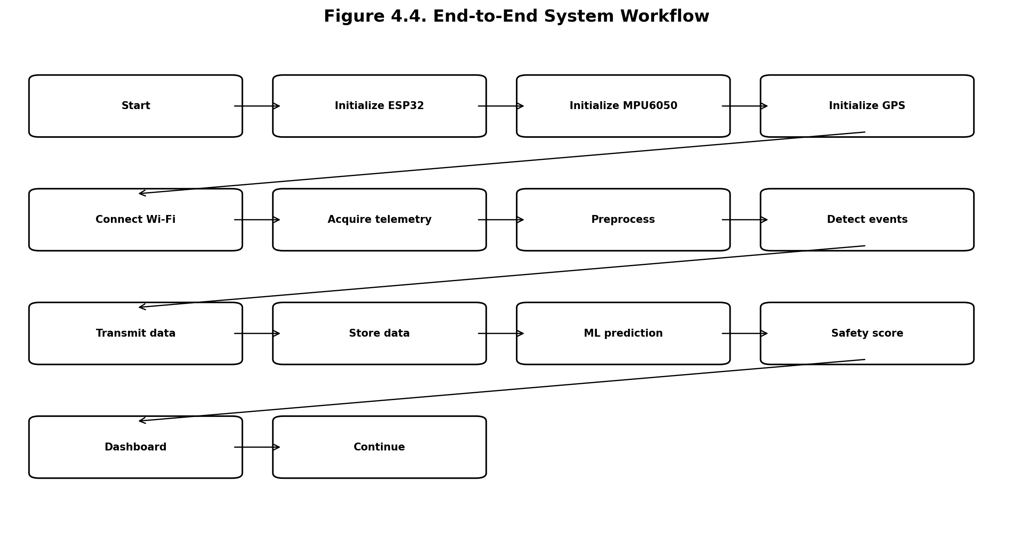
Figure 4.4. End-to-End System Workflow
The workflow begins with device initialization. The ESP32 initializes the IMU and GPS interfaces and attempts to connect to Wi-Fi. During operation, sensor readings are acquired at a configured sampling interval. Data are validated and transformed into features. Event detection runs locally or at the backend depending on the implementation. Telemetry is transmitted, persisted and analyzed. The dashboard requests the latest state and historical records.

4.7 Event Detection Flow
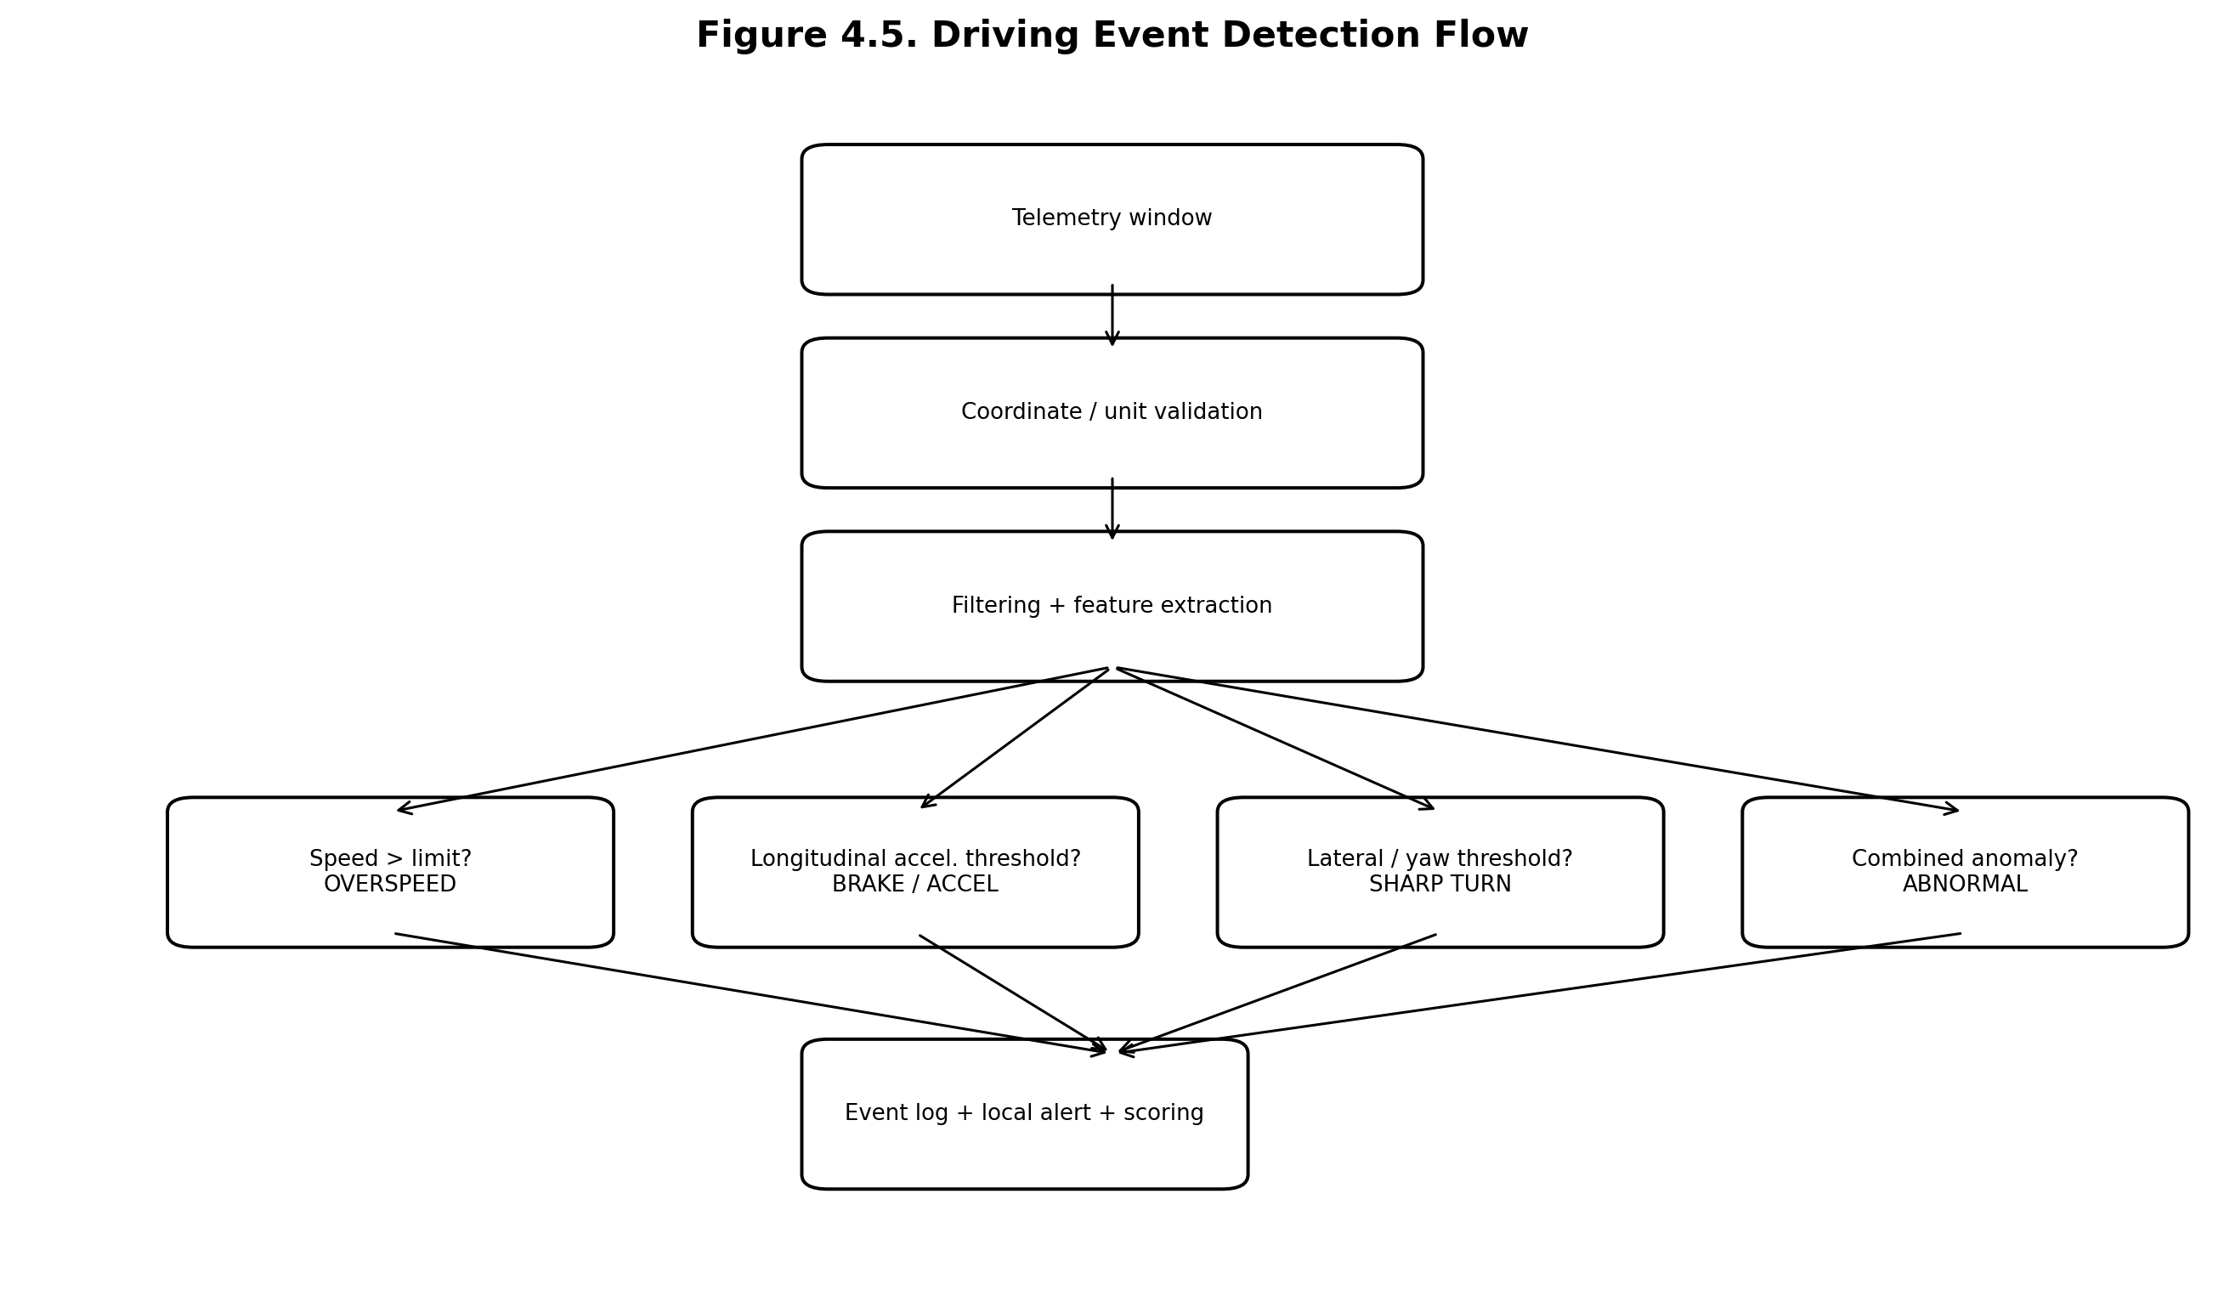
Figure 4.5. Driving Event Detection Flow
Event | Design Signal | Threshold Status | Evidence Requirement
Overspeeding | GPS speed | [Proposed/calibration value] | Must be set from road/test conditions
Harsh braking | Longitudinal acceleration | [Proposed/calibration value] | Must be calibrated with actual vehicle
Sudden acceleration | Longitudinal acceleration | [Proposed/calibration value] | Must be calibrated with actual vehicle
Sharp turn | Lateral acceleration / yaw rate | [Proposed/calibration value] | Must be calibrated with actual vehicle
Abnormal behavior | Event combination / ML output | [Model dependent] | Requires labeled dataset

4.8 Machine-Learning Pipeline
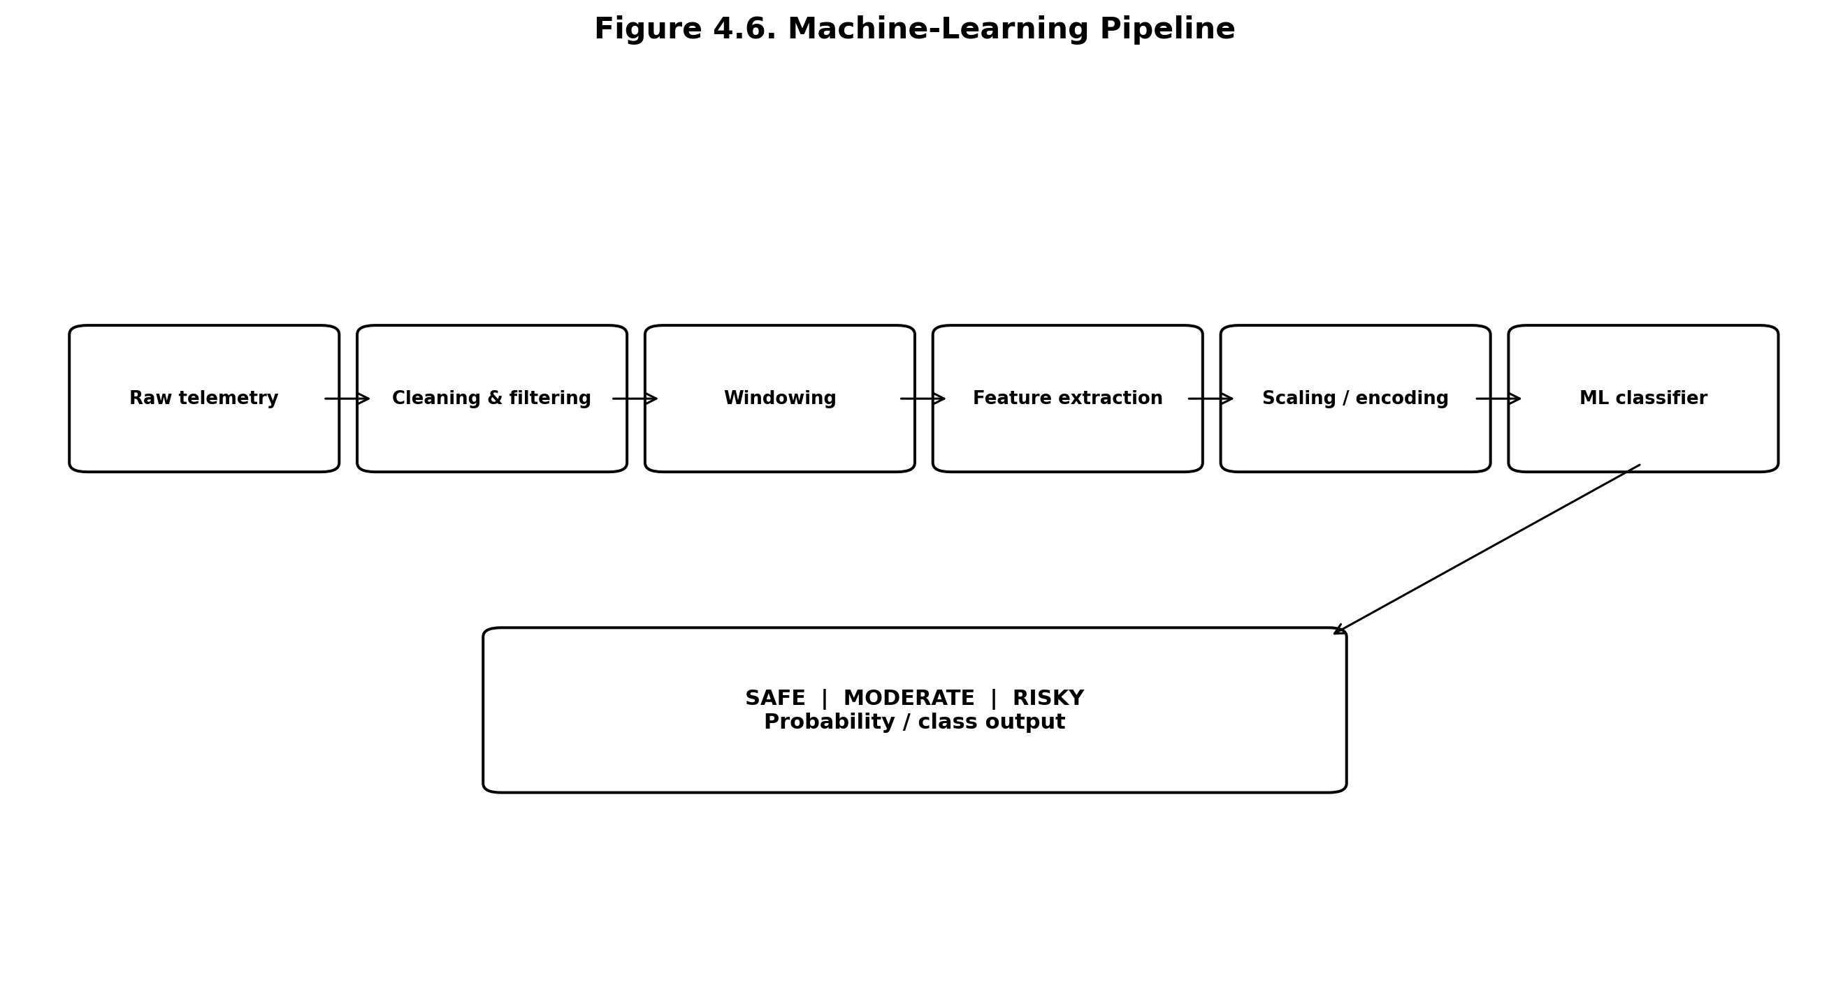
Figure 4.6. Machine-Learning Pipeline
The ML pipeline should be designed around trip windows or event windows rather than individual raw samples alone. Candidate features include speed statistics, acceleration statistics, gyroscope statistics, event counts, event severity, duration, speed variance and the proportion of time spent above a configured limit. If labels are SAFE, MODERATE and RISKY, the dataset must contain an explicit labeling policy.

4.9 Database Architecture
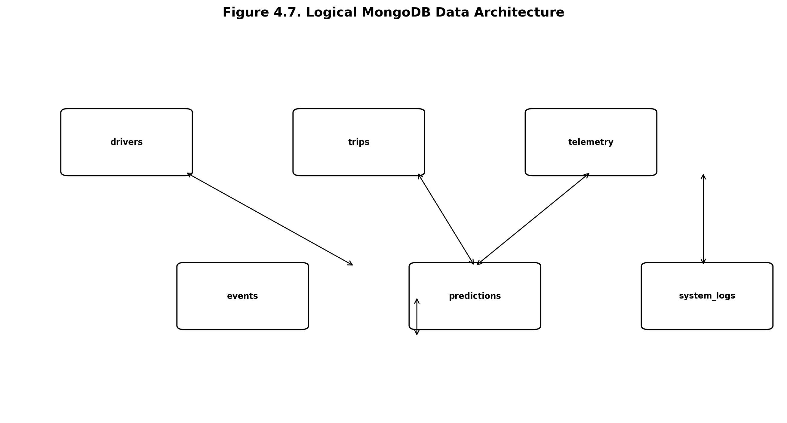
Figure 4.7. Logical MongoDB Data Architecture
Collection | Purpose | Representative Fields
drivers | Driver/device identity | driver_id, device_id, created_at
trips | Trip-level summary | trip_id, driver_id, start_time, end_time, score, class
telemetry | Time-series sensor records | timestamp, speed, ax, ay, az, gx, gy, gz, lat, lon
events | Detected events | trip_id, timestamp, type, severity, source
predictions | ML outputs | trip_id, model_version, class, probabilities
system_logs | Diagnostics | timestamp, device_id, level, message

4.10 Dashboard Architecture
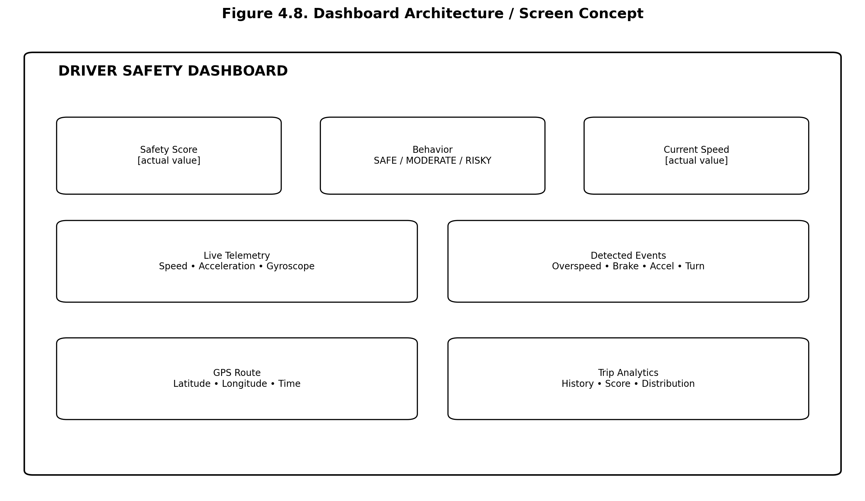
Figure 4.8. Dashboard Architecture / Screen Concept
The dashboard should separate current state from historical analytics. Current-state widgets can show speed, latest event, safety score and behavior class. Historical views can show trip summaries, event distributions and GPS traces. Actual screenshots must be inserted only after the dashboard is implemented and captured.

4.11 Advantages of Proposed System
- Low-cost modular hardware compared with many proprietary telematics solutions.
- Real-time monitoring through Wi-Fi-connected embedded sensing.
- Combination of inertial and GPS information.
- Immediate local feedback through buzzer/LED.
- Historical storage for trip-level analytics.
- ML-based higher-level classification.
- Scalable separation between device, backend, database and frontend.

CHAPTER 5 – IMPLEMENTATION

5.1 Hardware Requirements
Component | Specification | Purpose | Status
ESP32 | Actual development-board model: [To be filled] | Controller + Wi-Fi | Required; exact board not evidenced in workspace
MPU6050 | 6-axis IMU | Acceleration + angular rate | Required
GPS | Actual module model: [To be filled] | Location + speed | Required; exact model not evidenced
Buzzer | Actual specification: [To be filled] | Local alert | Required
LED | Actual specification: [To be filled] | Status / alert | Required
Power supply | Actual voltage/current: [To be filled] | Power | Required
The exact component model, wiring, voltage and GPIO assignments must be copied from the actual hardware and firmware before submission. Generic specifications in this report are intentionally not presented as evidence of physical assembly.

5.2 Software Requirements
Software | Role | Status
Arduino IDE or PlatformIO | ESP32 firmware development | Select actual environment
Python | Backend / ML runtime | Proposed
FastAPI | REST API | Specified project component
MongoDB | Database | Specified project component
React | Web dashboard | Specified project component
Node.js | Frontend development/runtime tooling | Required if used by React project
scikit-learn | ML experimentation/inference | Use only if actually selected
Git/GitHub | Version control | Repository URL to be filled if available

5.3 Dataset Description
No project-specific driver-safety dataset was identifiable in the inspected workspace. Therefore, the final report must record whether the model uses hardware-collected data, a public dataset, or synthetic data. A public Indian driver dataset exists and contains smartphone accelerometer and gyroscope information [8], but it should only be cited as the actual training dataset if it was genuinely used.
Field | Required Entry
Dataset source | [To be filled: hardware / public / synthetic]
Dataset name / URL | [To be filled]
Number of samples | [To be filled with actual dataset details]
Number of drivers | [To be filled]
Sampling frequency | [To be filled]
Features | [To be filled]
Class labels | SAFE / MODERATE / RISKY or actual labels
Train/test split | [To be filled]
Collection conditions | [To be filled]
Labeling method | [To be filled]

5.4 Data Preprocessing
Preprocessing should begin with schema validation. Each telemetry record should contain a timestamp and a defined unit for every numeric field. Missing values should be identified rather than silently replaced. Short gaps may be handled through interpolation only when appropriate; longer gaps should be marked as missing.
Sensor signals can be filtered using a low-pass filter, moving average or another method selected experimentally. Filtering must avoid removing the short-duration events the system is designed to detect. Windowing can convert raw time series into fixed-length feature vectors. Candidate statistical features include mean, standard deviation, variance, minimum, maximum, range and peak-to-peak amplitude.
If ML scaling is required, the scaler is fitted only on the training data. Categorical labels are encoded consistently. The test set remains isolated until final evaluation. If multiple drivers are available, a driver-independent split is preferable for testing generalization to unseen users.

5.5 Module Implementation

5.5.1 Sensor Acquisition
The ESP32 reads the MPU6050 through I2C and the GPS through the appropriate serial interface. The firmware should use a stable sampling schedule and timestamp each record. A device identifier should be included so multiple nodes can be distinguished.

5.5.2 GPS Processing
GPS records should be accepted only when validity information indicates a usable fix. Speed, latitude and longitude are retained with timestamps. Sudden impossible jumps should be detected as data-quality issues rather than interpreted automatically as driving events.

5.5.3 Event Detection
The embedded or backend event detector compares filtered features with calibrated thresholds. Persistence and hysteresis are recommended to reduce repeated triggering around a threshold. Event records should include type, timestamp, severity, source and the feature values that caused the event.

5.5.4 Communication
ESP32 Wi-Fi Station mode connects the device to an access point. Espressif's Arduino documentation provides station-mode APIs for connecting an ESP32 to a network [10]. The project can transmit JSON over HTTP/REST if that is the actual implementation. MQTT should not be described as implemented unless the firmware uses an MQTT client.

5.5.5 Backend
FastAPI receives telemetry using a defined request schema. Validation should reject malformed records. The backend can expose endpoints for device health, trip data, events, predictions and dashboard summaries. FastAPI's OpenAPI support provides interactive API documentation that can assist development and testing [11].

5.5.6 Database
MongoDB stores documents representing drivers, trips, telemetry, events and predictions. Indexes should be created for high-frequency queries such as device_id + timestamp and trip_id. Time-series collections may be considered if telemetry volume becomes large, but the actual deployed configuration must be recorded rather than assumed.

5.5.7 Machine Learning
A baseline classifier should be trained first. Candidate models can include Decision Tree, Random Forest, SVM and Logistic Regression. Cross-validation and a held-out test set should be used. Class imbalance should be monitored. Model version, training dataset identifier and preprocessing configuration should be stored with predictions so results are reproducible.

5.5.8 Dashboard
The React dashboard consumes backend APIs and updates the live-monitoring view. A suitable component structure is DashboardShell, SafetyCard, LiveTelemetry, EventTable, TripHistory, GPSMap and ModelAnalytics. The actual project component names should replace these examples if source code is later supplied.

5.6 Algorithm Implementation
The following example illustrates the structure of an event payload. It is a documentation example, not evidence that this exact JSON was implemented:
{
"device_id": "<actual-device-id>",
"timestamp": "<ISO-8601 timestamp>",
"speed_kmph": "<measured>",
"accel": {"x": "<measured>", "y": "<measured>", "z": "<measured>"},
"gyro": {"x": "<measured>", "y": "<measured>", "z": "<measured>"},
"gps": {"lat": "<measured>", "lon": "<measured>"},
"events": [],
"model": {"class": "<prediction>", "probabilities": {}}
}

5.7 User Interface / Screenshots
No authentic project dashboard screenshots were identified in the inspected workspace. Therefore, no screenshot is embedded as an implementation claim. Figure 4.8 is a design architecture concept only. After implementation, the following authentic screenshots should be inserted: live dashboard, sensor telemetry, event detection, trip details, safety score, GPS route, ML analytics and representative API response.

5.8 Implementation Procedure
- Assemble the ESP32, MPU6050, GPS, buzzer/LED and power supply using the verified pinout.
- Upload and validate firmware for sensor initialization.
- Verify raw IMU readings while the unit is stationary and during controlled motion.
- Verify GPS fix, latitude, longitude, time and speed fields.
- Implement event detection and local alert behavior.
- Connect the ESP32 to Wi-Fi and validate payload transmission.
- Implement FastAPI ingestion and validation.
- Create MongoDB collections and indexes.
- Prepare the labeled ML dataset and train/evaluate the model.
- Integrate ML inference with the backend.
- Develop the React dashboard.
- Perform end-to-end integration tests and record actual measurements.
- Insert only authentic screenshots, plots and metrics into the final report.

5.9 Proposed API Contract
Method | Endpoint | Purpose | Status
POST | /telemetry | Receive sensor telemetry | Endpoint path must be confirmed from actual code
POST | /events | Receive or register event | Endpoint path must be confirmed
GET | /trips/{trip_id} | Retrieve trip summary | Endpoint path must be confirmed
GET | /trips/{trip_id}/events | Retrieve trip events | Endpoint path must be confirmed
GET | /dashboard/live | Retrieve latest state | Endpoint path must be confirmed
POST | /predict | Run ML inference | Endpoint path must be confirmed

CHAPTER 6 – RESULTS AND DISCUSSION

6.1 Experimental Setup
The experimental evaluation must be performed only after the physical hardware is assembled and the firmware, backend, database and dashboard are integrated. The following fields must be populated from actual records.
Parameter | Actual Entry
ESP32 board | [Actual board model]
MPU6050 configuration | [Actual range / filter / sample rate]
GPS module | [Actual module model and configuration]
Power source | [Actual source]
Mounting position | [Actual mounting location and orientation]
Test vehicle | [Actual vehicle / test platform]
Test environment | [Controlled road / test track / simulation]
Test duration | [Actual duration]
Network | [Actual Wi-Fi setup]
Backend host | [Actual local/cloud environment]
Database deployment | [Actual MongoDB deployment]
ML model | [Actual model]
Dataset | [Actual dataset]

6.2 Performance Evaluation
The evaluation should cover the sensing layer, communication path, backend processing, ML inference and dashboard update behavior. Sensor response can be assessed by checking whether measurements change consistently during controlled motions. Event detection can be evaluated using predefined driving maneuvers or labeled naturalistic trips. API performance should be measured using timestamps rather than estimated from system design.

6.3 Results
Test | Expected | Actual | Status
ESP32 startup | Device initializes without fatal error | [Actual result required] | Not evidenced in workspace
MPU6050 read | Valid acceleration and gyroscope values | [Actual result required] | Not evidenced
GPS fix | Valid coordinates/speed | [Actual result required] | Not evidenced
Wi-Fi | Device connects and transmits | [Actual result required] | Not evidenced
Overspeed detection | Event generated above calibrated limit | [Actual result required] | Not evidenced
Harsh braking | Event generated for labeled braking event | [Actual result required] | Not evidenced
Sudden acceleration | Event generated for labeled acceleration event | [Actual result required] | Not evidenced
Sharp turn | Event generated for labeled turn event | [Actual result required] | Not evidenced
Backend ingestion | Valid telemetry stored | [Actual result required] | Not evidenced
ML prediction | Correct class on test sample | [Actual result required] | Not evidenced
Dashboard update | Latest state displayed | [Actual result required] | Not evidenced

6.4 Graphs and Tables
No project-specific telemetry CSV or database export was identified in the workspace, so no numerical project graphs are generated. The following graphs should be created after actual data are available: speed versus time; acceleration versus time; gyroscope versus time; event counts per trip; safety score per trip; behavior-class distribution; and ML confusion matrix.
A graph must include the data source, time range, units and filtering method. A plot generated from simulated or public data must be labeled explicitly as simulated or public-data analysis and must not be presented as a hardware experiment.

6.5 Comparison with Existing Methods
Criterion | Smartphone-only approaches | Traditional GPS tracking | Proposed architecture
Motion sensing | Available | Usually limited | Dedicated IMU
GPS | Available | Core feature | Integrated
Local alert | Depends on app/device | Usually limited | Buzzer/LED
IoT connectivity | Mobile network/Wi-Fi | Usually cellular | ESP32 Wi-Fi
Backend analytics | Possible | Usually available | FastAPI + MongoDB
ML classification | Research dependent | Varies | Dedicated ML layer
Safety score | Research dependent | Often proprietary | Explicit scoring layer
Dashboard | App/web | Fleet portals | React dashboard
This comparison describes architectural characteristics, not measured superiority. It should not be interpreted as proof that the proposed system has lower cost, higher accuracy or better reliability until those attributes are experimentally measured.

6.6 Performance Metrics
Metric | Formula / Definition | Actual Value
Accuracy | (TP + TN) / (TP + TN + FP + FN) | [Actual measured value required]
Precision | TP / (TP + FP) | [Actual measured value required]
Recall | TP / (TP + FN) | [Actual measured value required]
F1-score | 2PR / (P + R) | [Actual measured value required]
Event detection rate | Correctly detected labeled events / total labeled events | [Actual measured value required]
API response time | Measured request-response latency | [Actual measured value required]
Dashboard update latency | Sensor-to-dashboard observed delay | [Actual measured value required]

6.7 Discussion of Results
Because project-specific measurements were not available in the inspected workspace, a factual discussion of observed accuracy, latency or sensor behavior cannot be written without fabricating evidence. The correct final discussion should distinguish three categories: successful observations, failed or inconsistent observations and untested functions.
For sensor behavior, discussion should address noise while stationary, drift, vibration and the effect of mounting. For GPS, the discussion should address fix acquisition, speed stability and signal interruptions. For event detection, false positives and false negatives should be reported by event type. For machine learning, class imbalance and generalization to unseen drivers should be discussed. For the network path, packet loss, retry behavior and latency should be measured under the selected Wi-Fi conditions.
If the model performs well on a random train/test split but poorly on a driver-independent split, the latter should be emphasized because it better represents generalization to unseen drivers. Similarly, if an event detector is tuned on one road and fails on another, this should be documented rather than hidden.

6.8 Data Integrity and Evidence Classification
Evidence Type | Allowed Claim
Implemented in source code | Can be described as implemented if source is available
Hardware assembled but not measured | Can be described as assembled only if evidence exists
Controlled test with recorded data | Can be described as tested with measured results
Simulation | Can be described only as simulated
Public dataset experiment | Can be described as public-data evaluation
Design proposal | Must be labeled proposed
Missing evidence | Must be marked [To be filled] / not evidenced

CHAPTER 7 – CONCLUSION AND FUTURE WORK

7.1 Conclusion
This report presents a complete architecture and implementation methodology for an IoT-based smart driver safety and driving behavior monitoring system using ESP32, MPU6050, GPS, local alerts, Wi-Fi, FastAPI, MongoDB, machine learning and React. The system is designed to convert low-level sensor measurements into interpretable driving events and a higher-level behavior classification.
The principal engineering idea is the integration of complementary sensing modalities. GPS contributes speed and geographic context, while the MPU6050 captures motion that can occur over shorter time scales. The ESP32 provides a compact edge platform for acquisition and communication. FastAPI and MongoDB separate device telemetry from application logic and provide a persistent history. The ML layer can then operate on engineered features rather than directly coupling the dashboard to raw sensor streams.
The report does not claim experimentally validated accuracy because the inspected workspace did not contain project-specific test data, ML metrics or source-code evidence for this driver-safety implementation. This distinction is essential: a technically plausible architecture is not the same as a validated safety system. The next development step is therefore empirical validation using the actual hardware and a documented dataset.

7.2 Project Contributions
- Layered IoT architecture integrating embedded sensing and web analytics.
- Hardware-oriented event detection methodology.
- Explicit safety-score formulation with calibration requirements.
- Machine-learning pipeline design for SAFE/MODERATE/RISKY classification.
- Backend and database schema for telemetry and trip history.
- Evaluation protocol that avoids unsupported performance claims.

7.3 Limitations
- The exact hardware models and pin configuration were not evidenced in the inspected workspace.
- Project-specific experimental telemetry was unavailable.
- ML model choice and measured metrics remain to be populated from the actual implementation.
- GPS accuracy can vary with sky visibility, antenna quality and multipath conditions.
- IMU measurements depend on mounting orientation, vibration and calibration.
- Thresholds are vehicle- and context-dependent.
- Wi-Fi connectivity is not universally available during road travel.
- Small or biased datasets may produce misleadingly high evaluation scores.
- The system is not a certified automotive safety device.

7.4 Future Enhancement / Future Scope
- OBD-II integration to obtain vehicle speed and diagnostic parameters.
- CAN-bus integration where legally and technically appropriate.
- Cloud deployment with secure device authentication.
- Larger real-world datasets collected across multiple drivers and road conditions.
- Advanced models such as temporal neural networks or transformer-based sequence models.
- Camera-based drowsiness and distraction detection as a separate safety module.
- Mobile application for driver and fleet notifications.
- Edge AI inference to reduce cloud dependency.
- Emergency notification workflow for severe events.
- Fleet management and multi-device analytics.
- MQTT integration if the deployment requires broker-based telemetry.
- Model monitoring, drift detection and periodic recalibration.

7.5 Project Repository
The actual GitHub repository URL was not identified in the inspected project workspace. Therefore, no repository URL is invented in this report.
Once available, the repository section should provide the real URL and identify the folders containing ESP32 firmware, backend, frontend, ML code, dataset/configuration and documentation. The final submission should also record the repository commit or release used to produce the submitted report so that the implementation is reproducible.

REFERENCES
[1] A. Dehzangi, M. J. E. Akbari, and others, “Driving Style Recognition for Intelligent Vehicle Control and Advanced Driver Assistance: A Survey,” IEEE Transactions on Intelligent Transportation Systems, vol. 19, no. 3, pp. 666–676, 2018, doi: 10.1109/TITS.2017.2706978.
[2] G. Castignani, R. Frank, T. Engel, and M. A. K. others, “Driving analytics using smartphones: Algorithms, comparisons and challenges,” Transportation Research Part C: Emerging Technologies, 2017.
[3] “Smartphone sensing for understanding driving behavior: Current practice and challenges,” Transportation Research Interdisciplinary Perspectives, 2021.
[4] Espressif Systems, “ESP32 Series Datasheet,” Espressif Systems, Datasheet Version 5.2.
[5] InvenSense, “MPU-6000 and MPU-6050 Product Specification,” Document PS-MPU-6000A-00, Rev. 3.4, 2013.
[6] “A robust machine learning structure for driving events recognition using smartphone motion sensors,” Transportation Research Part C: Emerging Technologies, 2023.
[7] “A Novel Model-Based Driving Behavior Recognition System Using Motion Sensors,” Sensors, vol. 16, no. 10, 1746, 2016.
[8] “Smartphone Sensor Dataset for Driver Behavior Analysis,” Data in Brief, 2022.
[9] “Analysis of harsh braking and harsh acceleration occurrence via explainable imbalanced machine learning using high-resolution smartphone telematics and traffic data,” Accident Analysis & Prevention, 2024.
[10] Espressif Systems, “Arduino ESP32 Wi-Fi API Documentation,” Espressif Documentation.
[11] FastAPI, “FastAPI Documentation: FastAPI framework, high performance, easy to learn, fast to code, ready for production,” official documentation.
[12] MongoDB, “MongoDB Documentation,” official database documentation.
[13] Meta / React Team, “React Documentation,” official documentation.
Reference verification note: the scholarly and official sources above were selected from genuine publisher or vendor documentation. Bibliographic fields that require exact volume/page metadata should be checked against the publisher record before the final university submission, particularly where the search result exposed an article title but not all citation fields.

APPENDIX A – ESP32 FIRMWARE STRUCTURE
The complete firmware should remain in the project repository. The report should contain only the key structural elements necessary to understand the implementation.
setup()
initialize serial interfaces
initialize I2C and MPU6050
initialize GPS UART
initialize GPIO for buzzer/LED
connect to Wi-Fi
initialize local buffers
loop()
read IMU
read GPS
validate readings
compute derived features
detect events
trigger local alert when required
buffer telemetry
transmit when network is available
apply retry/backoff

APPENDIX B – API ENDPOINTS
Endpoint | Method | Request | Response
/telemetry | POST | Telemetry JSON | Acknowledgement / validation status
/events | POST | Event JSON | Stored event ID
/trips/{trip_id} | GET | Trip identifier | Trip summary
/trips/{trip_id}/events | GET | Trip identifier | Event list
/dashboard/live | GET | Optional device filter | Latest telemetry and status
/predict | POST | Feature vector | Class + probabilities
These endpoint names are a proposed contract and must be replaced with the exact implemented routes before final submission.

APPENDIX C – DATASET SAMPLE
timestamp, speed_kmph, ax, ay, az, gx, gy, gz, latitude, longitude, event, class
[actual sample row to be inserted]
[actual sample row to be inserted]
[actual sample row to be inserted]

APPENDIX D – ADDITIONAL SCREENSHOTS
Insert authentic screenshots only. Recommended evidence: firmware serial output, MPU6050 readings, GPS fix, Wi-Fi connection, FastAPI Swagger UI, MongoDB records, ML confusion matrix, dashboard live view and trip analytics.

APPENDIX E – TEST CASES
Test ID | Test Description | Expected Result | Actual Result | Status
TC-01 | Power-on initialization | All required modules initialize | [To be filled] | [To be filled]
TC-02 | Stationary IMU test | Stable readings within expected noise | [To be filled] | [To be filled]
TC-03 | GPS acquisition | Valid fix and speed | [To be filled] | [To be filled]
TC-04 | Wi-Fi transmission | Telemetry reaches backend | [To be filled] | [To be filled]
TC-05 | Overspeed event | Event detected at calibrated threshold | [To be filled] | [To be filled]
TC-06 | Harsh braking | Event detected | [To be filled] | [To be filled]
TC-07 | Sudden acceleration | Event detected | [To be filled] | [To be filled]
TC-08 | Sharp turn | Event detected | [To be filled] | [To be filled]
TC-09 | ML classification | Expected class returned | [To be filled] | [To be filled]
TC-10 | Dashboard update | Latest state visible | [To be filled] | [To be filled]

APPENDIX F – REQUIREMENTS TRACEABILITY
A requirements traceability matrix connects the project objectives to the corresponding technical modules and evidence required for final evaluation. This is useful for preventing a situation in which a feature is described in the report but has no implementation or test evidence.
Requirement | Module | Evidence | Verification
Acquire acceleration | ESP32 + MPU6050 | Firmware + serial/log data | Stationary and motion test
Acquire angular rate | ESP32 + MPU6050 | Firmware + telemetry | Controlled rotation / turning test
Acquire GPS speed | GPS + UART | NMEA/parser output | Valid GPS fix and speed comparison
Overspeed detection | Event detector | Event record | Controlled threshold test
Harsh braking detection | Event detector | Event record | Labeled braking maneuver
Sudden acceleration detection | Event detector | Event record | Labeled acceleration maneuver
Sharp-turn detection | Event detector | Event record | Labeled turning maneuver
Local alert | Buzzer/LED | Photo/video or test log | Alert activation test
IoT transmission | Wi-Fi + FastAPI | API log | End-to-end payload test
Persistent storage | MongoDB | Database record | Insert/query test
ML classification | ML service | Model file + metrics | Held-out test set
Safety score | Scoring module | Score calculation/log | Manual calculation cross-check
Dashboard | React | Authentic screenshot | Live/historical data test

APPENDIX G – SECURITY, PRIVACY AND DATA GOVERNANCE
A connected driver-monitoring system handles potentially sensitive information because location traces can reveal travel patterns. Even when a prototype is used only for academic evaluation, the system should minimize collection, restrict access and avoid exposing personally identifying information unnecessarily.
Device authentication should be considered before deployment beyond a trusted local network. A static shared credential embedded in firmware is not sufficient for a production system. Transport encryption should be used when telemetry crosses an untrusted network. Backend endpoints should validate input sizes, numeric ranges and timestamps to reduce malformed or malicious payloads.
MongoDB access should follow least privilege. Dashboard users should receive only the data required for their role. Historical GPS data should have an explicit retention policy. If real driver identities are used, the project should obtain the appropriate consent and follow institutional requirements for data handling.
Risk | Example | Mitigation
Unauthorized device | Unknown device sends telemetry | Device identity and authentication
Location exposure | Trip history visible to unauthorized users | Authorization and minimal retention
Malformed input | Extreme numeric payloads | Schema/range validation
Credential leakage | Database password in source code | Environment variables / secret management
Network interception | Telemetry captured on open network | HTTPS/TLS
Model manipulation | Adversarial or invalid telemetry | Validation + anomaly checks
Log leakage | Sensitive data written to logs | Structured, minimal logging

APPENDIX H – RELIABILITY AND FAULT-HANDLING STRATEGY
The device should continue collecting essential sensor information during short network interruptions. A local ring buffer can temporarily hold unsent records. Once connectivity returns, the firmware can transmit buffered records in chronological order. Records should include sequence numbers so duplicate transmission can be detected by the backend.
Sensor failures should be represented explicitly. An invalid GPS fix should not be converted to zero latitude and longitude because zero is a valid numeric value but an invalid representation of a missing fix. Similarly, impossible IMU values should be marked invalid rather than interpreted as extreme driving.
The backend should respond with explicit status codes. A successful record should return an acknowledgement. Validation failures should identify the field that failed. Transient database or service errors should be distinguishable from permanent client errors.
Failure | Expected Behavior | Evidence to Record
Wi-Fi loss | Buffer/retry telemetry | Disconnect/reconnect log
GPS loss | Mark fix invalid | GPS validity field
IMU read failure | Retry and flag sensor fault | Firmware error log
Backend unavailable | Retry with backoff | HTTP/network log
Database unavailable | Return service error | Backend log
ML service failure | Fallback to rule-based state or unavailable | Prediction status
Dashboard API failure | Show stale/unavailable state | Frontend error indicator

APPENDIX I – SENSOR CALIBRATION AND THRESHOLD PROCEDURE
Thresholds must not be selected merely because a value appears plausible. A defensible calibration procedure begins with a stationary baseline. The mean and standard deviation of each IMU axis should be recorded while the device is mounted but the vehicle is stationary. This establishes the sensor noise floor.
The next stage consists of controlled maneuvers. Braking, acceleration and turning should be performed at known conditions where possible. The measured distributions can then be compared with normal-driving segments. Candidate thresholds should be chosen to separate event and non-event distributions while limiting nuisance alerts.
GPS speed thresholds should be tested against a reference where possible. The project should distinguish the road's legal speed limit from an engineering detection threshold. The report must never claim that a fixed threshold is legally valid for every road.
Parameter | Calibration Method | Final Value
IMU sample rate | Compare event duration vs noise | [Actual value]
Low-pass filter | Evaluate noise/event preservation | [Actual configuration]
Braking threshold | Labeled braking trials | [Actual value]
Acceleration threshold | Labeled acceleration trials | [Actual value]
Turn threshold | Labeled turning trials | [Actual value]
Overspeed limit | Test-road condition | [Actual value]
Event persistence | False-positive analysis | [Actual value]

APPENDIX J – MACHINE-LEARNING EVALUATION PROTOCOL
The ML evaluation should be designed so that a high score reflects genuine generalization rather than leakage. If multiple observations from the same trip are randomly split between training and test sets, the model may learn trip-specific characteristics. A stronger evaluation keeps complete trips or drivers separated between training and testing where the dataset permits.
The classification report should include per-class precision, recall and F1-score, not only overall accuracy. A confusion matrix should show whether MODERATE cases are frequently confused with SAFE or RISKY. Class imbalance should be quantified before training.
Model selection should be reproducible. Record the feature list, preprocessing method, split strategy, random seed where applicable, hyperparameters, training dataset version and software-library versions. The final model artifact should be linked to a model version stored with each prediction.
Evaluation Item | Required Record
Dataset version | [To be filled]
Feature list | [To be filled]
Label definition | [To be filled]
Train/test split | [To be filled]
Driver-independent split? | [Yes/No]
Model | [To be filled]
Hyperparameters | [To be filled]
Accuracy | [Measured]
Precision per class | [Measured]
Recall per class | [Measured]
F1 per class | [Measured]
Confusion matrix | [Attach actual matrix]

APPENDIX K – DEPLOYMENT AND REPRODUCIBILITY GUIDE
A reproducible deployment should define the hardware firmware version, backend environment, database configuration and frontend build. Environment-specific secrets should not be committed to Git. A sample configuration file can document variable names without exposing credentials.
The backend deployment should document its host, Python version, dependency file and startup command. The frontend should document its build command and backend base URL configuration. The ESP32 firmware should document the board package version, libraries and compile settings.
The project repository should use a clear directory structure such as:
firmware/ backend/ frontend/ ml/ dataset/ docs/diagrams/ tests/ README.md
The exact repository structure must follow the actual project. The above is a recommended structure, not evidence that such directories currently exist.

APPENDIX L – TECHNICAL RISK REGISTER
Risk | Likelihood | Impact | Mitigation / Acceptance
GPS speed instability | Medium | Medium | Validity checks and smoothing
IMU orientation error | Medium | High | Fixed mounting and calibration
False event detection | High | Medium | Persistence + sensor fusion
Insufficient labeled data | High | High | Collect more data / use public data transparently
Class imbalance | Medium | High | Class weights/resampling + per-class metrics
Wi-Fi unavailable | High | Medium | Local buffering
Backend outage | Medium | Medium | Retry and health checks
Dashboard stale data | Medium | Medium | Timestamp and freshness indicator
Privacy exposure | Medium | High | Authentication and retention policy
Model drift | Medium | High | Periodic evaluation and retraining

APPENDIX M – FINAL EVIDENCE CHECKLIST
Before academic submission, the following evidence should be attached or referenced:
- Photograph of the actual assembled hardware with identifiable components.
- Verified ESP32 board model and wiring/pinout.
- Firmware source code or repository commit.
- Raw or exported sensor dataset.
- Dataset labeling procedure.
- Training script and saved model/version.
- Actual ML classification report and confusion matrix.
- Actual event-detection test records.
- Measured API response-time results, if claimed.
- Authentic dashboard screenshots.
- MongoDB schema/collection evidence.
- Actual GitHub repository URL.
- Experimental test dates and conditions.
- Any failed tests and corrective actions.
- Final mapping between every claimed feature and its evidence.

APPENDIX N – DETAILED TELEMETRY DATA DICTIONARY
A consistent telemetry schema is necessary for reliable storage, analytics and machine-learning inference. Each field should have a documented unit, source and validity rule. The following dictionary is a recommended schema; exact names must be aligned with the actual firmware and backend.
Field | Type | Unit | Source | Description
device_id | String | — | ESP32 | Unique device identifier
timestamp | Datetime | ISO-8601 | ESP32/backend | Measurement timestamp
speed_kmph | Float | km/h | GPS | Current GPS-derived speed
latitude | Float | degrees | GPS | Latitude when fix is valid
longitude | Float | degrees | GPS | Longitude when fix is valid
gps_valid | Boolean | — | GPS | Indicates valid fix
ax | Float | g or m/s² | MPU6050 | X-axis acceleration
ay | Float | g or m/s² | MPU6050 | Y-axis acceleration
az | Float | g or m/s² | MPU6050 | Z-axis acceleration
gx | Float | deg/s | MPU6050 | X-axis angular rate
gy | Float | deg/s | MPU6050 | Y-axis angular rate
gz | Float | deg/s | MPU6050 | Z-axis angular rate
accel_mag | Float | same as accel | Derived | Acceleration magnitude
gyro_mag | Float | deg/s | Derived | Angular-rate magnitude
event_type | String | — | Detector | Detected event label
event_severity | Float | project scale | Detector | Event severity
behavior_class | String | — | ML | SAFE/MODERATE/RISKY
safety_score | Float | 0–100 | Scoring | Trip/current score

APPENDIX O – DEVICE STATE MACHINE
The firmware can be modeled as a state machine to make recovery behavior explicit. The primary states are INIT, SENSOR_READY, WIFI_CONNECTING, MONITORING, BUFFERING and FAULT. The state machine prevents individual failures from silently stopping the monitoring loop.
State | Entry Condition | Main Action | Exit Condition
INIT | Power-on/reset | Initialize peripherals | Initialization successful / fault
SENSOR_READY | IMU/GPS initialized | Validate readings | Wi-Fi attempt
WIFI_CONNECTING | Network required | Connect/reconnect | Connected / timeout
MONITORING | Sensors + network available | Acquire, detect, transmit | Network loss / sensor fault
BUFFERING | Network unavailable | Store unsent records locally | Network restored / buffer full
FAULT | Unrecoverable peripheral error | Log fault, retry/reset as defined | Recovery successful
The exact implementation may differ. The final firmware documentation should state whether the device uses blocking delays, asynchronous tasks, FreeRTOS tasks or another scheduling mechanism.

APPENDIX P – DASHBOARD INFORMATION DESIGN
The dashboard should present information in a hierarchy that supports both immediate awareness and historical analysis. The top level should emphasize the current safety state rather than exposing raw sensor values without context.
Dashboard Area | Purpose | Recommended Data
Current status | Immediate driver/system state | Safety score, behavior class, current speed
Live telemetry | Engineering monitoring | Acceleration, gyroscope, GPS speed
Event feed | Explain current score | Event type, time, severity
Trip summary | Historical interpretation | Distance, duration, event counts, score
GPS route | Spatial context | Route polyline and event markers
ML analytics | Model interpretation | Class probabilities, confusion matrix offline
System health | Reliability | Last packet, Wi-Fi status, GPS validity, sensor status
Color semantics, accessibility and alert design should be validated separately. A safety dashboard should not depend on color alone; the class label and icon/text indicator should remain understandable without color.

APPENDIX Q – END-TO-END TEST EXECUTION PROTOCOL
Testing should proceed from individual components to integrated scenarios. Component tests reduce ambiguity: if the integrated system fails, the team can determine whether the source is sensing, communication, storage, inference or presentation.
- Record the exact firmware and software versions before each test session.
- Verify the device clock/timestamp strategy.
- Perform a stationary IMU test and record baseline noise.
- Perform GPS acquisition and record time-to-fix if measured.
- Verify Wi-Fi connection and one known telemetry packet.
- Verify database insertion and retrieval.
- Run controlled braking, acceleration and turning scenarios only in a safe environment.
- Compare detector output with manually labeled events.
- Measure false positives and false negatives by event type.
- Run the ML model on an isolated test set.
- Record accuracy, precision, recall and F1-score from the same test set.
- Measure API and dashboard latency only if timestamps are available.
- Document failures, corrective actions and retest results.
- Insert authentic plots and screenshots into Chapter 6.
This protocol intentionally avoids assigning numerical performance targets before data are collected. Targets can be established after a baseline measurement or based on an explicitly cited requirement.

