rAnalyzer
Environment Setup Guide
Prepared by Sania Gupta · Handoff reference for company team members

Overview
This document walks through everything needed to get rAnalyzer running locally: what to install, how to get the code and configuration, how to start the backend and frontend, where things live in the codebase, and a few git-specific notes for this repo. Follow it top to bottom for a first-time setup.

1. Prerequisites
Install these before doing anything else:
- Git
- Python 3.10 or newer (with pip and the venv module)
- Node.js 20 or newer, with npm
- (Optional) A MySQL client such as MySQL Workbench or DBeaver, useful for inspecting data directly
- (Only if redeploying via Docker — see section 11) Docker and Docker Compose installed on whichever machine runs the containers

2. Getting the Code
Clone the company repository:
git clone http://4.240.74.5:3000/Ilantus_Interns_Org/rAnalyzer.git
cd rAnalyzer

3. Environment Configuration
The backend folder already includes a backend/.env file with the working configuration (database connection string, encryption key, and SMTP settings) — it comes with the repo, so no manual setup is required to get started.
One thing to know: these particular credential values were exposed in git history earlier in the project, so they are due to be rotated out at some point after handoff settles. You'll be notified when that happens so you can pull the updated values. Until then, everything will work as-is.
If you ever need to generate a fresh encryption key yourself (for example, after rotation), the command is:
python -c "from cryptography.fernet import Fernet; print(Fernet.generate_key().decode())"

4. Running the Backend
cd backend
python -m venv venv
venv\Scripts\activate
pip install -r requirements.txt
uvicorn app.main:app --reload --port 8000
The backend will be available at http://localhost:8000, with interactive API docs at http://localhost:8000/docs.

5. Running the Frontend
In a separate terminal:
cd frontend
npm install
npm run dev
This opens the app at http://localhost:5173. By default it points at the backend on http://localhost:8000/api — see frontend/.env.example if you ever need to point it at a different backend (e.g. a shared deployment).

6. Running Both Together (One Command)
Instead of opening two terminals and starting the backend and frontend separately, there's a root-level package.json that uses a small helper (concurrently) to start both at once, with their output shown side by side in a single terminal, labeled and color-coded so it's clear which line came from which service.
One-time setup — from the project root (not backend or frontend):
npm install
Then, any time you want to start developing, from the project root:
npm run dev
This starts the backend (with auto-reload) and the frontend dev server together. Stopping it (Ctrl+C) stops both. The backend half runs with whichever python is on your PATH — if you set up a virtual environment per section 4 and want the shortcut to use it, edit the dev:backend line in the root package.json to point at your venv's python instead (e.g. backend\\venv\\Scripts\\python.exe).

7. Verifying Setup
- Backend health check: open http://localhost:8000/docs — you should see the FastAPI interactive docs page
- Frontend: open http://localhost:5173 — you should see the rAnalyzer login page
- Log in and confirm the Dashboard loads with real numbers (not zeros or errors)

8. Codebase Tour

Backend (backend/app/)
- routes/ — one file per feature area; defines the actual API endpoints
- services/ — business logic (role mining engine, matrix building, approval workflow, validation engine, etc.)
- models/ — SQLAlchemy ORM models, one per database table
- schemas/ — Pydantic request/response shapes
- utils/ — shared helpers (permissions, encryption, file storage)

Frontend (frontend/src/)
- pages/ — one folder per major feature area (Dashboard, DataFoundation, RoleEngineering, Governance, Analytics, etc.)
- components/ — reusable UI pieces shared across pages
- services/ — axios wrappers for calling the backend API

9. Git Notes
- Two remotes exist on this repo — confirm with the team which one is the source of truth for ongoing work before pushing.
- Windows users: run git config core.autocrlf true once, locally. Without it, files can show up as fully “changed” in git status/diffs purely from line-ending differences (CRLF vs LF), which is just noise, not a real change.
- Before merging someone else's branch in, check what they actually touched first (git diff <merge-base> <their-branch> --stat) rather than merging blind — especially in shared files like role_matrix_service.py and dashboard.py, where two people's changes have landed on the same functions before.

10. Troubleshooting
- Backend won't start / crashes immediately: check that backend/.env exists and has a value set for ENCRYPTION_KEY — the app fails to start on purpose if it's missing, rather than silently using an unsafe default.
- npm ci fails with a lockfile error: run npm install once locally to resync package-lock.json, then retry.
- Port already in use: change --port 8000 to another port for the backend, or stop whatever else is using it.
- Dashboard shows zeros everywhere: usually means the backend can't reach the MySQL database — check DATABASE_URL in backend/.env and confirm you have network access to the DB host.

11. How the Platform Is Hosted (Docker)
The platform is deployed on an Azure VM (4.240.74.5) using Docker, so the whole thing can be brought up with one command instead of running the backend and frontend manually. The repo already has everything needed: backend/Dockerfile, frontend/Dockerfile, and a docker-compose.yml at the project root. This is confirmed as the real deployment method actually in use, not an unused config — the commit history shows it being debugged and fixed live (CORS for the VM's origin, a bcrypt/passlib crash, port mapping).
The backend container runs FastAPI/Uvicorn directly, bound to 0.0.0.0:8000 so it's reachable from outside the container, and it reads its configuration from backend/.env via env_file — so the .env file needs to exist on the server the same way it does locally.
The frontend container is a two-stage build: it builds the Vite app with VITE_API_BASE_URL baked in at build time (set to http://4.240.74.5:8000/api for this deployment, since Vite bakes VITE_* variables into the static bundle rather than reading them at runtime), then serves the built files through nginx on port 80, mapped to 8081 on the host.
Important: this docker-compose.yml is wired specifically to redeploy onto this Azure VM — the frontend build bakes in that server's IP address, so it isn't a portable “run anywhere” setup. Running docker compose up on a different machine would still build a frontend that tries to reach the backend at 4.240.74.5:8000, not at that new machine. To stand this up somewhere else, the VITE_API_BASE_URL build arg would need to be changed first.
To actually run this, SSH into the server (see section 12 for the PuTTY steps), then from the project folder on the server:
cd rAanalyzer
docker compose up -d --build
That builds both images and starts both containers in the background. To check they're running, view logs, or stop everything:
docker compose ps
docker compose logs -f backend
docker compose logs -f frontend
docker compose down
If backend/.env changes on the server (e.g. after credential rotation), the backend container needs a restart to pick it up: docker compose restart backend.

12. Connecting to the Database Directly (PuTTY)
Sometimes it's useful to query the database directly rather than through the app — for example, to sanity-check data during testing. This is done by SSHing into the Azure VM with PuTTY, then running the MySQL command-line client on the server itself. Every step below is shown with a screenshot of the actual PuTTY session used for this project.

Step 1 — Enter the host name and port
Open PuTTY. Under Session, in the “Host Name (or IP address)” box, type: 4.240.74.5 — and in the “Port” box next to it, type: 56741 (this server does not use the default SSH port 22, so this has to be set explicitly). Connection type should be SSH (selected by default here).
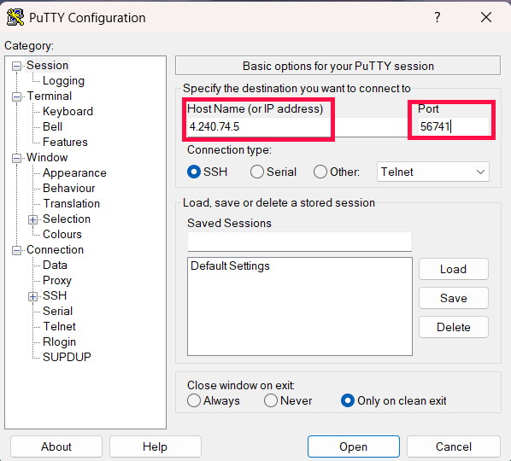
Host Name set to 4.240.74.5, Port set to 56741.

Step 2 — Expand SSH
In the Category tree on the left, click the + next to SSH (under Connection) to expand its sub-options.
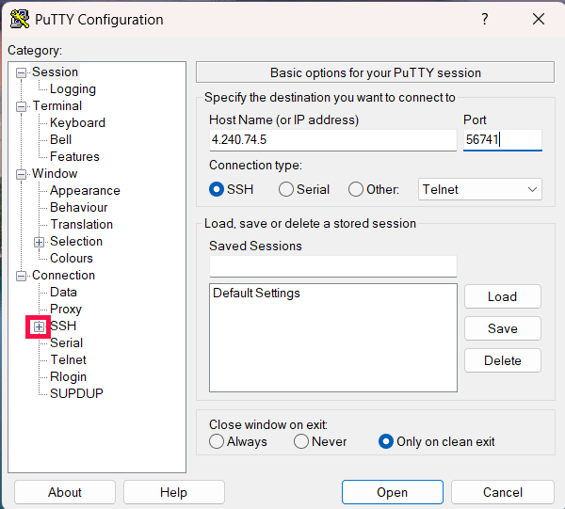
Clicking the + next to SSH to expand it.

Step 3 — Expand Auth
Under the now-expanded SSH section, click the + next to Auth to reveal Credentials and GSSAPI.
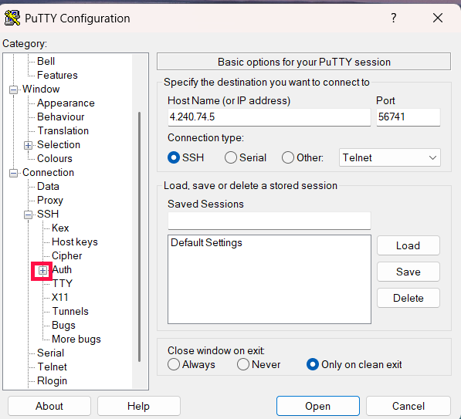
Clicking the + next to Auth to expand it.

Step 4 — Open Credentials
Click on Credentials (under Auth). This opens the page where the private key is set.
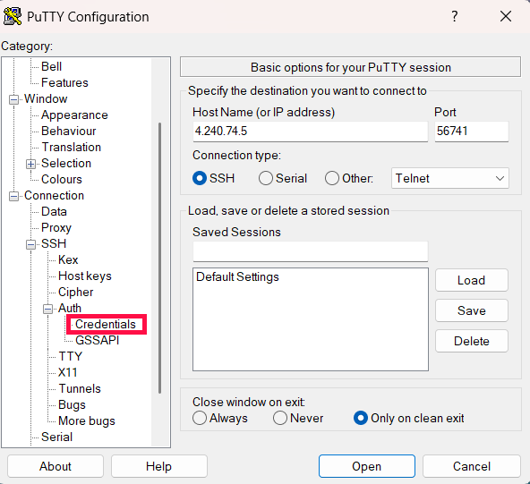
Clicking Credentials under Auth.

Step 5 — Credentials page
This is the Credentials page — empty at first, with a Browse... button for the private key file.
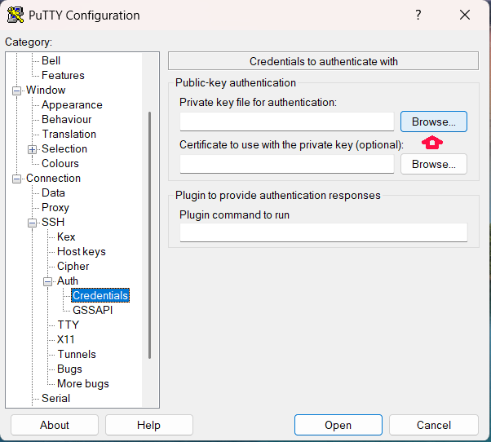
Credentials page open, empty, ready to browse for the key.

Step 6 — Browse for the private key
Click the Browse... button next to “Private key file for authentication,” then locate and select the key file — ranalyzer_key.ppk. This key file is itself a credential: whoever has it can log in as ilsuser, so it should be shared the same secure way as any other password, not over email or git.
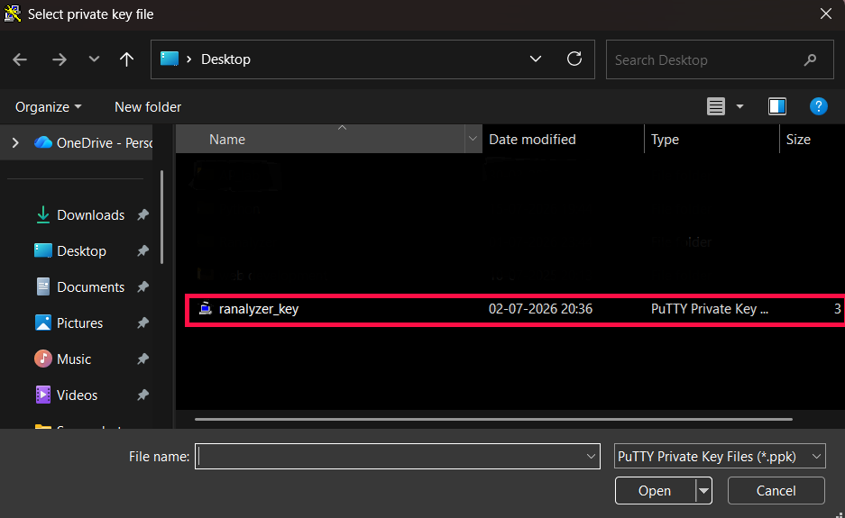
File picker — ranalyzer_key.ppk selected.

Step 7 — Click Open
With the key path now filled in, click Open (bottom of the PuTTY Configuration window) to start the session.
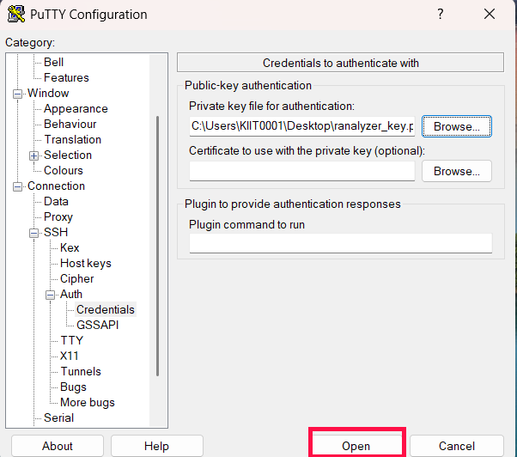
Private key path filled in — click Open to connect.

Step 8 — The terminal opens
A terminal window connects to 4.240.74.5 and prompts: login as:
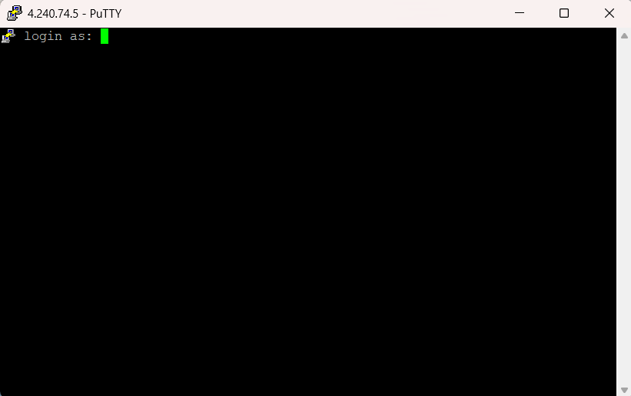
Terminal opens with the login as: prompt.

Step 9 — Log in as ilsuser
Type: ilsuser and press Enter. Since the private key was already provided, this logs straight in without asking for a separate SSH password.
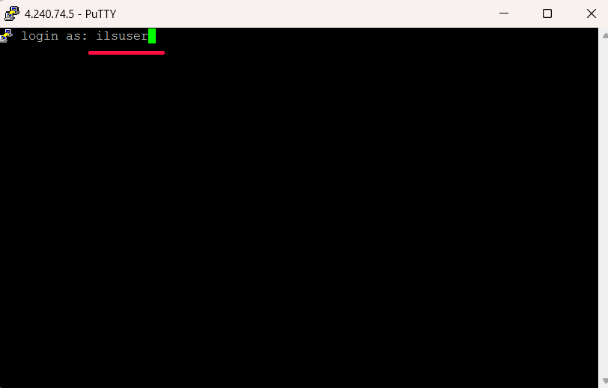
login as: ilsuser

Step 10 — Start the MySQL client
At the server's shell prompt (ilsuser@LinuxILSDEV1:~$), type:
mysql -u root -p
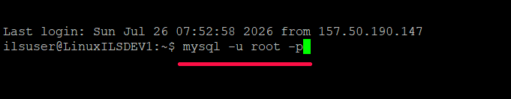
Running mysql -u root -p from the server shell.

Step 11 — Enter the MySQL password
At the Enter password: prompt, type the MySQL root password: Secure@password123. — nothing will appear on screen as you type (that's normal for a password prompt), then press Enter.
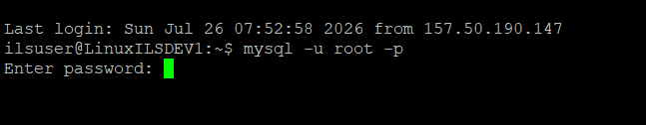
Enter password: prompt.

Step 12 — You're in MySQL
The MySQL monitor welcome message appears, ending in a mysql> prompt. From here, select the platform's database and list its tables:
USE rAanlyzer;
SHOW TABLES;
Use DESCRIBE table_name; to see a specific table's columns.
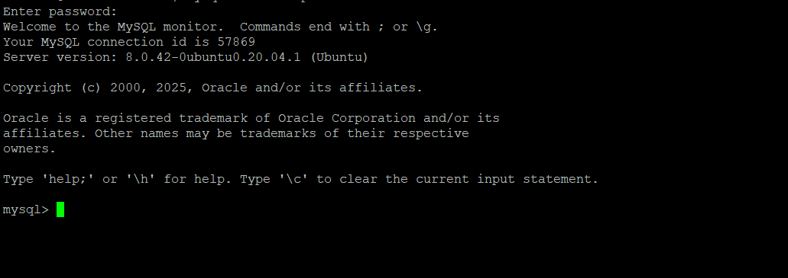
Logged into MySQL — welcome message and mysql> prompt.

13. Known Open Items
Documented here for visibility, not as blockers to getting set up:
- Authentication issues a role header on login but not a verified session/token yet — a real session/token system is planned.
- Some routes (Platform Users, Platform Roles, Menu Permissions, License Management, Connectors, Applications, Settings) don't yet have permission checks applied, though the mechanism to do so already exists in the code.
- No rate limiting on the login endpoint yet.
- SQL injection risks, hardcoded secret fallbacks, and an unsafe eval()-based validation path were found and fixed already this cycle.
- The database name has a typo (rAanlyzer instead of rAnalyzer) — cosmetic only, safe to leave as-is for now; renaming it requires updating DATABASE_URL everywhere it's used, so best done as a deliberate, coordinated step later rather than during handoff.

Questions
Reach out to Sania Gupta (saniagupta0909@gmail.com) for anything not covered here.

