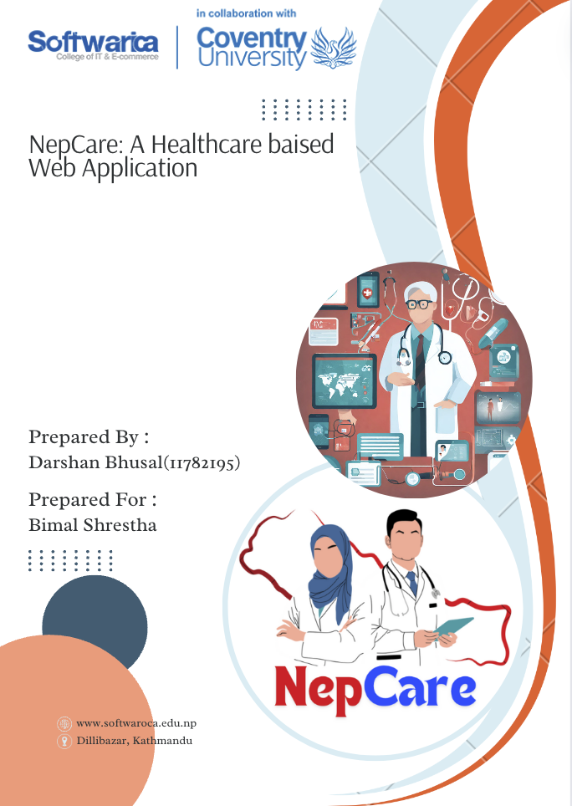

# Introduction

Welcome to NepCare, an innovative web-based healthcare management platform dedicated to transforming the way individuals interact with healthcare services. In today's fast-paced world, access to quality healthcare is paramount, yet often marred by inefficiencies and obstacles. NepCare seeks to bridge this gap by offering a seamless and intuitive solution that empowers users to take charge of their health journey with ease.

# Justification

The inspiration behind NepCare stems from the pressing need to revolutionize the healthcare experience for individuals worldwide. Across the globe, people encounter numerous challenges when accessing essential healthcare services, including long wait times, medication procurement issues, and a lack of reliable health information. These obstacles not only frustrate patients but also hinder their ability to make informed decisions about their health, leading to suboptimal outcomes. NepCare aims to address these challenges head-on by offering a user-centric platform that prioritizes accessibility, reliability, and convenience.

# Objective

The primary objective of NepCare is to develop a robust web application that simplifies the process of accessing healthcare services, empowers users with accurate health information, and fosters seamless communication between patients and healthcare providers. By leveraging technology, NepCare aims to enhance the overall healthcare experience, ultimately improving health outcomes for individuals.

# Mission

Our mission at NepCare is to empower individuals to take control of their health journey by providing them with convenient access to healthcare services, reliable health information, and personalized support. We are committed to leveraging technology to create a user-centric platform that prioritizes accessibility, transparency, and affordability, ultimately enabling users to lead healthier and happier lives.

# Vision

At NepCare, we envision a future where accessing quality healthcare is no longer a daunting task but rather a seamless and empowering experience for all. We strive to become the go-to platform for individuals seeking reliable health information, convenient access to healthcare services, and personalized support tailored to their unique needs. Through continuous innovation and collaboration, we aim to revolutionize the healthcare landscape, making optimal health and well-being accessible to everyone.

# Scope of Work

NepCare utilizes a modern technology stack comprising Node.js, Express.js, React.js, JavaScript (ES6+), HTML, CSS, and MongoDB. Node.js and Express.js handle backend development, React.js powers the frontend, and JavaScript is the primary programming language. HTML and CSS structure and style the user interface, while MongoDB manages the database. This comprehensive technology stack ensures the development of a robust, scalable, and user-friendly web-based healthcare management platform.

# Features of the Project

* Appointment Booking System: Streamline the process of scheduling appointments with healthcare professionals.
* Medication Procurement: Facilitate the purchase and delivery of prescribed medications and wellness products.
* Health Information Repository: Provide users with access to reliable health information, articles, and resources.
* Secure Health Records: Enable users to store and manage their health records securely within the platform.
* Community Forums: Create a supportive online community where users can share experiences, seek advice, and connect with others on similar health journeys.

# Prototyping

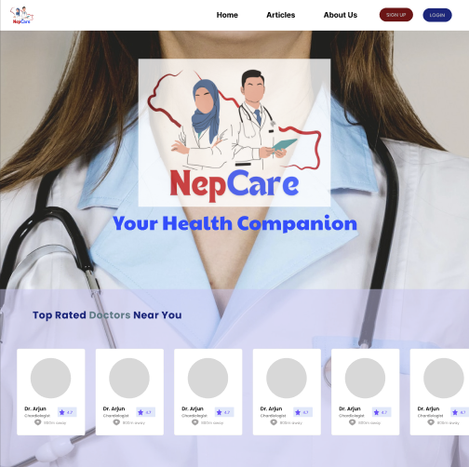

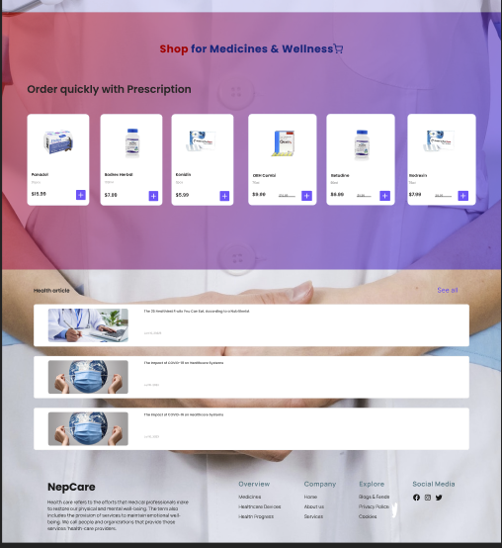

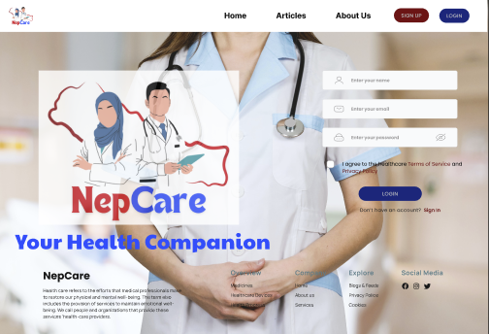

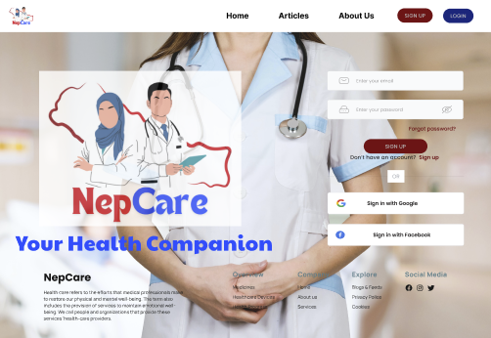

# Conclusion

In conclusion, NepCare represents a significant step towards revolutionizing the healthcare experience for individuals worldwide. By addressing the prevalent challenges in accessing healthcare services through a comprehensive web-based platform, NepCare aims to empower users to take control of their health journey with ease and confidence. Through innovative features such as appointment booking, medication procurement, health information repository, secure health records, and community forums, NepCare is poised to become a trusted companion in promoting optimal health and well-being. With a commitment to accessibility, transparency, and continuous improvement, NepCare endeavors to make quality healthcare accessible to everyone, ultimately fostering healthier and happier lives.

# References

* Free design tool: Presentations, video, social media | CANVA. (n.d.). <https://www.canva.com/>
* Figma community: Explore templates, plugins, and widgets published by the community. Figma. (n.d.-b). <https://www.figma.com/community>
* *What are the best apps for Healthcare Management Students and professionals?*. Healthcare Management Degree Guide. (2021, May 18). <https://www.healthcare-management-degree.net/faq/what-are-the-best-apps-for-healthcare-management-students-and-professionals/>