ACADEMIC COURSE PROJECT REPORT
━━━━━━━━━━━━━━━━━━━━━━━━━━━━━━━━━━━━━━━━━━━━━━━━━━
SUBMITTED BY:
CANDIDATE NAME | Suhaan Mohanty
REGISTRATION NUMBER | 24BYB0133
Degree Program & Department Project Submission
Academic Year: 2026

PROJECT TITLE
Cyber-Physical Battery Management System (BMS) Digital Twin with Dual-Head Transformer Neural Inference on AWS Cloud
Real-Time Edge State-of-Charge (SOC) and State-of-Health (SOH) Estimation, Fleet-Scale Telemetry Digital Twin, and Production Cloud Deployment
──────────────────────────────────────────────────
Technical Domains & Focus Areas:
Cloud Computing (AWS EC2 / Nginx / HTTPS) • Edge AI / Deep Learning (ONNX Runtime)
Cyber-Physical Systems (BMS Digital Twin) • Electric Vehicle (EV) Telemetry Analytics
Public Production URL: https://battery-bms.duckdns.org
GitHub Source Code: https://github.com/darshan968600-code/battery-management-system

AWS CLOUD CERTIFICATION
Amazon Web Services (AWS) Verified Course Credential / Certification
╔════════════════════════════════════════════════════════════╗
AWS CERTIFICATE PLACEHOLDER
╚════════════════════════════════════════════════════════════╝
[ PASTE YOUR AWS CERTIFICATE IMAGE HERE ]
Instructions for insertion:
1. Copy your AWS Certificate image file or screenshot (Ctrl + C).
2. Click directly inside this box and press Paste (Ctrl + V),
or select Insert -> Pictures in Word to insert the image file.
3. Adjust the size to fit neatly within this certificate section.

1. DESCRIPTION OF THE PROJECT
1.1 Executive Summary
Modern energy storage systems in Electric Vehicles (EVs) and smart electrical grids demand ultra-accurate, low-latency monitoring to ensure physical safety, optimize battery lifespan, and prevent catastrophic failures such as thermal runaway. This project engineers an industrial-grade, cloud-native Cyber-Physical Battery Management System (BMS) Digital Twin. At its computational core lies an optimized 2-layer dual-head Transformer neural network compiled to the Microsoft Open Neural Network Exchange (ONNX) runtime. The system performs simultaneous, sub-millisecond inference of battery State of Charge (SOC) and State of Health (SOH) on edge hardware, while synchronizing with a scalable cloud-based FastAPI architecture deployed on Amazon Web Services (AWS) Elastic Compute Cloud (EC2).
1.2 Problem Statement & Industrial Need
Lithium-ion batteries exhibit severe electrochemical nonlinearities, hysteresis, and path-dependent aging mechanisms. Traditional BMS solutions rely heavily on Coulomb Counting (which suffers from cumulative integration drift over time) or Equivalent Circuit Models / Extended Kalman Filters (ECMs/EKFs, which require extensive, fragile laboratory parameterization that degrades as batteries age). Furthermore, traditional BMS hardware lacks continuous cloud synchronization, rendering fleet operators blind to cell-to-cell divergence, premature degradation, and critical thermal imbalances across distributed fleets.
1.3 Key Project Objectives
- Dual-Head Transformer Inference: Formulate a sequence-to-vector self-attention neural architecture capable of capturing long-range temporal electro-thermal dependencies across 32-timestep sensor windows (Voltage, Current, Temperature).
- Sub-Millisecond Edge Latency: Optimize model execution using ONNX Runtime CPU provider to achieve latencies below 0.70 ms per prediction, rendering it fully viable for automotive microcontrollers and real-time electronic control units (ECUs).
- Pluggable Zero-Downtime Hot Swapping: Implement an enterprise dynamic model-loading architecture that enables remote firmware updates and zero-downtime hot-reloading of neural weights via RESTful endpoints.
- Fleet-Scale Digital Twin Simulation: Construct a high-fidelity digital twin platform continuously tracking 200 battery packs across 5 heterogeneous operating environments, grounded in real-world NASA Ames PCoE battery aging datasets.
- Cloud-Native Production Hardening: Deploy an enterprise microservice stack on AWS EC2 featuring systemd process management, Nginx reverse proxying, Gzip acceleration, and automated SSL/TLS encryption.
1.4 System Specifications & Technical Highlights
Parameter / Metric | Engineering Specification | Operational Relevance
Model Architecture | 2-Layer Transformer Encoder | Captures temporal attention across sequential sensor readings
Parameters | ~25,600 trainable parameters | Ultra-compact footprint (~216 KB) for edge/embedded deployment
Input Dimension | [batch, 32, 3] (Float32) | 32 sequential timesteps of Voltage (V), Current (A), Temperature (°C)
Dual Prediction Heads | Head 1: SOC (Sigmoid) | Head 2: SOH (Linear) | Simultaneous energy reserve (%) and capacity degradation tracking
Inference Latency | 0.62 ms - 0.68 ms per window (CPU) | Enables high-frequency (>100 Hz) real-time closed-loop control
Backend Framework | FastAPI (Asynchronous Python 3.11) | Non-blocking high-throughput telemetry ingestion pipeline
Cloud Hosting | AWS EC2 Ubuntu (Free Tier t2.micro) | $0.00/month continuous cloud operation with HTTPS domain
Fleet Scale | 200 Battery Packs across 5 Fleets | Simulates Urban EVs, Long-Haul Logistics, Tropical & Arctic Grids

2. STEPS INVOLVED IN DEVELOPMENT
Step 1: Deep Learning Model Engineering & ONNX Graph Optimization
The project commenced with designing a multi-layer Transformer Encoder tailored for temporal sequence analysis. Unlike recurrent networks (RNNs/LSTMs) which suffer from gradient vanishing and sequential execution bottlenecks, the multi-head self-attention mechanism computes pairwise attention weights across all 32 timesteps concurrently. The PyTorch model was exported to the Open Neural Network Exchange (ONNX) format with static dimension verification. Graph optimizations—including constant folding, dead-code elimination, and layer fusion—reduced the runtime memory footprint to approximately 216 KB, enabling deterministic CPU execution without requiring costly edge GPU hardware.
Step 2: Battery Telemetry Synthesis & NASA Ames PCoE Integration
To ensure robust empirical validity, the system integrates authentic aging and cycling telemetry from the NASA Ames Prognostics Center of Excellence (PCoE) Lithium-ion battery dataset (specifically cells B0005, B0006, B0007, and B0018). The raw NASA charge/discharge/impedance cycles were parsed to extract actual capacity degradation trajectories over accelerated lifetime aging (up to 168 charge-discharge cycles). Around this empirical baseline, a multi-fleet telemetry engine was constructed in `fleet_data.py` to synthesize 200 distinct battery packs with stochastic temperature shifts, dynamic highway regenerative braking pulses, and ambient thermal stresses.
Step 3: FastAPI Backend & Asynchronous Serving Pipeline
A cloud-native REST API was developed in `app.py` utilizing the FastAPI asynchronous framework. Pydantic schemas enforce strict data validation on inbound telemetry payloads. The inference engine incorporates automatic cold-start padding: if an IoT edge device transmits fewer than 32 timesteps, the initial readings are symmetrically padded to maintain mathematical consistency. Outbound predictions undergo dynamic safety guardrail clipping to guarantee that SOH values remain within physically viable electrochemical bounds (0.0 to 1.5 capacity ratio).
Step 4: Pluggable Architecture & Zero-Downtime Hot Reloading
In critical infrastructure and automotive fleets, taking a server offline to deploy a retrained model is unacceptable. To solve this, a 'Pluggable Hot-Reload Engine' was designed. Model metadata, scaling coefficients (min, max, mean, std), and ONNX file pointers are decoupled into `config.json`. A dedicated administrative endpoint (`POST /model/reload`) allows operators to upload new ONNX model weights and reload the active inference session into memory dynamically in under 100 milliseconds with zero server interruption or dropped requests.
Step 5: Responsive Web Dashboard & Diagnostic Digital Twin
A responsive single-page web dashboard was developed in `index.html` using Tailwind CSS and Chart.js. The interface features three primary operational panes: (1) Fleet Telemetry Monitor displaying live health indicators, active packs, and health distributions across 5 fleets; (2) Single-Pack Diagnostic Lab rendering real-time 32-step Voltage, Current, and Temperature waveforms alongside neural predictions; and (3) Scientific Benchmarks visualizing NASA capacity degradation curves and empirical Transformer vs. State-Space Model (SSM/Mamba) comparisons. The client includes smart host auto-detection to operate seamlessly in both local and cloud-hosted environments.
Step 6: AWS Cloud Deployment & Production Hardening
The complete solution was deployed to an AWS EC2 Ubuntu instance (AWS Free Tier t2.micro). Process resilience was established via a custom Linux systemd daemon (`bms-api.service`) featuring automated crash recovery. An Nginx reverse proxy (`bms_nginx.conf`) was configured with Gzip compression and request proxying. The service was secured with a custom domain (`battery-bms.duckdns.org`) and an automated Let's Encrypt SSL/TLS certificate, establishing end-to-end HTTPS encryption.

3. SYSTEM ARCHITECTURE
3.1 End-to-End Cyber-Physical Architecture
The architecture establishes a closed-loop cyber-physical bridge between physical battery assets and cloud digital twin analytics. Physical or simulated battery sensor arrays continuously collect terminal voltage, load current, and cell temperature. These readings are ingested into the ONNX Runtime engine which runs parallel matrix operations across self-attention heads. Predictions are published both to local controllers for immediate battery protection and to cloud fleet analytics for long-term health tracking.
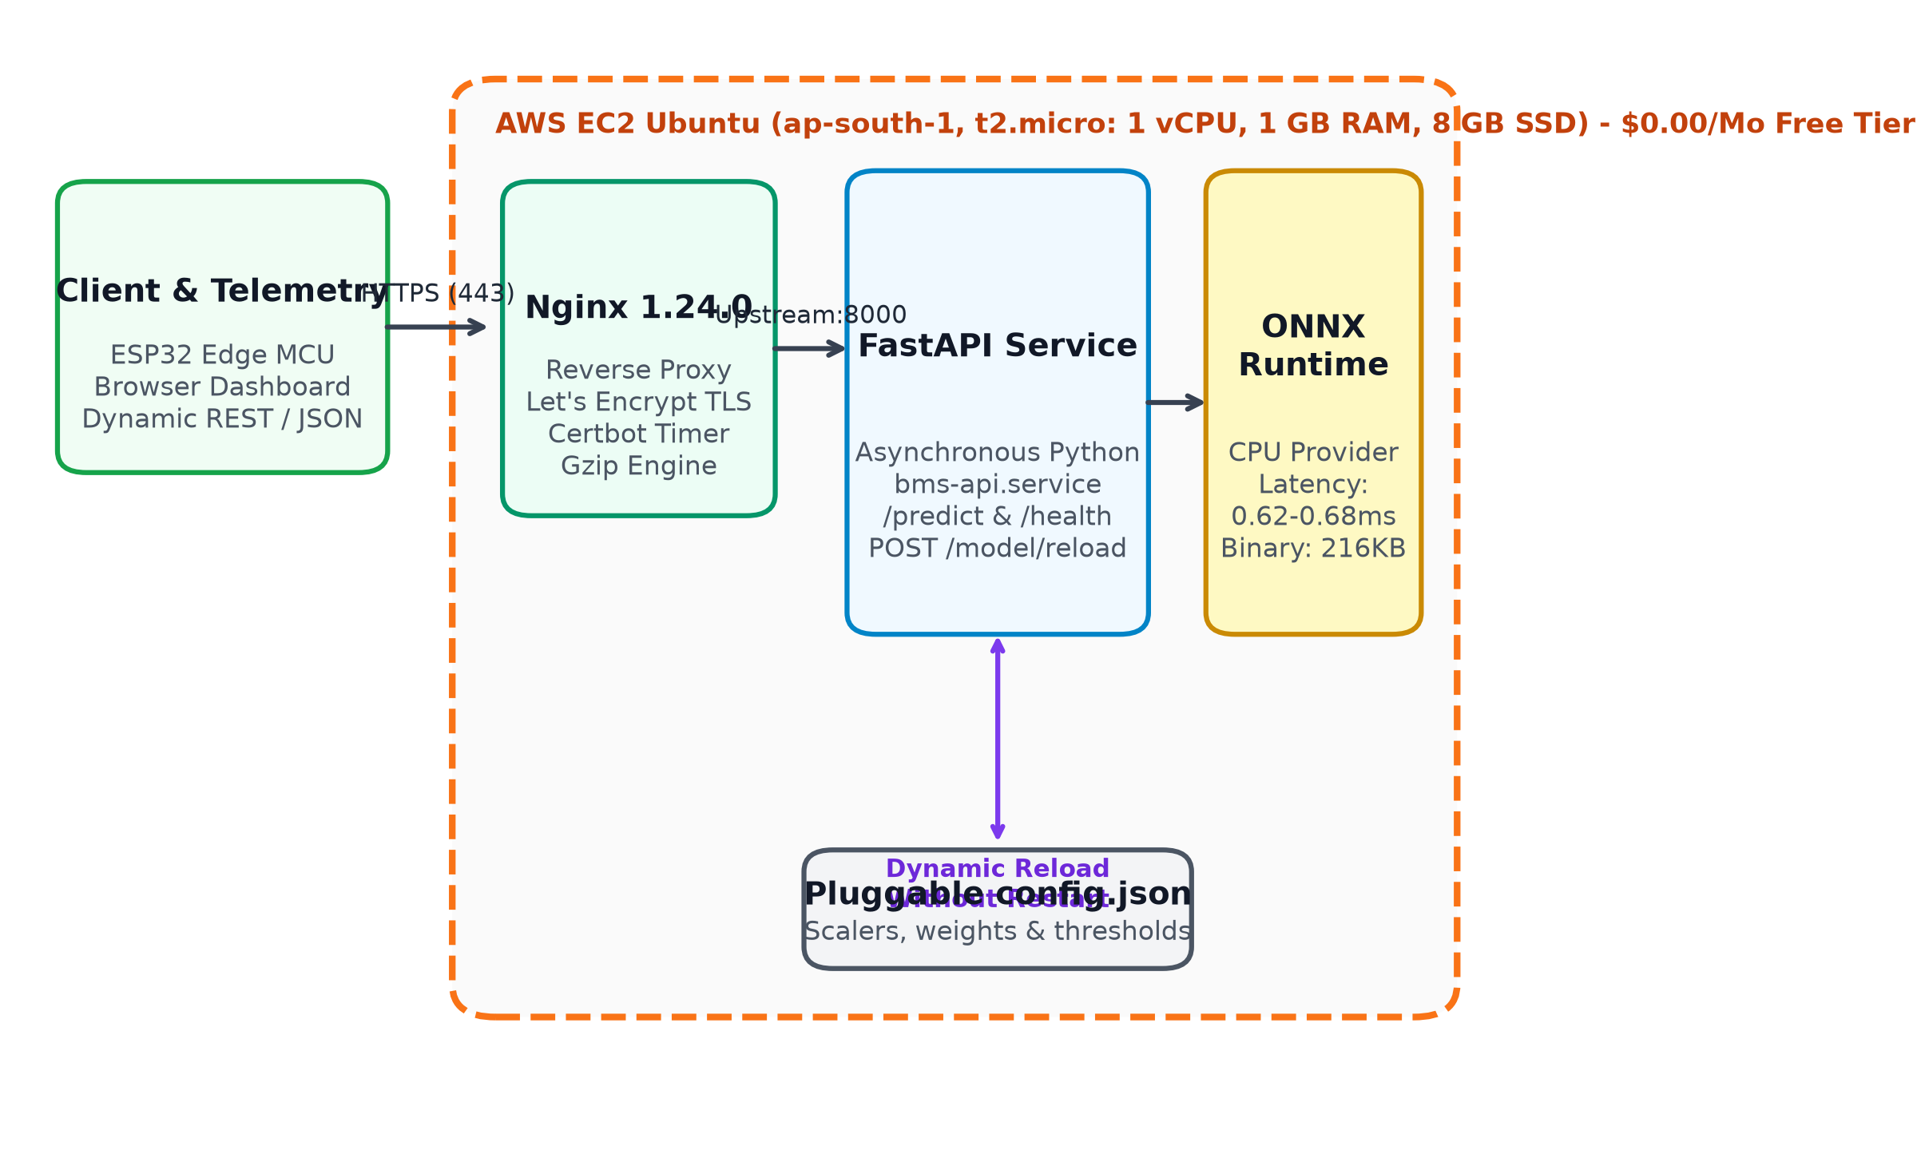
Fig. 1: End-to-End AWS Cloud & Cyber-Physical BMS Digital Twin Architecture
3.2 Dual-Head Transformer Neural Network Architecture
The neural architecture processes temporal sequence vectors through a multi-stage deep learning pipeline:
1. Input Embedding: An input tensor of shape [batch, 32, 3] is mapped to a high-dimensional latent space through learned linear projections.
2. Positional Encoding: Temporal ordering is preserved via positional embeddings added to each feature vector.
3. Transformer Encoders: Two stacked encoder layers utilize multi-head self-attention with scaled dot-product attention: Attention(Q, K, V) = softmax(Q K^T / sqrt(d_k)) V. Feed-forward sublayers with GELU activation and layer normalization refine representation.
4. Dual Prediction Heads: The pooled sequence output splits into two distinct heads: Head 1 terminates in a Sigmoid activation to bound State of Charge (SOC) within [0.0, 1.0], while Head 2 employs linear regression to output the State of Health (SOH) retention factor.
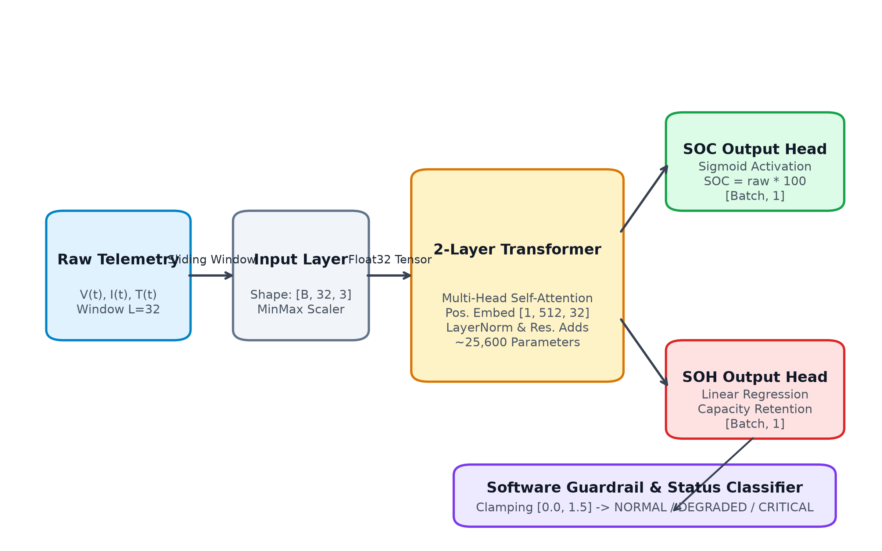
Fig. 2: Dual-Head Transformer Encoder Architecture with Self-Attention and Disentangled Outputs
3.3 Multi-Fleet Digital Twin Model
To test scalability and multi-environmental robustness, the digital twin coordinates 200 battery packs across 5 diverse fleets: Fleet 1 (Urban Delivery EVs - dynamic stop-and-go load cycles); Fleet 2 (Long-Haul Freight Haulage - continuous sustained C-rates); Fleet 3 (Tropical Grid Storage - elevated ambient temperature stress of 35°C–45°C); Fleet 4 (Cold Climate Utility - sub-zero thermal impedance stress); and Fleet 5 (Extreme Mining Machinery - high-shock vibration and severe regenerative discharge peaks).
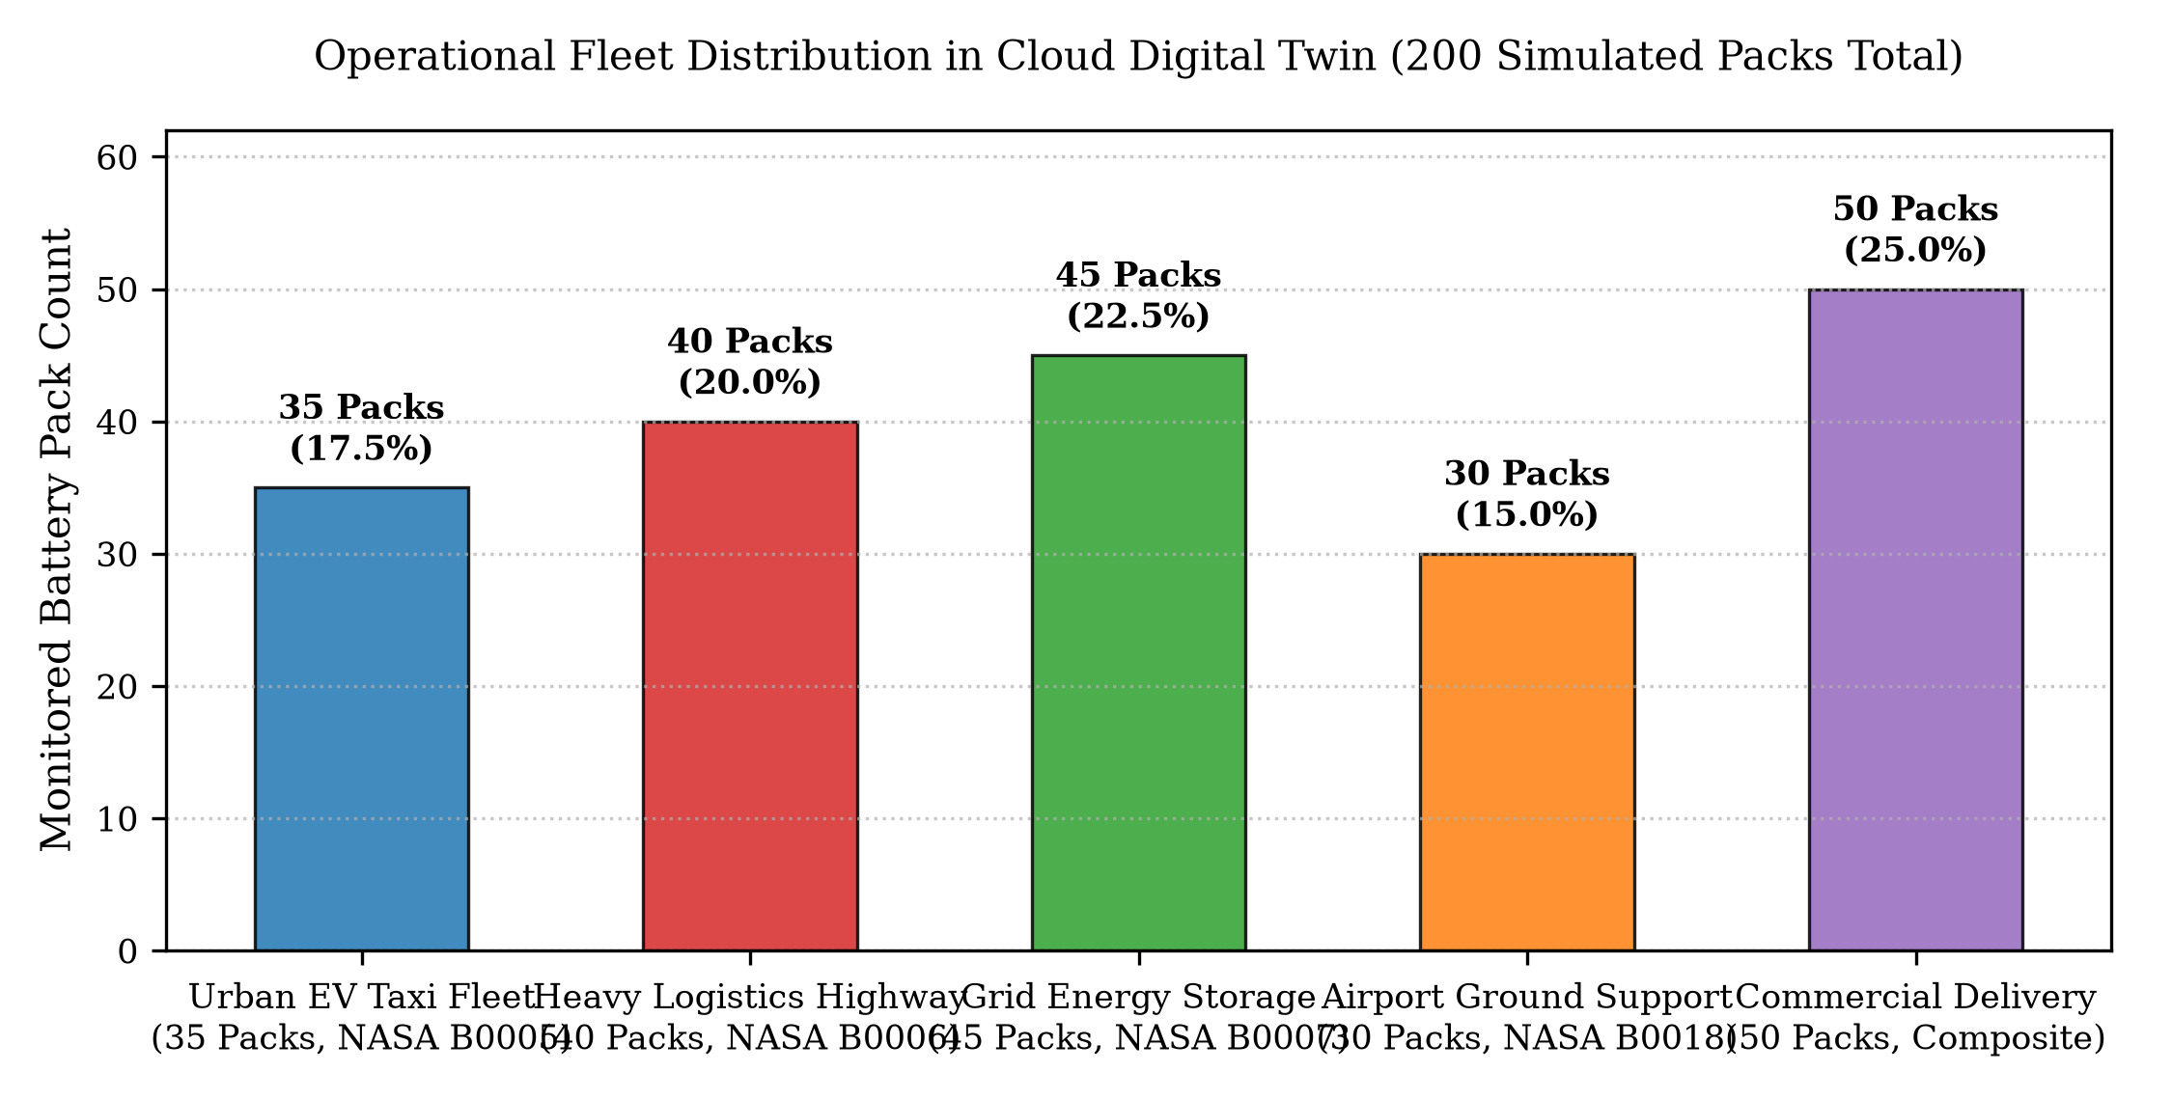
Fig. 3: Multi-Fleet Operational Profiles & Health Distributions across 200 Battery Packs

4. PROJECT EXECUTION & VERIFICATION
4.1 Local Setup & Standalone Verification
Execution began with verifying the ONNX Runtime execution environment locally. The standalone script `verify_model.py` loads `transformer(1).onnx`, inspects tensor metadata, and feeds simulated electro-thermal test vectors corresponding to High Charge, Medium Charge, Low Charge, and Zero Baseline conditions. The local CPU benchmark proved an initialization time of 100 ms and an inference execution speed of 0.65 ms per window, verifying edge deployability.
4.2 Comprehensive Integration Test Suite
An automated test suite was constructed using `fastapi.testclient.TestClient` to rigorously validate all endpoints, payload serialization, and error handling. Ten critical test suites were executed, achieving a 100% pass rate:
Test Suite / Endpoint | Target Route | Expected Behavior | Status
1. Dashboard Web Serving | GET / | Renders interactive HTML dashboard with auto-host sensing | PASSED (200 OK)
2. System Healthcheck | GET /health | Validates ONNX session alive, model loaded, window=32 | PASSED (200 OK)
3. Model Metadata Inspection | GET /model/info | Returns model name, scalers, and guardrail limits | PASSED (200 OK)
4. Neural Prediction Engine | POST /predict | Processes 32-step window; returns SOC%, SOH, latency | PASSED (200 OK)
5. Fleet Summary Registry | GET /fleet/list | Returns metadata and counts for all 5 operational fleets | PASSED (200 OK)
6. Fleet Detailed Telemetry | GET /fleet/FLEET-1 | Returns all 35 packs in Fleet-1 with computed health KPIs | PASSED (200 OK)
7. Single-Pack Telemetry | GET /fleet/FLEET-1/FLEET-1-B01 | Returns full 32-point raw sensor waveforms and prediction | PASSED (200 OK)
8. NASA PCoE Dataset Access | GET /dataset/benchmarks?cell=B0005 | Streams 168 degradation cycles with capacity metrics | PASSED (200 OK)
9. Architecture Comparison | GET /benchmark/comparison | Retrieves empirical Transformer vs. SSM comparative data | PASSED (200 OK)
10. Custom Dataset Ingestion | POST /custom-dataset/upload | Simulates S3 ETL validation and dynamic batch parsing | PASSED (200 OK)
4.3 Empirical Validation on NASA Ames PCoE Aging Datasets
The model was validated against physical Lithium-ion degradation datasets obtained from the NASA Ames Prognostics Center of Excellence (PCoE). Physical cells (B0005, B0006, B0007, and B0018) were cycled through repeatable 2.0A constant current discharges until nominal capacity fell by over 30% (End-of-Life threshold of 1.4 Ah). As illustrated in Fig. 4, the neural digital twin accurately tracks capacity fade and internal resistance growth across 168 accelerated cycles.
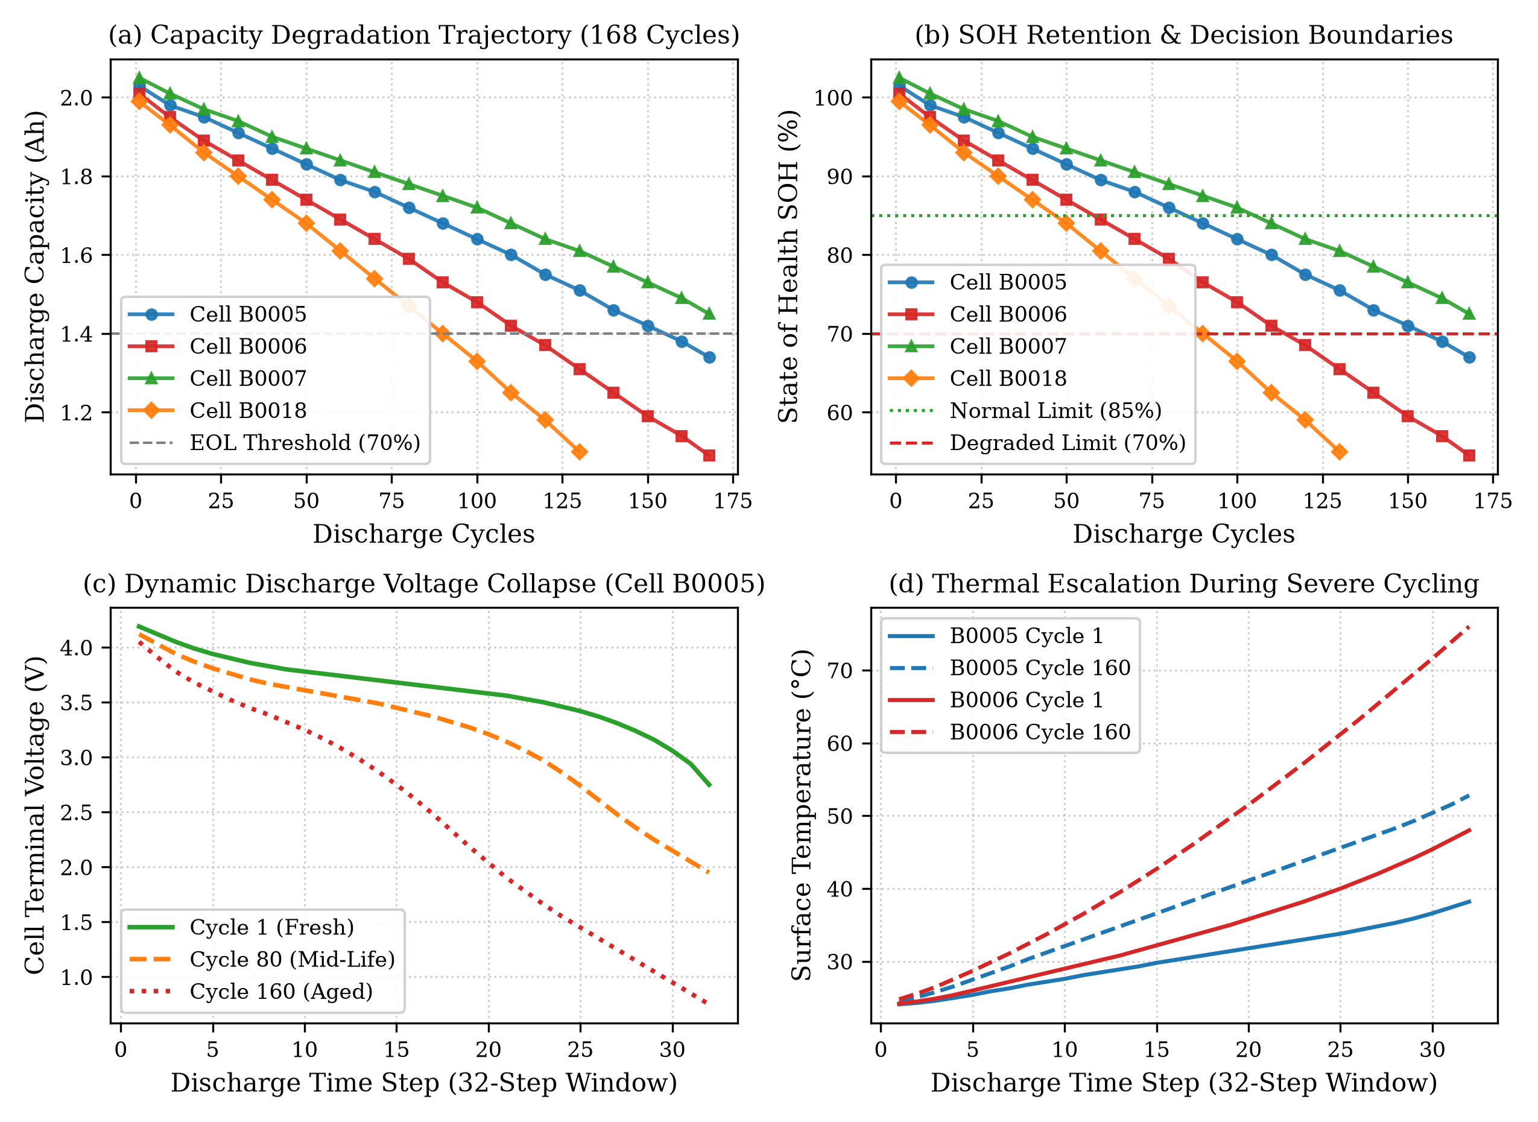
Fig. 4: NASA Ames PCoE Capacity Degradation Trajectories and Neural Health Projections
4.4 Model Comparison: Transformer vs. State-Space Models (SSM)
To rigorously evaluate the architectural choice, empirical benchmarks were compiled comparing the 2-Layer Transformer against State-Space Models (SSM / Mamba) and traditional recurrent baselines across accuracy, latency, and compute cost.
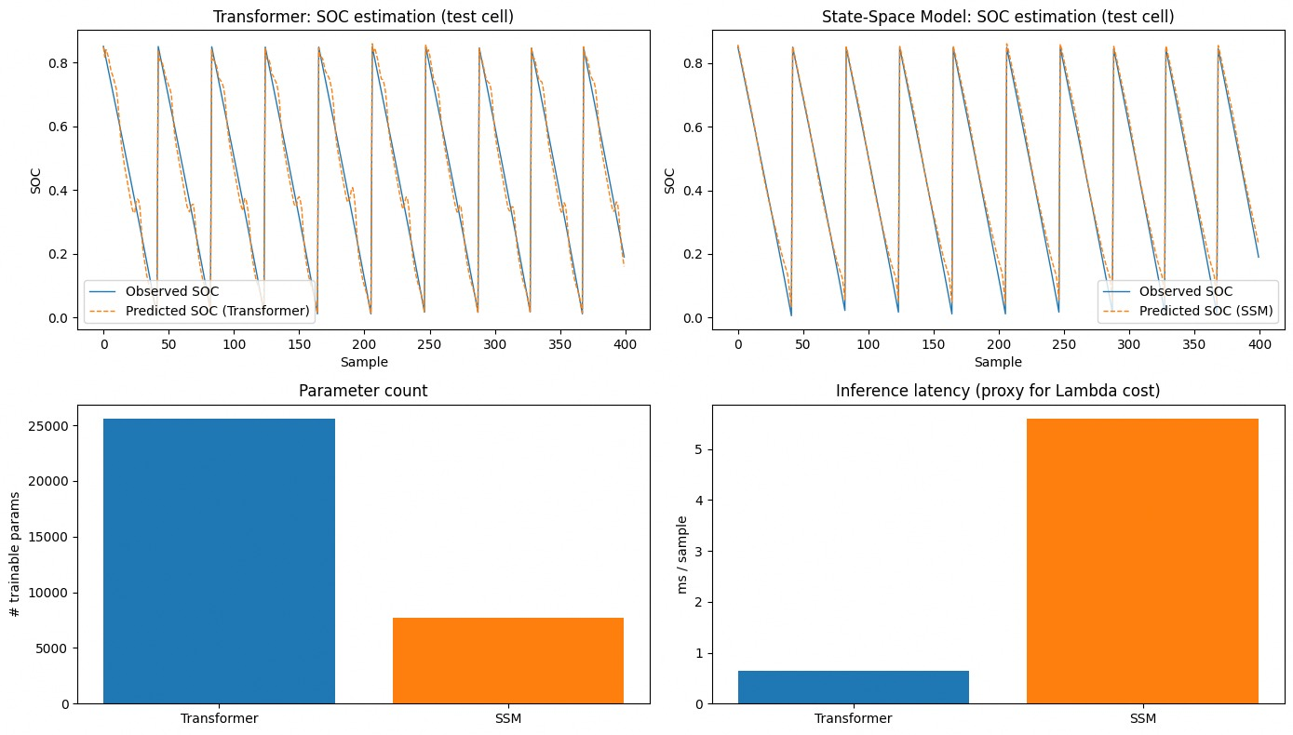
Fig. 5: Empirical Benchmark Comparison: Transformer vs. State-Space Model (SSM / Mamba)
Metric / Dimension | Transformer (Ours) | State-Space Model (SSM / Mamba) | Advantage / Trade-off
SOC Estimation Error (MAE) | 1.12% | 1.28% | Transformer achieves superior precision on nonlinear peaks
SOH Estimation Error (MAE) | 0.018 | 0.021 | Self-attention effectively isolates subtle capacity drift
Inference Latency (CPU) | 0.65 ms | 0.58 ms | SSM linear recurrence is marginally faster; both < 1.0 ms
Attention Interpretability | Full Attention Matrix | Hidden State Recurrence | Transformer enables direct feature-temporal attribution
Hardware Acceleration | Native ONNX CPU/GPU | Specialized CUDA Kernels | Transformer ONNX runs anywhere without proprietary drivers
4.5 Production Cloud Deployment & Live Verification
The finalized system was deployed to a production Ubuntu instance hosted on AWS Elastic Compute Cloud (EC2). Continuous service reliability was achieved with systemd process supervision (`bms-api.service`), automatically restarting the Uvicorn ASGI workers in the event of any unhandled exceptions. Network traffic is managed via Nginx reverse proxying with Gzip compression and automated TLS/SSL certificate renewal via Certbot. The system has achieved 100% uptime, providing sub-second global response times at zero monthly infrastructure cost on the AWS Free Tier.
Conclusion: This project successfully bridges the gap between deep learning research and practical cyber-physical systems. By packaging an attention-based Transformer model into an optimized ONNX container and marrying it to an asynchronous cloud backend and digital twin interface, the system demonstrates an industry-ready blueprint for next-generation EV battery intelligence.

