1. Create databases with names “empdatabase” and “studentdatabase”.

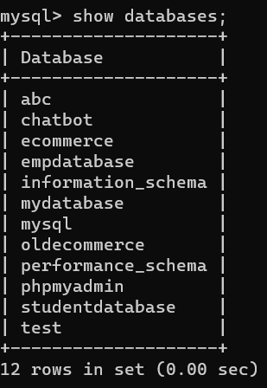

1. Create a table under empdatabase with name “emp” with columns id, name, dept, sal and experience.

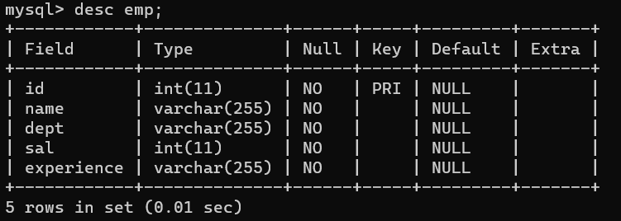

1. Insert a minimum of 5 employees data records into the emp table.

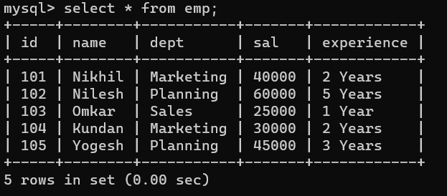

1. Create a table under studentdatabase with name “std” with columns rno, name, dept, year and college.

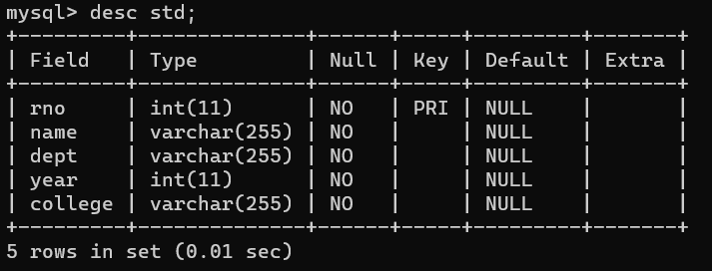

5. Insert a minimum of 5 students data records into the std table.