FINANCIAL FRAUD
ANALYSIS
A Python-Based Exploratory Data Analysis of Fraud Patterns,
Risk Indicators, and Business Implications

Dataset: 1,000,000 Transactions | Period: 2020–2024
Prepared by Darshan
Data Analytics & Business Intelligence Project

Executive Summary
This report analyzes 1,000,000 financial transactions recorded between 2020 and 2024 to identify fraud patterns, distinguish fraud volume from actual fraud risk, and translate the findings into practical business recommendations. Across the full dataset, 55,255 transactions were fraudulent, producing an overall fraud rate of 5.53%. The detailed investigation focuses primarily on 2024, the latest year available.
1,000,000  Transactions | 55,255  Fraud Transactions | 5.53%  Overall Fraud Rate | 48,121  Customers Affected

The strongest observed risk signals were repeated failed attempts, international transaction status, and merchant category. Transactions associated with two or more failed attempts showed fraud rates near 14%, international transactions reached 9.85%, and Jewelry, ATM Withdrawal, and Crypto Exchange each exceeded 8.7%. By contrast, high fraud counts for the USA, Mobile devices, and Credit Cards mainly reflected transaction volume and should not automatically be interpreted as higher inherent risk.

Objectives
- Establish the overall scale and persistence of fraud.
- Identify where fraud cases are concentrated across countries, payment methods, devices, customer groups, and merchant categories.
- Separate high fraud volume from high fraud rate to avoid misleading risk conclusions.
- Identify actionable behavioral and transaction-level indicators that can support risk-based monitoring.

Dataset Overview
26  Columns / Features | 2020–2024  Coverage | 198,662  Unique Customers | 5.53%  Baseline Fraud Rate

Variable Group | Examples
Transaction details | Date, time, hour, amount, weekend/night flags, transaction frequency
Customer information | Age, credit score, account age, account balance
Fraud attributes | Fraud flag, fraud type, failed attempts, recent PIN change
Channel information | Payment method and device type
Geography | Country, city, distance from customer home
Transaction origin | Domestic versus international status

1. Overall Fraud Landscape
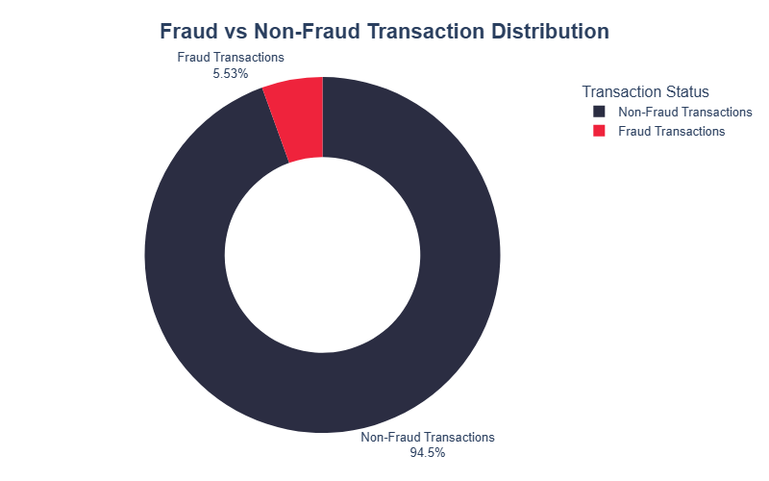
KEY INSIGHT
Across the full dataset, 55,255 of 1,000,000 transactions were fraudulent, giving an overall fraud rate of 5.53%. Among 198,662 unique customers, 48,121 were affected by at least one fraudulent transaction.
BUSINESS PROBLEM ADDRESSED
Management needs a reliable baseline for the scale of fraud and the number of customers exposed to fraudulent activity.
RECOMMENDATION
Track both transaction-level fraud rate and unique customers affected. Use the 5.53% overall rate as a benchmark when comparing individual segments.

2. Year-over-Year Transaction and Fraud Stability
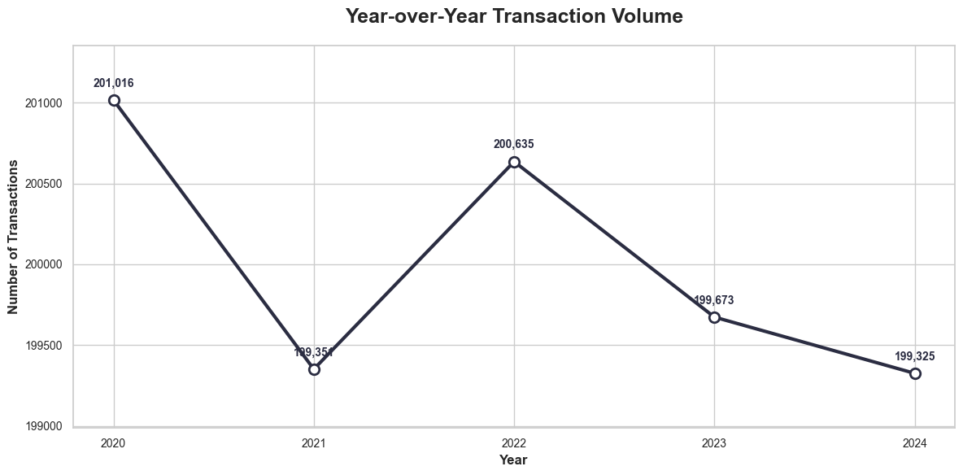
KEY INSIGHT
Annual transaction volume remained close to 200,000 from 2020 through 2024, while annual fraud rates stayed approximately between 5.49% and 5.58%. Fraud is persistent rather than rapidly escalating.
BUSINESS PROBLEM ADDRESSED
Management must know whether fraud is accelerating, declining, or remaining structurally persistent.
RECOMMENDATION
Treat fraud prevention as an ongoing operational capability. Investigate monthly and segment-level movement rather than assuming stable annual averages mean risk is controlled.
Analytical note: The chart shows transaction volume, not fraud rate. The conclusion on fraud stability comes from the annual fraud-rate calculation.

3. 2024 Fraud Overview
KEY INSIGHT
In 2024, 10,949 of 199,325 transactions were fraudulent, producing a fraud rate of 5.49%. A total of 10,643 customers were affected by fraud.
BUSINESS PROBLEM ADDRESSED
Stakeholders need a current-year baseline before investigating specific risk factors.
RECOMMENDATION
Use the 2024 fraud rate of 5.49% as the latest-year benchmark and compare segments against it to identify materially elevated risk.

199,325  Transactions | 10,949  Fraud Transactions | 5.49%  Fraud Rate | 10,643  Affected Customers

4. Country-Level Fraud Concentration
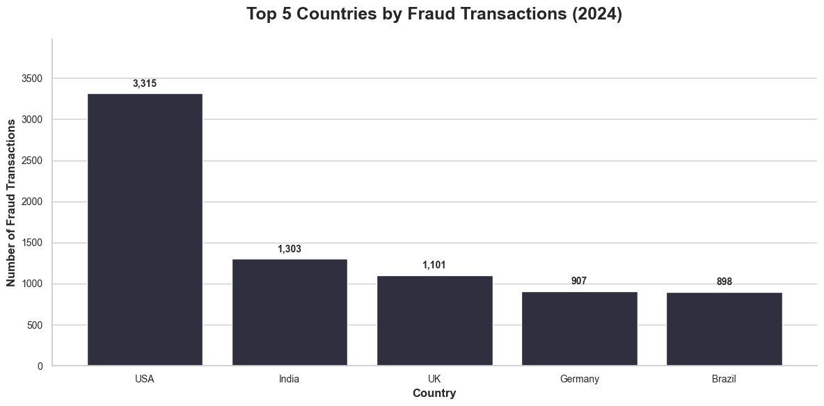
KEY INSIGHT
The USA recorded 3,315 fraudulent transactions in 2024, followed by India with 1,303 and the UK with 1,101. However, country-level fraud rates were relatively close, generally around 5.1%–5.7%.
BUSINESS PROBLEM ADDRESSED
Large markets can generate high fraud counts simply because they process more transactions.
RECOMMENDATION
Use fraud count for workload planning and fraud rate for relative-risk assessment. Do not classify the USA as the highest-risk market solely from case volume.

5. Payment Method Analysis
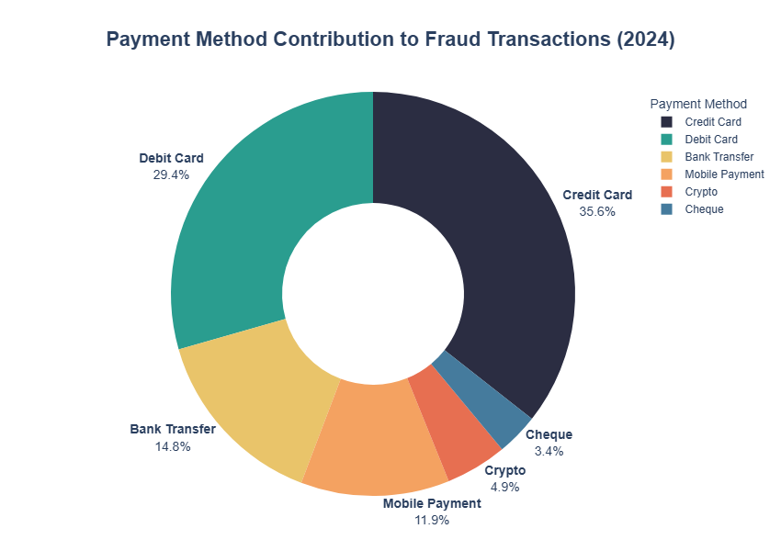
KEY INSIGHT
Credit Cards contributed 35.6% of 2024 fraud cases and Debit Cards 29.4%. However, Cheque transactions had the highest observed fraud rate at 6.22%, while most other payment methods were around 5.4%–5.6%.
BUSINESS PROBLEM ADDRESSED
High case volume and high probability of fraud are different business problems.
RECOMMENDATION
Use contribution share to allocate investigation capacity, but use fraud rate to assess channel risk. Give targeted attention to Cheque transactions while maintaining strong operational monitoring for high-volume card channels.

6. Device-Level Fraud Distribution
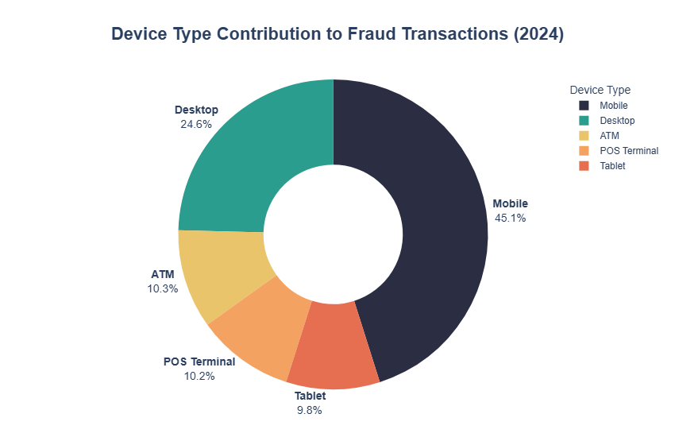
KEY INSIGHT
Mobile devices generated 4,940 fraud cases, or 45.1% of all 2024 fraud, followed by Desktop at 24.6%. Device fraud rates were nevertheless similar, approximately 5.34%–5.62%.
BUSINESS PROBLEM ADDRESSED
High usage can make a device appear risky when the underlying fraud probability is not materially higher.
RECOMMENDATION
Prioritize Mobile for investigation capacity because of case volume, but combine device type with behavioral indicators before applying stronger controls.

7. Fraud Timing Patterns
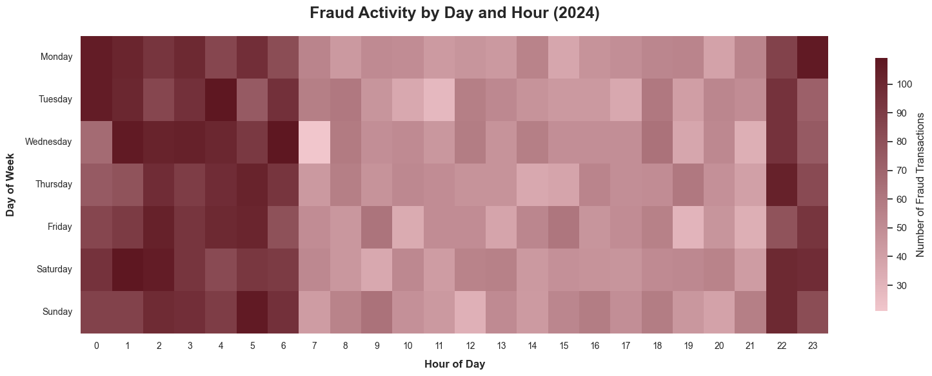
KEY INSIGHT
Late-night and early-morning periods, roughly 22:00–06:00, frequently show higher fraud counts across several days of the week.
BUSINESS PROBLEM ADDRESSED
Uniform monitoring sensitivity may miss recurring time-based concentrations of suspicious activity.
RECOMMENDATION
Consider enhanced overnight monitoring, but validate the pattern using fraud rates by hour before implementing strict time-based rules.
Analytical note: The heatmap displays fraud counts. Higher counts can partly reflect transaction volume, so hourly fraud rates should be calculated before concluding that a time window is inherently riskier.

8. Customer Age Distribution
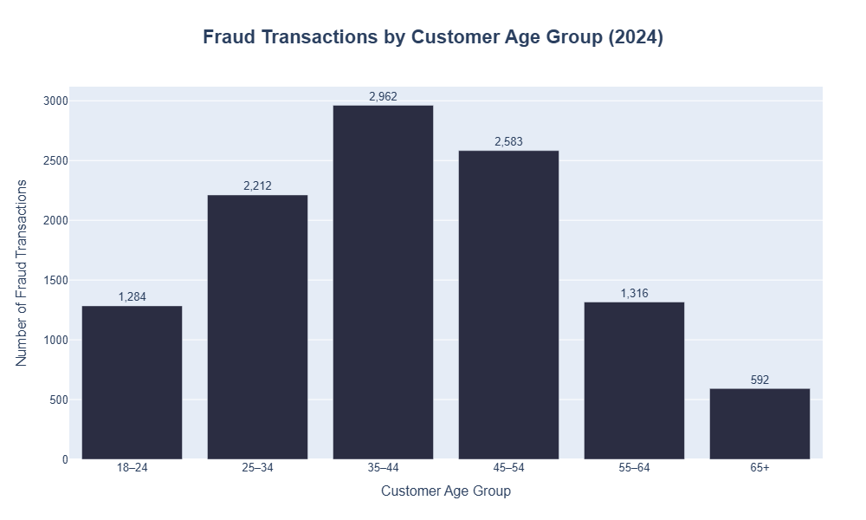
KEY INSIGHT
The 35–44 age group recorded the largest fraud count in 2024 with 2,962 cases, followed by 45–54 with 2,583 and 25–34 with 2,212.
BUSINESS PROBLEM ADDRESSED
Fraud teams need to know which customer groups account for the largest investigation workload.
RECOMMENDATION
Use the distribution for investigation prioritization, not as proof of vulnerability. Calculate fraud rate within each age group before introducing age-targeted controls.

9. Merchant Category Risk
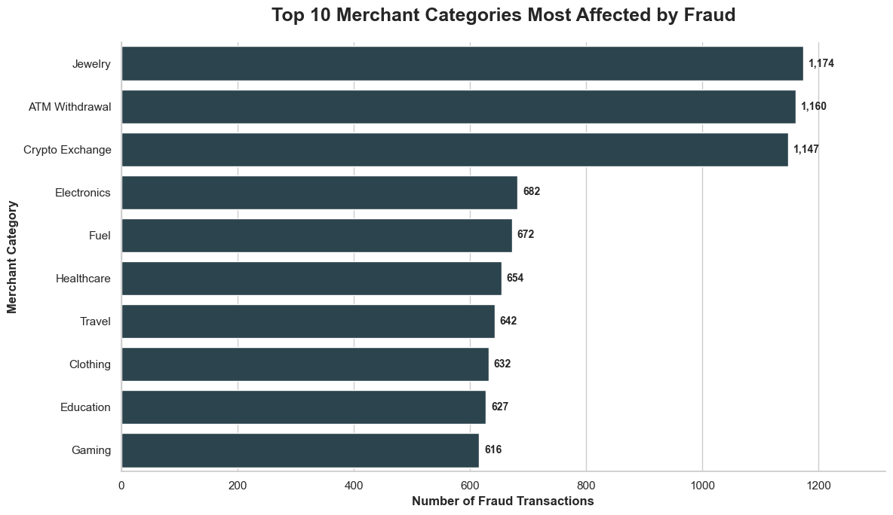
KEY INSIGHT
Jewelry had the highest observed merchant-category fraud rate at 8.86%, followed by ATM Withdrawal at 8.79% and Crypto Exchange at 8.71%. These were materially above Electronics (5.04%), Fuel (4.96%), and Healthcare (4.95%).
BUSINESS PROBLEM ADDRESSED
Uniform transaction controls can under-protect categories where fraud occurs at a substantially higher rate.
RECOMMENDATION
Apply enhanced risk-based monitoring to Jewelry, ATM Withdrawal, and Crypto Exchange transactions, including additional verification, velocity checks, and context-aware limits where appropriate.

10. Failed Attempts as a Strong Fraud Indicator
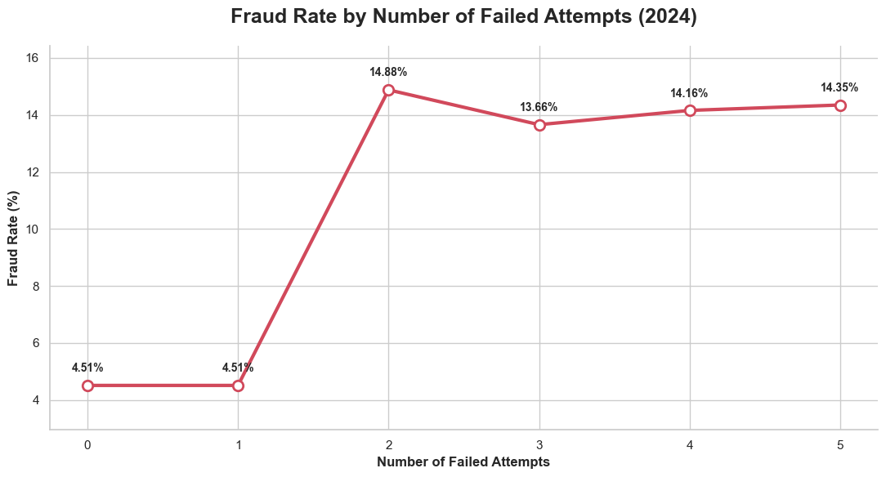
KEY INSIGHT
Fraud rate was 4.51% for zero or one failed attempt, jumped to 14.88% at two attempts, and remained around 13.66%–14.35% for three to five attempts.
BUSINESS PROBLEM ADDRESSED
Repeated failed attempts may indicate credential compromise, unauthorized access, or suspicious authentication behavior.
RECOMMENDATION
Treat two or more failed attempts as a high-priority signal for additional verification or enhanced monitoring. Validate the threshold operationally before production deployment.
Analytical note: This is a strong association, not proof that failed attempts cause fraud.

11. International vs Domestic Transaction Risk
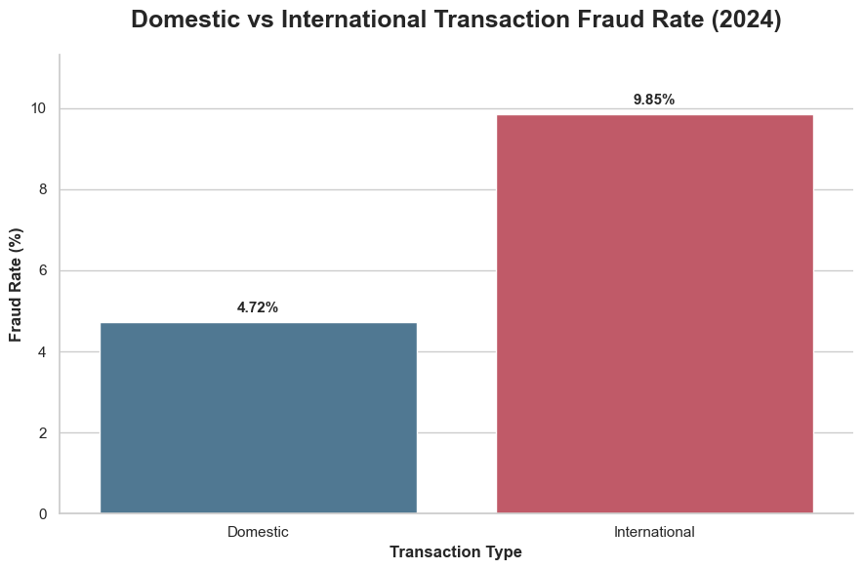
KEY INSIGHT
International transactions had a 9.85% fraud rate in 2024 versus 4.72% for domestic transactions—more than twice the domestic rate.
BUSINESS PROBLEM ADDRESSED
Cross-border activity can introduce additional fraud exposure but blanket blocking would create unnecessary customer friction.
RECOMMENDATION
Apply enhanced authentication to unusual international activity and combine international status with failed attempts, merchant category, amount, device behavior, and customer history.

12. Fraud Type Distribution
The three most frequent fraud types in 2024 were Phishing (1,852 transactions), Identity Theft (1,841), and Account Takeover (1,830). Their similar counts indicate that fraud is distributed across several major attack mechanisms rather than being dominated by one category.

Business implications
Controls should be differentiated by fraud mechanism: customer awareness and suspicious-link education for phishing; stronger identity verification for identity theft; and multi-factor authentication plus unusual-login monitoring for account takeover.

Priority Findings and Action Plan

Priority Finding | Evidence | Recommended Action
Repeated failed attempts | ~14% fraud rate at 2+ attempts | Trigger step-up verification and high-priority monitoring.
International activity | 9.85% vs 4.72% domestic | Use risk-based authentication for unusual cross-border transactions.
High-risk merchant categories | >8.7% for Jewelry, ATM Withdrawal, Crypto Exchange | Apply category-sensitive controls and enhanced verification.
High-volume channels | Mobile and Credit Card generate the most cases | Scale investigation capacity without confusing volume with inherent risk.
Persistent baseline | Fraud remained near 5.5% over five years | Maintain continuous fraud operations and monitor shorter-term changes.

