**Module Code & Module Title**

**FC6W51NA Work Related Learning**

**Assessment Weightage & Type**

**75% Individual Coursework**

**Year and Semester**

**2021 Autumn**

**Student Name: Manzil Katwal**

**College ID: np05cp4a190083@iic.edu.np**

**Assignment Due Date: 31st May 2022**

**Assignment Submission Date: 31st May 2022**

**Academic Supervisor: Ronal Niraula**

**Word Count:**

*I confirm that I understand my coursework needs to be submitted online via Google Classroom under the relevant module page before the deadline in order for my assignment to be accepted and marked. I am fully aware that late submissions will be treated as non-submission and a mark of zero will be awarded.*

**Acknowledgement**

First and foremost, I would like to express my deepest appreciation to all those who are involved in this project. A special gratitude I give to my internship supervisor **Mr. Hemanta Jung Karki** and academic supervisor **Mr. Ronal Niraula** for their valuable assistance, and constant support throughout this module.

It would have been impossible for me to accomplish this module without his guidance and help.

I would also like to express my gratitude towards "**Itahari International College**" and **“Cubical Technologies”** for creating a suitable and inviting environment in which I was able to learn valuable knowledge and improve my professional abilities. Similarly, I would like to express our gratitude to **London Metropolitan University** for providing me with the opportunity to take this course and this amazing yearlong module.

Finally, I would be pleased to express my special thanks to my friends, family and the relatives who helped me to accomplish my mission by providing a great motivation and support for me during this project.

Thank You!

**Table of Contents**

1. Introduction 1

1.1. Background to the placement 1

1.2. Structure and role of the company 1

1.3. Details of the specific department worked in 2

2. Review of Activities 3

2.1. LO1: LO1 Teamwork and communication skills 3

2.2. LO2: LO2 Time management skills 3

2.3. LO3: LO3 Problem solving skills 4

2.4. LO4: LO4 Angular JS CRUD with Firebase 4

2.5. LO5: LO5 Git and GitHub Skills 5

2.6. LO6: LO6 NodeJS, ExpressJS and mongoDB skills 5

2.7. LO7: LO7 Web-app development skills 6

3. Academic Context 6

3.1. Database: 7

3.2. Software Engineering: 7

3.3. Information system: 7

3. Abilities Evaluation 8

4.1. LO1: LO1 Teamwork and communication skills 8

4.2. LO2: LO2 Time management skills 8

4.3. LO3: LO3 Problem solving skills 8

4.4. LO4: LO4 Angular JS CRUD with Firebase 9

4.5. LO5: LO5 Git and GitHub Skills 9

4.6. LO6: LO6 NodeJS, ExpressJS and mongoDB skills 9

4.7. LO7: LO7 Web-app development skills 9

4. Challenges 9

5. Conclusion 9

6. References 9

7. Appendix 9

7.1. WRL form 9

FC6W51 Work Related Learning (WRL) Form 9

7.2. Attendance Sheet 17

7.3. Internship Completion Letter 18

7.4. CV (after internship included) 20

7.5. Evidence 25

7.5.1. LO1 Evidence 25

7.5.2. LO2 Evidence 26

7.5.3. LO3 Evidence 27

7.5.4. LO4 Evidence 28

7.5.5. LO5 Evidence 29

7.5.6. LO6 Evidence 30

7.5.7. LO7 Evidence 31

# Introduction

During work related learning placement, I got an internship opportunity on the software development company named as Cubical Technologies. There I spend a lot of time of gaining a professional based skills on software production.

## Background to the placement

I was taken in by the cubicle technologies company during the work-related placement as a web developer for an internship. Cubical Technologies, expertise in different technical fields, started with the aim to develop technology Sector in Nepal. So, to help grow technology sector they started providing internship for the students from various technical field.(Cubical technologies, 2021).

The company was established in the year 2016 A.D. and currently located at Aitabare, Itahari Metropolitan city wad no-6. Cubical Technologies is a technology consulting firm that offers end-to-end solutions, from concept and strategy, to design, implementation and support, helping clients achieve their business goals.

## Structure and role of the company

Cubical Technologies is made up of very influential and skilled individuals. Each person's function in this organization differs depending on their knowledge, talents, and experiences. Although each person's function is distinct, each office employee's goal is the same.

Since its inception, this company has been involved in a variety of IT-related fields. It keeps track of all new technologies and upcoming inventions and integrates them into the organization. As a result, it consistently meets the market's needs and requirements (in IT domains) with cutting-edge solutions. It has been promoting its product through digital marketing, content authoring, and other means in addition to software development.

## Details of the specific department worked in

Above is a diagram of the cubical technology hierarchy. Considering the task division within the organization, I was hired as a full stack web developer by the company.

Cubical Technologies is divided into various departments. I worked directly for the development department. Hemanta Jung Karki and Manish Regmi are the expertise under development divisions based on the duties. I was coached by both heads, Manish Regmi on the front end and Hemanta Jung Karki on the backend. This department focused on helping small businesses, agencies, and large organizations streamline their IT sourcing and reduce cost/time to market. It has also been involved in international outsourcing projects. This component of the department focuses on web development, mobile applications, and domain hosting, among other things.

# Review of Activities

## LO1: LO1 Teamwork and communication skills

Prior to internship I would consider myself quite an introvert and had very bad social skills, but I think it was because I never had to deal with social activities as I was always able to avoid such events. Internship was different, it had a professional environment for me to make any excuses to avoid communications or social activities I had to work with new other interns on completely new topics and even for the progress I had to compromise and adept to the environment. There was various presentations about various topics which was extremely hard for me as I have anxiety when it to public speaking but after a lot of research and practice I could finally overcome my fear and be a good team player.

## LO2: LO2 Time management skills

As a professional, I recognized that I possessed the best soft skills that were always necessary, the most important of which was project time management. The responsibilities were allocated among the team members during the project and had to be accomplished within a certain amount of time. So, to finish the task effectively and on time, I learnt time management strategies for that project as well as future projects. I developed a habit to schedule my time for the projects that I would be working on. My time management log prioritizes the scheduled activities as per their importance and I always kept my projects on my top priority.

## LO3: LO3 Problem solving skills

For me everything about internship was new. This WRL module was not just a module it required us to properly learn in a real working environment. We only ever learned what our module leaders asked us to learn but here we had to decide what to learn which was quite new and kind of unsettling. NodeJS, ExpressJS, Mongo dB, GitBash, Presentations, supervisor everything was new for me. I applied to do backend in a completely unfamiliar language, so I struggled a lot as I was met with error on every step of my learning process which was frustrating. There were various minor errors which I taught myself to solve using google but as I progressed there were some errors which were beyond my understanding, and I was guided by my supervisor through those errors. After so many hours of error handling and supervisor guidance I slowly started to learn how to solve errors quickly. I bookmarked various sites that my supervisor visited during error handling process and studied them and tried using them when I was stuck on any error which improved my problem-solving skills.

## LO4: LO4 Angular JS CRUD with Firebase

As I had been using some basic elements of HTML for static web development, but I had never been experienced using the frontend frameworks. Since I was engaged in the company for full stack web development, so I was much emphasized on Angular framework for frontend development. Initially it took more time to learn. But under the guidance of my supervisor, official docs, and blogs, I was able to understand the working structure of the framework. Building angular project and understanding the structure it was the main task given commanded to get more familiar with this framework. After certain days of research and understanding, I was suggested to perform crud operation using this framework. From there, I got the entire mechanism of data flow in this framework which makes me capable of building a dynamic web application under it. Besides, I got chance to integrate my CRUD project with firebase for database and user authentication.

## LO5: LO5 Git and GitHub Skills

GitHub and Git are two tools that every developer, regardless of their field, should get their hands on. Git is a version control system that lets you track the changes to your files over time, and GitHub is a service that hosts Git repositories online.

It was my first time working in a professional atmosphere as a developer. As a result, I needed to learn about git and GitHub. I was able to understand the commands and mechanisms of git and GitHub by following my supervisor's instructions and supervision, read the official document, blogs, and YouTube. After that, I began utilizing git and GitHub for text documents, and it was there that I gained a thorough understanding of the process. To gain a better understanding and familiarity with git and GitHub, I began utilizing them with other simple static projects (development), such as the login form. I experienced a lot of troubles with git commands when I first started learning and using git and GitHub. I was able to tackle those challenges because I had a good understanding of branches and was able to do so with the help of suitable research and supervisory guidance.

## LO6: LO6 NodeJS, ExpressJS and mongoDB skills

Angular Framework study was very short-lived due to vivid reasons such as interns extreme interest in learning NodeJS. So, Node JS replaced the angular, we skipped the pure node and went on to directly use it along with Express JS which was very helpful framework of Node. As our supervisor warned us it was quite difficult even though we had the concept of how the crud works during our angular framework learning there still were rising a lot of confusion. But ExpressJS was quite helpful as we could install it and skip various complex steps that pure node required. MongoDB was quite new concept as I had no practical knowledge about the database and had to go through various error as I could not integrate the database to frontend. With the help of my supervisor I could finally make a functional nodeJS and mongoDB.

## LO7: LO7 Web-app development skills

After I got basic knowledge about the NodeJS crud and mongo DB working process I was handed with a project which was a huge challenge since I never actually did a complete project myself. The project was content management system and I completely managed to design my frontend and make it functional with crud along with the mongo DB integration, but I was unknown about the image upload feature. With the help of google I tried doing it using body-parser but due to deprecation issues I failed, and my supervisor helped me with some guidance and hints. Finally, I completed my first solo project which was CMS.

# Academic Context

Firstly, all our course were equally important and helpful in their own rights but in the context of my placement I would believe that database, Software Engineering and information system were the most relatable courses. Database is the mandatory factor for any kind of system development so even though the contents were limited to queries, relational diagrams, and normalizations it still helped us build that fundamental understanding about the database, Software Engineering was a module, which was very vast but helpful, it taught us to work in a team, time management, project management etc. information system basically introduced me to the web development world. Honestly, I was hoping to build my career around mobile app development but after the placement I learned that there is a way to do things and to be a good developer we need to follow that so, I decided to be a web developer after my placement. I would say as query related as it was, this course was surprisingly helpful since we needed database in every project to be designed in the beginning and we were taught that many times in our course. And it came in handy during my internship.

### 3.1. Database:

Database was a module which I never actually though would hold such importance in my first-year times regardless of how many times my module leader told me that it was the backbone of any project. We learned how the database works with queries, how tables were related and anomalies it can have, we learnt to design the database filtering all the dependencies using normalization. When I was working as an intern I was handed with some project and to do anything with that project I had to understand its database first and to build any project I had to design its database first, thanks to my collage database courses all these things were already taught to me during classes. It help me to design the CMS (Content management system) database, to learn the crud of any language we had to understand the working process of database.

### 3.2. Software Engineering:

Software engineering was a course which taught us how big can and vast software development is and how the big software is developed. It taught us, in real life a single developer cannot develop a software properly, it requires a team, planning, techniques etc. this course had team projects, which was of very big scope, and we required time management, teamwork, decision making etc. all these skills were learned during the course and it was very helpful

### 3.3. Information system:

This module was very real-life based module even though it mostly included frontend work it had that web design hints. This project taught us how to use HTML, CSS, Bootstrap and design a complete web application. We designed our first portfolio during this module coursework. During my internship I had to develop and design various projects and the knowledge of this course came in handy during the difficult time of designing.

This internship was extremely helpful and will remain helpful in my future works too. Before internship I had not idea about framework, database integration, CRUD and many more but post internship I understood how a system should be developed. This internship was the sole reason for my successful final year project submission. I did my FYP in the NodeJS with Express JS framework which I learnt during my internship. I still have a lot to learn about this language and wants to go further with it so in future I would like to be a NodeJS developer.

# Abilities Evaluation

## 4.1. LO1: LO1 Teamwork and communication skills

Teamwork and communication skills were the qualities I lacked, it was nothing new but never had I imagined that these two qualities would be such important factor in professional life or work life. With the team projects I was able to understand the teamwork and do the projects effectively and being in the team also made my communication skills better. I was too insecure to ask for assistance when I had error at first, but I learned to approach my supervisor quite comfortably for any kinds of error without any hesitation which eventually became my habit and improved my knowledge.

## 4.2. LO2: LO2 Time management skills

This skill is extremely underrated, we as a student mostly depended upon a burst of energy or pulling a whole nighter right before the deadline but in professional world projects done in such circumstances are easily detected and despised. The project done with proper time has different quality. Time management can divide the amount of stress and help us easily complete the project. Now I even apply time management in my normal life and for the collage projects which has been proven quite effective.

## 4.3. LO3: LO3 Problem solving skills

When I worked in the Cubical as an intern, there was not a day that went without bugs or error. I struggled with the errors the most so I mostly depended upon supervisor guidance, it took me a while, but I realized that problem solving skills comes from trying to solve the errors and I started to solve my error myself regardless of the amount of time it took me and finally I started to get the idea of how this works. Google was very helpful as it always has been and always will be but now, I feel like I can fix any bug that comes my way.

## 4.4. LO4: LO4 Angular JS CRUD with Firebase

This was most difficult thing I did on my whole internship. This was the first task we were taught, and everything went over my understanding. But after hours of reading CRUD documents and watching videos, I got the idea of how CRUD functions. Even though I did not go through with this language, but it taught me the most fundamental thing for all programming language, CRUD. Now I could understand the CRUD functionality of any other language after short study as I have understood how it works and using angular, I also understood to perform authentication with firebase

## 4.5. LO5: LO5 Git and GitHub Skills

Before internship I had no idea about the git and GitHub. We were taught to whatever we did in GitHub from the very biggening. This was nothing related to our coding or academics, but it was taught to use as the most important tools by our supervisor. This tool had many steps and was confusing at first but as I went on to use it, GitHub became on of the most convenient tools that helped me to backup my file to recover my file, share the file during team-projects etc.

## 4.6. LO6: LO6 NodeJS, ExpressJS and mongo DB skills

NodeJS, ExpressJS, mongo DB were the programming language, framework, and database I learnt during my internship. As I mentioned in my learning outcomes, I overcame all the hardship and now able to understand NodeJS and mongo DB. NodeJS was quite challenging, but its framework helped me a lot in many ways and mongo DB was quite fun to use. I learned to use NodeJS and integrate MongoDB with it to develop a system.

## 4.7. LO7: LO7 Web-app development skills

After learning everything on a basic level I was provided with a complete solo project that was too done using NodeJS, ExpressJS framework along with mongo DB. It was content management system which I was assigned with. To do the project from the scratch it was quite challenging but with the knowledge and support of my supervisor I felt confident. I learnt many things during this project about the designing importance, CRUD was the main thing for backend which I know but front end took my most of the time, I learned to create, read, update, and delete the content i.e., image during this project. By the time I completed this project which took me approximately a moth I became confident enough to do a project using node and mongo DB alone without any assistance.

# Challenges

Internship was a completely new for me I had never been and intern and never actually worked as a professional in a real environment so it was quite difficult to adapt and I obviously face various challenges few of them are stated below:

## Lack of social skills

This was one of the first things I noticed about me was going to be the problem for me as I was awkward and anxious around my supervisor. I was extremely self-conscious and could do simple thing when my supervisor was watching me code or do something. Presentations and team-projects were like nightmares for me.

As the time went by, I learnt to cope with the environment and learnt to approach my seniors and socially get involved with friend which improved my teamwork and learning progress. I also overcame my stage fear by forcing myself to give numerous presentations. By the end, I was still kind of nervous around my supervisor, but they were so understanding and friendly that nothing really bothered me anymore.

I learned that you have to go through the hard phase for it to seem easy for you. Until and unless you are put into the difficult situation you cannot learn understand and learn new things.

## Time management

I have never been a punctual person; I was usually punished for being late in school. It was kind of my habit to be late and I could not help it. However, this was work and here I did not wanted to be late but I ended up being late most of the time and was being told off by my supervisor. I also couldn’t finish my share of projects on time and I let my team members down

## Weak in problem solving technique

# Conclusion

# References

# Appendix

## WRL form

## FC6W51 Work Related Learning (WRL) Form

**Student**

Student Londonmet ID: __19031758 ______

Student Name: __Manzil Katwal______

College E-mail ID: _np05cp4a190083@iic.edu.np____

Mobile No: __9811345784_____

Student’s work/placement address: _Itahari, Sunsari

**Employer**

Employer Name : _Cubical Technologies_______

Employer's Address including department: _Itahari, Sunsari, Web Development

Company Supervisor’s Name and Position: _ Hemanta Jung Karki, Project Manager_

Company Supervisor’s Tel No: _9824386694___

Company Supervisor’s email address: __ hemantajungkarki@gmail.com_

**Work Related Learning Activity**

Start Date: __05-06-2021___

End Date (if known): _18-09-2021____________

Your role at the placement (position): Web app developer (NodeJS)_

Brief description of your work at the placement: My role in this company is to check and help in minor works such as (setting images and texts) on the websites created by the professionals at the company and also to get the correct images ready. I am also occassionaly assigned with research tasks which i am to present to my mentor.

**Proposed learning outcomes from the Work Related Learning Activity:**

It is very important that you read the learning agreement guide before filling in this form. You need to list **at least 7 learning** outcomes, and at least **two** learning activity should be closely relevant to the course you are doing at the university.

|  |  |  |  |
| --- | --- | --- | --- |
| **Learning Outcome ID** | **Learning outcomes**  By the end of my work placement, I will be able to develop what skills or knowledge: (e. g. develop my XXX skills, enhance my knowledge of XXX) | **Activities and tasks**  I will achieve this learning outcome by carrying out what tasks (e. g. participating in a Web development project, or to work in a team, or to engage in group discussion) | **Evidence**  Evidence I could use to demonstrate that I have achieved this learning outcome? (e. g. feedback from the employer, artefacts I will develop, screen shots or video capture, meeting minutes) |
| LO1 | By the end of my work placement, I will be able to enhance my Teamwork and communication skills. | I will achieve this learning outcome by carrying out various team activities and presentations. | I will give evidence by providing the feedback of my mentors form the cubical Technologies. |
| LO2 | By the end of my work placement, I will be able to develop my time management skills. | I will achieve this learning outcome by carrying out different task as per the routine. | I will provide evidence as log of work routine. |
| LO3 | By the end of my work placement, I will be able to develop problem-solving skills. | I will achieve this learning outcome by carrying out various website designing and checking. | I will give evidence by providing Screen shots of errors that I got while doing my tasks. |
| LO4 | By the end of my work placement, I will be able use the CRUD function of Angular JS | I will achieve this learning outcome by carrying out various Crud project using angular | I will show the screenshot of how I used angular JS crud. |
| LO5 | By the end of my work placement, I will be able to develop my git and GitHub skills. | I will achieve this learning outcome by using GitHub to stage files, add, commit, create repository, push and merge branches on the command line. | I will provide the screenshots and a link to my GitHub sites. |
| LO6 | By the end of my work placement, I will be able to use Node, Express JS, and MongoDB. | I will achieve this learning outcome by learning the CRUD operations using mongo DB | I will provide the screenshot and link of my work. |
| LO7 | By the end of my work placement, I will be able to design Web- app using NodeJS | I will achieve this learning outcome by carrying out various tasks provided by mentors and their guidance. | Screenshots of NodeJS code will be provided which I shall use along with ExpressJS and mongodb. |

***This form is approved by WRL academic supervisor***

**Academic Supervisor Name: Ronal Niraula**

**Academic Supervisor Signature:**

**Date of Signature: 22-08-2021**

**If you work at an external company or organization, the following “Heath and Safety checklist” form must be completed before your placement can be approved.**



|  |
| --- |
| **External Work Related Learning (PLACEMENT) PROVIDER**  **HEALTH AND SAFETY CHECKLIST** |

Name of the Placement Provider (Company name): Cubical Technologies

Placement site Supervisor: Hemanta Jung Karki

Supervisor’s Position: Project Manager

Address: Itahari (Aitabare), Sunsari

Email: hemantajungkarki@gmail.com

Telephone: 9824386694

|  |  |  |  |
| --- | --- | --- | --- |
|  | | Yes | No |
| 1 | Do you have a written Health & Safety policy? |  | No |
| 2 | Do you have a policy regarding health and safety training for people working in your undertaking, including use of vehicles, plant and equipment, and will you provide all necessary health and safety training for the student? |  | No |
| 3 | Is the organisation registered with? (tick as appropriate)  (a) the Health & Safety Executive or  (b) the Local Authority Environmental Health Department |  | No |
| 4 | **Insurance**  (a)Is Employer and Public Liability Insurance which will cover the duration of the placement?  (b) Employer and Public Liability Insurance policy number _______________________  (c)Will your insurance cover any liability incurred by a placement student as a result of his/her duties as an employee? |  | No |
| 5 | **Risk Assessment**  (a)Have you carried out any risk assessment of your work practices to identify possible risks whether to your own employees or to others within your undertaking?  (b)Are risk assessments kept under regular review?  (c)Are the results of risk assessment implemented? |  | No |
| 6 | **Accidents and Incidents**  (a)Is there a formal procedure for reporting and recording accidents and incidents in accordance with RIDDOR (Reporting of Injuries, Disease & Dangerous Occurrence Regulations)?  (b)Have you procedures to be followed in the event of serious and imminent danger to people at work in your undertaking?  (c)Will you report to the university all recorded accidents involving placement students?  (d)Will you report to the university any sickness involving placement students which may be attributable to the work. |  | No |

The above statements are true to the best of my knowledge and belief.

Signed on behalf of the company with the company stamp:

Name: Hemanta Jung Karki

Signature:

Date: 22-08-2021

## Attendance Sheet

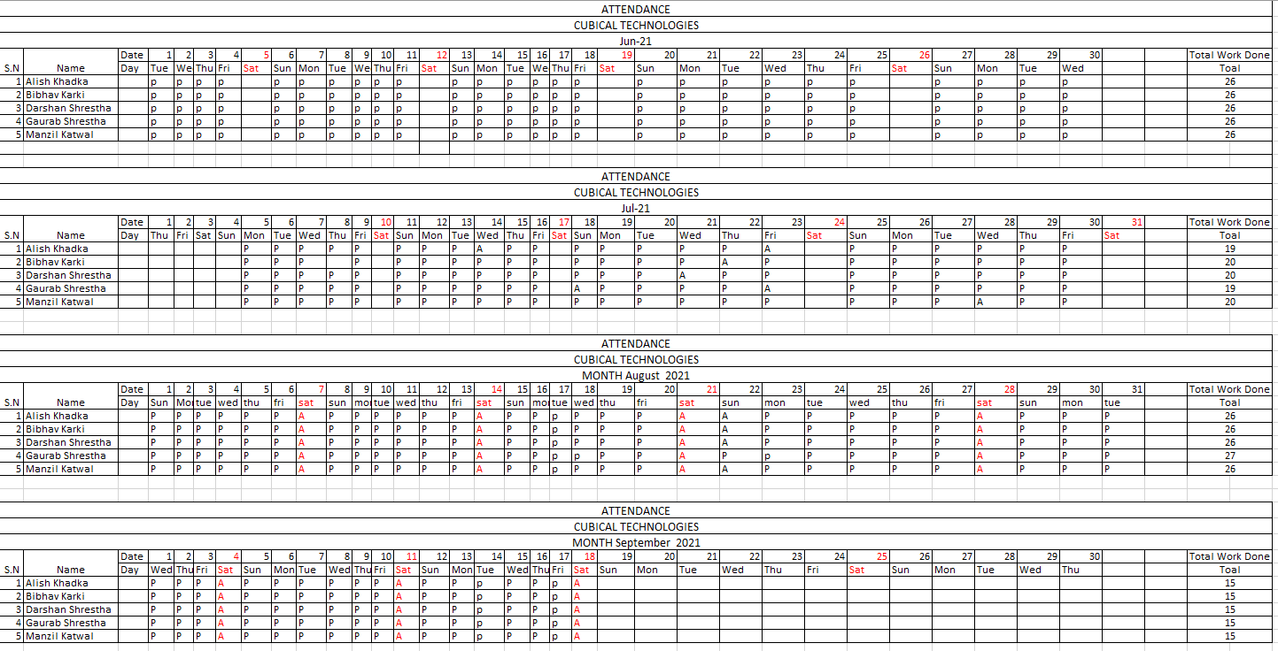

## Internship Completion Letter

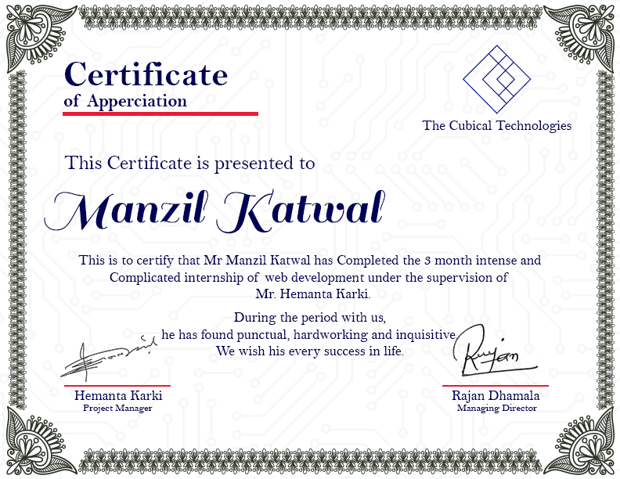

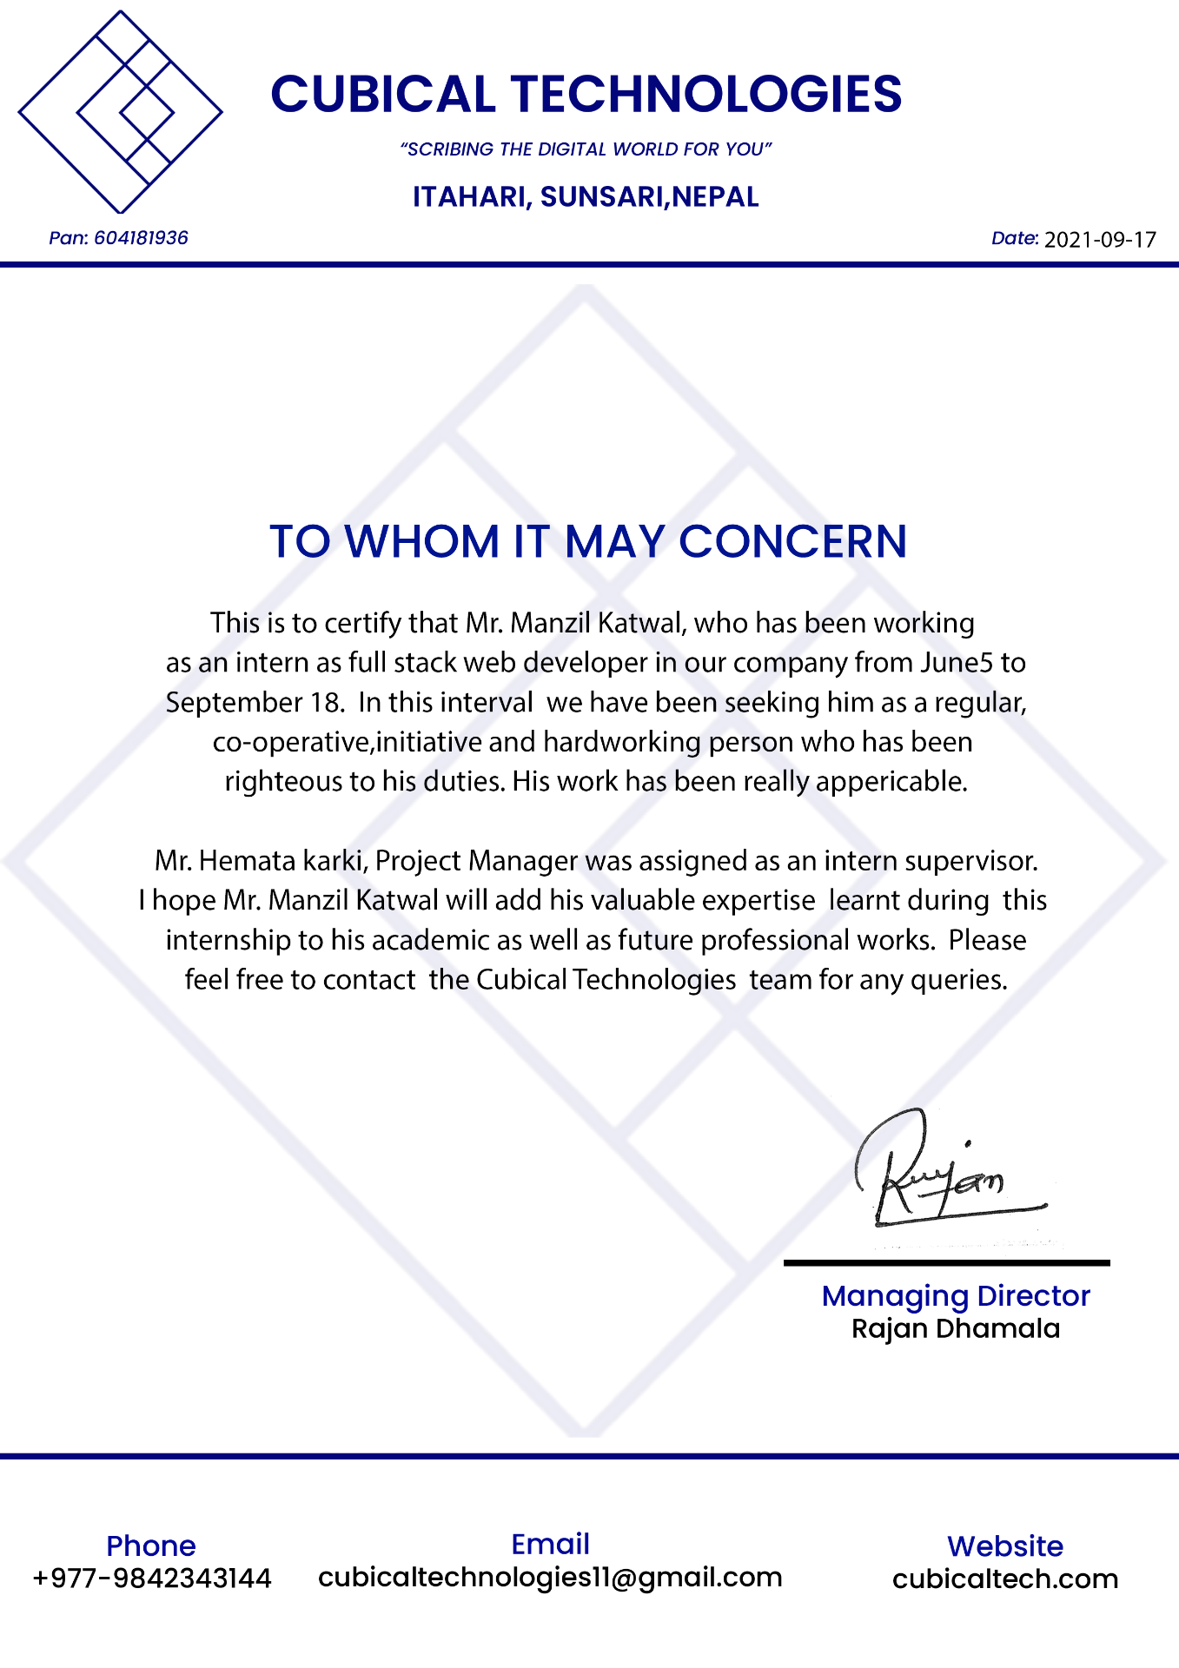

## CV (after internship included)

|  |  |  |  |
| --- | --- | --- | --- |
|  | | | |
|  | |  | | --- | | MANZIL KATWAL  INTERESTED IN WEB APP DEVELOPMENT | | |  |
|  | | | |
|  | | PROFILE    I am an IT student at the IIC with surface knowledge of programming and designing. After all the projects and assignments, I find myself more inclined towards the web app development. I have worked as an intern in the Cubical Technologies as a web developer.    0BJECTIVES    I look forward fully utilize my training and skills, while making a significant contribution to the success of the company. I can learn quickly to handle any required task provided by the company. | |
| CONTACT    9811345784, 9827081734  manzilkatwal@gmail.com    ADDRESS    Sunsari, Itahari-7 | |
|  | |
|  | | PROJECTS    Unix Script Programming  *Provided by itahari international collage*   * THIS PROJECT HAD TWO PARTS, FIRST ONE WAS SIMPLY THE INTRODUCTION OF LINUX AND HOW IT WORKED WITH SURFACE RESEARCH AND SCOND PART, WE MADE A SIMPLE PROGRAM IN LINUX USING FUNCTIONS. * IN THE FIRST PART WE DID BASICS OF LINUX LIKE USING THE BASIC LINUX COMMAND IN SCRIPT FILE * IN THE SECONCD PART WE WROTE A CODE IN BASH FILE WHICH WOULD DISPLAY THE FOOTBALL PLAYERS DETAILS IF THE INPUT IS INPUT IS ENTERED CORRECTELY. * MANY ERROR MESSAGE WERE PROGRAMMED IN CASE OF INVALID INPUT.   <https://drive.google.com/drive/u/0/folders/18ofiQ9fUM4B7RtXjK2UpXZZ0tawm7Yk1> | |
| SKILLS    ◦ JAVA  ◦ HTML, CSS & JAVASCRIPT  ◦ SQL  ◦ XML  ◦ UNIX SCRIPTING BASIC  ◦ BOOTSTRAP  ◦ ExpressJS  ◦ NodeJS  ◦ MongoDB | |
|  | |
|  | | Software design of sound strong music institute  *Provided by itahari international collage*   * THIS WAS THE INDIVIDUAL COURSE WORK WHERE WE DESIGNED THE SOUND STRONG’S ONLINE REGISTRATION SYSTEM * THIS SYSTEM NEEDED FEATURES ARE DESIGNED USING DIAGRAMS LIKE USE CASE, SEQUENCE, COLLABORATION, CLASS DIAGRAM. * THE TIMETABLE FOR EVERY PROCESS HAS BEEN PLANNED OUT USING GANTT   CHART  <https://drive.google.com/drive/u/0/folders/1sTh_5Tu62_tGDw8Hybc6Fsz2x-G_S565>      DECIMAL TO BINARY AND BINARY TO DECIMAL ADDTION  *Provided by itahari international collage*   * THIS WAS THE INDIVIDUAL COURSE WORK WHERE WE DEVELOPRD A ADDTION SYSTEM FOR BOTH DECIMAL AND BINARY * HERE WE WROTE A CODE IN PYTHON FOR ADDING TWO NUMBERS * IN THIS PROGRAM THE USER CAN CHOOSE EITHER BINARY OR DECIMAL FORM   FOR RESULTS  <https://drive.google.com/drive/u/0/folders/1mD9pD79pmbKcBU6HCrLATTtis7SLDLlZ>    DEVELOPMENT OF MOBILE SHOP INVENTORY  INFORMATION SYSTEM  *Provided by itahari international collage*   * THIS WAS THE TEAM COURSE WORK WHERE WE DEVELOPED A MOBILE ACCESSORIES INVENTORY INFORMATION SYSTEM * THIS COURSE WORK TAUGHT ME HOW TO BE A TEAM PLAYER AND TO ADJUST IN AMONG OTHERS * THIS INOFRMATION SYSTEM HELPS THE CUSTOMER SEARCH THEIR REQUIRED ITEM ONLINE MARK IT FOR LATER. * THERE IS CATEOGRY AND PRICE FOR BUTTON CREATED WHICH SHOWS THE CATEGORIZED ITEMS AND PRICE FOR SPECIFIC ITEMS. * ALL CODES WERE WRITTEN USING JAVA PROGRAMMING LANGUAGE <https://drive.google.com/drive/u/0/folders/18m2xeUiQhwCCYSHm6BczqgArw2K-8px2>     STAFF HIRING SYSTEM USING JAVA  *Provided by itahari international collage*   * THIS IS THE INDIVIDUAL COURSE WORK WHERE WE HAD TO CREATE ASTAFF HIRING SYSTEM * THIS SYSTEM HAD SOME FEATURES LIKE ADD VACANCY, APPOINT, TERMINATE,   DISPLAY, BACK AND CLEAR  <https://drive.google.com/drive/u/0/folders/1Aa8eWiJiDVc0fOV8bnS2Z8aDYCL2naY6>    WEB DESIGN USING XML  *Provided by itahari international collage*   * CATEGORIZING THE ALBUMS IN THE MUSIC STORE * HERE WE USE XML, DTD, AND SCHEMA * THIS DISPLAYS THE ALBUMS IN CHRONOLONGICAL ORDER SO THE CUSTOMERS CAN EASILY SPOT THEIR FAVOURITE ITEMS.   <https://drive.google.com/drive/u/0/folders/1_Ucr_yOPVHWRUd9TWeDqycGf67E-y5dh>  Content Management system USING NodeJS, ExpressJS, mongo DB  *Provided by Hemanta Jung Karki (Project manager), cubical Technologies*   * DISPLAYS THE INFORMATION ABOUT THE BAND TRIBAL RAIN * DISPLAYS THE NEWS ABOUT THE BAND AND UPDATE IT USING NEWSPORTAL * THIS SHOWS ABOUT THE BAND MEMBERS DETAILS * THERE WE USE NODEJS FOR BACKEND AND MOSTLY BOOTSTRAP FOR FRONTEND DEVELOPMENT   <https://github.com/Makeouthill2055/TribalRain>  Kalo Vatvatey USING NodeJS, ExpressJS, mongo DB  *Provided by Hemanta Jung Karki (Project manager), cubical Technologies*   * Ecommerce that sells product * Developed by using NodeJS, MongoDB, ajax, JS, Bootstrap * This shows the products, price, payment method, similar product * This project was very high level and was pretty   <https://github.com/Alish33/E-Commerce/tree/master/Advance-Ecommerce-master> | |
| EDUCATION    BSc (Hons) Computing  2019-present  Itahari international collage  I am currently in my final year of undergraduate studies.    Management  2017-2019  Bishnu memorial higher school    SEE  2016  Bishnu memory higher secondar school  GPA: 3.4 (A)  EXPERIENCE    2021 June 5 to 2021 September 18  Cubical Technologies  Intern of Web app development  Reference  **Prakash Koirala**  Prakash.koirala@iic.edu.np  **Pratik karki**  Pratik.karki@iic.edu.np  **Lekhnath katwal**  [Lekhnath.katwal@iic.edu.np](mailto:Lekhnath.katwal@iic.edu.np)  **Pradhumna Dhungana** pradhumna.dhungana@iic.edu.np  **Hemanta Jung Karki**  [hemantajungkarki@gmail.com](mailto:hemantajungkarki@gmail.com) | |
|  | |

## Evidence

### LO1 Evidence

LONDON METROPOLITAN UNIVERSITY

PROFESSIONAL WORK PLACEMENT

LEARNING OUTCOME EVIDENCE

Evidence for learning outcome 1

Feedback report from the supervisor

Supervisor Name: Hemanta Jung Karki

Supervisor Signature:

### LO2 Evidence

LONDON METROPOLITAN UNIVERSITY

PROFESSIONAL WORK PLACEMENT

LEARNING OUTCOME EVIDENCE

Evidence for learning outcome 2

Project link and screenshots

Supervisor Name: Hemanta Jung Karki

Supervisor Signature:

### LO3 Evidence

LONDON METROPOLITAN UNIVERSITY

PROFESSIONAL WORK PLACEMENT

LEARNING OUTCOME EVIDENCE

Evidence for learning outcome 2

Project link and screenshots

Supervisor Signature:

### LO4 Evidence

LONDON METROPOLITAN UNIVERSITY

PROFESSIONAL WORK PLACEMENT

LEARNING OUTCOME EVIDENCE

Evidence for learning outcome 1

Feedback report from the supervisor

Supervisor Name: Hemanta Jung Karki

Supervisor Signature:

### LO5 Evidence

LONDON METROPOLITAN UNIVERSITY

PROFESSIONAL WORK PLACEMENT

LEARNING OUTCOME EVIDENCE

Evidence for learning outcome 2

Project link and screenshots

Supervisor Name: Hemanta Jung Karki

Supervisor Signature:

### LO6 Evidence

LONDON METROPOLITAN UNIVERSITY

PROFESSIONAL WORK PLACEMENT

LEARNING OUTCOME EVIDENCE

Evidence for learning outcome 2

Project link and screenshots

Supervisor Name: Hemanta Jung Karki

Supervisor Signature:

### LO7 Evidence

LONDON METROPOLITAN UNIVERSITY

PROFESSIONAL WORK PLACEMENT

LEARNING OUTCOME EVIDENCE

Evidence for learning outcome 2

Project link and screenshots

Supervisor Name: Hemanta Jung Karki

Supervisor Signature: