**NUID: 002705752  
  
Inferences based on visualizations**

**Business questions to build visualization.**

1. **Service Requests Over Time:**  
   • What is the overall trend in Service Requests over the years 2018-2021?  
   • How have Service Requests changed on a monthly basis?

**Summary of Service Requests Over Time**

Yearly Trend (2018-2021):

* 2018-2019: Increase in service requests, peaking in 2019.
* 2020-2021: Sharp decline in service requests.

**Monthly Trend:**

* Start of the Year: High in January, declining to a low in April.
* Mid-Year: Increases, peaking in July and August.
* End of the Year: Steady decline from September, slight rise in December.

**(2) Volume of service requests received from different sources:**

• What is the overall trend in Service Requests over Sources?

**(3) Volume of service requests received by Department:**

• What is the overall trend in Service Requests received by Departments?

Service Requests from Different Sources: Steady increase from 2006 to 2019, followed by a decline in 2020 and 2021.

Service Requests by Departments: Cyclical pattern within each year: high in January, low in April, peak in July-August, decline towards November, slight rise in December.

**(4) Top 10 Performance Metrics (Response Time) per CATEGORY and Type of Request: (SQL Only)**

• What are the top 10 cases whose response time was fastest? Categorize it with Category1 and Type of Request.

**(5) Geographical Visualization: (Create individual visuals for each criteria - Use address, Zip code and Lat Log as criteria)**

• What are the Top 10 areas where most number of request were raised?

Based on the geographical visualization, the top 10 areas where the most service requests were raised are concentrated in and around the Kansas City area, specifically:

* Kansas City, MO
* Overland Park, KS
* Independence, MO
* Olathe, KS
* Lee's Summit, MO
* Shawnee, KS
* Blue Springs, MO
* Lenexa, KS
* Liberty, MO
* Grandview, MO

**6) Departmental Workload Comparison:**

• How does the workload vary among different departments and work groups? Create a visual representation to highlight the distribution.

• Hint: Generate a stacked bar chart or tree map to illustrate the distribution of service requests among different departments and work groups. This can help identify which departments are handling a larger share of the workload.

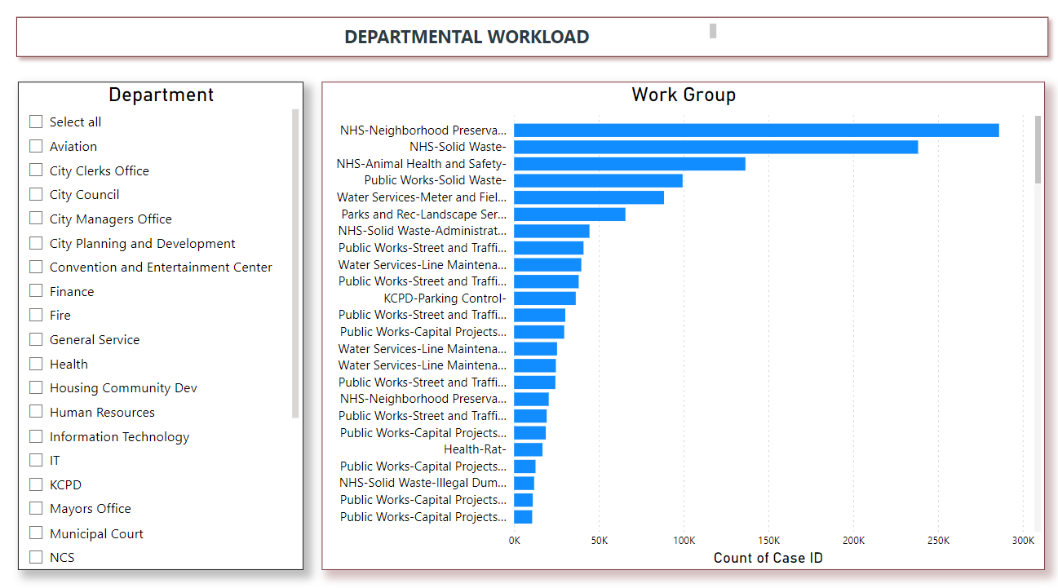

* NHS-Neighborhood Preservation and NHS-Solid Waste have the highest workloads, each handling around 250,000 to 300,000 cases.
* NHS-Animal Health and Safety and Public Works-Solid Waste follow, with significant but lesser workloads.
* Other departments such as Water Services-Meter and Field and Parks and Rec-Landscape Services also manage considerable numbers of requests, ranging from 50,000 to 120,000 cases.
* The remaining work groups handle fewer cases, with Public Works-Capital Projects-Inspections being the lowest among the listed groups.

**(7) Response Time Analysis:**

• Visualize the distribution of response times for each department. Are there any outliers or patterns in response times?

**Outliers:**

* NHS (Neighborhood Services): Has the highest response time, significantly above all other departments, at around 4000 units.
* Water Services: Also has a high response time, but lower than NHS, around 2000 units.

The response times drop sharply after the top two work groups.

Most other departments have much lower and relatively similar response times, generally below 500 units.

The NHS and Water Services departments have significantly higher response times compared to other work groups.

Most other departments have consistently lower response times, indicating more uniform and potentially more efficient handling of service requests.

**(8) Service Request Status Composition:**

• Create a visualization to show the composition of service request statuses (open, closed, in progress). How has this composition changed over the years 2018-2021?

1. 2018-2019:

* There is a steady increase in the count of service requests.
* The highest peak is observed in 2019, indicating a large number of requests processed during this period.

2. 2020:

* A sharp decline in the number of service requests compared to 2019.
* This drop may be influenced by external factors such as the COVID-19 pandemic.

3. 2021:

* The count of service requests continues to decline significantly from 2020 levels.
* The reduction is even more pronounced, possibly indicating changes in service operations or reduced activity.

**(9) Time to Closure Analysis:**

• Visualize the average days to close service requests for each category1. Are there categories with consistently longer closure times?

• Show top 10 (If you need help on how to restrict top 10 contact us and we can guide / help you)

**Categories with Longest Closure Times:**

1. Weeds (Category 1): Over 400 days

2. Property & Nuisance Violations (Category 1): 200-300 days

3. Buildings (Category 2): Close to 200 days

4. Construction (Category 3): Over 150 days

5. Property Violations (Category 1)

6. Water Main Breaks (Category 1)

7. Property (Category 1)

8. Mowing (Category 1)

9. Information Requests (Category 1)

10. Parking (Category 2)

**(10) Workload Efficiency:**

• Create a visualization to show the relationship between workload (number of service requests) and efficiency (days to close) for each department?

