PROJECT:
AI STUDYBUDDY
phase-wise project documentation
ai-powered study assistant — backend project

team members & their contribution:
team leader: darshana.b - coding, debugging, github upload.
team members: asha.g - video editing and demonstration.
sunil kumar.c – presentation and documentation.

phase 1: brainstorming & ideation

background

rahul is a second-year engineering student preparing for multiple semester examinations while also learning new technical skills for internship and placement opportunities. his study material is scattered across lecture notes, pdfs, textbooks, online articles, and handwritten notes, making it difficult to organize and revise effectively. with limited preparation time, rahul struggles to identify important concepts, create revision notes, and evaluate his own understanding before exams.

problem statement

difficulty understanding lengthy study material within limited time
manual note preparation consumes a large share of study time
creating flashcards and revision questions is repetitive and labor-intensive
no personalized study plans based on available time and exam schedules
no centralized, secure platform to store ai-generated learning resources
difficulty self-assessing knowledge without ready-made quizzes
switching between multiple apps for notes, quizzes, and scheduling reduces productivity

idea

build a centralized backend platform — ai studybuddy — that lets a student upload their own study material once, then automatically generates a summary, flashcards, a quiz, and a personalized study plan from that material using a generative ai model (google gemini), removing the manual effort of preparing each of these individually.

phase 2: requirement analysis

functional & non-functional requirements
requirement | details
user registration & login | secure sign-up and sign-in with jwt-based session handling
study material upload | authenticated users can submit text-based study content
ai summary generation | condense uploaded material into a short revision-friendly summary
ai flashcard generation | auto-generate question/answer flashcards for active recall
ai quiz generation | auto-generate multiple-choice questions for self-assessment
ai study plan generation | produce a structured, day-by-day study schedule from the material
security | passwords hashed with bcrypt; protected routes require a valid jwt
scalability | modular mvc-style structure (controllers/routes/models/middleware) for easy extension

software & hardware requirements

requirement | specification
operating system | windows 10/11 (also supports macos/linux)
runtime | node.js v16 or above
package manager | npm v8 or above
framework | express.js
database | mongodb atlas (cloud-hosted nosql)
ai provider | google gemini api
testing tool | postman
editor | visual studio code
version control | git + github desktop

hardware: intel core i5 (8th gen) / amd ryzen 5 or equivalent, 8 gb ram minimum (16 gb recommended), 1 gb free disk space.

phase 3: project design

architecture overview

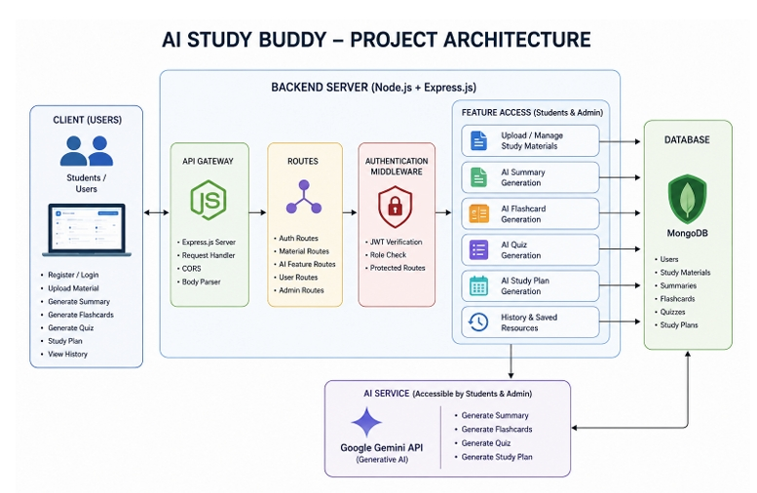

the backend follows a modular restful architecture. client requests pass through express.js routing, jwt authentication middleware, into controllers that contain the business logic, which in turn talk to mongodb (via mongoose) for storage and to the google gemini api for ai content generation.

mvc pattern

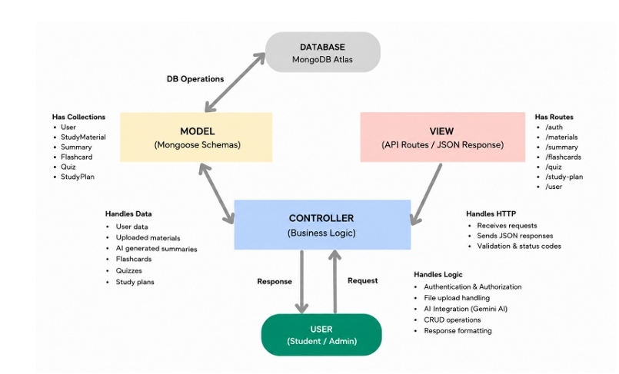

model: mongoose schemas (user, material) defining and validating stored data
view: since this is a pure rest api, the “view” is the structured json returned by each endpoint

controller: business logic — handles requests, talks to the database and to gemini, returns responses

Entity-Relationship (ER) Diagram Description
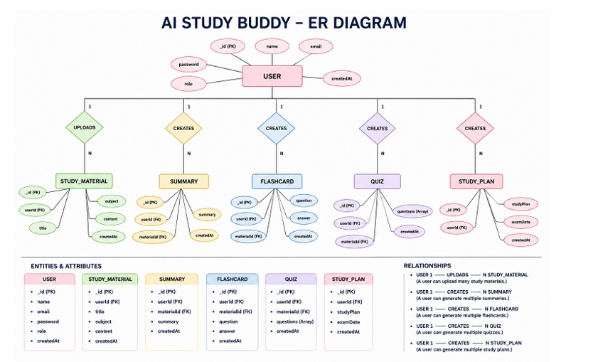
data model (entities)

user: _id, name, email, password (hashed), role (student/admin), createdat
material: _id, user (ref → user), title, content, flashcards[], quiz[], summary, studyplan, createdat
each material document belongs to one user, and holds its own generated summary, flashcards array, and quiz array — so all ai outputs for a given piece of material stay grouped together.

phase 4: project planning
work breakdown

setup: initialize node.js project, install dependencies, configure environment variables

backend development: build authentication, material upload, and ai integration modules

database configuration: define schemas, connect to mongodb atlas

execution & testing: run the server locally and verify every endpoint using postman

version control & submission: push the project to a public github repository, organized phase-wise

demonstration: record a walkthrough video of the working project
tools used
visual studio code — development
postman — api testing
mongodb atlas — cloud database
github desktop — version control
google gemini api — ai content generation

phase 5: project development

the backend was implemented in node.js and express.js with a clear separation of concerns:
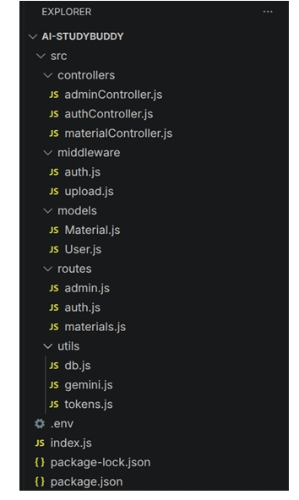

key modules

src/utils/db.js — connects to mongodb via mongoose before the server starts accepting requests

src/middleware/auth.js — verifies the jwt on protected routes and enforces role-based access

src/utils/gemini.js — sends prompts to the google gemini model and returns generated text

src/middleware/upload.js — handles and validates incoming material uploads

src/models/user.js — hashes passwords with bcrypt before saving, and exposes a password-check method

src/models/material.js — stores the uploaded content plus its generated summary, flashcards, and quiz

the full source code is available in this repository's root (see the src/ folder and index.js).

phase 6: project testing

every endpoint was manually tested end-to-end in postman against the running local server (http://localhost:5000), using a real registered user and a real uploaded material document.
method | endpoint | purpose
post | /api/auth/register | create a new user account
post | /api/auth/login | authenticate and issue jwt tokens
post | /api/materials/upload | upload study material
post | /api/materials/:id/summarize | generate ai summary
post | /api/materials/:id/flashcards | generate ai flashcards
post | /api/materials/:id/quiz | generate ai quiz
post | /api/materials/:id/study-plan | generate ai study plan

sample verified results

register (201 created):
{ "message": "registered successfully", "accesstoken": "<jwt>", "refreshtoken": "<jwt>", "user": { "id": "...", "name": "darshana", "role": "student" } }
upload material (201 created): material saved with an empty flashcards/quiz array, ready for ai generation.
summarize (200 ok):
{ "summary": "**node.js – quick revision:** ... non-blocking and event-driven ... npm (default)." }
flashcards (200 ok): 5 question/answer pairs generated directly from the uploaded content.
quiz (200 ok): 5 multiple-choice questions, each with 4 options and a correct answer.
study plan (200 ok): a structured multi-day study plan generated from the material.

issues found & resolved

eaddrinuse (port already in use) — resolved by closing the stale server process
expired jwt access token — resolved by re-logging in to obtain a fresh token
transient 503 from the gemini api under high demand — resolved by retrying after a short delay
a trailing space in a postman url caused a 404 — resolved by correcting the url

phase 7: project documentation

this document itself constitutes the project documentation phase, consolidating the ideation, requirements, design, planning, development, and testing work into a single reference. a companion api testing report (ai_studybuddy_submission_report.docx) contains the complete request/response
evidence for every endpoint.

Phase 8: project execution

The AI StudyBuddy backend can be executed locally using Node.js. Before running the application, ensure that MongoDB is running and the required environment variables are configured correctly. The backend exposes REST APIs that can be tested using Postman or Thunder Client.
Running the Backend Server Install all required dependencies:
Start the development server:

After successful execution, the server connects to MongoDB and starts listening for incoming API requests.

API Testing

The backend APIs can be tested using Postman.
- User Registration: Registers a new user by accepting the required details and securely storing the encrypted password in the MongoDB database. Endpoint: POST /api/auth/register
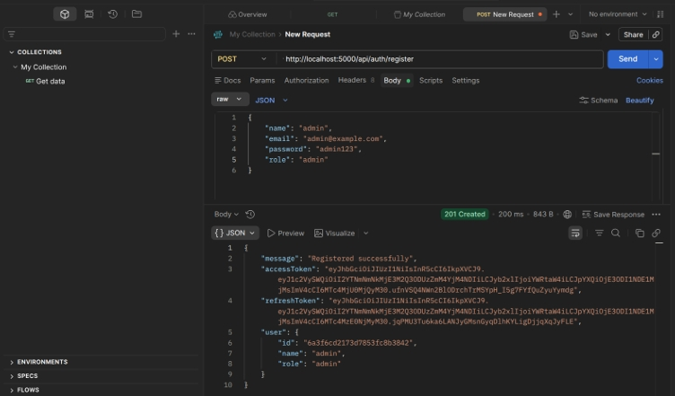

- User Login: Authenticates the registered user and generates a JWT access token for accessing protected APIs. Endpoint: POST /api/auth/login.
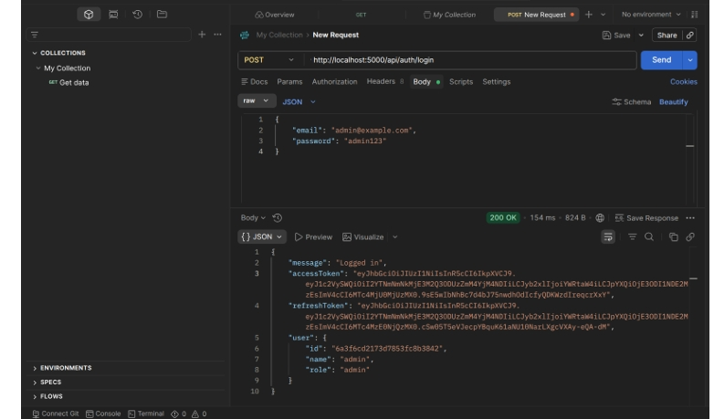
- Upload Study Material: Allows authenticated users to upload study material that will be used as input for AI-powered content generation. Endpoint: POST /api/material/upload

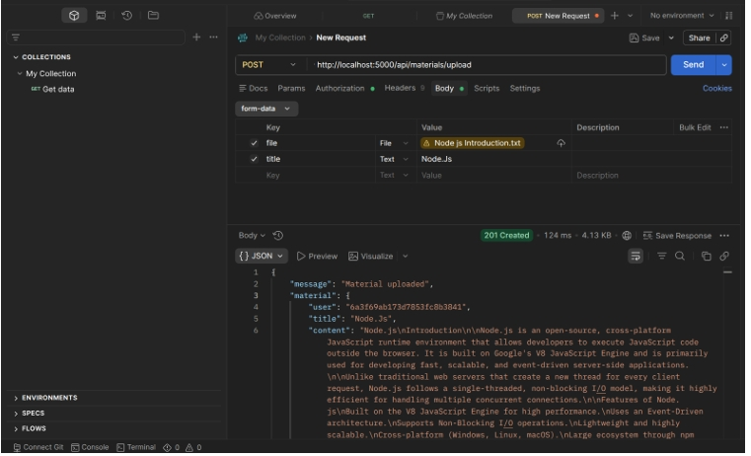
- Generate AI Summary: Sends the uploaded study material to the Google Gemini API and generates a concise summary. Endpoint: POST /api/materials/:id/summarize
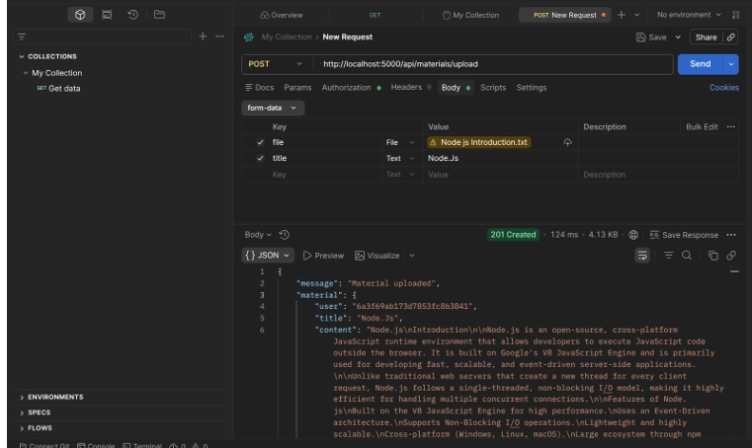

- Generate AI Flashcards: Creates AI-generated flashcards from the uploaded study material for effective revision. Endpoint: POST /api/ai/flashcards

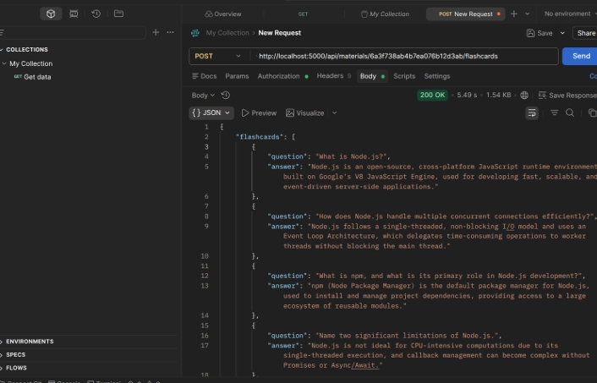

- Generate AI Quiz: Generates multiple-choice questions from the uploaded study material to help users assess their understanding. Endpoint: POST /api/ai/quiz

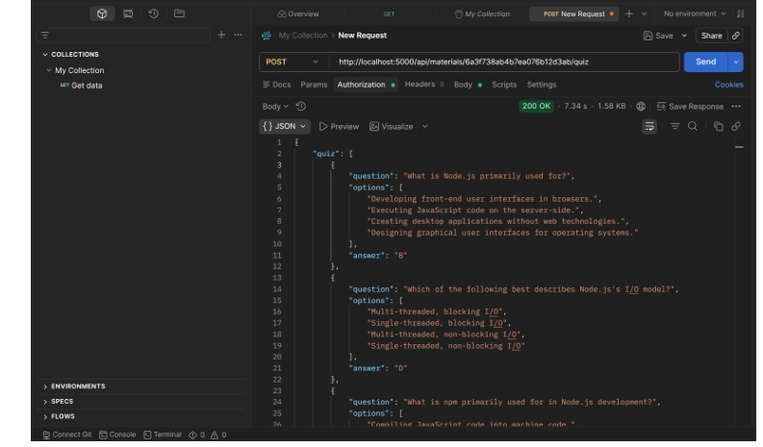

- Generate AI Study Plan: Creates a personalized study schedule based on the user's learning goals and available study time. Endpoint: POST /api/ai/study-plan
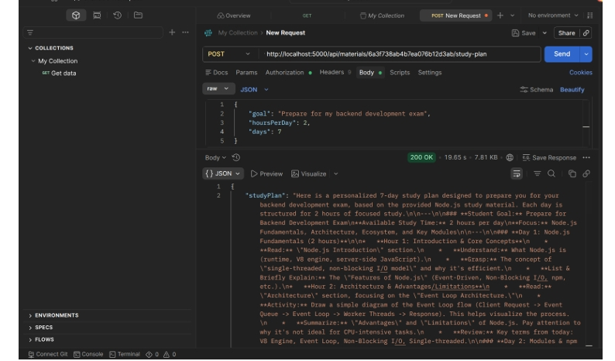

Phase 9: project demonstration

a screen-recorded walkthrough video was produced covering: the project name and purpose, the problem it solves, a live run of the server, and a live demonstration of every endpoint (register, login, upload, summarize, flashcards, quiz, study plan) in postman, followed by a look at the public github repository.

demo video link: https://drive.google.com/file/d/1UHINUTuWtKfCsjTRJUcIJPNCuS-Z82ci/view?usp=sharing

github repository: https://github.com/darshanabbca24krmmc-bit/aistudybuuddy.git

