Assignment 1:

1. Create csv file

1. API :Post

Validate Status code, Response time and Response header

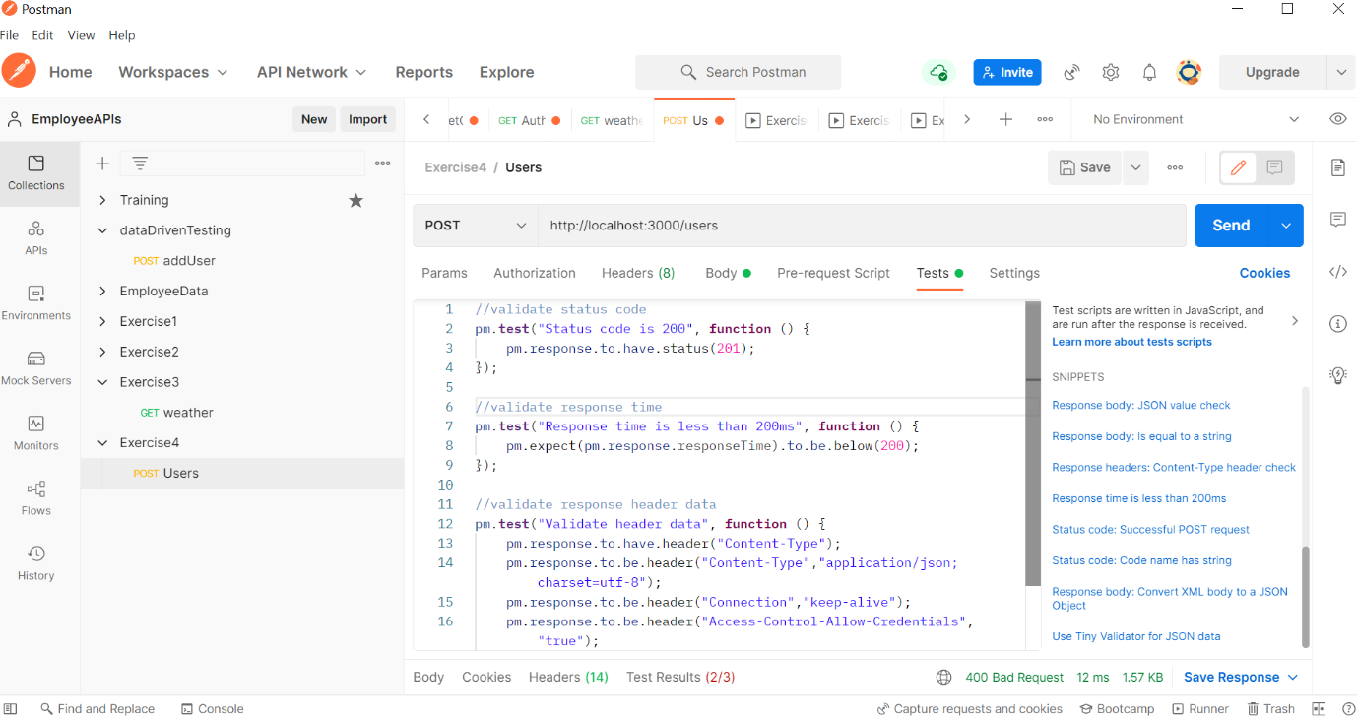

Result:

