**Collections**

The **Collection in Java** is a framework that provides an architecture to store and manipulate the group of objects.

Java Collections can achieve all the operations that you perform on a data such as searching, sorting, insertion, manipulation, and deletion.

Java Collection means a single unit of objects. Java Collection framework provides many interfaces (Set, List, Queue, Deque) and classes ([ArrayList](https://www.javatpoint.com/java-arraylist), Vector, [LinkedList](https://www.javatpoint.com/java-linkedlist), [PriorityQueue](https://www.javatpoint.com/java-priorityqueue), HashSet, LinkedHashSet, TreeSet).

Hierarchy of Collection Framework

amework.

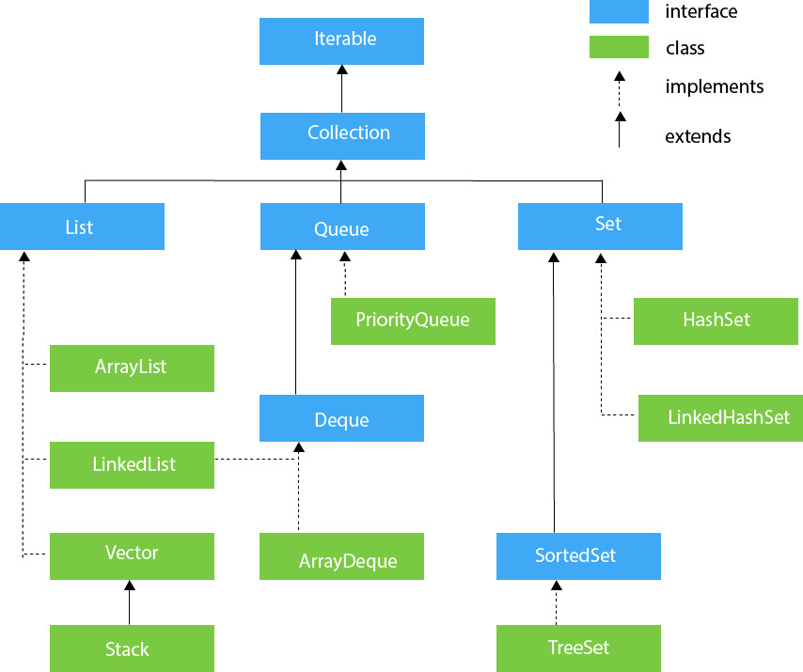

## **Collection Interface**

 implemented by all the classes in the collection framework

* **List Interface**

Boolean add ( Object obj),

Boolean addAll ( Collection c),

void clear(),

To instantiate the List interface, we must use :

1. List <data-type> list1= **new** ArrayList();
2. List <data-type> list2 = **new** LinkedList();
3. List <data-type> list3 = **new** Vector();
4. List <data-type> list4 = **new** Stack();

## **ArrayList**

implements the List interface.

dynamic array to store the duplicate element of different data types.

maintains the insertion order and is non-synchronized.

## **LinkedList**

LinkedList implements the Collection interface

uses a doubly linked list internally to store the elements.

It can store the duplicate elements

maintains the insertion order and is not synchronized

# **Java Collection Interface**

Collection is a group of objects, which are known as elements.

It is the root interface in the collection hierarchy.

This interface is basically used to pass around the collections and manipulate them where the maximum generality is desired.

There are many methods defined in the Collection interface. These are as follows:

|  |  |
| --- | --- |
| **Method** | **Description** |
| [add()](https://www.javatpoint.com/java-collection-add-method) | This method returns a Boolean value true if it inserts the specified element in this collection. |
| [addAll()](https://www.javatpoint.com/java-collection-addall-method) | This method returns a Boolean value true if it adds all the elements of specified collection in the invoking collection. |
| [clear()](https://www.javatpoint.com/java-collection-clear-method) | It removes all the elements automatically from this collection. |
| [contains()](https://www.javatpoint.com/java-collection-contains-method) | It returns a Boolean value true if this queue contains the specified element. |
| [containsAll()](https://www.javatpoint.com/java-collection-containsall-method) | It returns a Boolean value true if this collection contains all the elements in the specified collection. |
| [equals()](https://www.javatpoint.com/java-collection-equals-method) | This method returns a boolean value true if the specified object is equal with this collection. |
| [hashCode()](https://www.javatpoint.com/java-collection-hashcode-method) | It returns a hash code value for this collection. |
| [isEmpty()](https://www.javatpoint.com/java-collection-isempty-method) | This method returns true if this collection contains no elements or is empty. |
| [iterator()](https://www.javatpoint.com/java-collection-iterator-method) | It returns an iterator over the elements in proper sequence. |
| [remove()](https://www.javatpoint.com/java-collection-remove-method) | It removes the specified element from this queue, if it is present in the collection. |
| [removeAll()](https://www.javatpoint.com/java-collection-removeall-method) | It removes all the elements of this collection which are also present in the specified collection. |
| [removeIf()](https://www.javatpoint.com/java-collection-removeif-method) | It removes all the elements of this collection that satisfy the given predicate filter. |
| [retainAll()](https://www.javatpoint.com/java-collection-retainall-method) | This method retains only those elements in this collection that are present in the specified collection. |
| [size()](https://www.javatpoint.com/java-collection-size-method) | It returns the total number of the elements in this collection. |
| [spliterator()](https://www.javatpoint.com/java-collection-spliterator-method) | It returns a spliterator over the elements in this collection. |
| [toArray()](https://www.javatpoint.com/java-collection-toarray-method) | It returns an array containing all the elements of this collection which are in proper sequence. |